Oracle 12c RAC

Lab Module 14

Module 14 Lab: Use CRSCTL/OCRCHECK

1) User crsctl to check the status or CRS

a. On rac1

b. $. oraenv

c. +ASM1

d. $ crsctl check crs

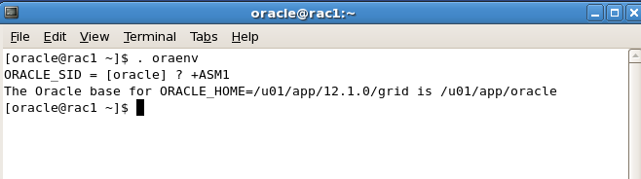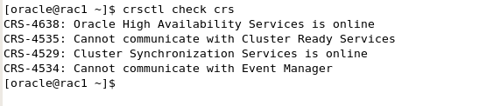

2) Check the status of all the RAC resources.

a. crsctl stat res

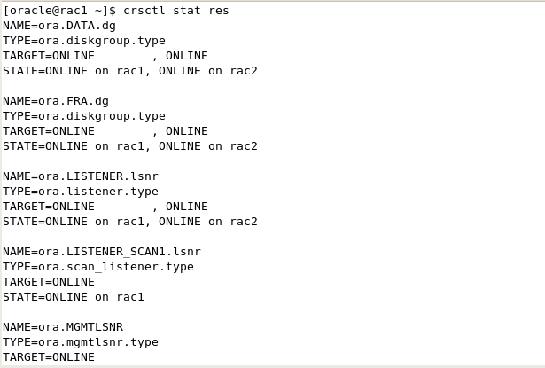

3) Find the location of the voting disk

a. crsctl query css votedisk

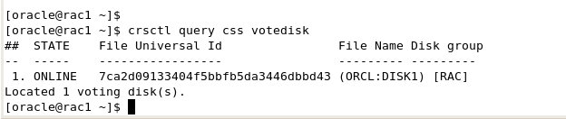

4) Display the options for crsctl

a. crsctl –h

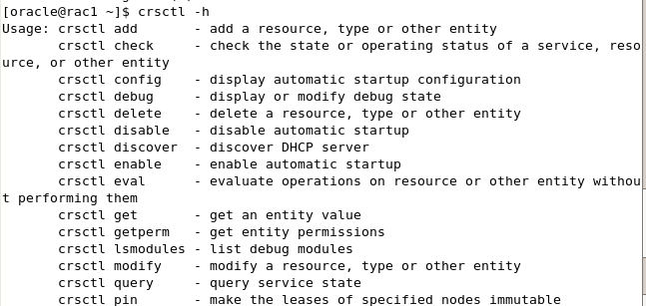

5) Show the configuration of crs. This must be performed as the root account.

a. su –

b. Enter the root password: oracle

c. . oraenv

d. +ASM1

e. crsctl config crs

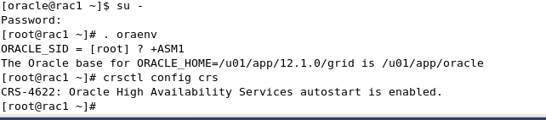

6) Check the location of the OCR disk

a.) ocrcheck

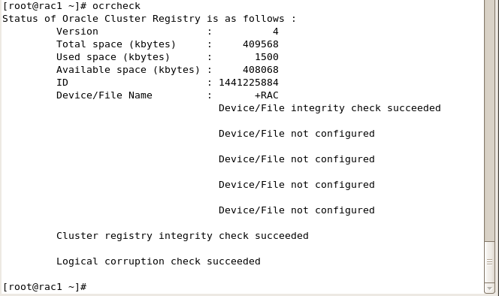

b. Check the location of the local ocr disk

c. ocrcheck –local

