# Lab Exercise 16: MONITORING

|  |
| --- |
| Configure PMI  Request Metrics  Start TPV  Create Report |

## Configure PMI

## Enable request metrics

## Start Tivoli Performance Viewer

## Create monitoring report

Configure PMI

Request Metrics

Start   
TPV

Create Report



**Task 1: Configure PMI**

**Step 1:** Navigate to “Monitoring and Tuning>Performance Monitoring Infrastructure (PMI)” and click on the application server name you want to configure.

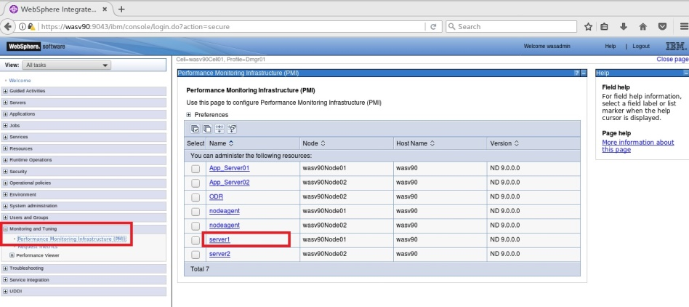

Configure PMI

Request Metrics

Start   
TPV

Create Report



**Step 2:** Select “Enable Performance Monitoring Infrastructure” and select statistics set as “Basic”, then click “OK”.

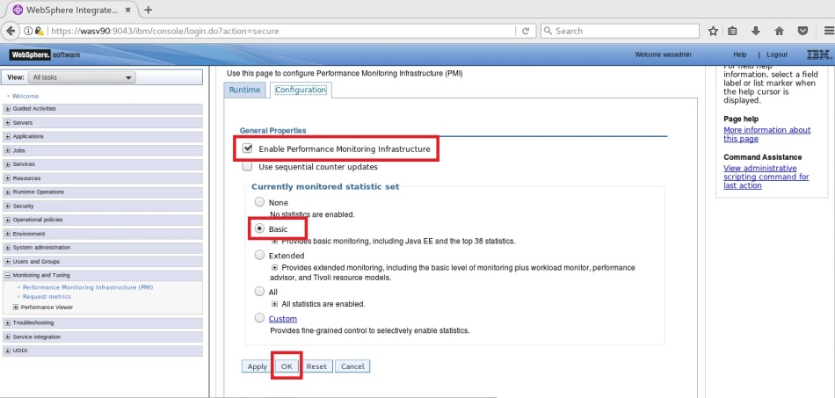

Configure PMI

Request Metrics

Start   
TPV

Create Report



**Step 3:** Click “Save” to write changes to the master configuration file.

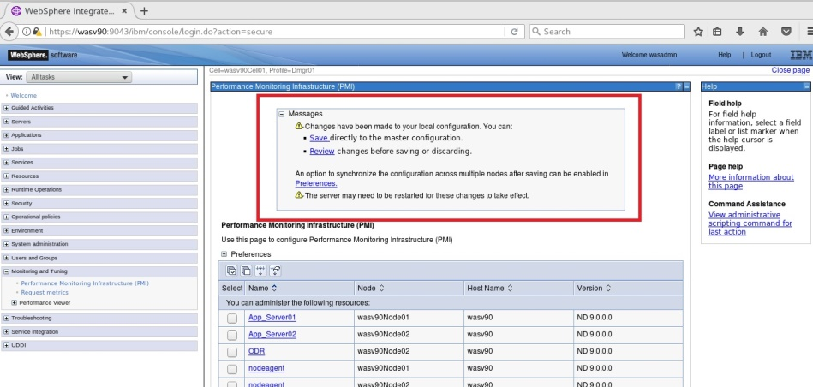

**Task 1 is complete!**

Configure PMI

Request Metrics

Start   
TPV

Create Report



**Task 2: Enable Request Metrics**

**Step 1:** Navigate to “Monitoring and Tuning>Request Metrics”.

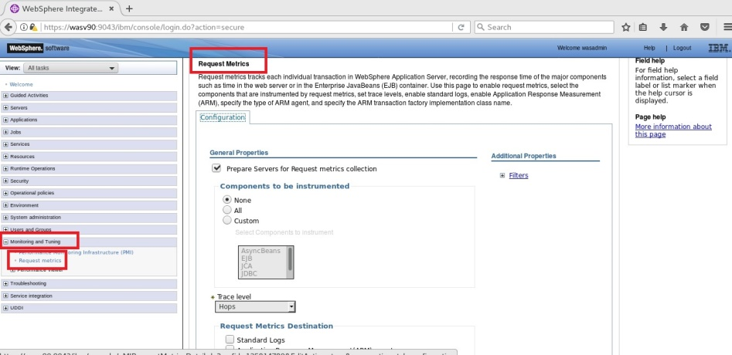

Configure PMI

Request Metrics

Start   
TPV

Create Report



**Step 2:** Select “Prepare Servers for Request metrics collection” and mark “Standard Logs” as “Request Metrics Destination”, then click “OK”.

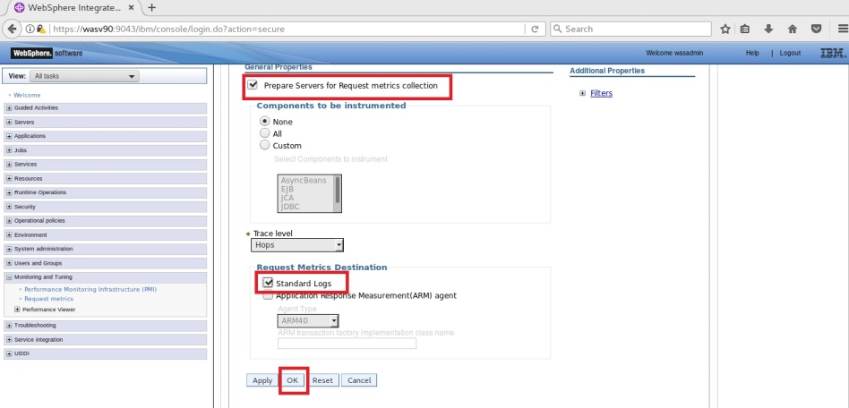

Configure PMI

Request Metrics

Start   
TPV

Create Report



**Step 3:** Click “Save” to write changes.

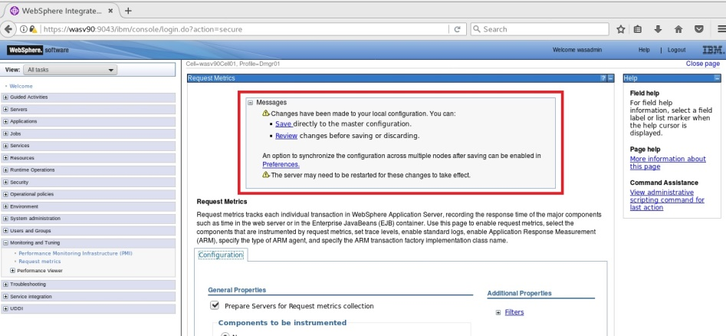

**Task 2 is complete!**

Configure PMI

Request Metrics

Start   
TPV

Create Report



**Task 3: Start Tivoli Performance Viewer**

**Step 1:** Navigate to “Monitoring and Tuning>Performance Viewer>Current activity”.

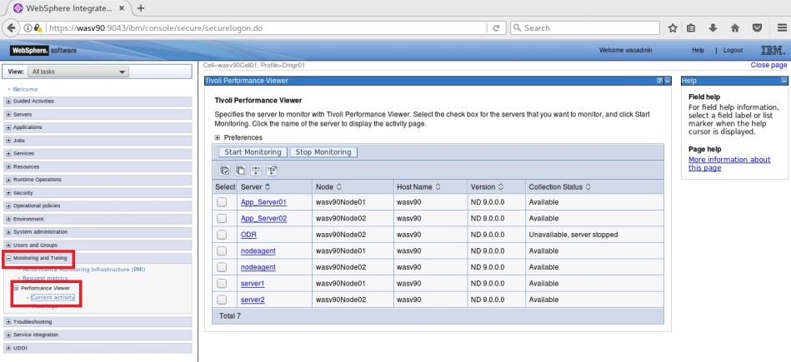

Configure PMI

Request Metrics

Start   
TPV

Create Report



**Step 2:** Select the application servers that you want to start Tivoli Performance Viewer and then click “Start Monitoring”.

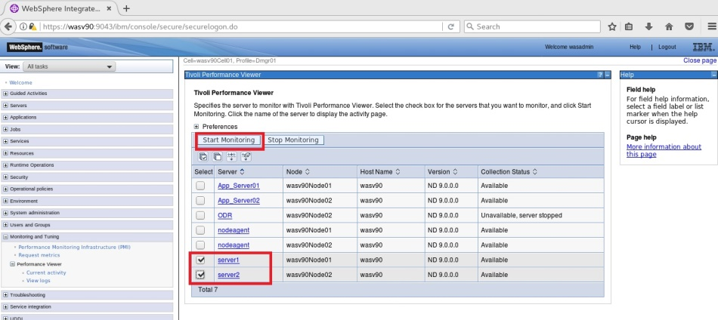

Configure PMI

Request Metrics

Start   
TPV

Create Report



**Step 3:** Expect a similar success message as below.

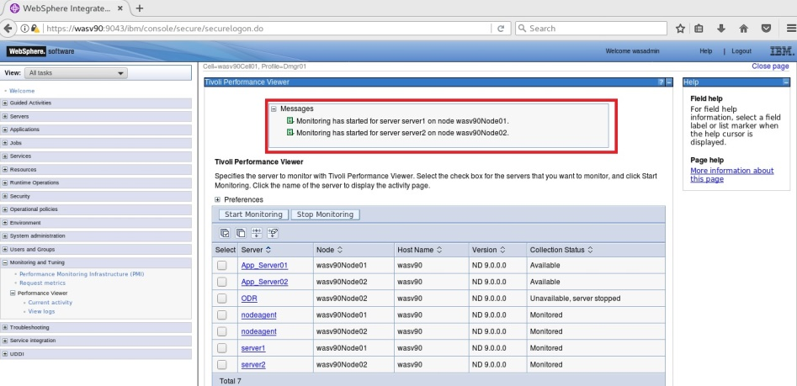

**Step 4:** You can check the values by clicking on the name of the application server under “Current activity”.

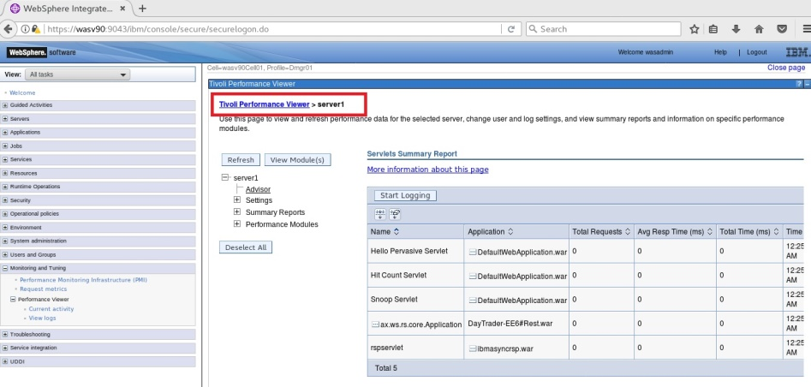

**Task 3 is complete!**

Configure PMI

Request Metrics

Start   
TPV

Create Report



**Task 4: Create Monitoring Report**

**Step 1:** Navigate to “Runtime Operations>Reports” and click on “View Chart in New Window”.

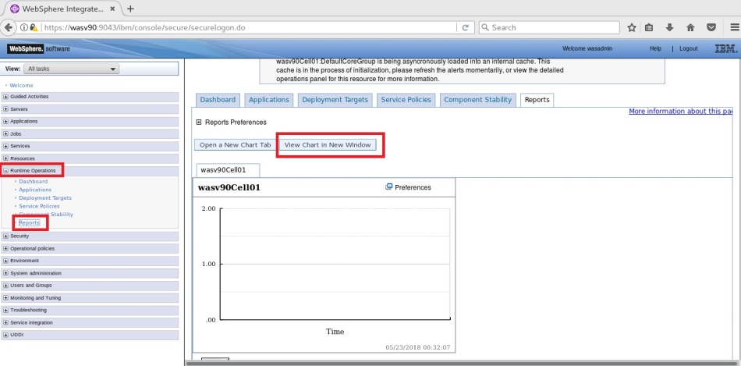

Configure PMI

Request Metrics

Start   
TPV

Create Report



**Step 2:** Click “Change Scope” to define the report you want to get/

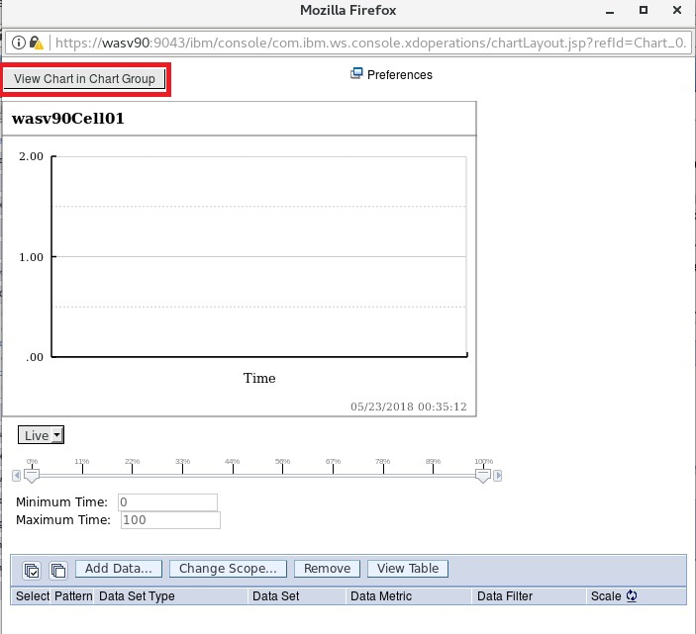

Configure PMI

Request Metrics

Start   
TPV

Create Report



**Step 3:** Change the “Object Type” and the “Object Instance” as application server and application server instance. You can also choose the metrics and then click “OK”.

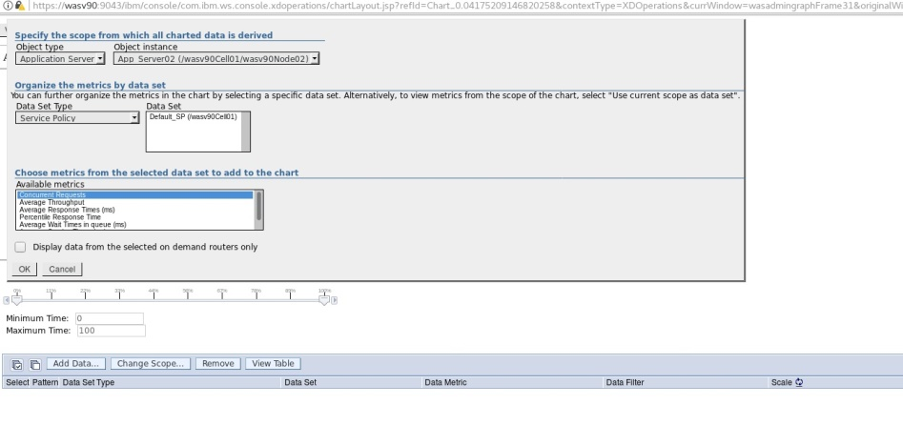

**Task 4 is complete!**

# SUMMARY

IBM WebSphere Application Server provides strong infrastructures to gather monitoring data to be used in application environment management activities including performance tuning. PMI collects runtime application server and system data and provides interfaces to allow internal and external applications to reach the collected data. Request metrics provide help in tracking request flow and identifying the time elapsed for each of the major WebSphere Application Server components. In WebSphere Application Server version 8.5, Tivoli Performance Viewer (TPV) is integrated to the administrative console and it allows you to display the PMI data collected from application servers.

# REFERENCES

* http://pic.dhe.ibm.com/infocenter/wtelecom/v7r1m0/index.jsp?topic=%2Fcom.ibm.twss.doc%2Fcom_perfmonitoring_c.html
* http://publib.boulder.ibm.com/infocenter/tivihelp/v63r1/index.jsp?topic=%2Fcom.ibm.itcamt.doc_7.3%2Ftt%2Fdita%2Fconcept%2Fkto_dom_was.html
* http://publib.boulder.ibm.com/infocenter/wsdoc400/v6r0/index.jsp?topic=/com.ibm.websphere.iseries.doc/info/ae/ae/tprf_tpvmonitor.html

# INDEX

PMI 495

Request metrics 496

Tivoli Performance Viewer 495