# CHAPTER 19: TROUBLESHOOTING

## Theory

Troubleshooting of WebSphere Application Server may be required due to several reasons like performance issues or application unavailability. In order to resolve the problem, we need to collect as much data as possible to identify it. There are multiple ways of data collection in WebSphere Application Server including java log files, java traces, thread dumps, heap dumps and system dumps.

Here is the list of log files that are used in problem determination:

* *SystemOut.log and SystemErr.log:* In these files standard JVM output and errors are stored.
* *stopServer.log and startServer.log:* These logs store information during stop and start of application servers.
* *trace.log:* This file contains diagnostic trace information if the tracing is enabled.
* *native_stdout.log and native_stderr.log:* These files are used by operating system to log memory exceptions and garbage collection data.

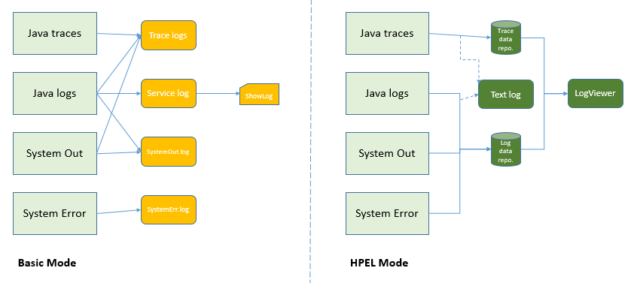

WebSphere Application Server provides 2 different modes of logging and tracing:

* **Basic Mode**: This is the standard and default mode for logging and tracing. This mode is available from older versions of WebSphere Application Server.
* **HPEL Mode**: High Performance Extensible Logging (HPEL) mode is a new framework for logging and tracing which provides a log data repository that contains SystemOut and SystemErr logs, and a trace data repository for trace content. In order to see the logs, you need to use the “logViewer” command. It is also possible to mirror the logs in the repositories to a text log which is the default option.

For further troubleshooting, you can use java core and heap dumps. You can trigger these dumps from WebSphere administrative console. These dumps are mostly used to diagnose memory problems like memory leaks. Although in certain cases, these logs must be collected, you should take into consideration the impact of this process to system performance.

WebSphere Application Server provides features to help you to capture more data for problem determination such as:

* Hang detection policy is enabled by default to report potential hangs. A hung thread can be a result of many different causes and without a proper reporting system will run in a degraded mode.
* Memory leak detection policy can be configured to detect, prevent and take action against potential application memory leaks.

## AIM

In this lab exercise, you will configure most used configuration items of WebSphere Application Server for problem determination. To achieve this goal, you will need to complete following tasks:

* Change JVM log settings
* Enable HPEL
* Enable trace
* Generate heap dump

# Lab Exercise 19: TROUBLESHOOTING

|  |
| --- |
| JVM  Log  Enable  HPEL  Enable Trace  Dump Heap |

## 1. Change JVM log settings

## 2. Enable HPEL

## 3. Enable trace

## 4. Generate heap dump

**Task 1: Change JVM log settings**

JVM   
Log

Enable   
HPEL

Enable Trace

Dump Heap



**Step 1:** Navigate to “Troubleshooting>Logs and trace” and click on the application server name that you want to work on.

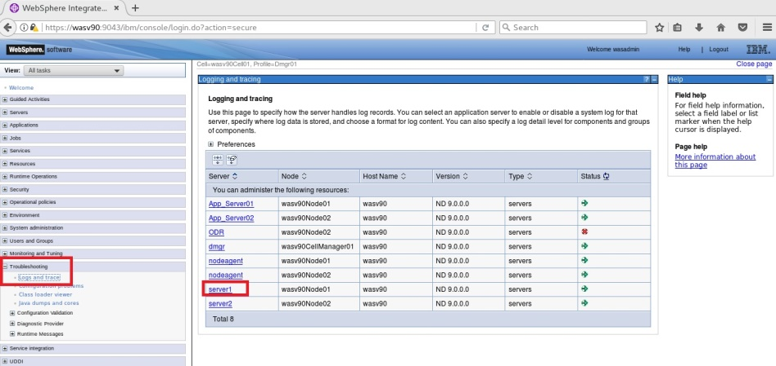

**Step 2:** Click “JVM Logs”.

JVM   
Log

Enable   
HPEL

Enable Trace

Dump Heap



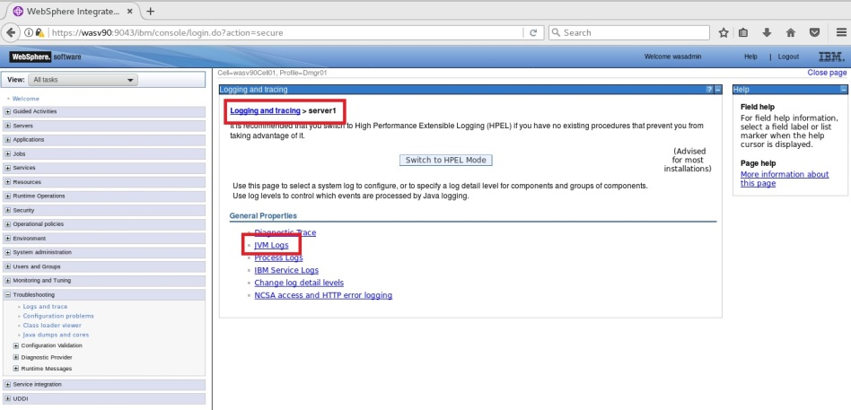

**Step 3:** You can now configure the details of JVM logging of “server1” for “System.out” logging.

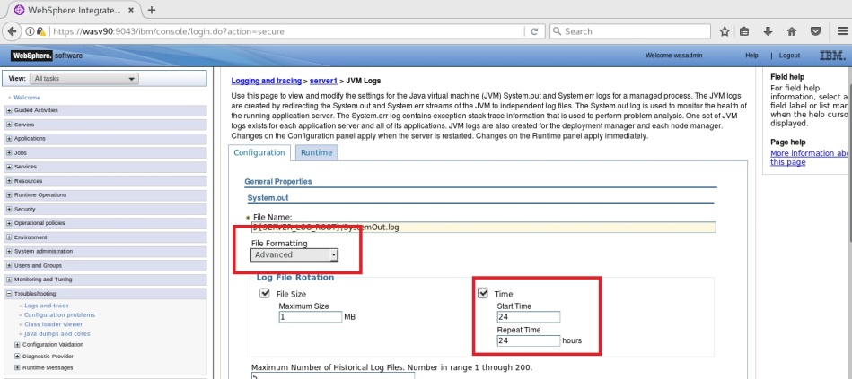

**Step 4:** Configure the “System.err” logging and click “OK”.

JVM   
Log

Enable   
HPEL

Enable Trace

Dump Heap



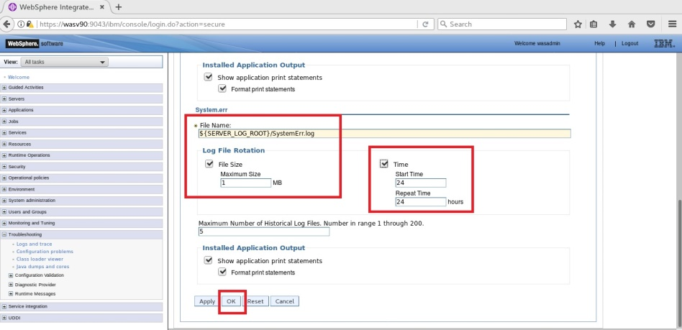

**Step 5:** Click “Save” to write changes to the master file.

JVM   
Log

Enable   
HPEL

Enable Trace

Dump Heap



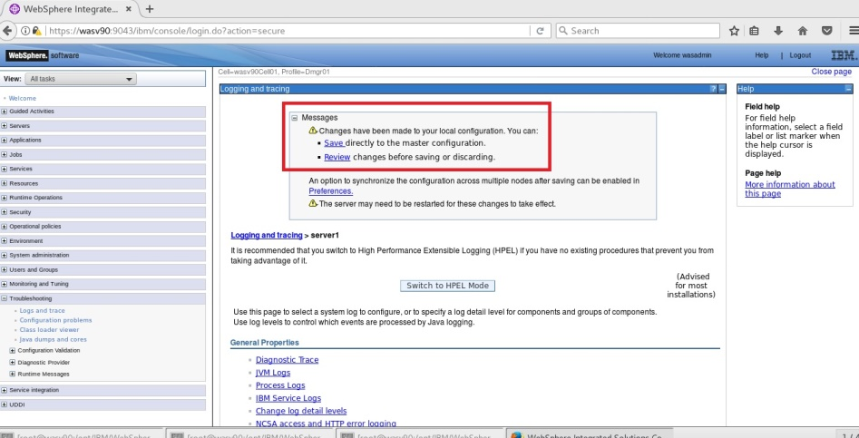

**Task 1 is complete!**

**Task 2: Enable HPEL**

JVM   
Log

Enable   
HPEL

Enable Trace

Dump Heap



**Step 1:** Navigate to “Troubleshooting>Logs and trace” and click on the application server name you want to enable HPEL logging.

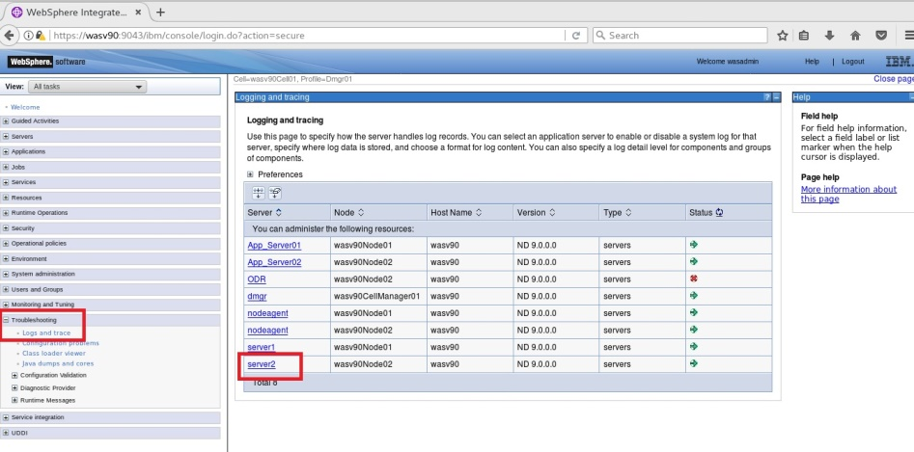

**Step 2:** Click on the button “Switch to HPEL Mode”.

JVM   
Log

Enable   
HPEL

Enable Trace

Dump Heap



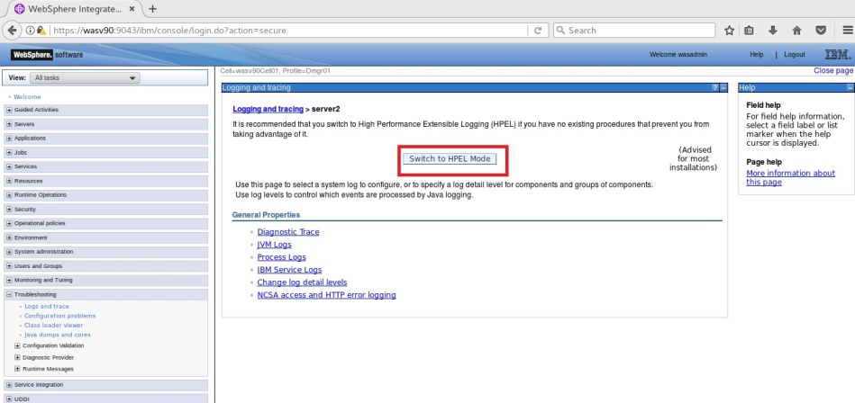

**Step 3:** Click “Save” to write changes.

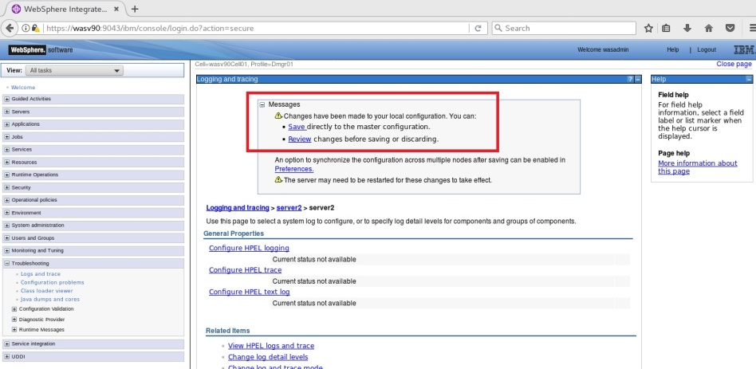

**Step 4:** When HPEL is enabled, you can see and change properties of HPEL logging.

JVM   
Log

Enable   
HPEL

Enable Trace

Dump Heap



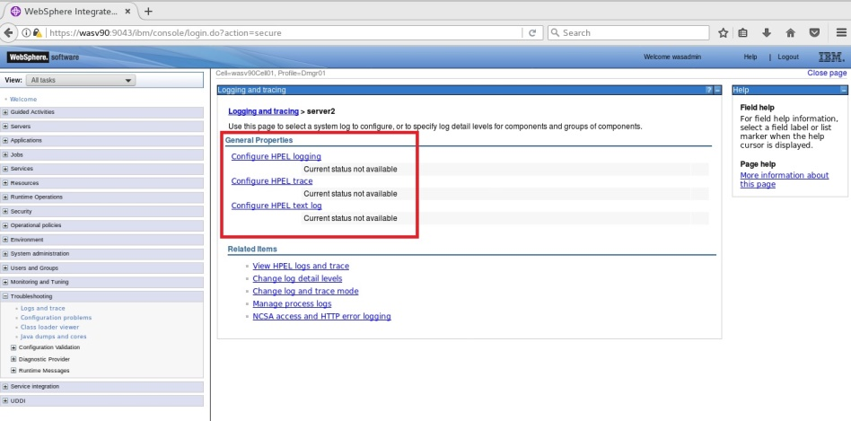

**Task 2 is complete!**

**Task 3: Enable Trace**

JVM   
Log

Enable   
HPEL

Enable Trace

Dump Heap



**Step 1:** Navigate to “Troubleshooting>Logs and trace” and click on the application server name.

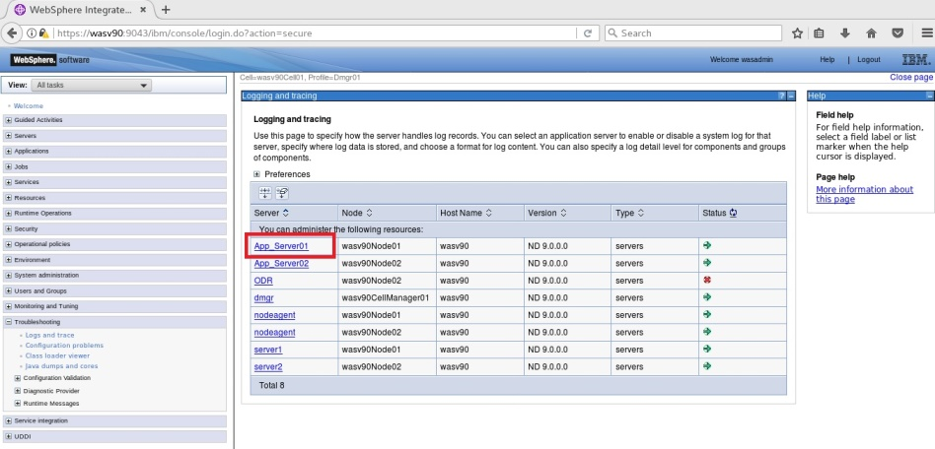

**Step 2:** Click on “Diagnostic Trace” to configure.

JVM   
Log

Enable   
HPEL

Enable Trace

Dump Heap



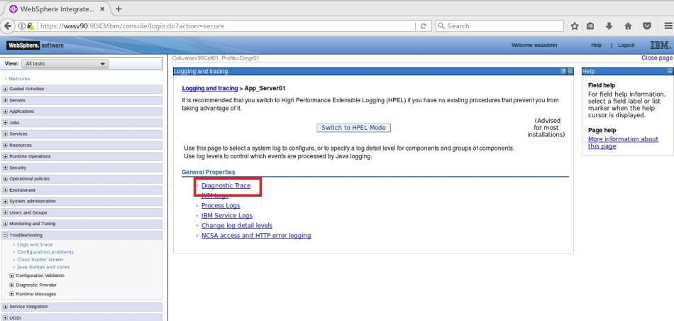

**Step 3:** On the “Runtime” tab, where the changes takes effect immediately, configure the file size, location and number of archive and click “OK”.

JVM   
Log

Enable   
HPEL

Enable Trace

Dump Heap



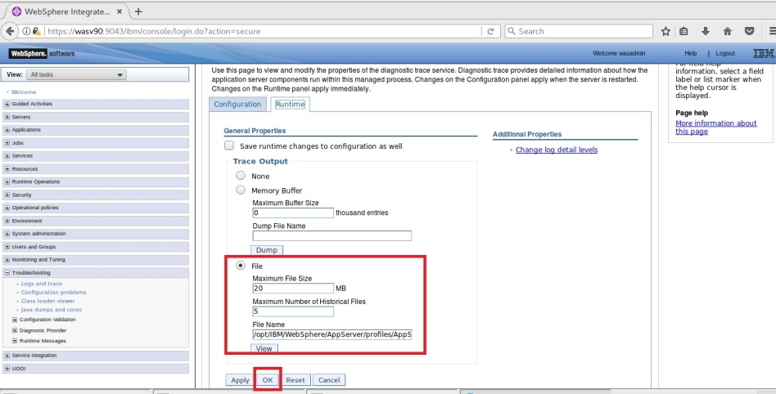

**Task 3 is complete!**

**Task 4: Generate heap dump**

JVM   
Log

Enable   
HPEL

Enable Trace

Dump Heap



**Step 1:** Navigate to “Troubleshooting>Java dumps and core” and select the application server from the list and click “Heap dump” button.

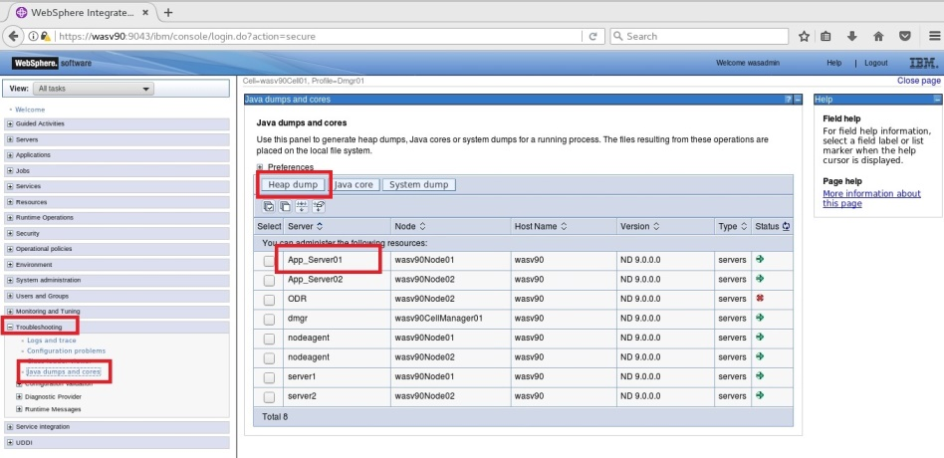

**Step 2:** You need to wait for the dump to be ready.

JVM   
Log

Enable   
HPEL

Enable Trace

Dump Heap



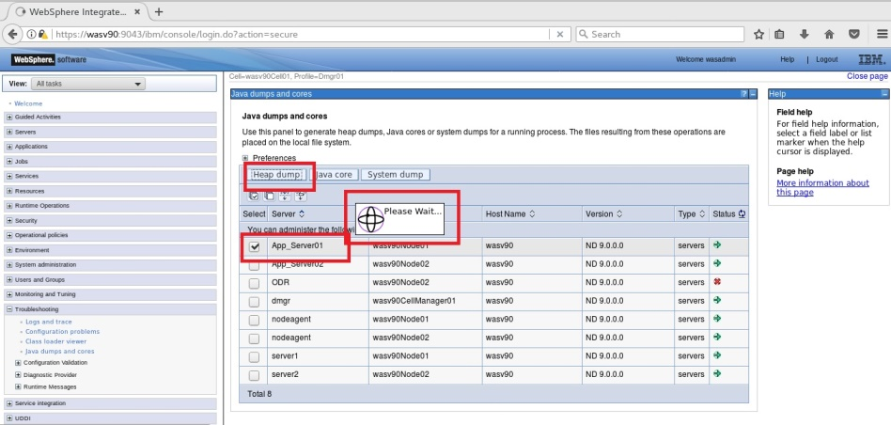

**Step 3:** When it’s ready, you should have a similar success message with the location of the dump file.

JVM   
Log

Enable   
HPEL

Enable Trace

Dump Heap



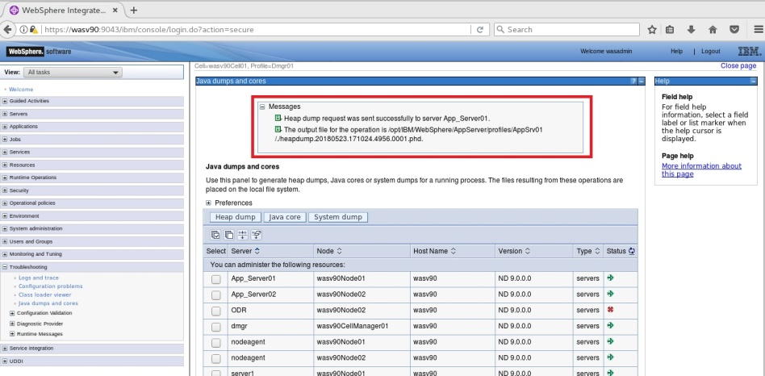

**Task 4 is complete!**

# SUMMARY

In order to resolve issues like response time, application unavailability and so on, WebSphere Application Server provides several different ways for problem determination. There are multiple ways of data collection in WebSphere Application Server including java log files, java traces, thread dumps, heap dumps and system dumps. It is also possible to use java core and heap dumps for troubleshooting purposes. Moreover, built-in policies such as hang detection policy and memory leak policy, allow WebSphere Application Server to identify possible issues and even take proper action to fix them.

# REFERENCES

* http://www-304.ibm.com/support/docview.wss?uid=swg27005324
* http://publib.boulder.ibm.com/infocenter/ieduasst/v1r1m0/index.jsp?topic=/com.ibm.iea.was_v8/was/8.5/ProblemDetermination.html
* http://www-01.ibm.com/support/docview.wss?uid=swg27036217

# INDEX

heap dumps 557

HPEL 558

java log files 557

java trace 557

Memory leak detection policy 558

thread dumps 557