# CHAPTER 10: APPLICATION DEPLOYMENT

## Theory

WebSphere Application Server supports three different types of applications to be deployed that are:

* *Enterprise Applications,* that can be an EAR (Enterprise Archive), a WAR (Web Application) file or a JAR (Java Archive) file. When an EJB module or Web module is installed, WebSphere Application Server will automatically pack it as an EAR file. It is similar case for WAR files, meaning, deployment process will convert WAR file in to EAR automatically.
* *Business Level Application,* is a WebSphere Application Server configuration artifact that provides a complete definition of an application from business view. It doesn’t contain any application file but presents a configuration that contains units which represents application files.
* Asset, is an application binary file such as EAR files, EJB modules, web modules, shared libraries and etc. that are stored in a repository managed by WebSphere Application Server.

You can deploy the applications from local file system that means the file system of the system that deployment manager runs or from a remote file system which means your system that is connected to administrative console.

ACCESS APP

Deploy App.



**Task: Start Default Application**

**Step:** Make sure that default application is running. It can be started by checking checkbox and click submit action.

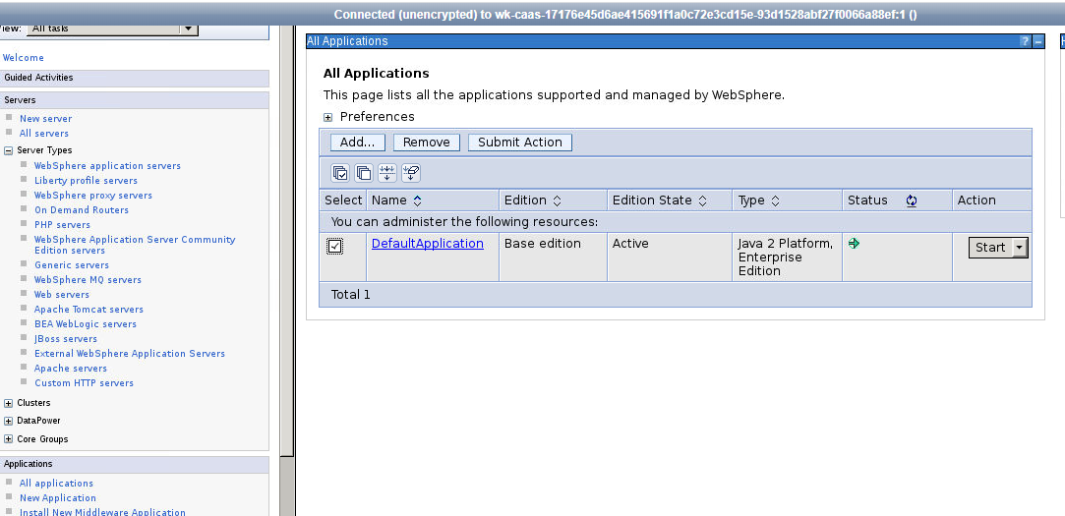

**Task: Deploy a sample application  
  
Step 1:** Navigate to “Applications>New Application” and click on “New Enterprise Application”.

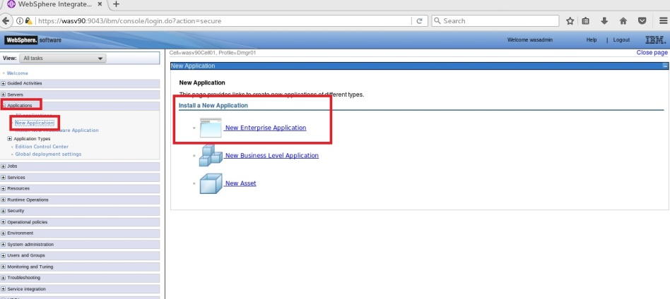

**Step 2:** Run the following commands in the terminal:

$ cd /headless/Desktop/websphere/

$ jar -cvf sample.javaee7.websocket.war

$ cd ./sample.javaee7.websocket/src/main/webapp

$ jar -xvf MyWebApp.war

Locate the “MyWebApp.war” war file on the local file system and click “Next”.

**/headless/Desktop/websphere**

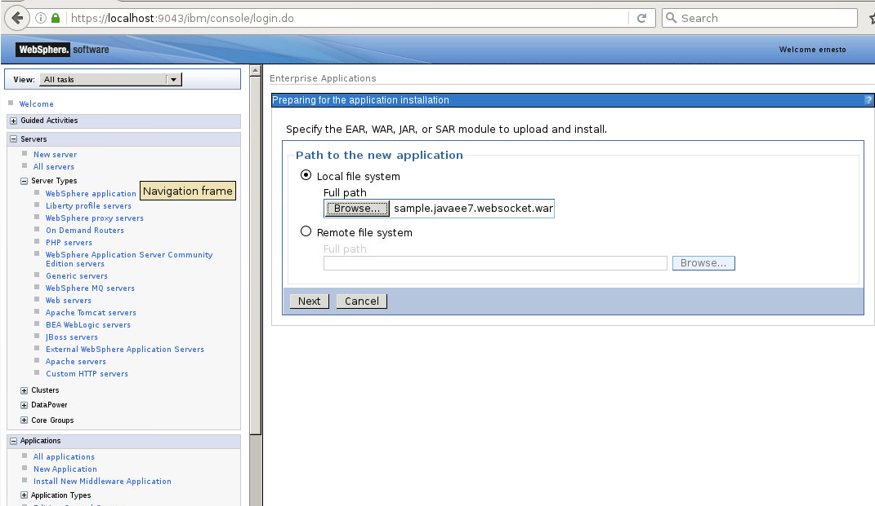

ACCESS APP

Deploy App.



**Step 3:** Select “Fast Path” and click “Next”.

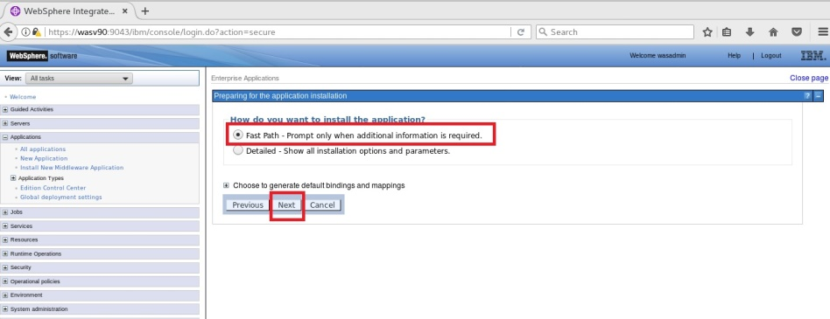

**Step 4:** Change application name to “SampleApplication” and click “Next”.

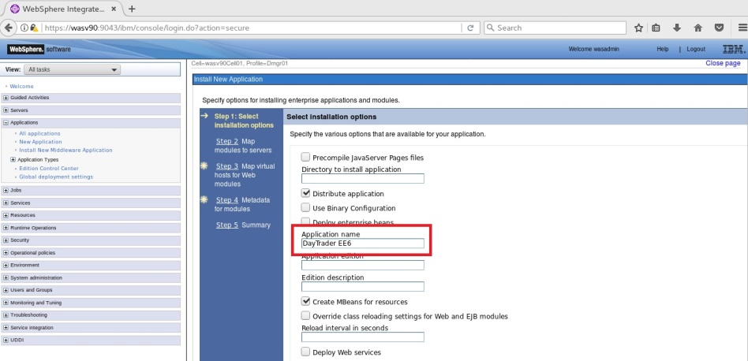

**Step 5:** Map module of the application and click “Apply”, then click “Next”.

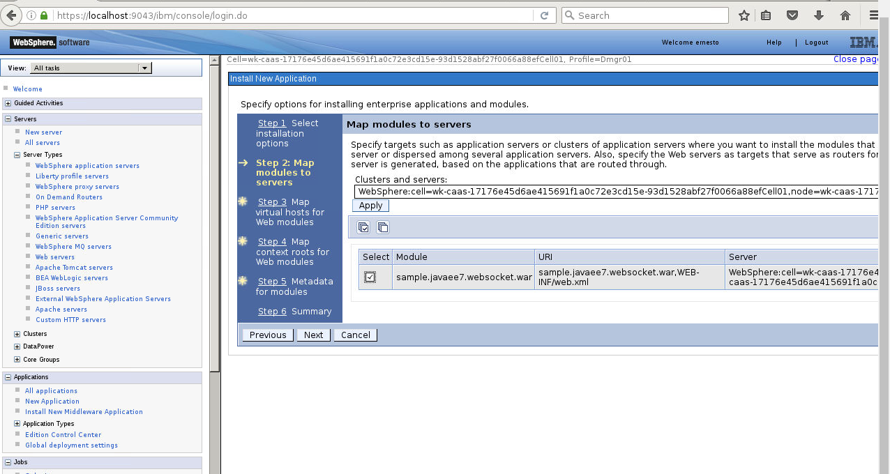

ACCESS APP

Deploy App.



**Step 6:** Enter context root **“/sample” and** Click “Next”.

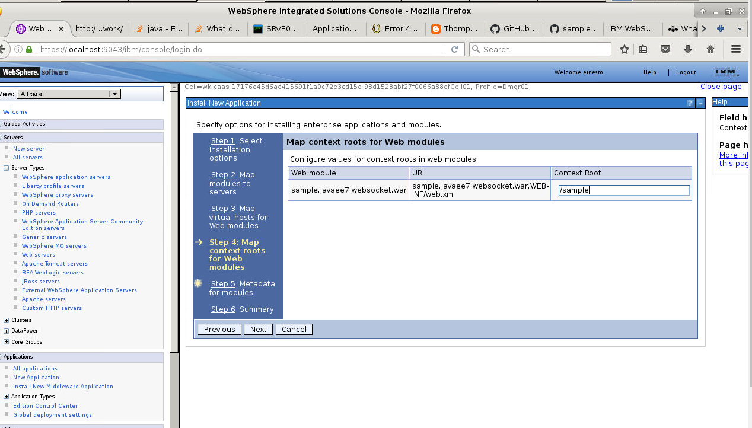

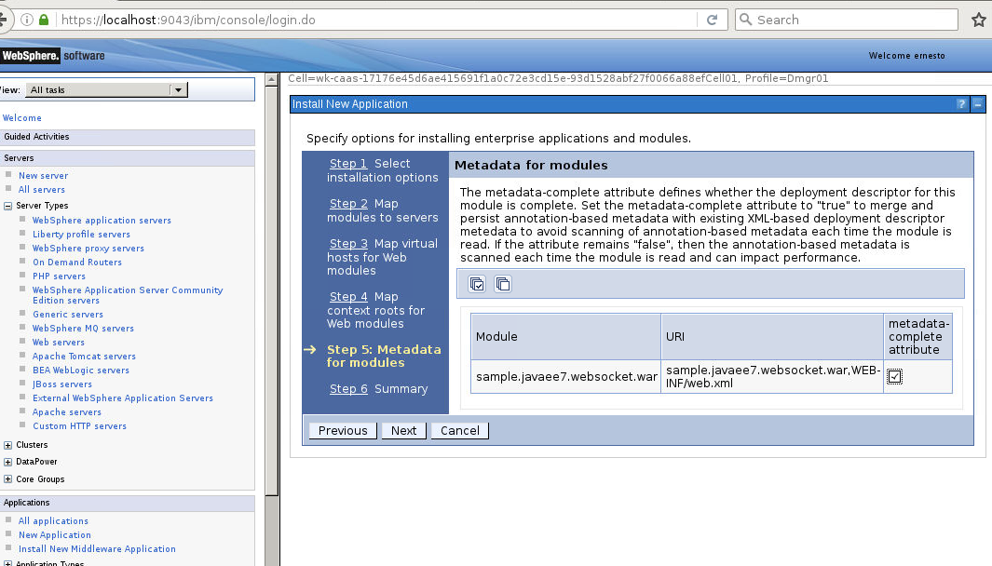

**Step 7:** Click “Finish” to start deployment.

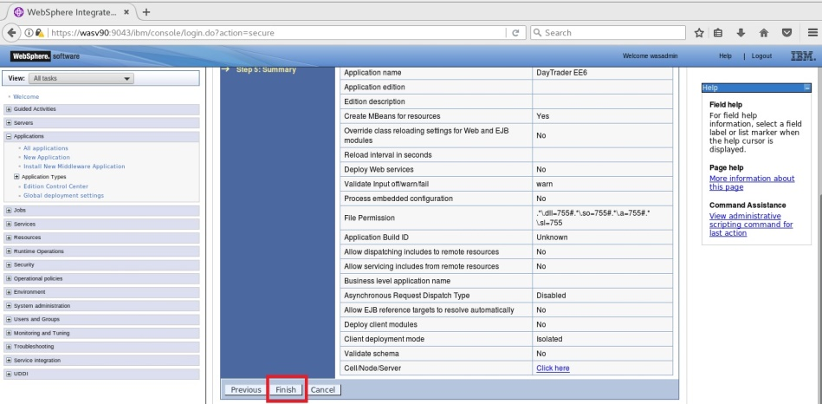

**Step 8:** You should see the success message, then click “Save” to write changes to the master configuration.

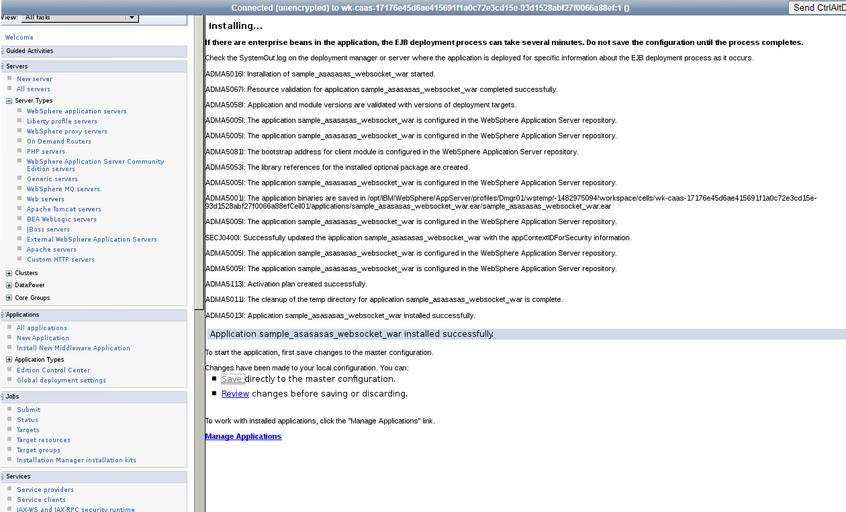

ACCESS APP

Deploy App.



**Step 9:** Select the application and action as “Start” and click “Submit Action”.

**Note: Wait for couple of minutes before starting application so that changes are synced.**

You should see the success message as follows. Reload status to get updated status.

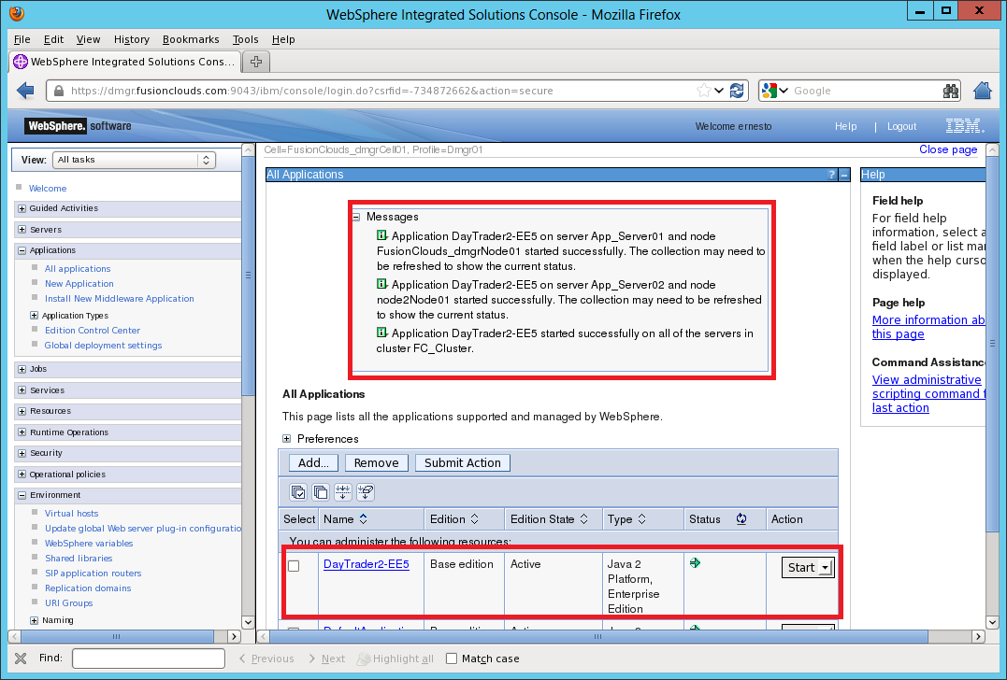

Task is complete!

**Task: Access New Application**

<http://localhost:9080/sample>

**this assumes you mapped to the URI of sample.

http://<update>.eastus.azurecontainer.io:9080/sample.javaee7.websocket/

**Access Default applications**

Open browser and enter “http://localhost:9080/snoop” to access application.

JSP can be accessed at “http://localhost:9080/HitCount.jsp”