# Troubleshoot:

## Open Applications (form CentOS container)

Click Applications > IBM Installation Manager to open IBM Installation Manager.

Click Applications > System > Profile Management Tool to open Profile Management Tool.

Click Applications > System >

to open websphere tools and other related applications.

## Install packages

Any required package can be installed form here:

<https://www.ibm.com/support/knowledgecenter/SSEQTP_9.0.5/com.ibm.websphere.installation.base.doc/ae/cins_repositories.html>

## Firefox

[https://localhost:<port](https://localhost:%3cport)********

## (Chapter 3) Task 3 : Stop & Start Application

Node agent needs to be restarted first from the terminal. Because that how server and default application starts. Instructions added in lab guide

/opt/IBM/WebSphere/AppServer/profiles/AppSrv01/bin/startNode.sh

<https://stackoverflow.com/questions/33024058/how-to-start-a-node-agent-in-websphere/33027287>

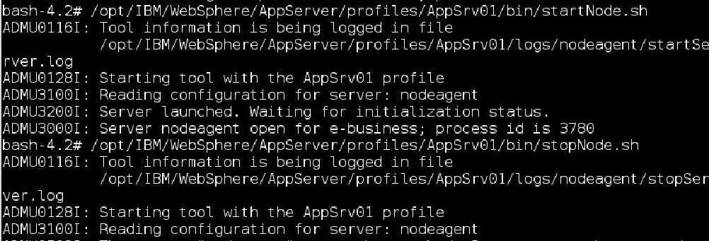

## (Chapter 5) Install IBM http server

****

****