Rum Runners
Capitalism meets Anarchy

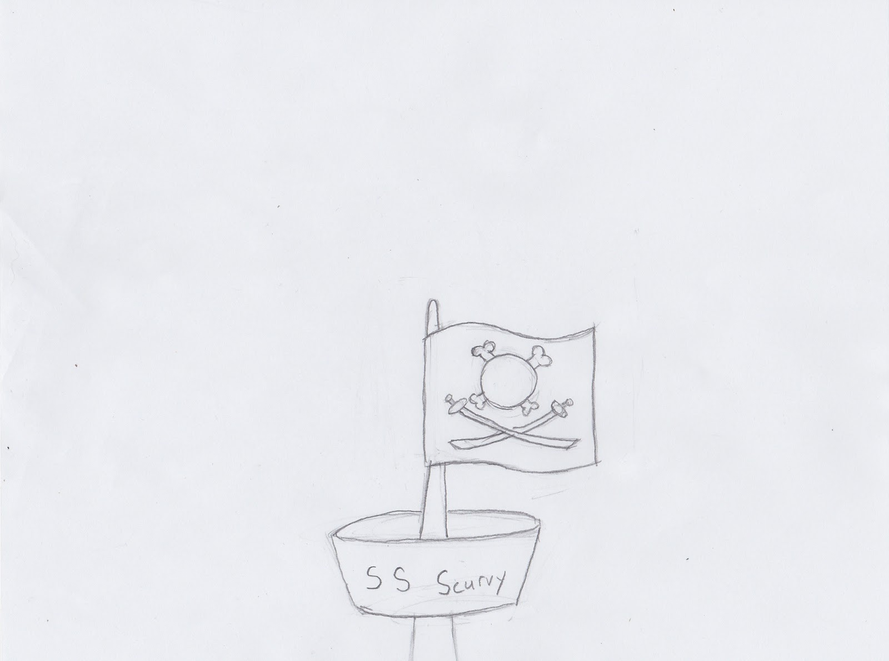

Leigh Garbs, James Szabo, Justin Smith, and Christine Shen
Change Log
Version | Date | Description
1.0 | 10/5/2014 | First iteration of Game Design Document. First draft has been finalized for the first presentation and will be updated as more progress has been made.
1.1 | 10/6/2014 | Cleaned up in preparation for design report. Added reference to design proposal in Overview section.
1.2 | 10/7/2014 | Removed “more to come soon …” from Software Architecture section.

Executive Summary
As a young man in debt in the Caribbean, you are forced to turn to privateering to pay back a loan shark. Navigate the high seas buying low and selling rum high to make money before your final loan is due, while battling other pirates and keeping your crew happily drunk. Sid Meier’s Pirates meets Transport Tycoon in this novel trade simulation and adventure game.

Overview
Title: Rum Runner
Tag Line: Capitalism meets anarchy
Names: Leigh Garbs, James Szabo, Justin Smith, Christine Shen
Genre: Simulation/Strategy/Adventure
Platform: PC
Market: ages 10 and up
Setting: Caribbean, 1600s
Plays like: Sid Meier’s Pirates meets Transport Tycoon
Summary: You are a “rum runner”, a pirate seeking profit in the illegal rum trade. Navigate the high seas and keep your crew of pirates happy. Acquire your rum at low cost and sell for a profit while surviving various sea hazards, including weather and other pirates.
Mechanics:
- Economy: supply and demand of rum
- Collection time limit: win if earn money before time limit, lose if run out of rum (mutiny), lose if you don’t earn enough money before time limit
- Buy and sell ports
  - can only buy at buy ports, can only sell at sell ports
  - buy ports deplete rum over time, sell ports generate rum over time
  - price of rum at port = 11 - amount of rum at port
  - once inventory at port changes (because of buy or sell), price changes inversely
- Resource depletion: rum supply on ship depletes over time
- Bounded inventory between 0 and 10
- Ship-to-ship combat (to be added later)
- Sea hazards: damage to ship, crew, etc. (to be added later)
A proposal document with additional information is attached.

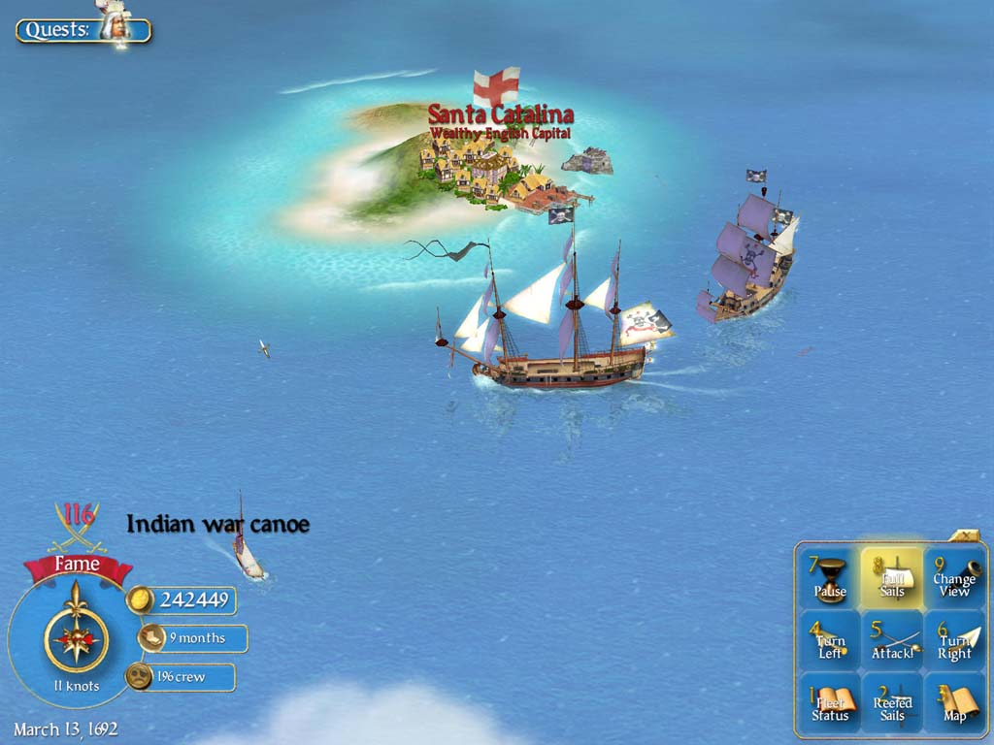
Related Games
Game: Sid Meier’s Pirates (2004)
Developer: Firaxis (developer)
Genre: Strategy/Action/Adventure
Description: Pirates, is a remake of a game published in 1987. Made for the Xbox in 2005, additional platforms include: Windows, PlayStation Portable, Wii, iPad, iPhone, and Windows Phone. Pirates consists of several different skill-based mini-games, connected by an overall "sailing map" mode of the Caribbean around which the player navigates looking for adventure. Some examples of the skills include: sailing technique,running from guards, naval gunnery, fencing, and strategic planning. Players can also gain items and special crew members who give an advantage for one of the skills required to play the mini games.
The game is playable using only the keyboard (numpad keys and enter), except for selecting options on the start menu and control screen.
[Source: Wikipedia http://en.wikipedia.org/wiki/Sid_Meier%27s_Pirates!_(2004_video_game)]
Rum Runners (RR) will be the most similar to this game, in terms of theme and ability to sail from island to island in the Caribbean. RR will also include combat and ship upgrades, if time permits. However, RR will mostly use the mouse and WASD keys as an input, and success in RR will not depend on skill, but chance and strategy.

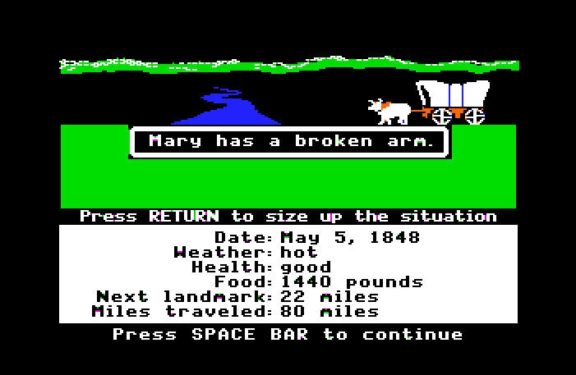
Game: Oregon Trail (1974)
Producer: Minnesota Educational Computing Consortium
Genre: Simulation/Adventure
Description: The original game was developed to teach children about the harsh conditions of 19th century pioneer life on the Oregon Trail. The game takes place on the Oregon Trail, stretching from Independence, Missouri, to Oregon's Willamette Valley, in 1848. As the player, one takes on the role of wagon train leader of a small group of settlers. The game has since been adapted for Facebook and mobile apps (Windows, iPhone, and Android).
Hunting is an important feature of the game because hunting wild animals can add to food reserves and prevent starvation. Guns and bullets need to be purchased to be able to hunt.
Another key feature is the occurrence of random events such as measles, snakebite, dysentery, typhoid, cholera, and exhaustion, which can contribute to the death of one of the members of the party. The player's oxen were also subject to illness and death.
[Source: Wikipedia http://en.wikipedia.org/wiki/The_Oregon_Trail_(video_game)]
RR will incorporate some elements of surprise and chance, similar to the random deaths in Oregon Trail, in the ship encountering sea hazards to be added if time permits. Similarly, as a player in RR, one will play the role of captain of the pirate ship and be responsible for providing one’s crew with rum.

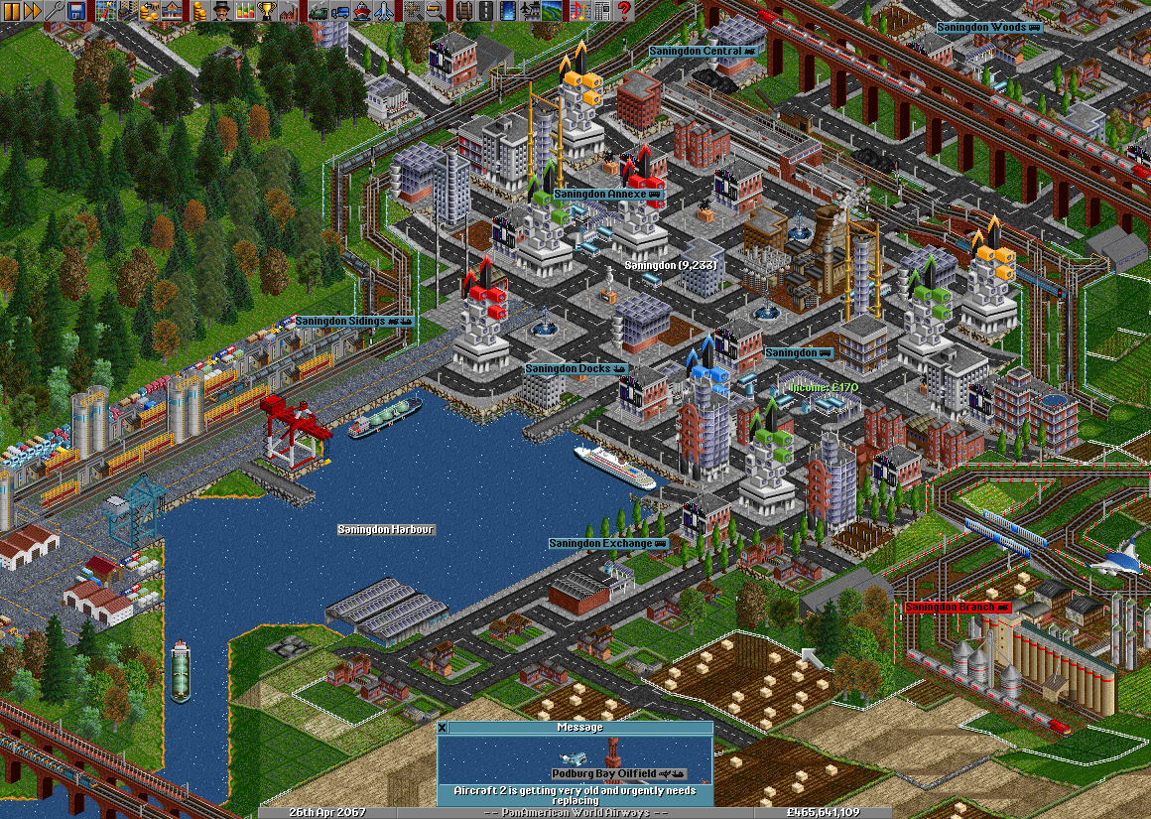
Game: Transport Tycoon (1994)
Publisher: Microprose
Genre: Simulation
Description: Transport Tycoon is a business simulation game in which the player acts an entrepreneur in control of a transport company. The goal of the game is to compete against rival companies and make as much profit as possible by transporting passengers and various goods by road, rail, sea and air. A version of the game for Android and iOS was released in 2013.
To create transport routes, the player must construct stations near industries or towns. One complete transport route can involve multiple forms of transport; for example, train→ship→truck. The game begins in 1930, and ends in 2030. To simulate the changes in time period, a progression of technology is observed; in the beginning there are only steam engines, but later diesel and electric engines are introduced.
To expand early in the game, the player must take out loans, and will be charged interest on those loans until the debt is repaid. Once the player turns a profit, he or she can choose to expand service along existing routes, or expand the transportation network. The player can earn revenue by transport goods or people to stations with demand for them. A station close to a town for instance, will demand passengers. The amount of revenue gained will depend on distance, quantity, and speed of delivery. For example, mail can only be delivered profitably over short distances, or over long distances quickly. Conversely, coal loses value very slowly, so it can be transported in bulk slowly and still remain profitable.
[Source: Wikipedia http://en.wikipedia.org/wiki/Transport_Tycoon]
RR’s mechanic of economy and trading ports will be most similar to this game. Ports with high demand will pay a higher price for rum, while ports with low demand will pay a lower price. However, RR will only have gold and rum to trade and only use the pirate ship as a means of transport. The goal is to pay back a loan to a loan shark, somewhat similar to paying back the loans in Transport Tycoon. An element of competition may be introduced, against other rum runners, if time permits.

Player Composition
Player Profiles:
- Timothy, 10, elementary school student. Obviously single. Plays computer games by himself after school when his mom lets him, ~3 times a week. He enjoys simulation games like Roller Coaster Tycoon and Sim City, and playing with Legos.
- Mark, 20, college student. Single. Plays computer games by himself occasionally after class, ~2 times a week. Plays more over the weekend. Looking for nostalgia from childhood games like Roller Coaster Tycoon and Oregon Trail.

World
The game takes place in the Caribbean during the Age of Discovery, focusing on the various pirate shanty towns and colonial settlements dotting the islands. However, this is more of the pirate pulp novel fantasy so there are mythical beasts to hunt and ancient temples to explore. This world’s lifeblood is the rum that everyone wants to either buy or sell and its transportation serves as the primary goal of the player.
In terms of how this translates to gameplay the map is a 2D grid composed of sea tiles and continuous islands. These islands usually have port tiles and might also have other geographic features, such as mountains or fields. The world has some sense of chronology in that there is weather which can affect how easy it is to navigate the sea or how much rum the plantations yield. Things like sea beasts are represented by random events and don’t show up on the map however certain kinds of enemies might.

Characters
You play a pirate captain and entrepreneur who owes a large amount of money to a dastardly loan shark. As such your primary goal is to accumulate enough money through the exchange/possibly pillaging of rum so that you can pay him off before he breaks both your peg legs. As far as gameplay goes, you are represented by your 2D pirate ship which can sail through the world’s sea tiles.
The loan shark is not a cool dude. He’s one of the most feared pirates around these parts and everyone knows he does not forgive debts. Some even say he’s literally a shark but few who’ve seen him have lived to tell the tale. As far as gameplay goes the loan shark represents both the victory and the failure state for the game. If he’s paid off in time it’s a victory and if the loan expires it’s a failure. He is not normally physically in the world.
Your crew requires rum to not mutiny, which means they steadily drink some as you move from port to port. If they don’t get their rum they mutiny leading to a possible failure state. In game they are less of a physical presence and more of a game stat.

Progression Graph
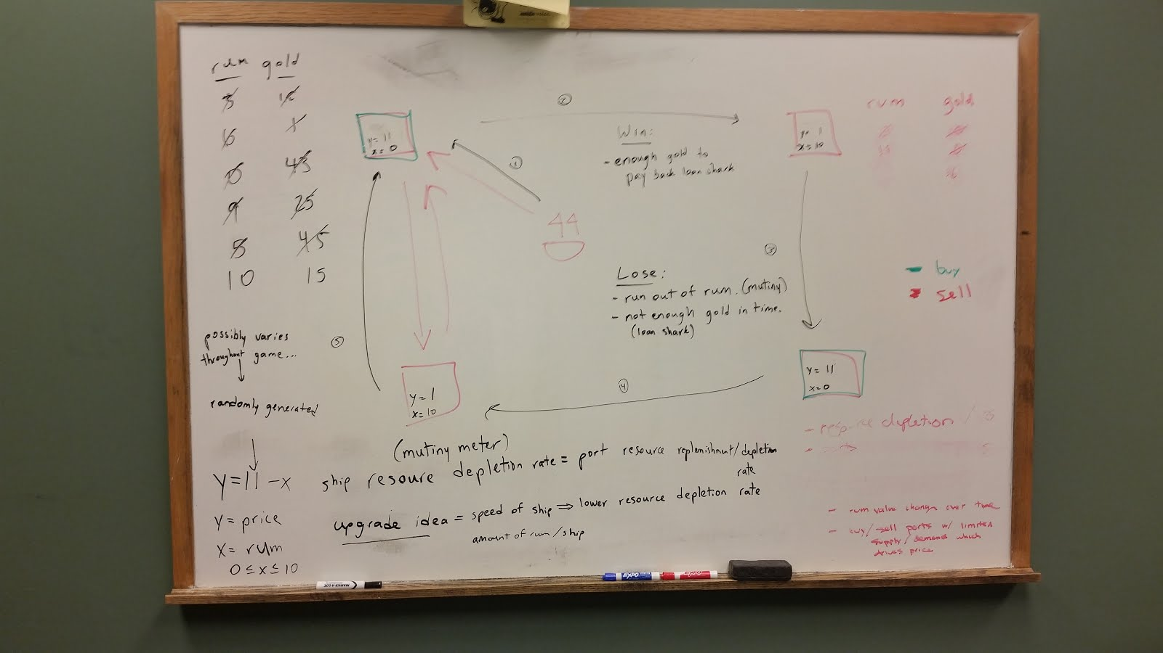

Art Direction
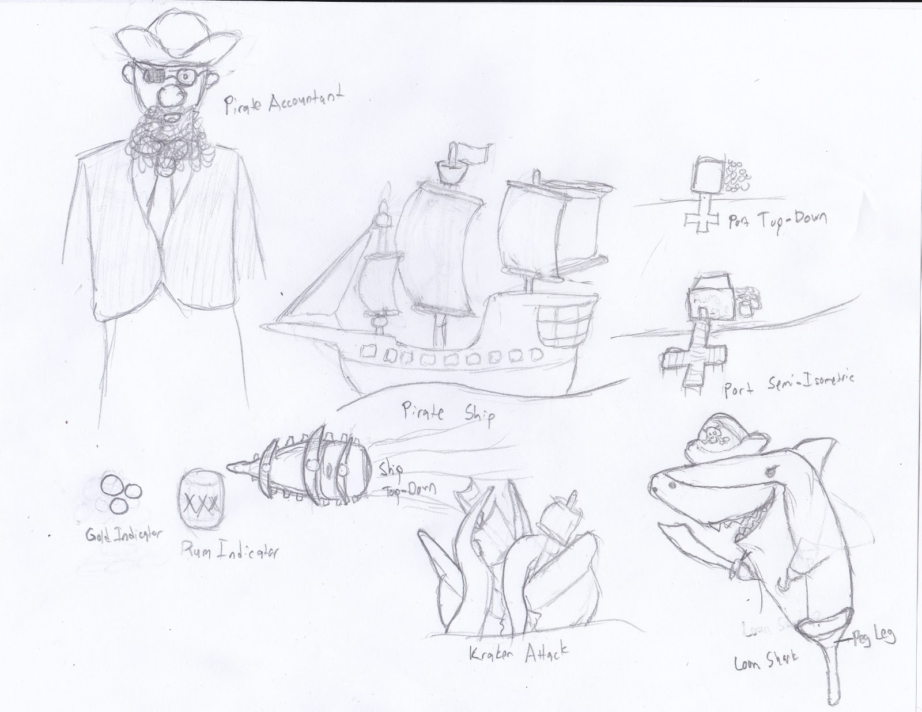

UI Story Boards
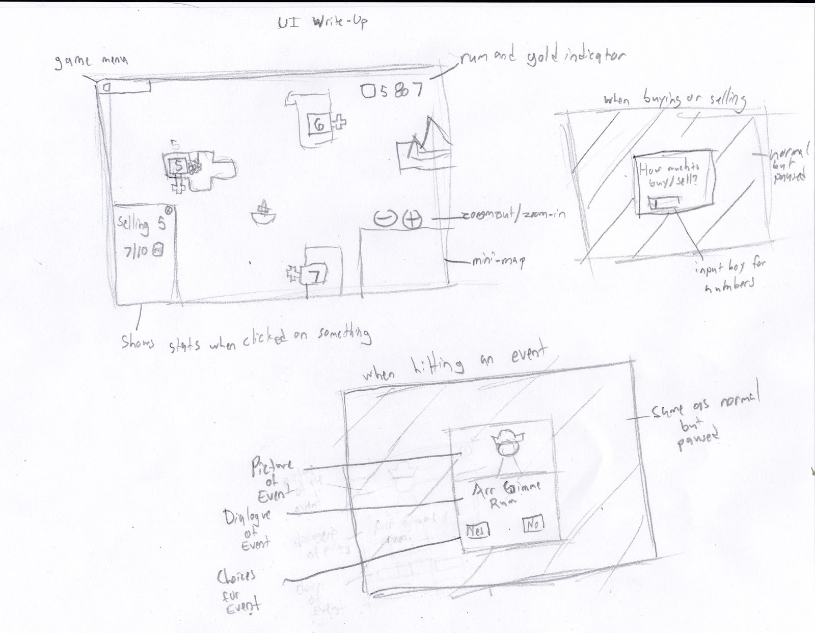

Tags & Dialog
Tags:
- MOVE <direction> = “Ship Moves in the Specified Direction”
- BUY <amount> = “Buy Rum from a Port”
- SELL <amount> = “Sell Rum to a Port”
- LOSE = “Game Over; Player Loses”
- WIN = “Gave Over; Player Wins”
- ENGAGE = “Approach AI Ship”
- BARTER = “Negotiate with Other Ship for Rum”
- ATTACK = “Attack Ship”
- DEPLETE = “Deplete Ship Resources”
- REPLENISH = “Replenish Port Rum”
- DIMINISH = “Diminish Port Rum”
Dialog:
- Loan shark to player at start of game
o Loan shark to Player: “…I’m tired of waiting for your money back! I know what I’ll do with you. See that floating pile of rubbish over there? (Screen shows SS Scurvy) You’re going to captain that pirate ship and make me my money back by running rum around the Caribbean. You’ve got 30 days! Or else…”
o Player to Loan Shark: “But I don’t know nothin’ about runnin’ no rum!”
o Loan Shark to Player: “Useless…” (pan to ship again, assume player and loan shark are on it)
o Loan Shark to Player: (With view of buy port) “See that nice farm town over there? They just finished bottling some rum. We’re going to go sail over there and buy some.”
o Game to Player: “Use the ‘WASD’ keys to move the ship over to the ‘BUY’ port.” (Player moves ship to port. See loan shark buy rum from farmer)
o Player to Loan Shark: “What are we going to do with all that??”
o Loan Shark to Player: “Well, we’re going to sail over to that derelict pirate town (name?) and sell this poison!”
o Game to Player: “Move the ship over to the ‘SELL’ port.”
o Player to Loan Shark: “Wow this is pretty easy.”
o Loan Shark to Player: “We’ll see if you’re still saying that in a month. Get me (X amount of gold) in (Y number of days) or ELSE!!!” (Loan Shark leaves ship)
o Player’s thoughts: (View of ship) “Should have hired that accountant…”
- Dialog when buying rum
o Port to player: “Hello! We have (X amount of) rum which we are selling for (price of rum). How much would you like to buy?”
o Player: (types in number)
o Port to player: “Come back soon!”
- Dialog when selling rum
o Port to player: “Ahoy! We’re running a bit low on rum. We will buy up to (X amount of rum) from ye for (price of rum). How much will ya give us?”
o Player: (types in number)
o Port to player: “Huzzah! Fare-thee-well…”
- Dialog after the first time your rum is depleted:
o Loan Shark to Player: “I forgot to tell ya…your crew needs rum to help navigate your ship. Every (Z amount of time) they drink (A amount of rum). Don’t run out of rum or your crew will mutiny!”
- Dialog when you win
o (As soon as you make a trade to reach the desired amount of gold) Loan Shark to Player: “Well I guess you made a decent pirate after all. Give me my gold you scalawag!”
o Game to Player: “Congrats! You have repaid the Loan Shark (X amount of gold) in (Y number of days). Continue playing to earn more gold or end game?”
- Dialog when you lose
o If time is up:
§ Loan Shark to Player: “Time’s up, ya scalawag! You’re mine now…”
§ Game to Player: “You didn’t get the Loan Shark his money in time. You lose! Try again?”
o If no more rum:
§ Loan Shark to Player: “Uh-oh! Looks like your crew has gone and mutinied on you!”
§ Game to Player: “You ran out of rum while at sea. You lose! Try again?”

Software Architecture
The software architecture for Rum Runners closely follows the game logic/view/application layer design.

Controls
For simplicity Rum Runners will be initially developed with WASD controls for controlling the ship.
- W, A, S, and D keys move ship up, left, down and right (respectively) on the map.
- Contact/right-click on a port within proximity of the ship opens the trade menu.
- Keyboard used for text input within menus.
- Mouse used for menu selection in menus.
As development progresses traditional real-time strategy (RTS) controls may begin to make more sense, and in that case Rum Runners may move to RTS controls.
- Left-click is select
- Right-click is take action (i.e. move ship to a point)
- Keyboard used for text input within menus.
- Mouse used for menu selection in menus.

Level design
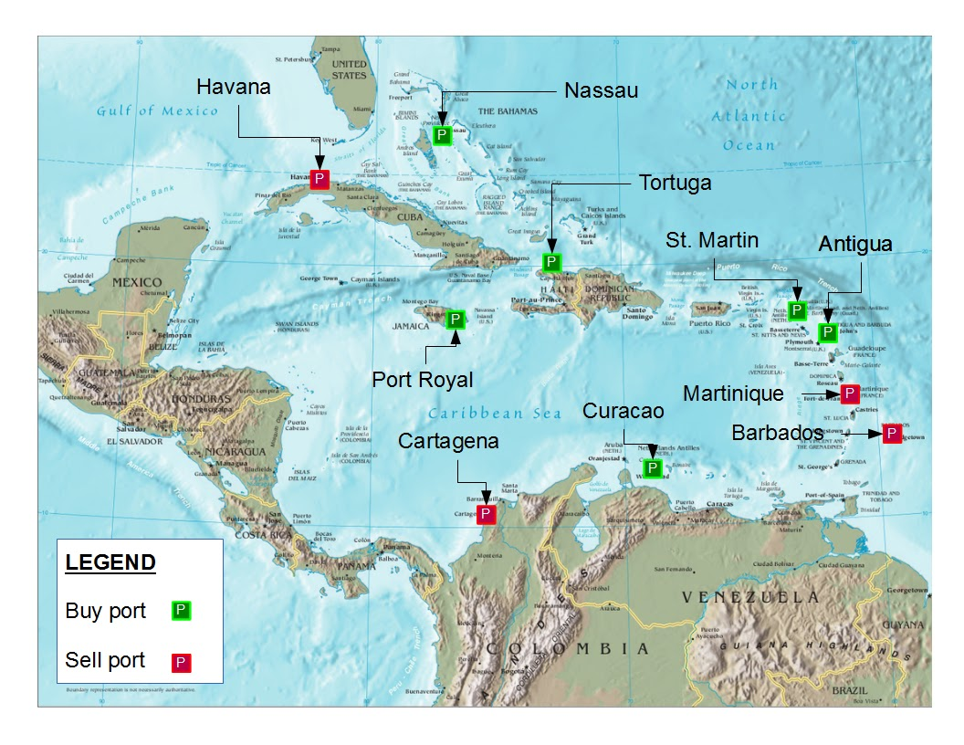
The first Rum Runners level is the Caribbean Sea. There are a total of 10 ports for the player to interact with. 4 are “buy ports”, and 6 are “sell ports”. Since the player controls a ship, the player must navigate around landmasses to reach the various ports.
The ports were assigned their “buy” or “sell” status purely for gameplay purposes. They were selected with the goal of requiring the player to move about the entire map, interacting with new ports as previously frequented ports’ inventories replenish. The positioning of these ports and the port inventory mechanics are related, and balancing this relationship will be done over the course of development.
Additional ports may be added as time permits.

Mechanics Analysis
Basic Mechanics
- Buy and sell ports
  - Can only buy at buy ports, can only sell at sell ports; restricts where you can buy and sell. This prevents a player from buying from and selling to the same port once the prices change for that port. For example, when a player buys all the rum from one port, the demand at that port would increase and the price of the port should increase. If there was no delineation of buy and sell ports, one could potentially sell all the rum that he/she had just purchased back to the port for a profit, which would not make sense.
  - Buy ports deplete rum over time, sell ports generate rum over time; restricts where you can buy and sell at a certain point in time. Once you buy from a buy port, can’t buy from there again until their stock of rum replenishes. Similar for sell ports. This creates the need for the player to explore the whole map rather than buy and sell in the same areas.
  - Price of rum at port = 11 - amount of rum at port; creates a price floor of 1 gold.
  - Once inventory at port changes (because of buy or sell), price changes inversely due to demand. Adds an extra level of complexity and simulates a real economy. Motivates player to sell rum at higher demand ports where they will buy rum for a higher price.
- Bounded inventory between 0 and 10 at ports; limits amount of rum you can carry at one time. Creates the need for upgrades to ship speed and size of cargo (if time permits).
- Resource depletion
  - Rum supply on ship depletes over time; creates added pressure for player to travel to port quickly in order to sell remaining stock.
- Win if you have enough gold to pay back loan shark; adds pressure and motivation to game.
- Lose if you run out of rum (mutiny) or game ends (deadline to pay loan shark); adds pressure and motivation to game.

Scheduling
Tasks:
- Milestone 1: Playable Core Game
  - Create 2D Grid
  - Define what water, land, port, and boat are
  - Display 2D Grid with graphics
  - Create boat class including how to draw it
  - Allow boat to move from place to place
  - Create port class
    - Buy or sell
    - Fixed price and fixed amount of rum demand/supply (per arrival at port)
  - When boat arrives at port make optimal trade
  - Time limit for Loan Shark
- Milestone 2: Playable, but slightly more challenging base game
  - When boat arrives, prompt dialog for amount of goods you want to trade
  - Implement depletion of resources
  - Implement supply/demand pricing
  - Ports should now have a randomly assigned capacity
  - Implement port resource replenishment/depletion
- Milestone 3: Other events
  - Encounter random ships on the map
    - Can steal your things or gift you rum/gold based on a coin flip
  - Weather events:
    - Can damage ship
      - Repair by paying gold or rum
    - Can move ship off course
    - Can affect rum price/quantities at ports
  - Random, very rare game-over scenarios:
    - Kraken eats the ship
    - Other pirates take over your ship
- Milestone 4: Upgrades
  - Battling:
    - Other ships, possibly with dice roll combat
    - Ports:
      - You win, you take their rum/gold for free
      - You lose, they take half of your gold/rum
  - Battle upgrades
  - Implement ship cargo capacity, which can be upgraded by spending gold/rum
  - Speed of ship, which means lower resource depletion rate for ship, higher rate for ports
  - Expanded map
- Milestone 5: Small variations
  - Port capacity can possibly vary throughout the game randomly
  - Rum value can change universally throughout the game, due to random weather events or something
  - Other ships can also buy/sell from ports which affects the price of rum at ports
Issue Tracking: None yet
Status: Rum Runners has been designed such that it will be playable and fun, but not fully fleshed out. There are many more features that will improve the complexity, challenge, and entertainment of the game, such as battling, random obstructions and obstacles, and upgrades to the ship. The game has not been implemented at any level yet. The design document is in its first iteration with no set milestones.

