**http://www.jiatengxu.com/**

**About Me**

To me, Geographic Information Science (GIS) is the science that incorporates geographic and time factors into decision making. Furthermore, with the combination of GIS and Web 2.0, WebGIS can visualize the geographic information to the public, and gather the volunteered geographic information from the public. <br><br>

I am currently a graduate student pursuing a master’s degree in GIS at the University of Minnesota. I previously obtained my bachelor degrees in GIS and Geomatics with a minor in computer science from Wuhan University and University of Waterloo respectively. Over the past four years, my passion about GIS has continued growing, and I am especially interested in the field of spatial statistics, application development and WebGIS. For my future career, I am currently seeking a internship position at a private agency or research organization as a GIS application developer, in the field of spatial statistics. <br><br>

Since GIS is an interdisciplinary science, the experience and knowledge accumulations are crucial for GIS professional. Owing to my background and experience, I am familiar with spatial analysis, spatial databases, remote sensing, web mapping, and the following programming languages: C, Python, and JavaScript. I have hand-on experience with GI-systems, such as ArcMap, ArcGIS pro, ArcGIS online, ENVI, ERDAS, and QGIS. <br><br>

The Clifton StrengthesFinder identifies my top 5 themes as Input, Learner, Developer, Activator, and Communication, which I think suit me well. The themes Input, Learner and Activator are demonstrated by my eagerness to learn and turn thoughts into action. During my fourth year as an undergraduate, I learned web design by myself from scratch, and I got a summer internship as a mapping website designer. Now, I have created 3 mapping websites for carpool sharing, field photo exhibition, and analysis map exhibition. The themes Developer and Communication are related to my ability to work in a group. I used to work for the Dept. of Public Information of College Student Union at Wuhan University as the leader of the technical group. I taught students in our faculty how to make high-quality slides, posters, and videos, and I delegated tasks to group member to make multi-media materials for student activities. <br><br>

In my daily life, I love to travel, watch movies, and listen to music because they show me the world I haven't seen, and the world in others’ eyes. <br><br>

Thank you for your time! If you're interested in working together, Please contact me.

**Quantitative Assessment and UAS Data Processing Workflow for the Rice Creek Meander Project in Arden Hills, MN**

**Description**

In the early 1900s, Rice Creek’s channel was straightened for agriculture purpose. However, without twists and turns, the water in the channel moves faster, which accelerates the erosion of steam bank and bed. To mitigate the issue, the Rice Creek Meander Restoration Project was carried out. Starting form 2015, new meanders have been constructed, and these constructed meanders were left there for one year with filling water to let vegetation establish.

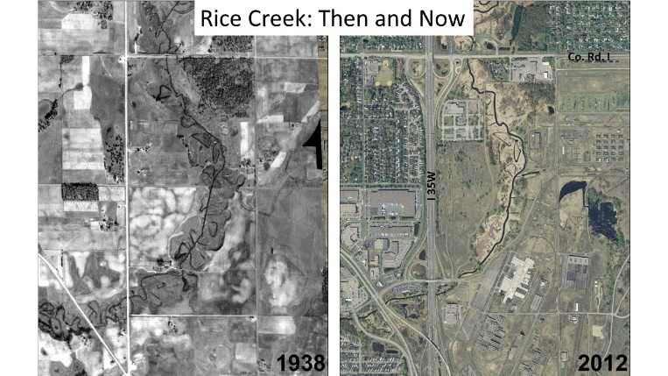

In addition, due to major road construction at the intersection of county road H and I-35W, Rice Creek channel around this section was relocated for road construction.

Our investigation group supported USGIS to assess the condition of one constructed meander. The study area is the upstream of the relocated channel around intersection of county road H and I-35W. This was a group project of my master course, started from October 17, and ended at December 17.

**Methodology**

1. We used the phantom 4 drone from DJI to collect geotagged-image. The drone collection plan was made on Pix4D Capture.
2. Multiple processing tool including Pix4D, Drone Deploy, and Open Drone Map were utilized to reconstruct 3D models from geotagged-image.
3. The accuracy of these three 3D models were assessed and compared.
4. The Digital elevation model(DEM) generated using Pix4D and the pervious Lidar generated DEM from USGIS were used for change detection analysis.

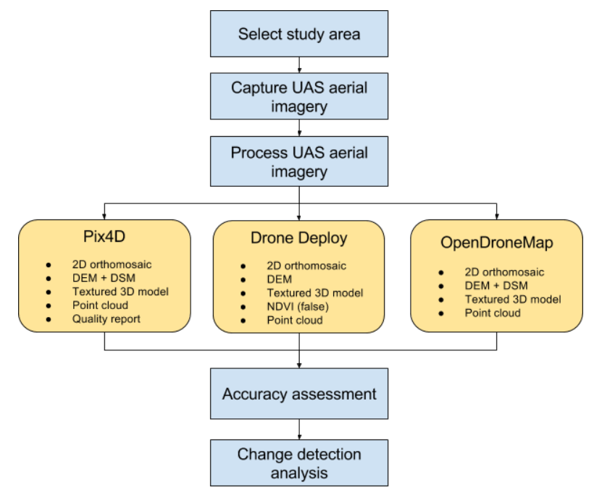

**Results**

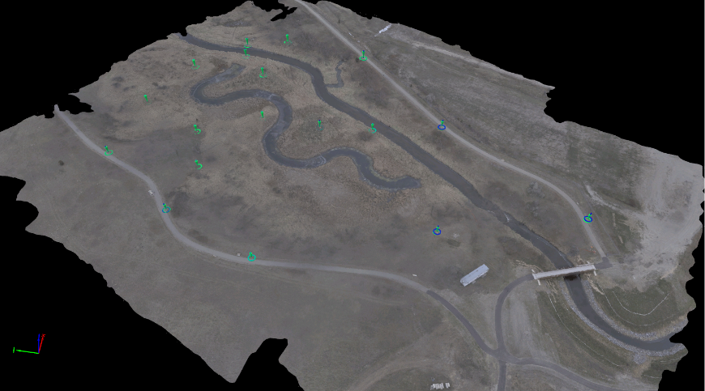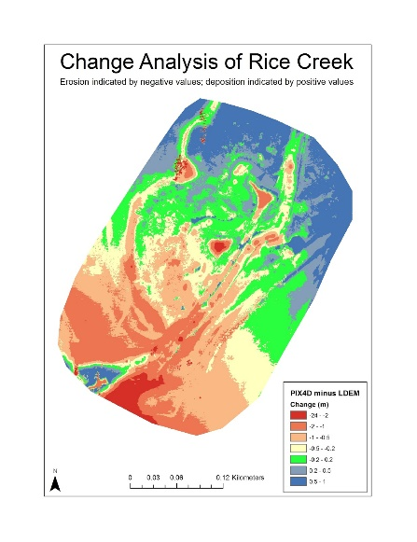

**Field Photo Exhibition, Downloading, and Uploading**

**Description**

This website was created during my internship at the Chinese Academy of Science.

The Field Map website was designed for field photo exhibition, downloading and uploading. There is a database at the server side storing all the field photo and user information. The BaiduMap API was used here for mapping purposes, each mark on the map represents a field photo. The map is also linked to the information bar on the right hand. For example, if the photo category is changed on the information bar, the photos shown on map are changed accordingly. If I click one photo in the information bar, the map will zoom in to the photo and show the photo’s information. Besides, the marker cluster was generated to power up the website’s performance, right click function is added to solve the marker overlay issue; and the search function is also available in the website. The photo download page allows users to download the photos in the customized area from the database, and the upload page allow users to upload the image to the database.

**Link**

<http://www.resdc.cn/FieldPhoto/index.html>

**The** **Electronic Atlas of Analysis Maps at China-India Border**

**Description**

This website was created during my internship at the Chinese Academy of Science.

The electronic atlas website was designed to display of the analysis maps of the China-India border. BaiduMap API was used here for mapping purposes. The analysis map was transferred to a set of tiles using ArcGIS tile packages. And the tiles were used as the upper layer base map.

The key feature of this website is that all the list content, drop-down menus, and navigation bar, can automatically update when the folder structure is changed at the server side. So, there is no need to change the HTML file when a new category is created or a new analysis map is added.

**Link**

<http://www.resdc.cn/border/index.html>