表1. 不同胆固醇降低方法对比分析
trt | n | M±SD | F | p-value | $$η_{p}^{2}$$ | Sig-Diff  Groups
1time | 10 | 5.78±2.88 | 32.433 | <0.001 | 0.742 | a
2times | 10 | 9.22±3.48 | 32.433 | <0.001 | 0.742 | ab
4times | 10 | 12.37±2.92 | 32.433 | <0.001 | 0.742 | bc
drugD | 10 | 15.36±3.45 | 32.433 | <0.001 | 0.742 | c
drugE | 10 | 20.95±3.35 | 32.433 | <0.001 | 0.742 | d
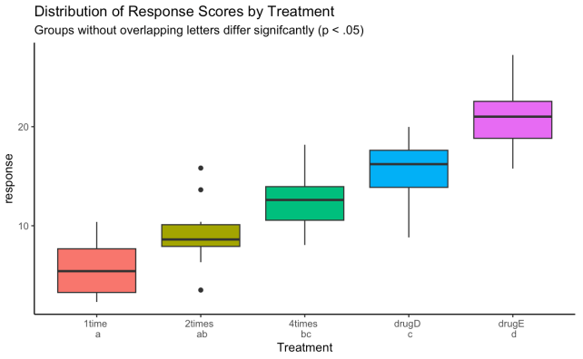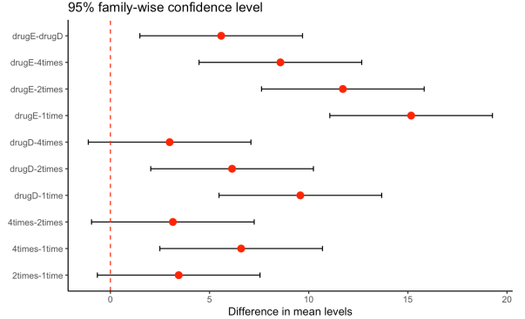
图1. 不同胆固醇降低方法对比分析
对新研药物在不同给药频次（1time、2times、4times）下与对照药物（drugD、drugE）降低胆固醇效果进行比较，经单因素方差分析结果（表1及图1）显示，五种治疗方式的组间效应显著（F=32.433，p<0.001，$η_{p}^{2}$=0.742），表明治疗方式对胆固醇变化具有较大的效应量并在统计意义之外亦具有实际意义。
经事后多重比较（TukeyHSD）结果显示：1time给药方案的胆固醇降低幅度显著低于drugD与drugE，表明低频给药方案在疗效上明显弱于两种对照药物；2times给药方案在胆固醇降低效果上与drugD之间差异未达到显著水平，但显著低于drugE，提示该给药频次在疗效上已接近drugD，但仍与疗效较强的对照药物存在一定差距；4times给药方案与drugD之间差异不显著，且其与drugE之间的差距较低频给药方案明显缩小，说明提高给药频次在一定程度上可增强新研药物的降胆固醇效果，并缩小其与对照药物之间的疗效差异。
综合比较三种给药频次可见，4times给药方案在统计意义和实际效果上最接近对照药物的疗效水平，其次为2times给药方案，而1time给药方案与对照药物之间的疗效差距最大。

表1. 不同胆固醇降低方法对比分析
Group | M±SD | F | Sig. | Partial-Eta  Squared | Multiple Comparisons
 |  |  |  |  | Between-Group | Cohen's d¹ | 95% (LLCI,ULCI)²
1time | 5.78±2.88 | 32.433 | <0.001 | 0.742 | 1time-4times***  1time-drugD***  1time-drugE***  2times-drugD***  2times-drugE***  4times-drugE***  drugD-drugE*** | 2.042  2.968  4.700  1.902  3.634  2.658  1.732 | (1.060,3,005)  (1.888,4.026)  (3.382,5.994)  (0.933,2.854)  (2.470,4.775)  (1.614,3.681)  (0.777,2.670)
2times | 9.22±3.48
4times | 12.37±2.92
drugD | 15.36±3.45
drugE | 20.95±3.35
Note: ¹: Cohen's d = (M_{i} - M_{j}) / Sqrt(MSE), MSE(Mean Square Error) is the pooled unbiased estimator of the common population variance σ² across all treatment groups under the assumption of homoscedasticity.; ²: R Package: MBESS; ***: p<0.001.

Appendix:

library(MBESS)
mse <- 10.417
df_error <- 45
m_i <- 20.95
m_j <- 15.36
n_i <- 10
n_j <- 10

get_d_ci_unbalanced <- function(m_i, m_j, n_i, n_j, mse, df_error, conf.level = 0.95) {
d_val <- (m_i - m_j) / sqrt(mse)
t_val <- d_val * sqrt((n_i * n_j) / (n_i + n_j))
nct_ci <- conf.limits.nct(
t.value = t_val,
df = df_error,
conf.level = conf.level
)
conversion_factor <- sqrt((n_i * n_j) / (n_i + n_j))
d_lower <- nct_ci$Lower.Limit / conversion_factor
d_upper <- nct_ci$Upper.Limit / conversion_factor
return(list(
d = d_val, ci_lower = d_lower, ci_upper = d_upper, t = t_val
))
}
result1 <- get_d_ci_unbalanced(m_i, m_j, n_i, n_j, mse, df_error)
result_row <- data.frame(m1 = m_i,m2 = m_j,n1 = n_i,n2 = n_j,
d = round(result1$d, 3),
ci_lower = round(result1$ci_lower, 3),
ci_upper = round(result1$ci_upper, 3),
ci_text = sprintf("[%.3f, %.3f]", round(result1$ci_lower, 3), round(result1$ci_upper, 3)),
t_value = round(result1$t, 3),
stringsAsFactors = FALSE
)
sprintf("d=%.3f, 95%% CI=[%.3f, %.3f]",
result1$d, result1$ci_lower, result1$ci_upper)

