中介分析结果

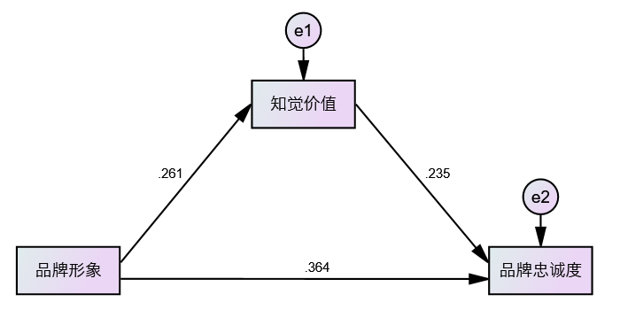
表1 预设识别模型中介效应分析结果（显变量）
路径：品牌形象-->知觉价值-->品牌跨度度
 | 标准化效应值 | 效应值 | 标准误 | 占总效应之比 | 95%CI |  | p
 |  |  |  |  | LLCL | ULCL | p
直接效应 | 0.364 | 0.517 | 0.073 | 85.60% | 0.374 | 0.665 | 0.001
间接效应 | 0.061 | 0.087 | 0.026 | 14.40% | 0.043 | 0.148 | <0.001
总效应 | 0.425 | 0.604 | 0.067 | —— | 0.478 | 0.741 | 0.001

附：Amos syntax
附：SPSS-Process设置

附：Amos syntax
#Region "Header"
Imports System
Imports Microsoft.VisualBasic
Imports AmosEngineLib
Imports AmosEngineLib.AmosEngine
Imports AmosEngineLib.AmosEngine.TMatrixID
Imports MiscAmosTypes
Imports MiscAmosTypes.cDatabaseFormat
#End Region
Public Class CUserValue : Implements IUserValue

Function Value( groupNumber As Integer, bootstrapSampleNumber As Integer, v As CValue) As Object Implements IUserValue.Value
' Your code goes here.
Dim x(5) As Double
x(0)=v.ParameterValue("c1")
x(1)=v.ParameterValue("a") * v.ParameterValue("b")
x(2)=x(0)+x(1)
x(3)=v.GetStandardizedDirectEffectsElement("ly","bi")
x(4)=v.GetStandardizedIndirectEffectsElement("ly","bi")
x(5)=v.GetStandardizedTotalEffectsElement("ly","bi")
Return x
End Function

#Region "Advanced"
Function Label( groupNumber As Integer) As Object Implements IUserValue.Label
' You can replace the following line.
Dim mylabel(5) As String
mylabel(0)="direct effect"
mylabel(1)="indirect effect"
mylabel(2)="total effect"
mylabel(3)="Standardized direct effect"
mylabel(4)="Standardized indirect effect"
mylabel(5)="Standardized total effect"
Return mylabel
End Function

Public Sub Initialize() Implements IUserValue.Initialize
End Sub

Sub CleanUp() Implements IUserValue.CleanUp
End Sub
#End Region
End Class

附：SPSS-Process设置
