条件过程分析（Conditional Process Analysis）
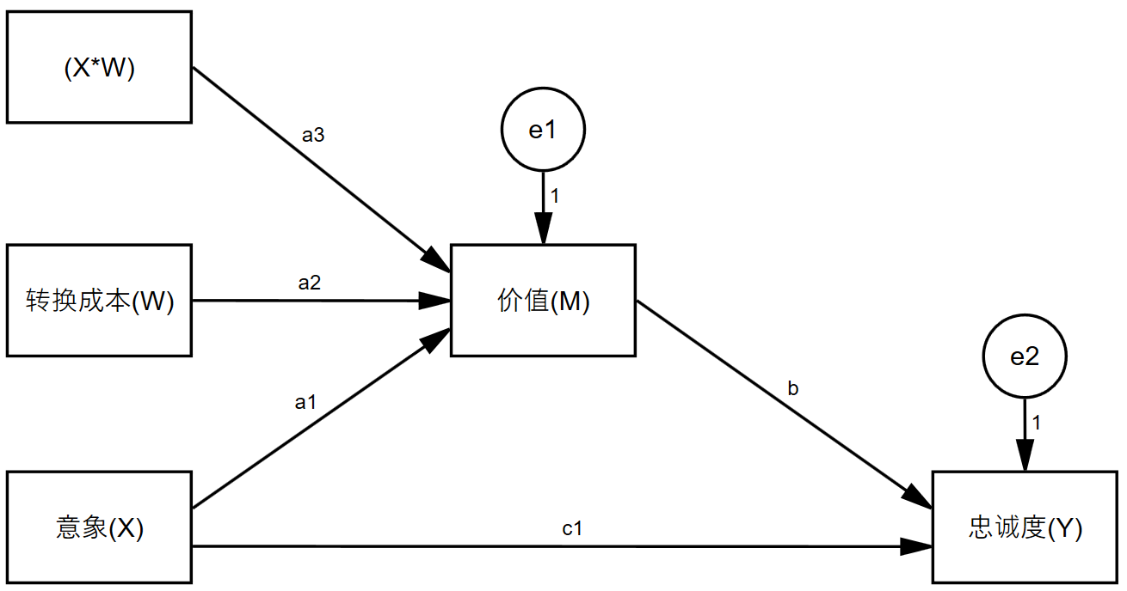
一、 Process实现过程
1. Process设置
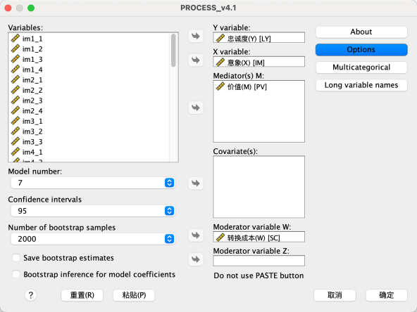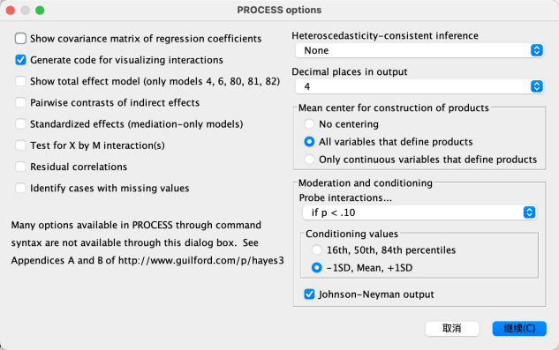
2. 分析结果
2.1 模型分析结果
2.1.1 Model Summary Outcome Varaiable:PV
 | coeff | se | t | p | LLCI | ULCI
constant | 5.0045 | 0.0641 | 78.0287 | <0.001 | 4.8783 | 5.1306
IM | 0.3457 | 0.0703 | 4.9158 | <0.001 | 0.2074 | 0.4840
SC | 0.1760 | 0.0479 | 3.6757 | <0.001 | 0.0819 | 0.2702
Int_1 | -0.1151 | 0.0543 | -2.1217 | 0.0345 | -0.2219 | -0.0084
R=0.3103,R-sq=0.0963,F(df1,df2)=12.8913(3,363)***
R2-chng=0.112,F(df1,df2)=4.5014(1,363)*
Note:Int_1=IM*SC

2.1.2 Model Summary Outcome Varaiable:LY
 | coeff | se | t | p | LLCI | ULCI
constant | 3.1655 | 0.2162 | 14.6428 | <0.001 | 2.7404 | 3.5906
IM | 0.2183 | 0.0586 | 3.7232 | <0.001 | 0.103 | 0.3336
PV | 0.3498 | 0.0418 | 8.3648 | <0.001 | 0.2676 | 0.432
R=0.4696,R-sq=0.2205,F(df1,df2)=51.4955(2,364)***
2.1.3 Direct And Indirect Effects of X ON Y
Indirect effects of X on Y:IM->PV->LY
Moderater(SC) |  | Indirect effect |  | S.E. |  | LLCI |  | ULCI
-1.3411 |  | 0.1749 |  | 0.0495 |  | 0.0805 |  | 0.2767
0.000 |  | 0.1209 |  | 0.0316 |  | 0.0623 |  | 0.1885
1.3411 |  | 0.0669 |  | 0.0329 |  | 0.0031 |  | 0.1325
Direct effect of X on Y
Direct effect | S.E. |  | t |  | p |  | LLCI |  | ULCI
0.2183 | 0.0586 |  | 3.7232 |  | 0.0002 |  | 0.1030 |  | 0.3336
Index of moderated mediation
 |  | Index |  | BootSE |  | BootLLCI |  | BootULCI
 |  | -0.0403 |  | 0.0207 |  | -0.0801 |  | -0.0011
二、 R语言可视化过程
1.简单斜率检验
1.1 R Script
Moderator <- factor(plot_dzx$SC,levels = c(1,2),labels = c("Low","High"))
ggplot(data = plot_dzx,aes(x = IM,y = PV)) +
geom_line(size = 1,aes(color = Moderator)) +
ggtitle("Simple-Slope Test") +
xlab("IM(Mean-Centralized)") +
theme_classic() +
theme(legend.position = "top")

1.2 Plot
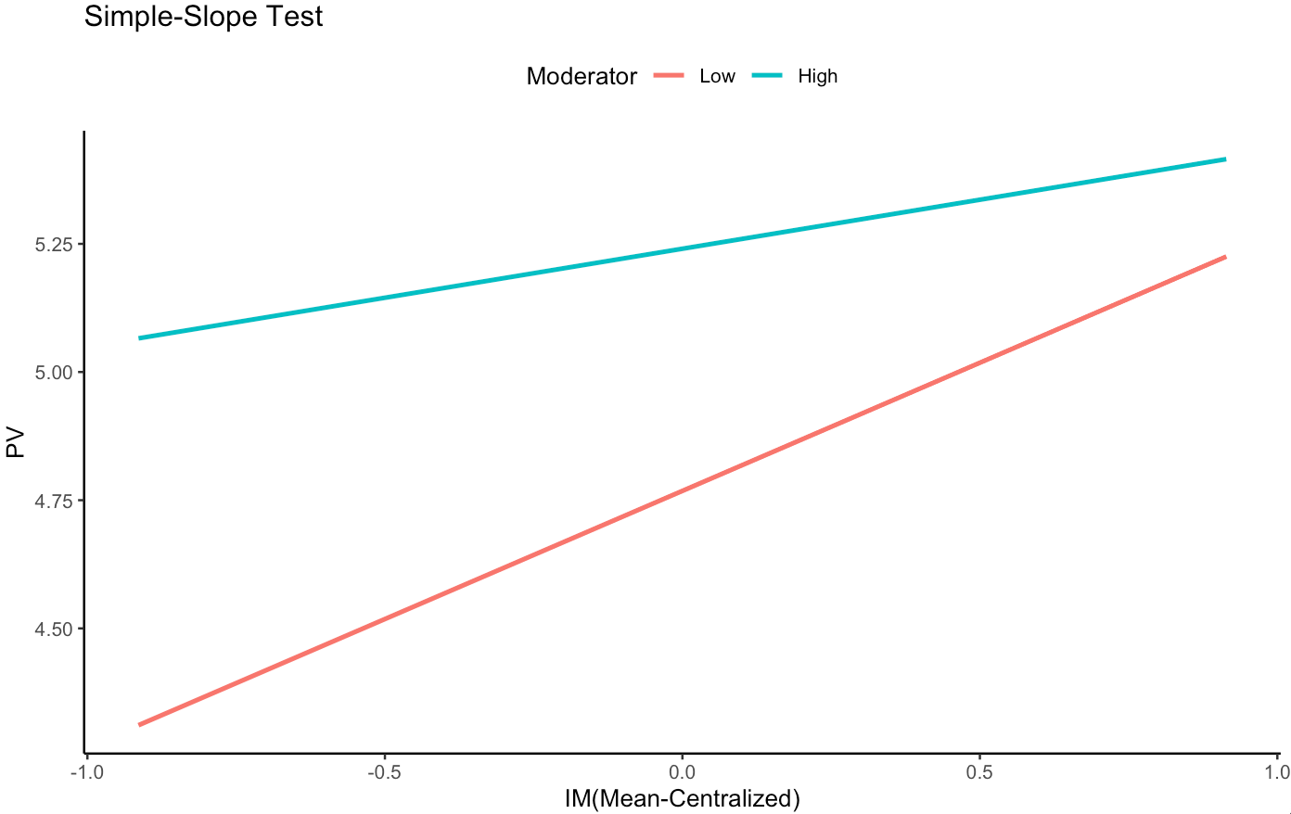
2.Johnson-Neyman Plot
2.1 R Script
fit <- lm(LY ~ IM + SC + IM*SC,data = consumer)
johnson_neyman(model = fit,pred = IM,modx = SC,digits = 4)
2.2 Plot
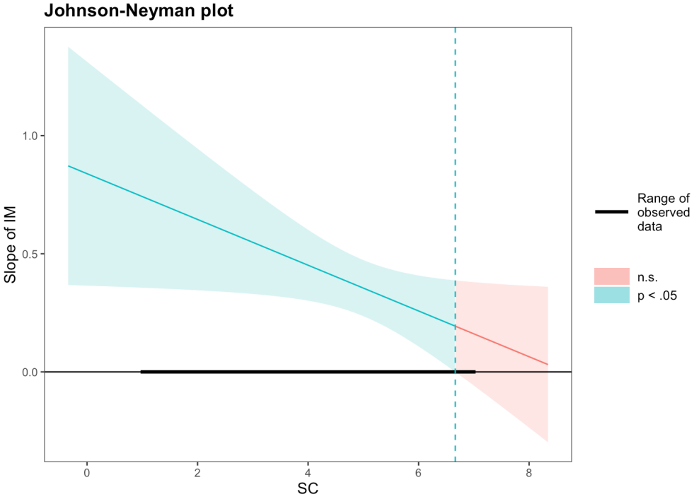
Note:When SC is OUTSIDE the interval [6.6635, 75.0675], the slope of IM is p < 0.05.

