Outlier
Table 1
Descriptive Statistics for the pt.age (N = 100)
n | Min | Q1 | Mdn | Q3 | Max | IQR
100 | 66 | 69 | 71.5 | 74 | 91 | 5
Note. The data were sourced from the SPSS built-in dataset adl.sav.

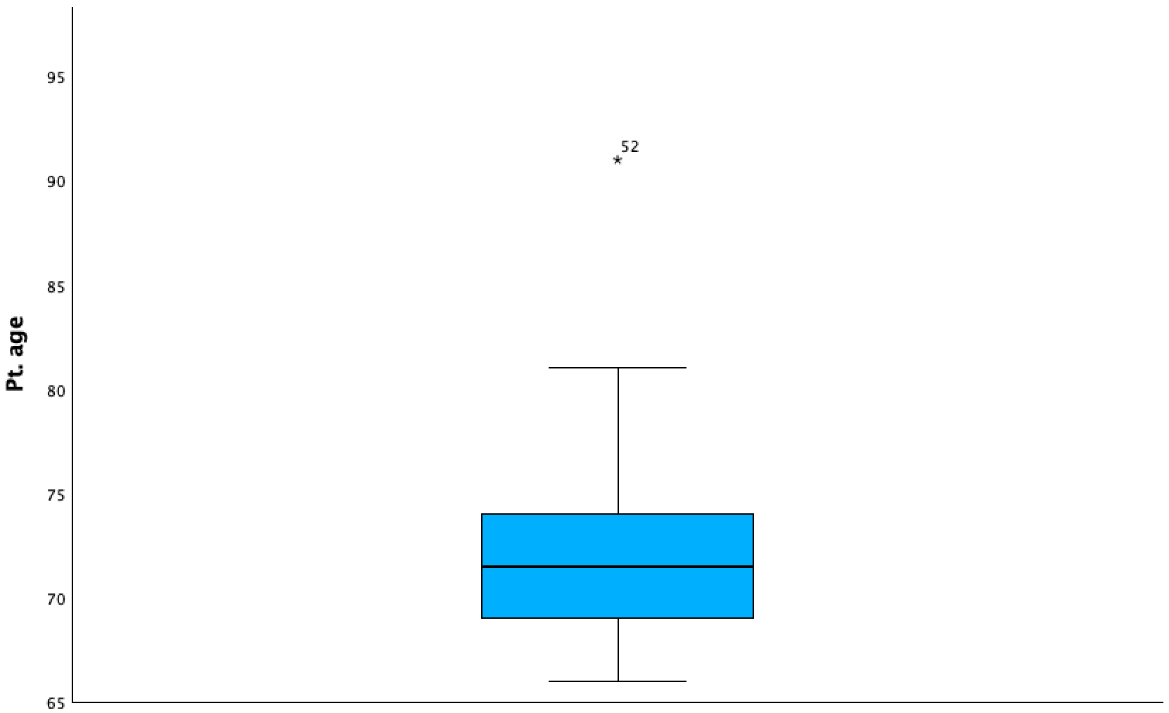
Figure 1
Boxplot showing the extreme outlier (value = 91, row 52) in dataset adl.sav. The outlier exceeds the threshold of Q₃+ 3 × IQR = 89.

