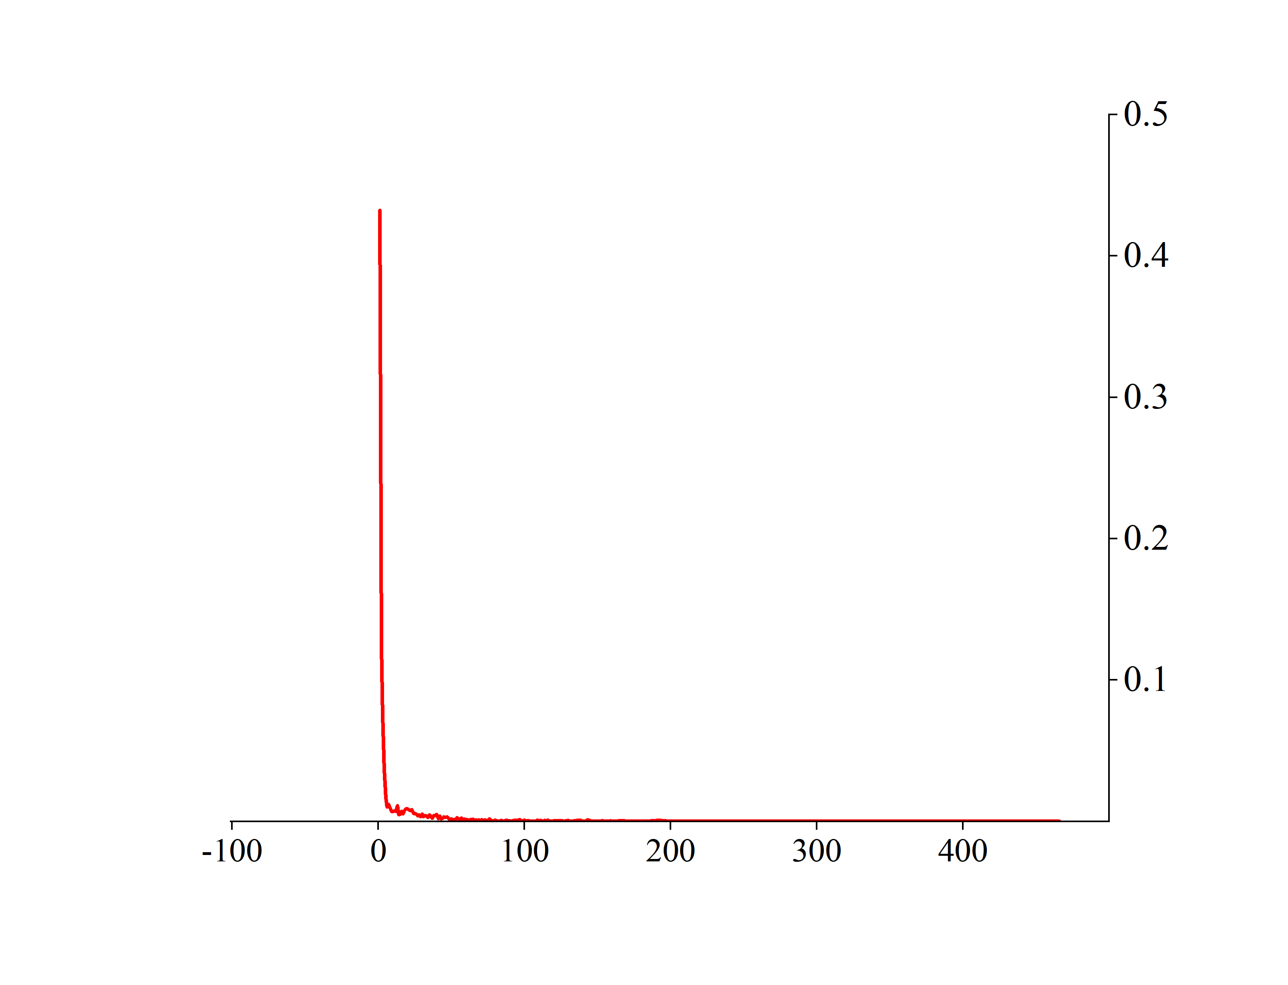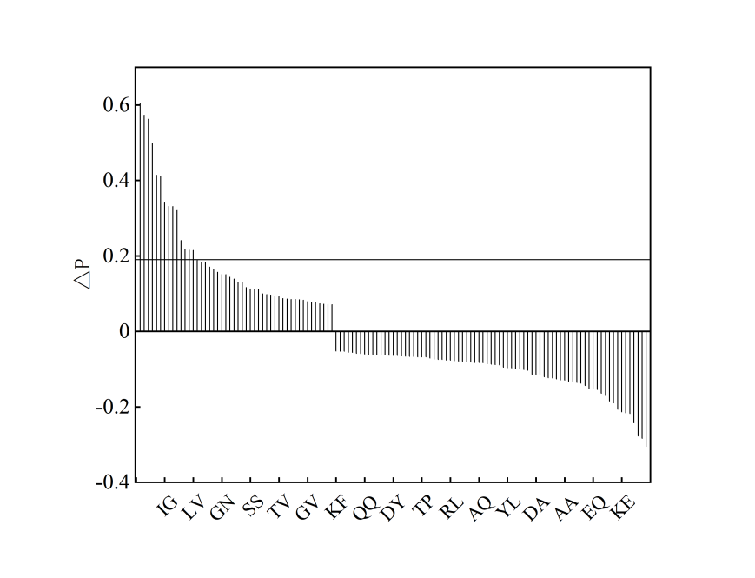
FigureS1: (a) Probability of ATP ligand binding residue distance, (b) Statistical classification of ATP neighbor correlation
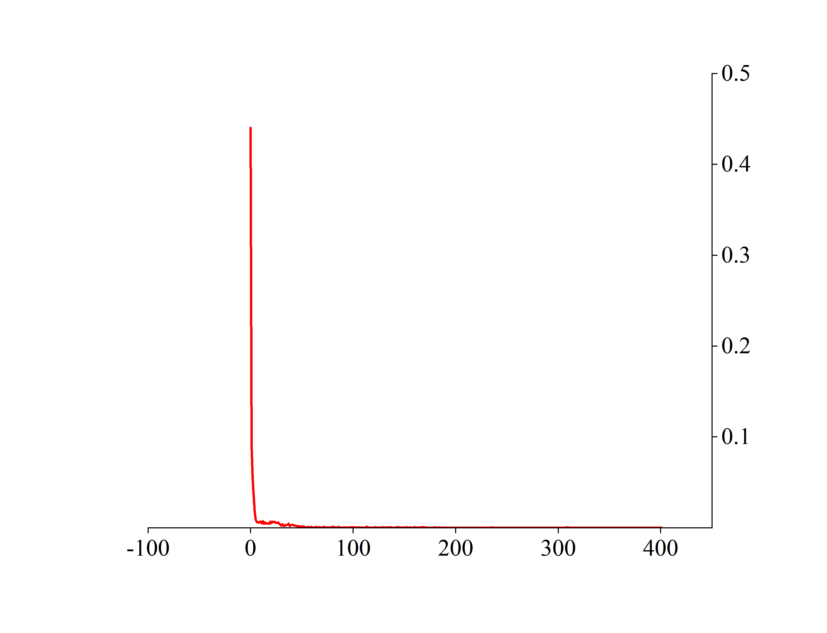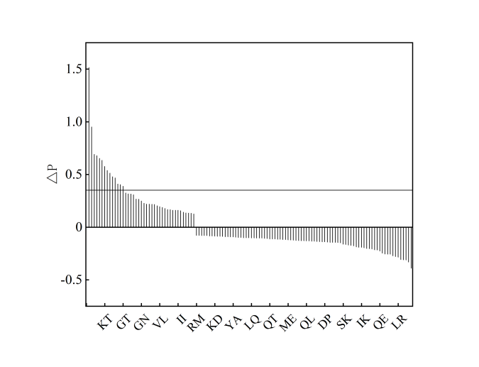
FigureS2: (a) Probability of GDP ligand binding residue distance, (b) Statistical classification of GDP neighbor correlation
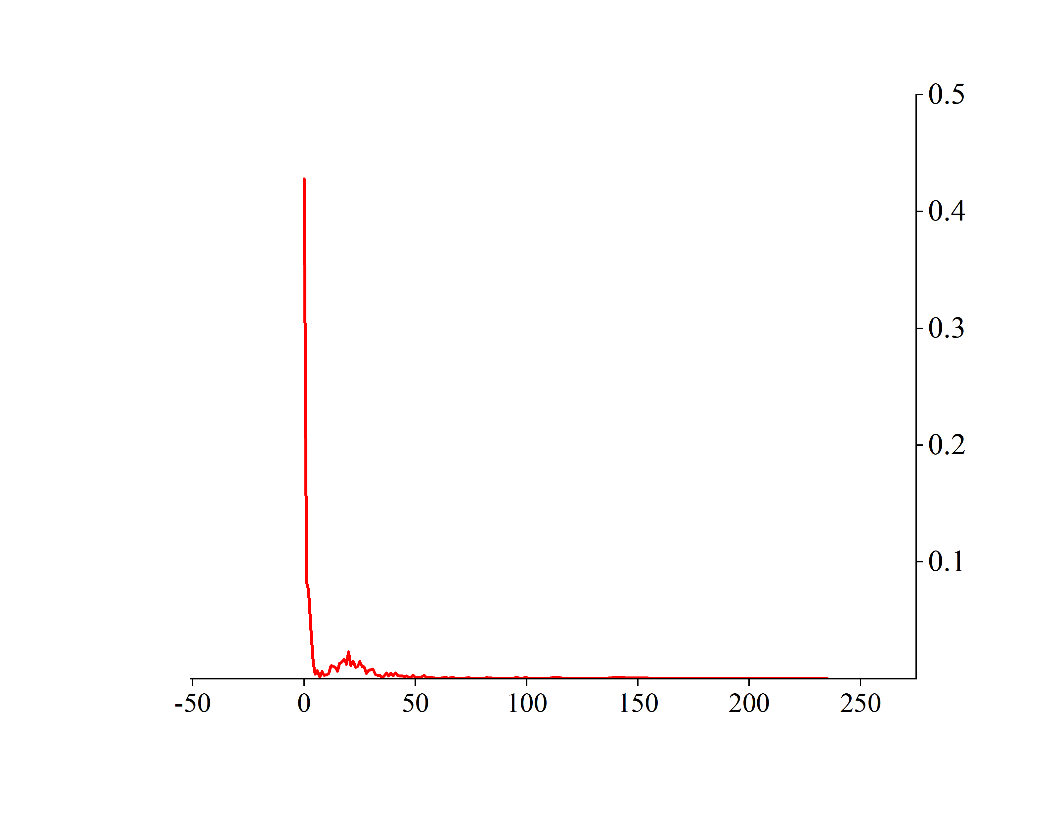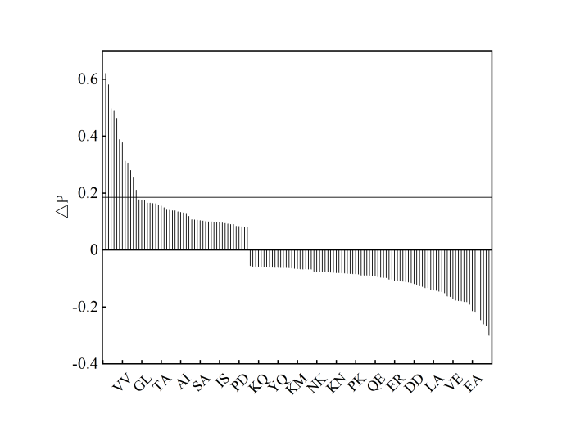
FigureS3: (a) Probability of NAD ligand binding residue distance, (b) Statistical classification of NAD neighbor correlation
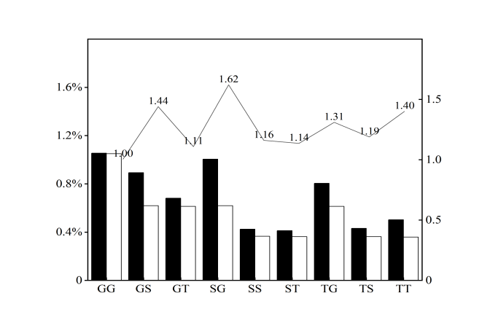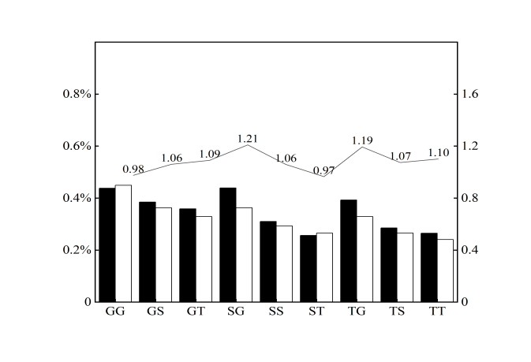
FigureS4: Ratio of positive and negative sample residue pair probabilities of ATP to random pairing probabilities

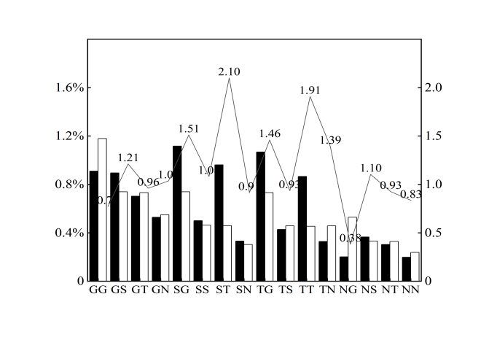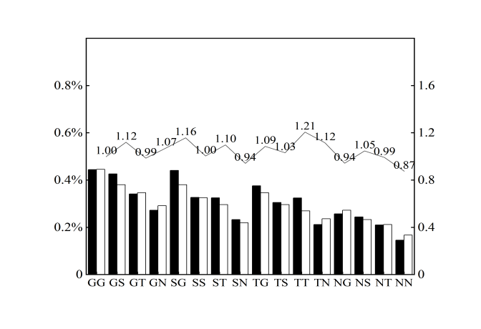
FigureS5: Ratio of positive and negative sample residue pair probabilities of GDP to random pairing probabilities
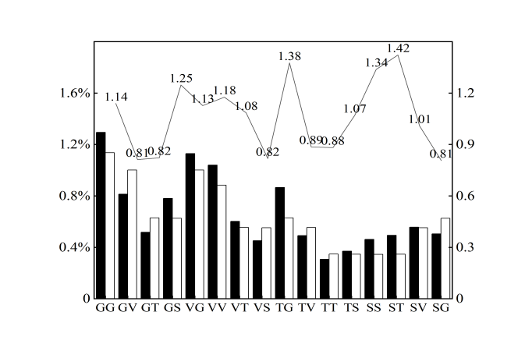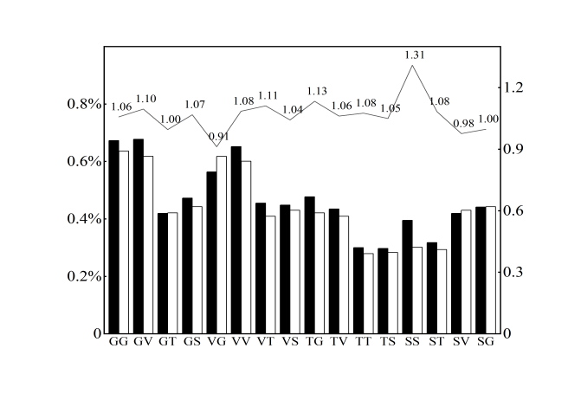
FigureS6: Ratio of positive and negative sample residue pair probabilities of NAD to random pairing probabilities

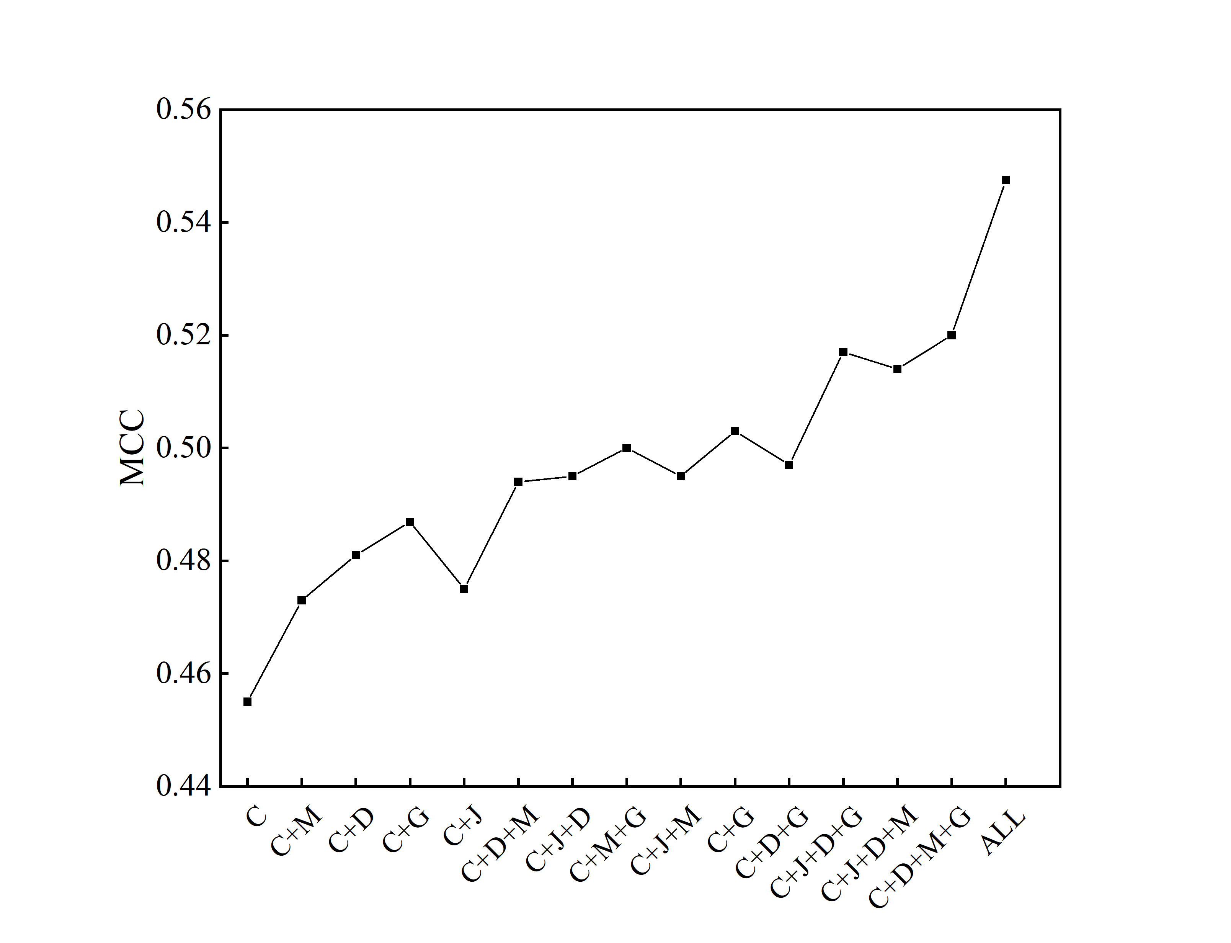
FigureS7: The results of ADP ligand five-fold cross-validation

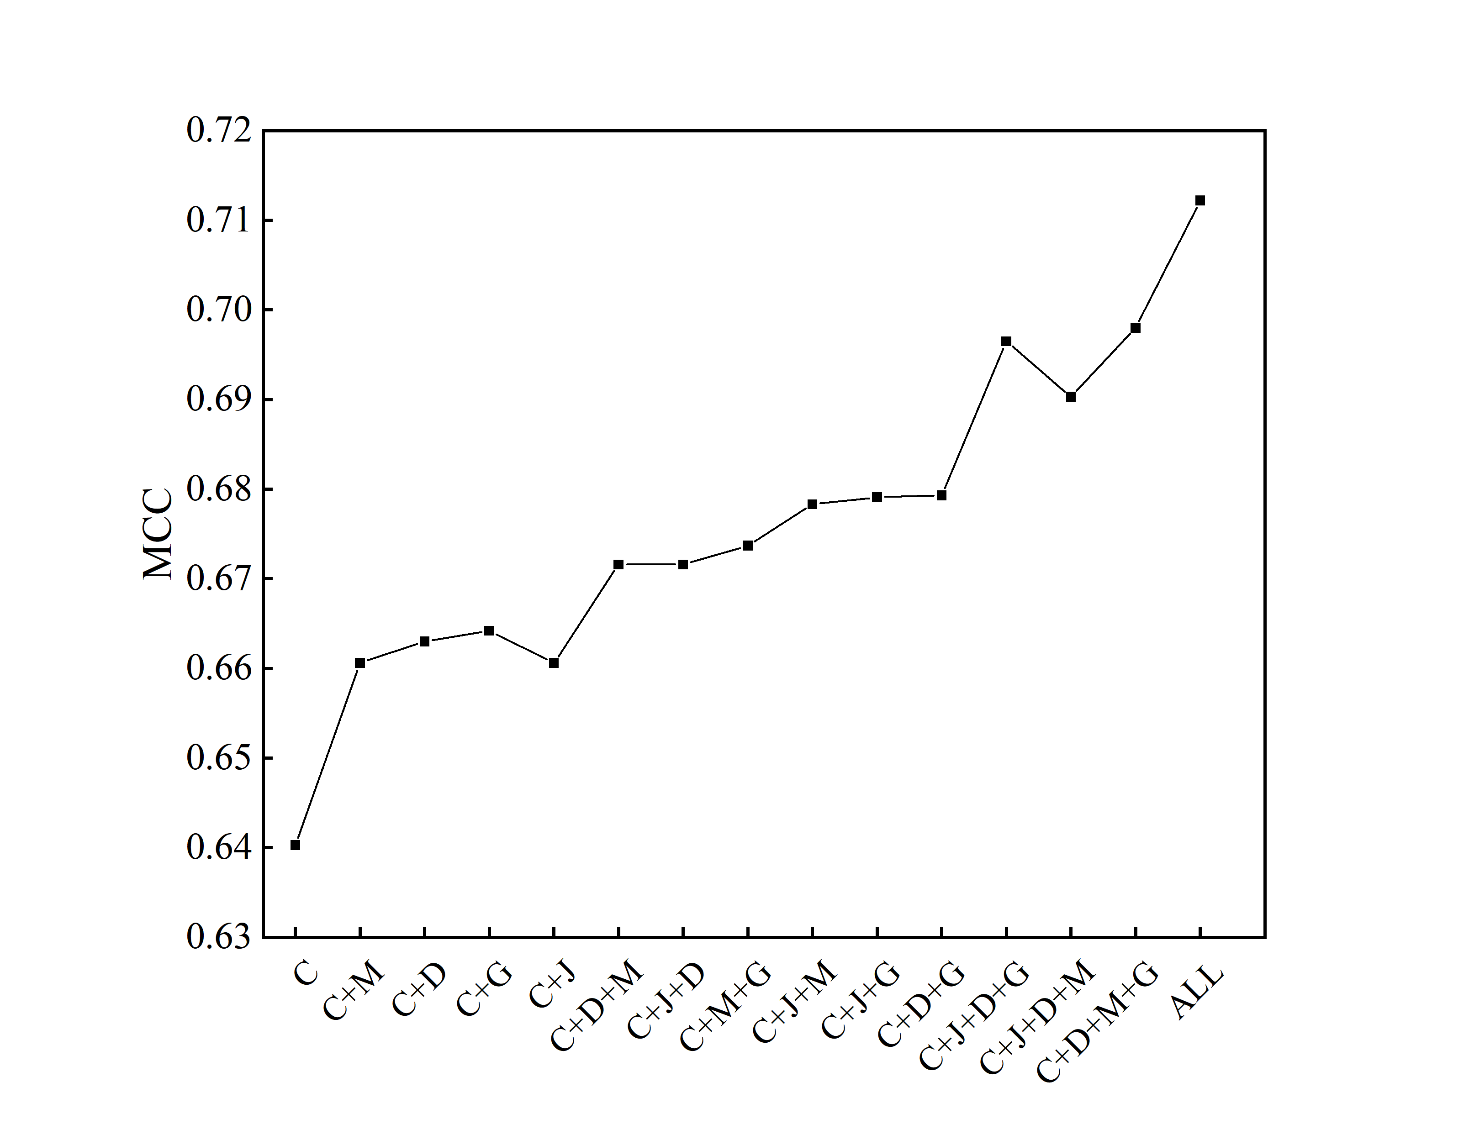
FigureS8: The results of GDP ligand five-fold cross-validation

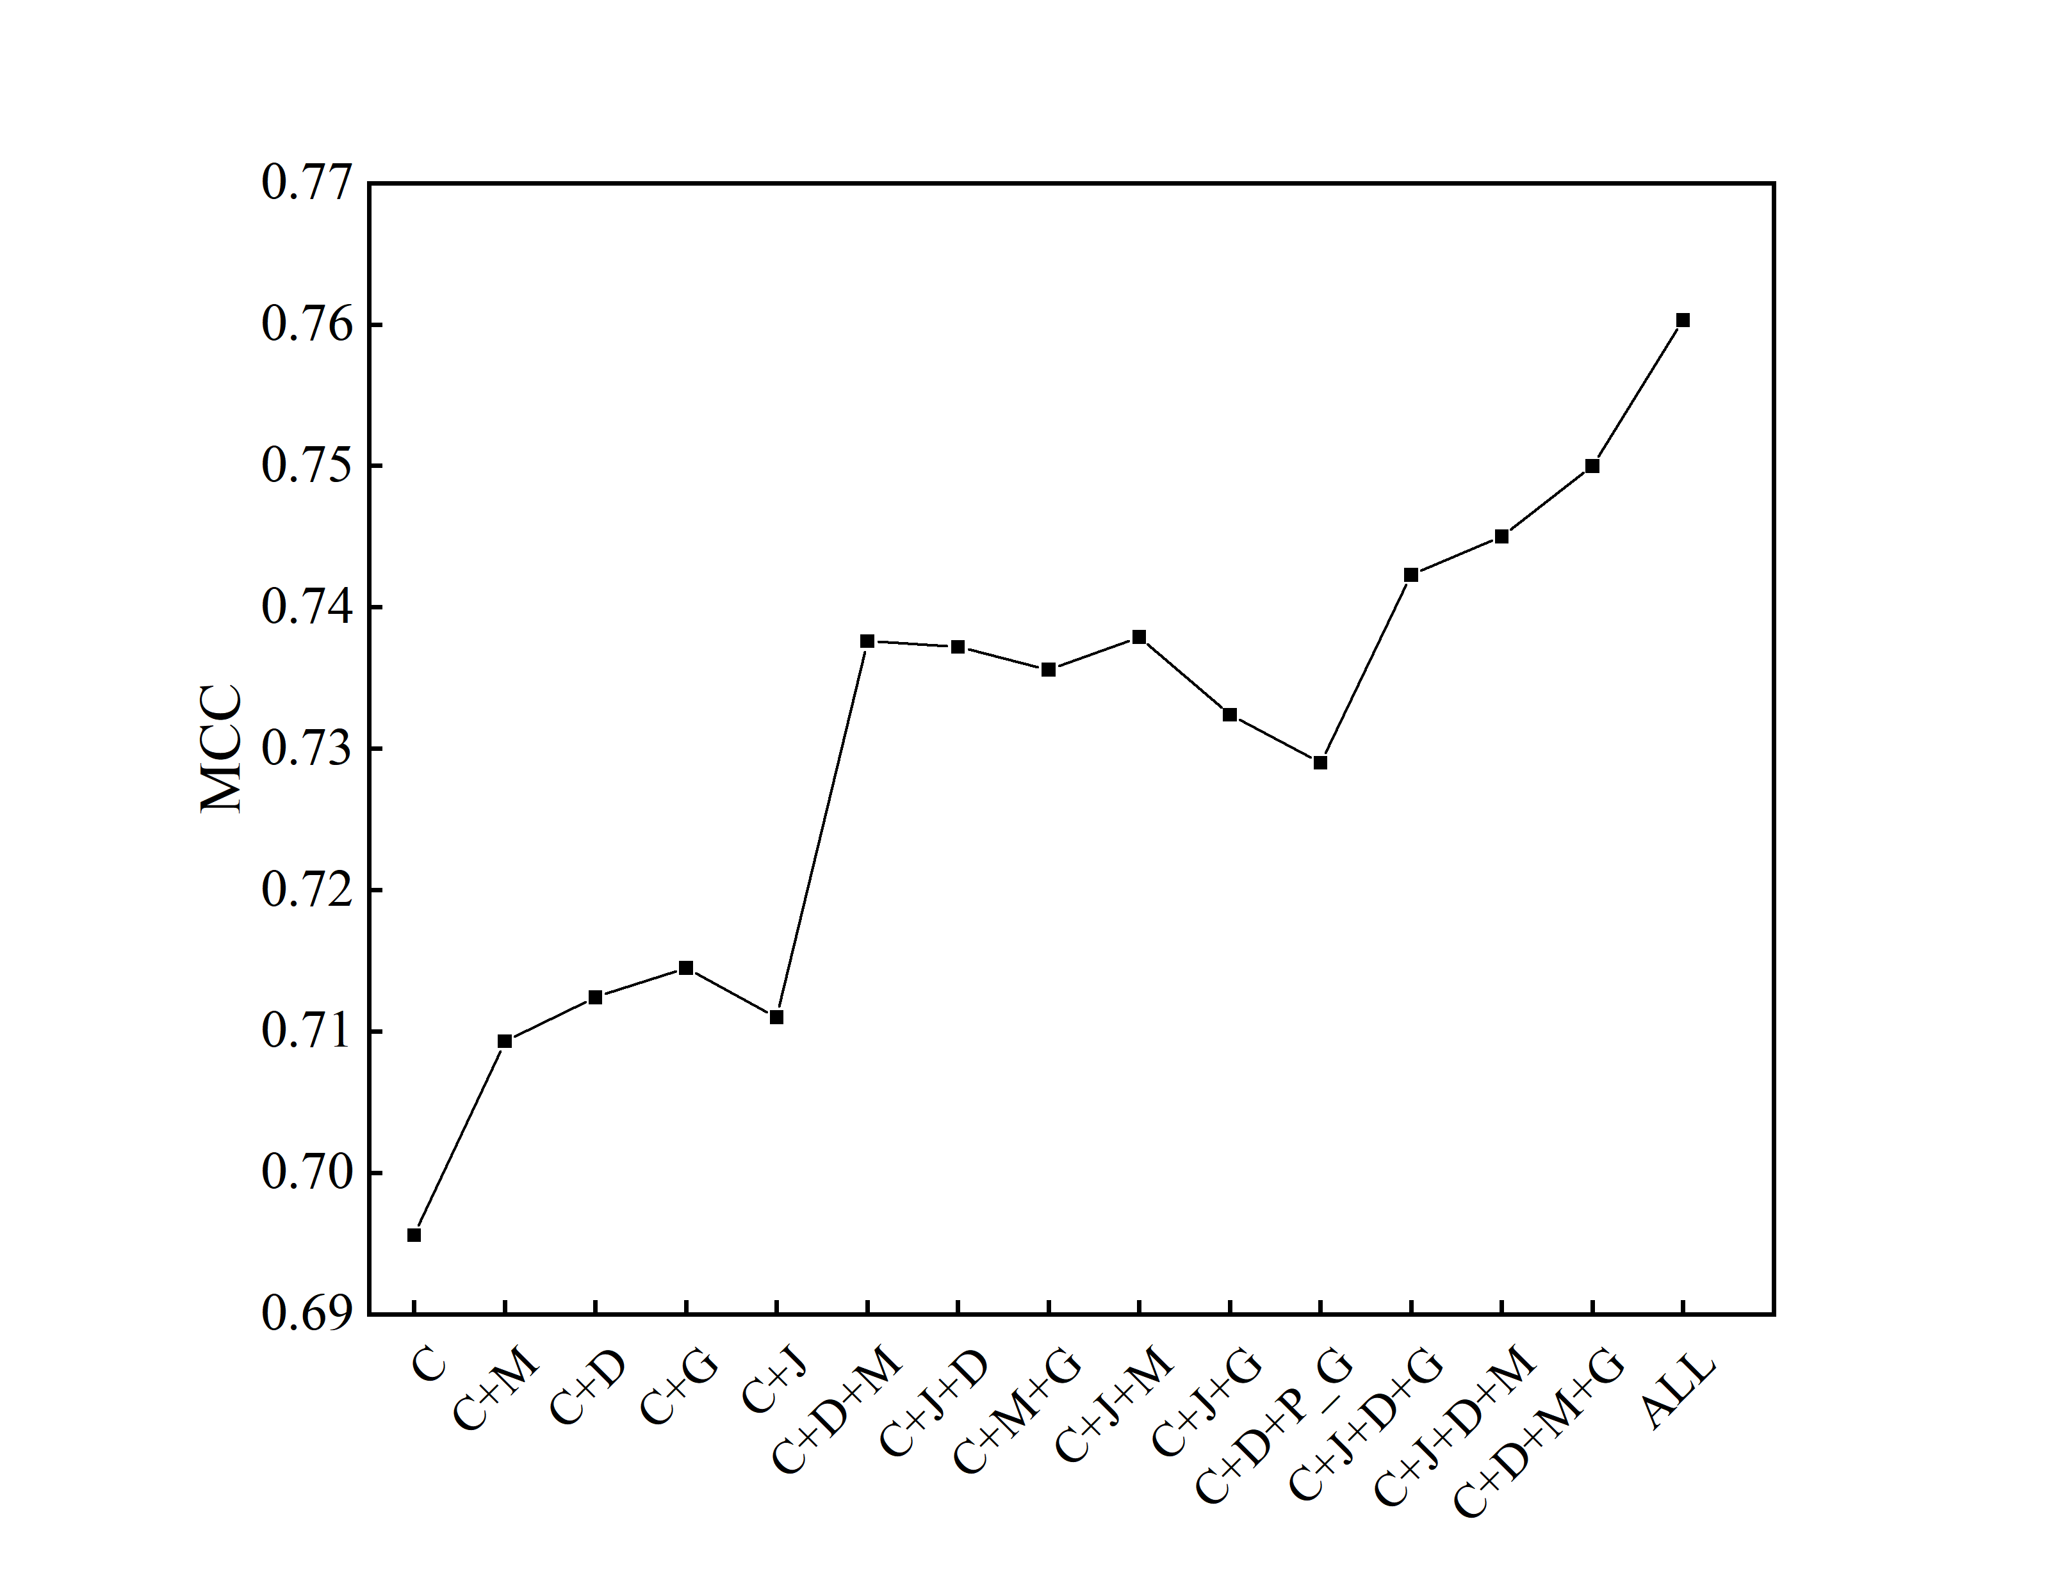
FigureS9: The results of NAD ligand five-fold cross-validation

TableS1 Classification of ATP central motifs
categorize | Types of center motifs
preferred center motifs | GKS KTT GKT KST GSG GNG SGK GGS GST IDF
slightly preferred center motifs | GTG GRG VKP GTT SGT VGG SGD GGG VGS AGD GGI GAG GGT TDV GTS VGK GGV KGG GKG GVG TGK LSG GGL IGA GDG LGS AGK AGG GGA GTA LID
rare center motifs | Other amino acid tripeptide composition

TableS2 Classification of GDP central motifs
categorize | Types of center motifs
preferred center motifs | GKS VDH NKM KST KTT GGT SGK HGK VGK GKT
slightly preferred center motifs | DHG TGS GNK NKV GTG NKI SAL TTL KSS INK SAK GVG STL VNK AGK NVG PNV TGT TSA GGG GGG GSG DAD TKL NAL ISA IDL GKG VSA ALK GGV DLP LNK
rare center motifs | Other amino acid tripeptide composition

TableS3 Classification of NAD central motifs
categorize | Types of center motifs
preferred center motifs | GST GSG VIG LGG AGI ATG AGA AGP EKP GGS GRV VGG TGG GGG GGV GGA HLA VVG GNV YDI GTA
slightly preferred center motifs | GDL GDV GVG LIG VGL TGS VDV GIG AGY GLG IGA DNL ATP GGA IGG AGG GSV GAG GYI IIG GDG NAG GYG FTG AIG VGA LVG AGV AVG DIN TGA DVV PFG GGI ANP NNA GVP AGF APG LDV FIG NTA GTG TSS STS
rare center motifs | Other amino acid tripeptide composition

TableS4 Comparison of ATP-388 predictions
Algorithm | Sn(%) | Sp(%) | Acc(%) | MCC | AUC
S-DCNN (3,32,16) | 59.41(51.34) | 98.78(99.06) | 97.24(96.8) | 0.5941(0.597) | 0.907(0.905)
Burota (3,32,16) | 59.6(51.64) | 98.8(99.11) | 97.26(96.86) | 0.6167(0.604) | 0.913(0.907)
S-SITEatp[14] | 69.88(67.51) | 94.47(92.65) | 93.53(91.51) | 0.455(0.416) | -
NsitePred[5] | (46.74) | (97.70) | (95.39) | (0.456) | (0.852)
TargetATPsit[34] | (41.25) | (99.49) | (96.84) | (0.559) | (0.853)
TargeNUCs[35] | (46.88) | (99.66) | (97.26) | (0.627) | (0.856)
ATPseq[14] | 57.52(54.45) | 98.86(99.27) | 97.27(97.2) | 0.605(0.639) | 0.913(0.878)
ATPensemble[36] | (49.7) | (99.6) | (97.3 ) | (0.642) | (0.902)
Note: The results of independent tests are in parentheses

TableS5 Comparison of the prediction results of ATP-221

Algorithm | Hyperparameters | Sn(%) | Sp(%) | Acc(%) | MCC | AUC
S-DCNN | 4,32,16 | 58.76(50.54) | 98.57(98.85) | 96.98(97.04) | 0.5841(0.549) | 0.919(0.914)
Burota |  | 58.59(50.85) | 98.59(98.82) | 96.98(97.02) | 0.594(0.5488) | 0.920(0.914)
SXGBsite[15] | - | 40.3(43.7) | 98.6(98.5) | 96.4(96.5) | 0.448(0.463) | 0.886(0.880)
EC-RUS[7] | - | 58.6(45.4) | 97.9(98.8) | 96.4(96.8) | 0.537(0.506) | 0.912(0.871)
TargetS[14] | - | 48.4(50.1) | 98.2(98.3) | 96.2(96.5) | 0.492(0.502) | 0.887(0.898)
Note: The results of independent tests are in parentheses

TableS6 Comparison of ADP-296 prediction results
Algorithm | Hyperparameters | Sn(%) | Sp(%) | Acc(%) | MCC | AUC
S-CDNN | 3,32,16 | 59.74(44.37) | 99.02(99.42) | 97.55(97.7) | 0.615(0.514) | 0.931(0.883)
Burota |  | 59.67(44.65) | 99.03(99.46) | 97.56(98.00) | 0.616(0.521) | 0.929(0.885)
EC-RUS[7] | - | 46.4(37.3) | 98.9(99.5) | 97(97.7) | 0.521(0.488) | 0.907(0.885)
SXGBsite[15] | - | 62.2(44.4) | 98.6(99.2) | 97.3(97.6) | 0.610(0.511) | 0.939(0.872)
Note: The results of independent tests are in parentheses

TableS7 Comparison of GDP-82 forecasts

Algorithm | Hyperparameters | Sn(%) | Sp(%) | Acc(%) | MCC | AUC
S-CDNN | 3,16,16 | 64.03(55.5) | 98.78(98.36) | 97.35(96.39) | 0.652(0.568) | 0.92(0.902)
Burota |  | 64.31(56.02) | 98.77(98.21) | 97.35(96.27) | 0.653(0.561) | 0.924(0.904)
SXGBsite[14] | - | 57.0(40.2) | 99.5(99.7) | 97.9(97.1) | 0.678(0.576) | 0.930(0.894)
EC-RUS[7] | - | 67.2(36.6) | 98.9(99.9) | 97.6(97.1) | 0.676(0.579) | 0.937(0.872)
Note: The results of independent tests are in parentheses

