TableS1 The average probability of four metalloenzymes being both catalytic residues and binding residues

|  |  |  |  |  |
| --- | --- | --- | --- | --- |
|  | Ca2+ | Mg2+ | Mn2+ | Zn2+ |
| Ave-BC1 | 24.40% | 47.80% | 68.50% | 52.80% |
| Ave-BC2 | 79.70% | 85.50% | 92% | 86.50% |

Note: Ave-BC1 represents the probability value of residues being both binding residues and catalytic residues across all chains; Ave-BC2 represents the probability value of at least one shared residue (acting as both binding and catalytic residue) occurring in the remaining chains after excluding chains without any such shared residues.

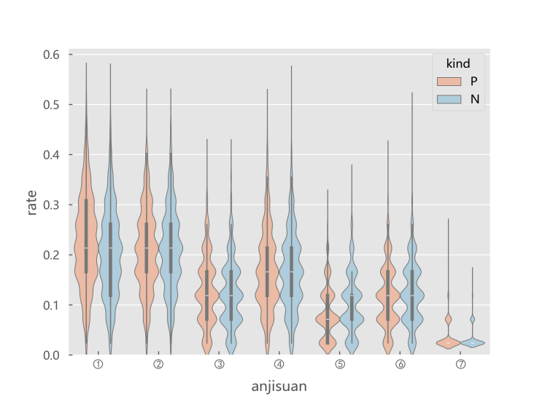

Fig.S1 The seven types of one-hot amino acid components of the positive and negative ligand sets of

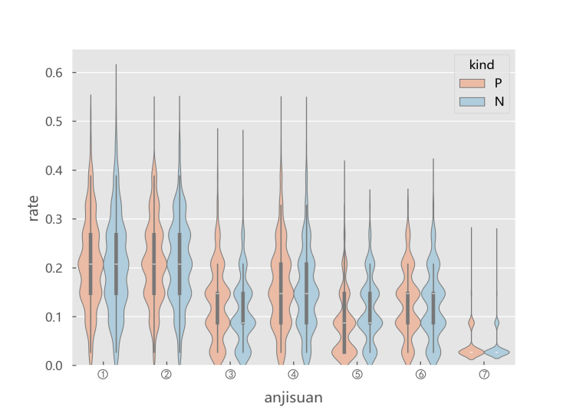

Fig.S2 The seven types of one-hot amino acid components of the positive and negative ligand sets of

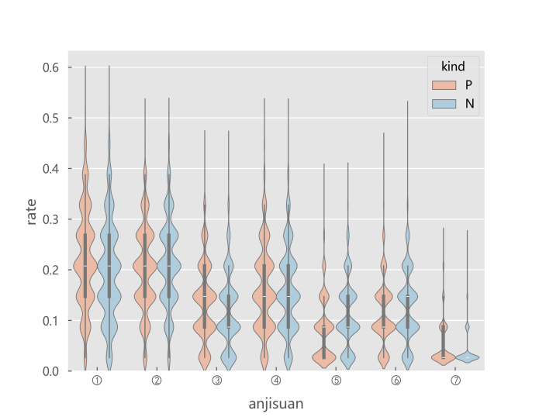

Fig.S3 The seven types of one-hot amino acid components of the positive and negative ligand sets of



a) The position weight matrix (PWM) constructed from the positive training set of Ca²⁺ ligands



b) The position weight matrix (PWM) constructed from the negative training set of Ca²⁺ ligands

Fig.S4 The position weight matrix (PWM) constructed from positive

and negative training sets of binding ligands



a) The position weight matrix (PWM) constructed from the positive training set of Mn²⁺ ligands



b) The position weight matrix (PWM) constructed from the negative training set of Mn²⁺ ligands

Fig.S5 The position weight matrix (PWM) constructed from positive

and negative training sets of binding ligands



a) The position weight matrix (PWM) constructed from the positive training set of Zn²⁺ ligands



b) The position weight matrix (PWM) constructed from the negative training set of Zn²⁺ ligands

Fig.S6 The position weight matrix (PWM) constructed from positive

and negative training sets of binding ligands

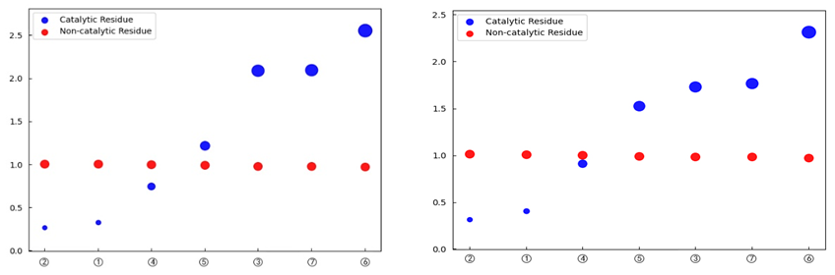

Fig.S7 The propensity factors of binding ligands for one-hot amino acids,

hydrophilicity/hydrophobicity, and acid-base polarity

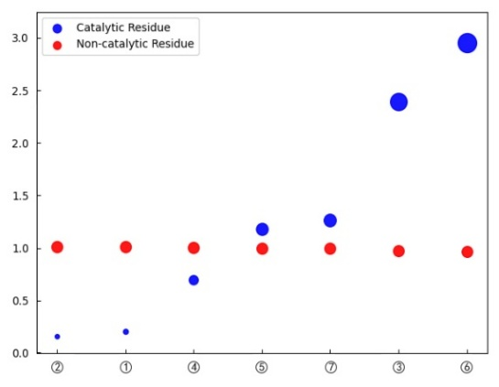

Fig.S8 The propensity factors of binding ligands for one-hot amino acids,

hydrophilicity/hydrophobicity, and acid-base polarity

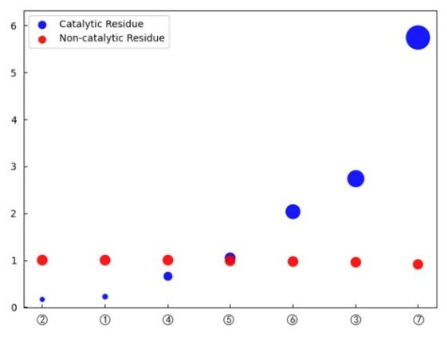

Fig.S9 The propensity factors of binding ligands for one-hot amino acids,

hydrophilicity/hydrophobicity, and acid-base polarity

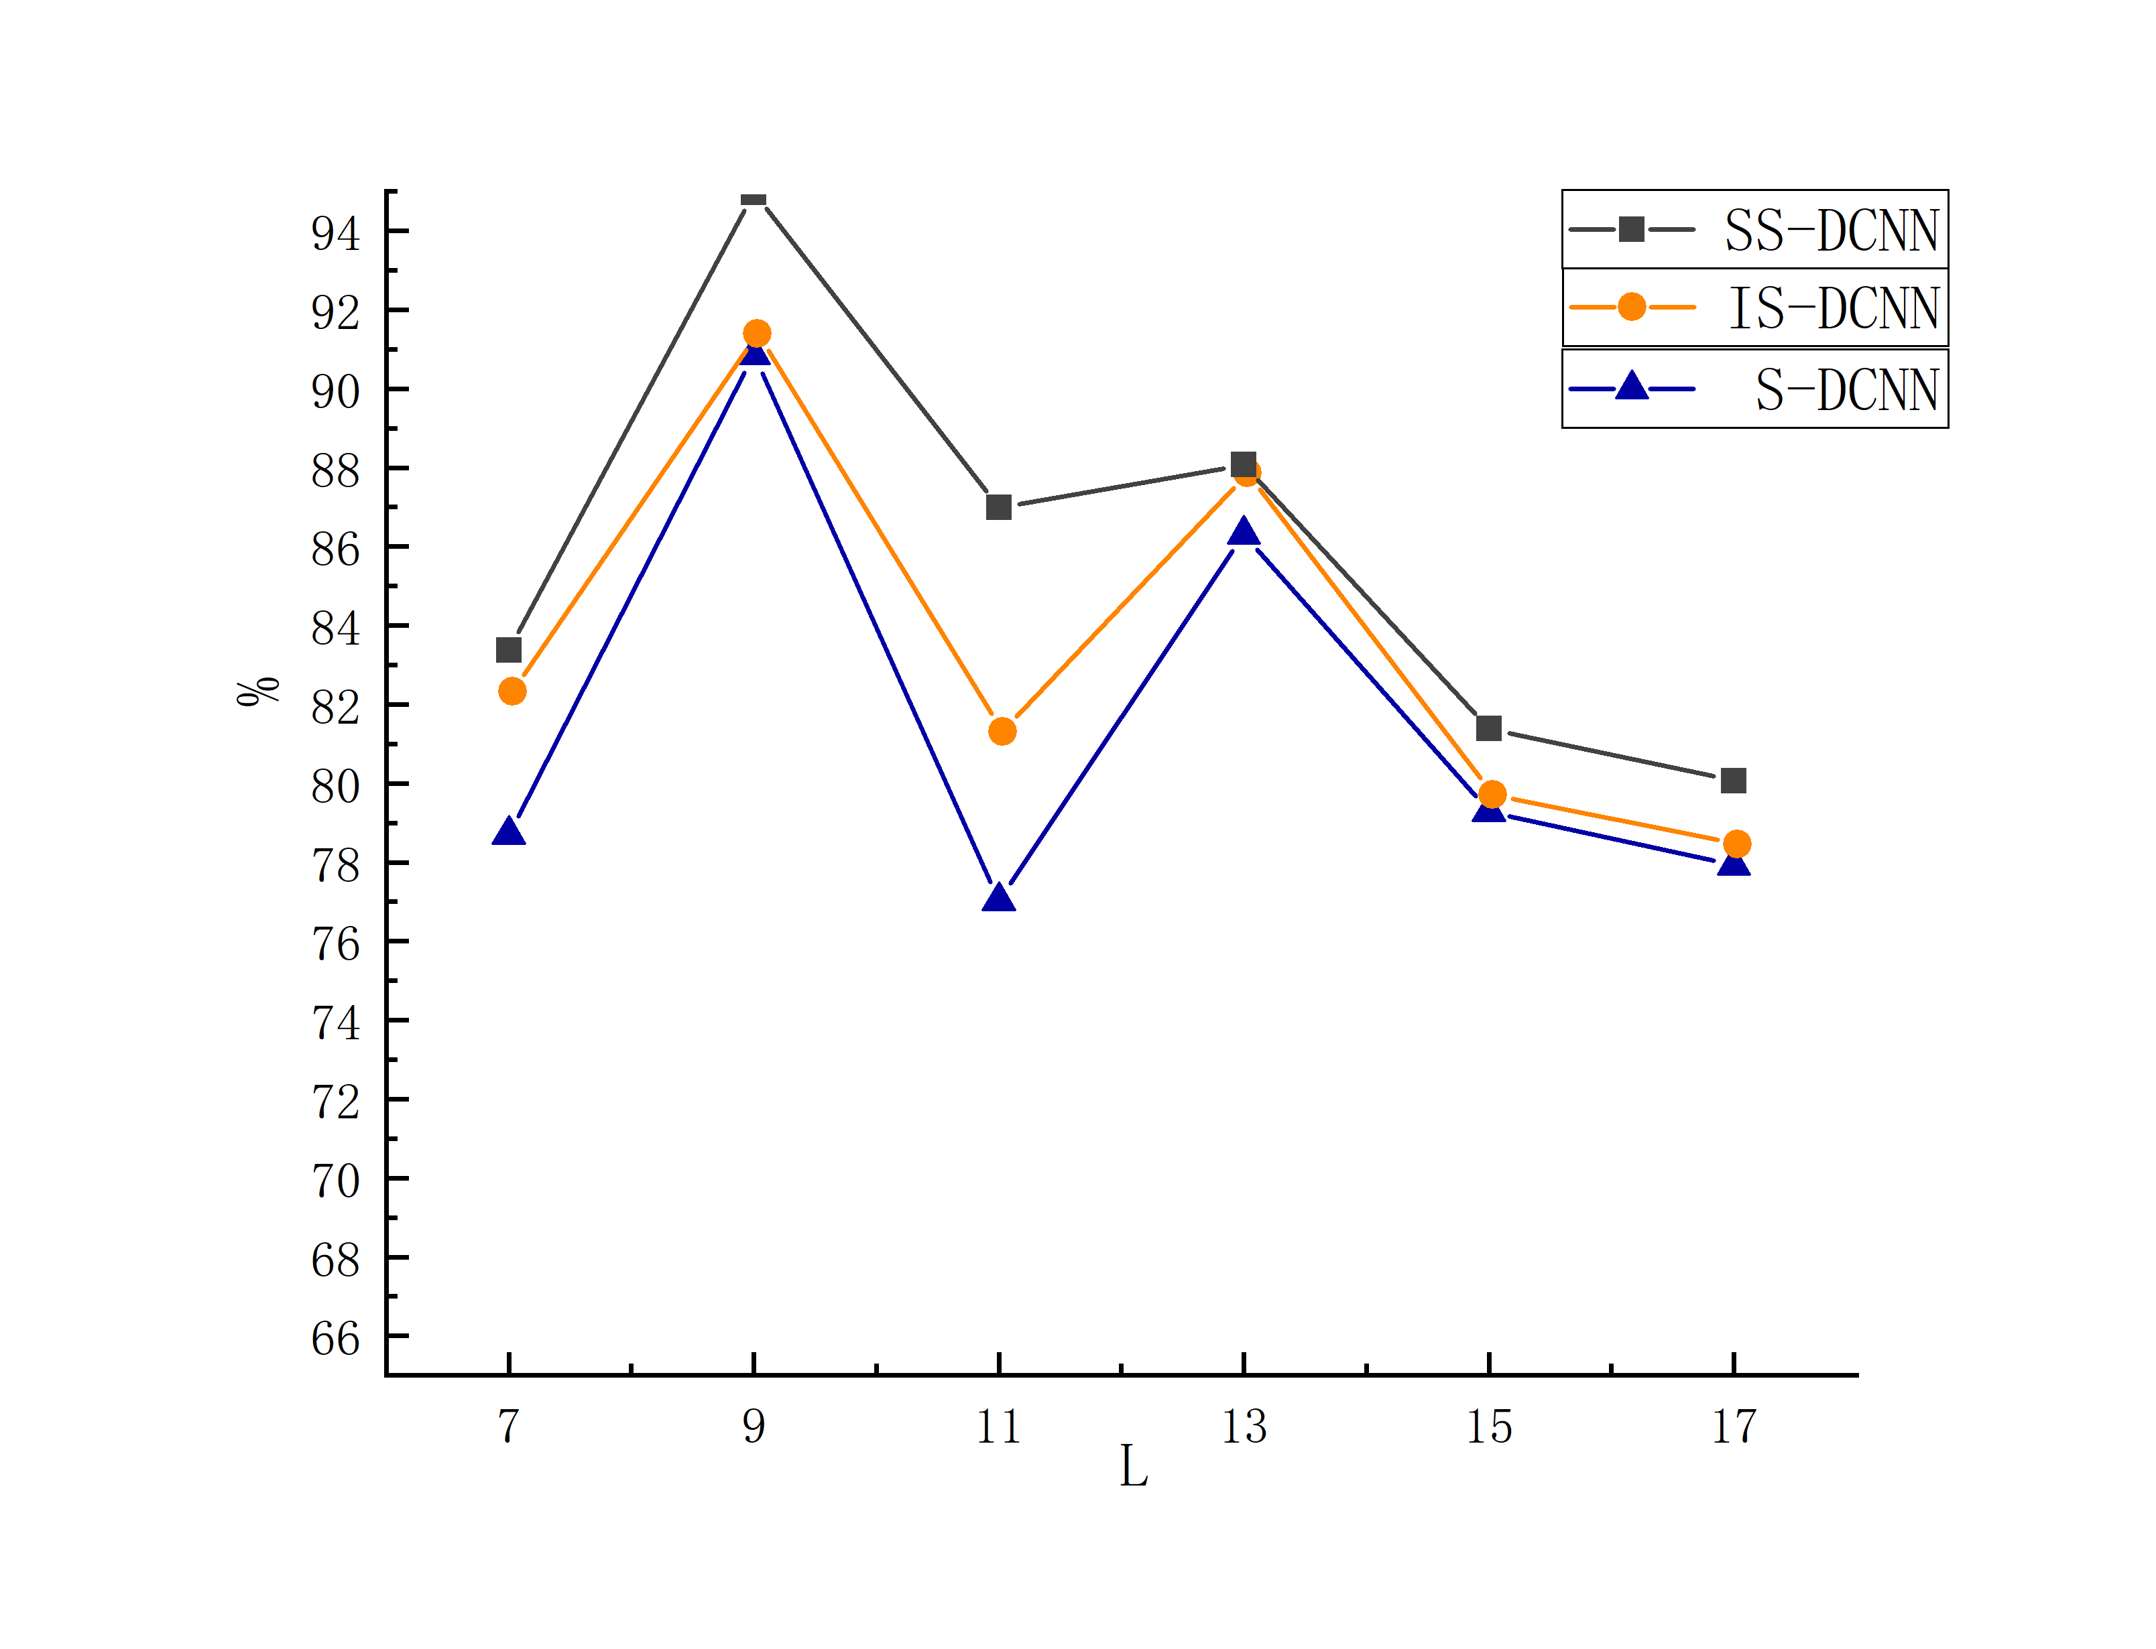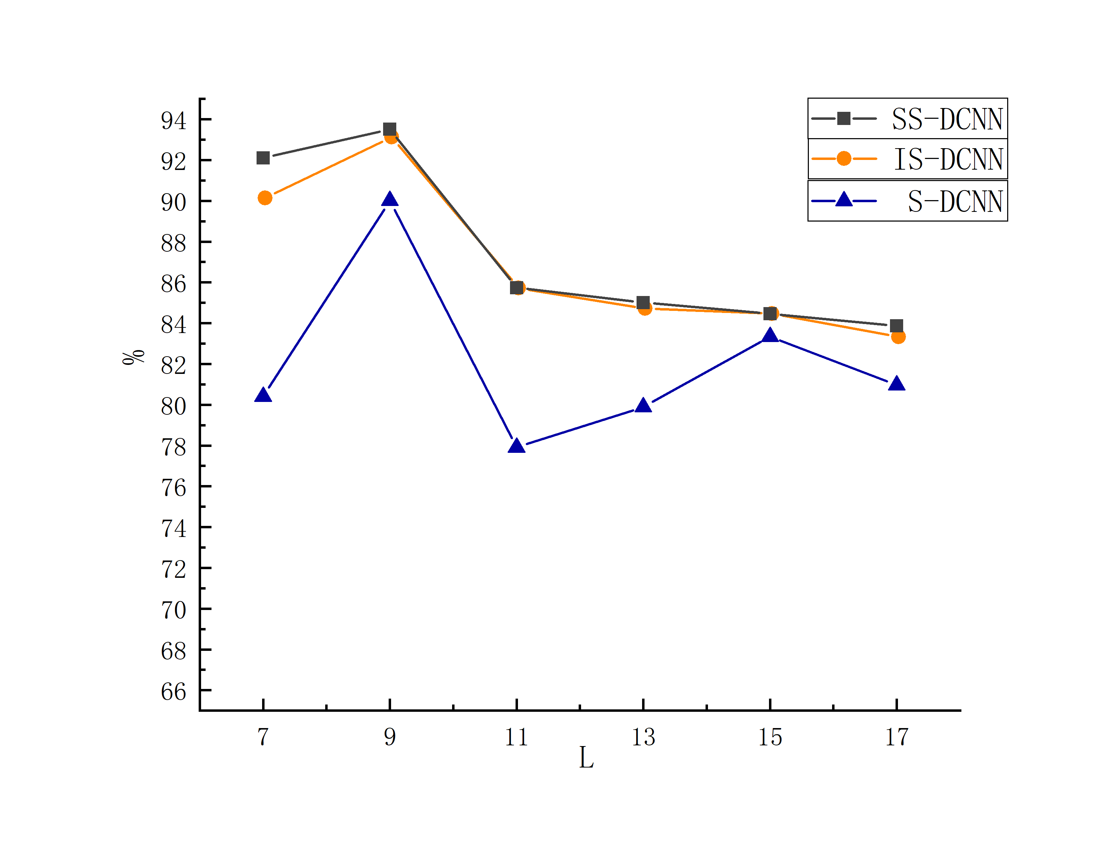

1. Sn (b) Sp

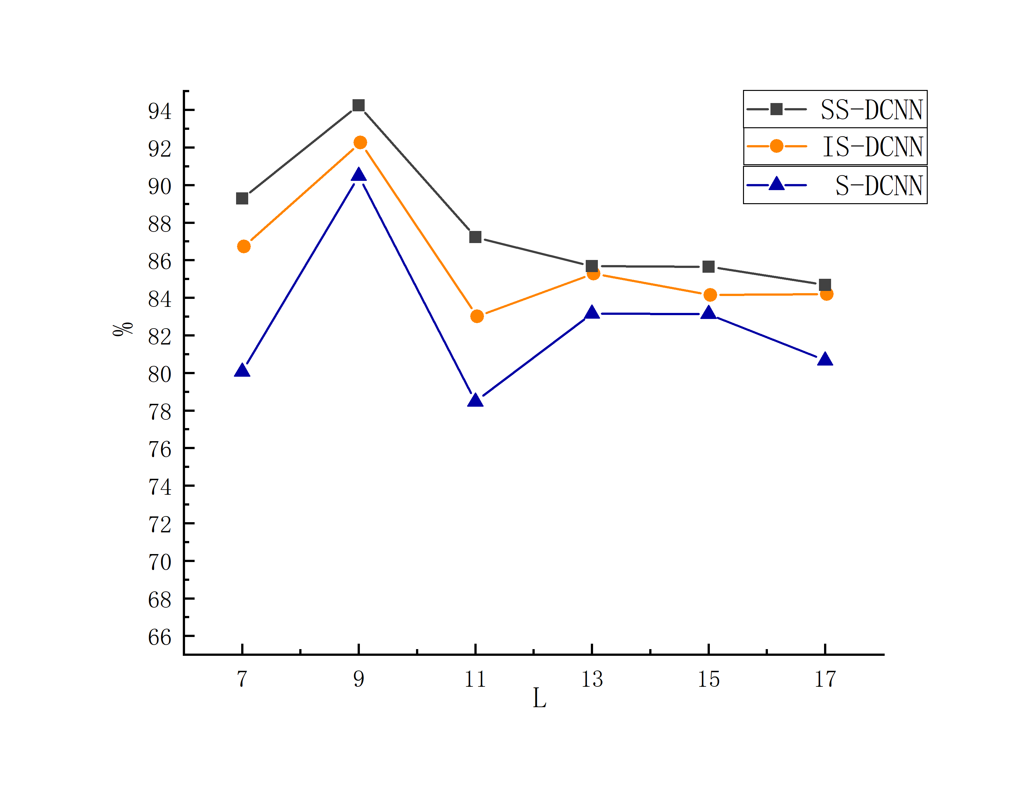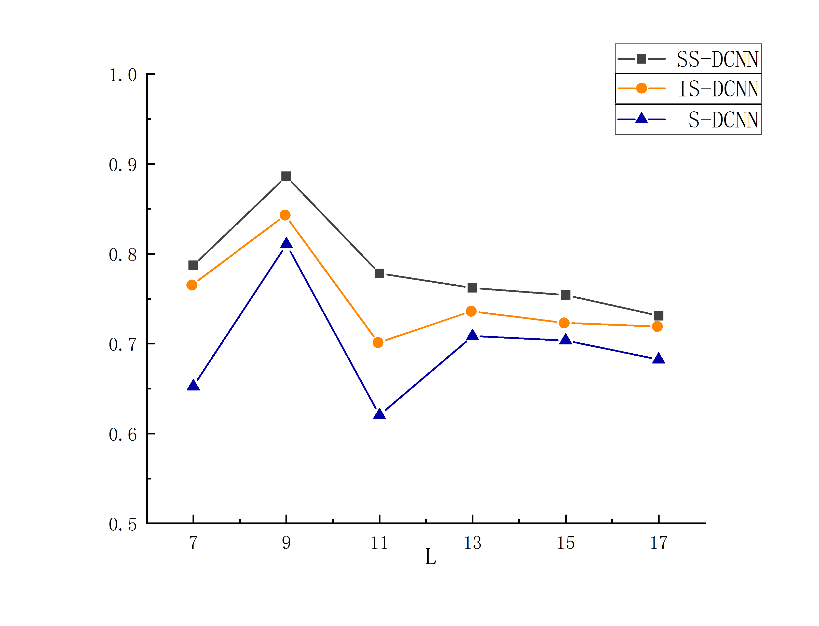

(c) Acc (d) MCC

Fig.S10 The evaluation index values of Ca2+ ligands under three different algorithms with varying window lengths

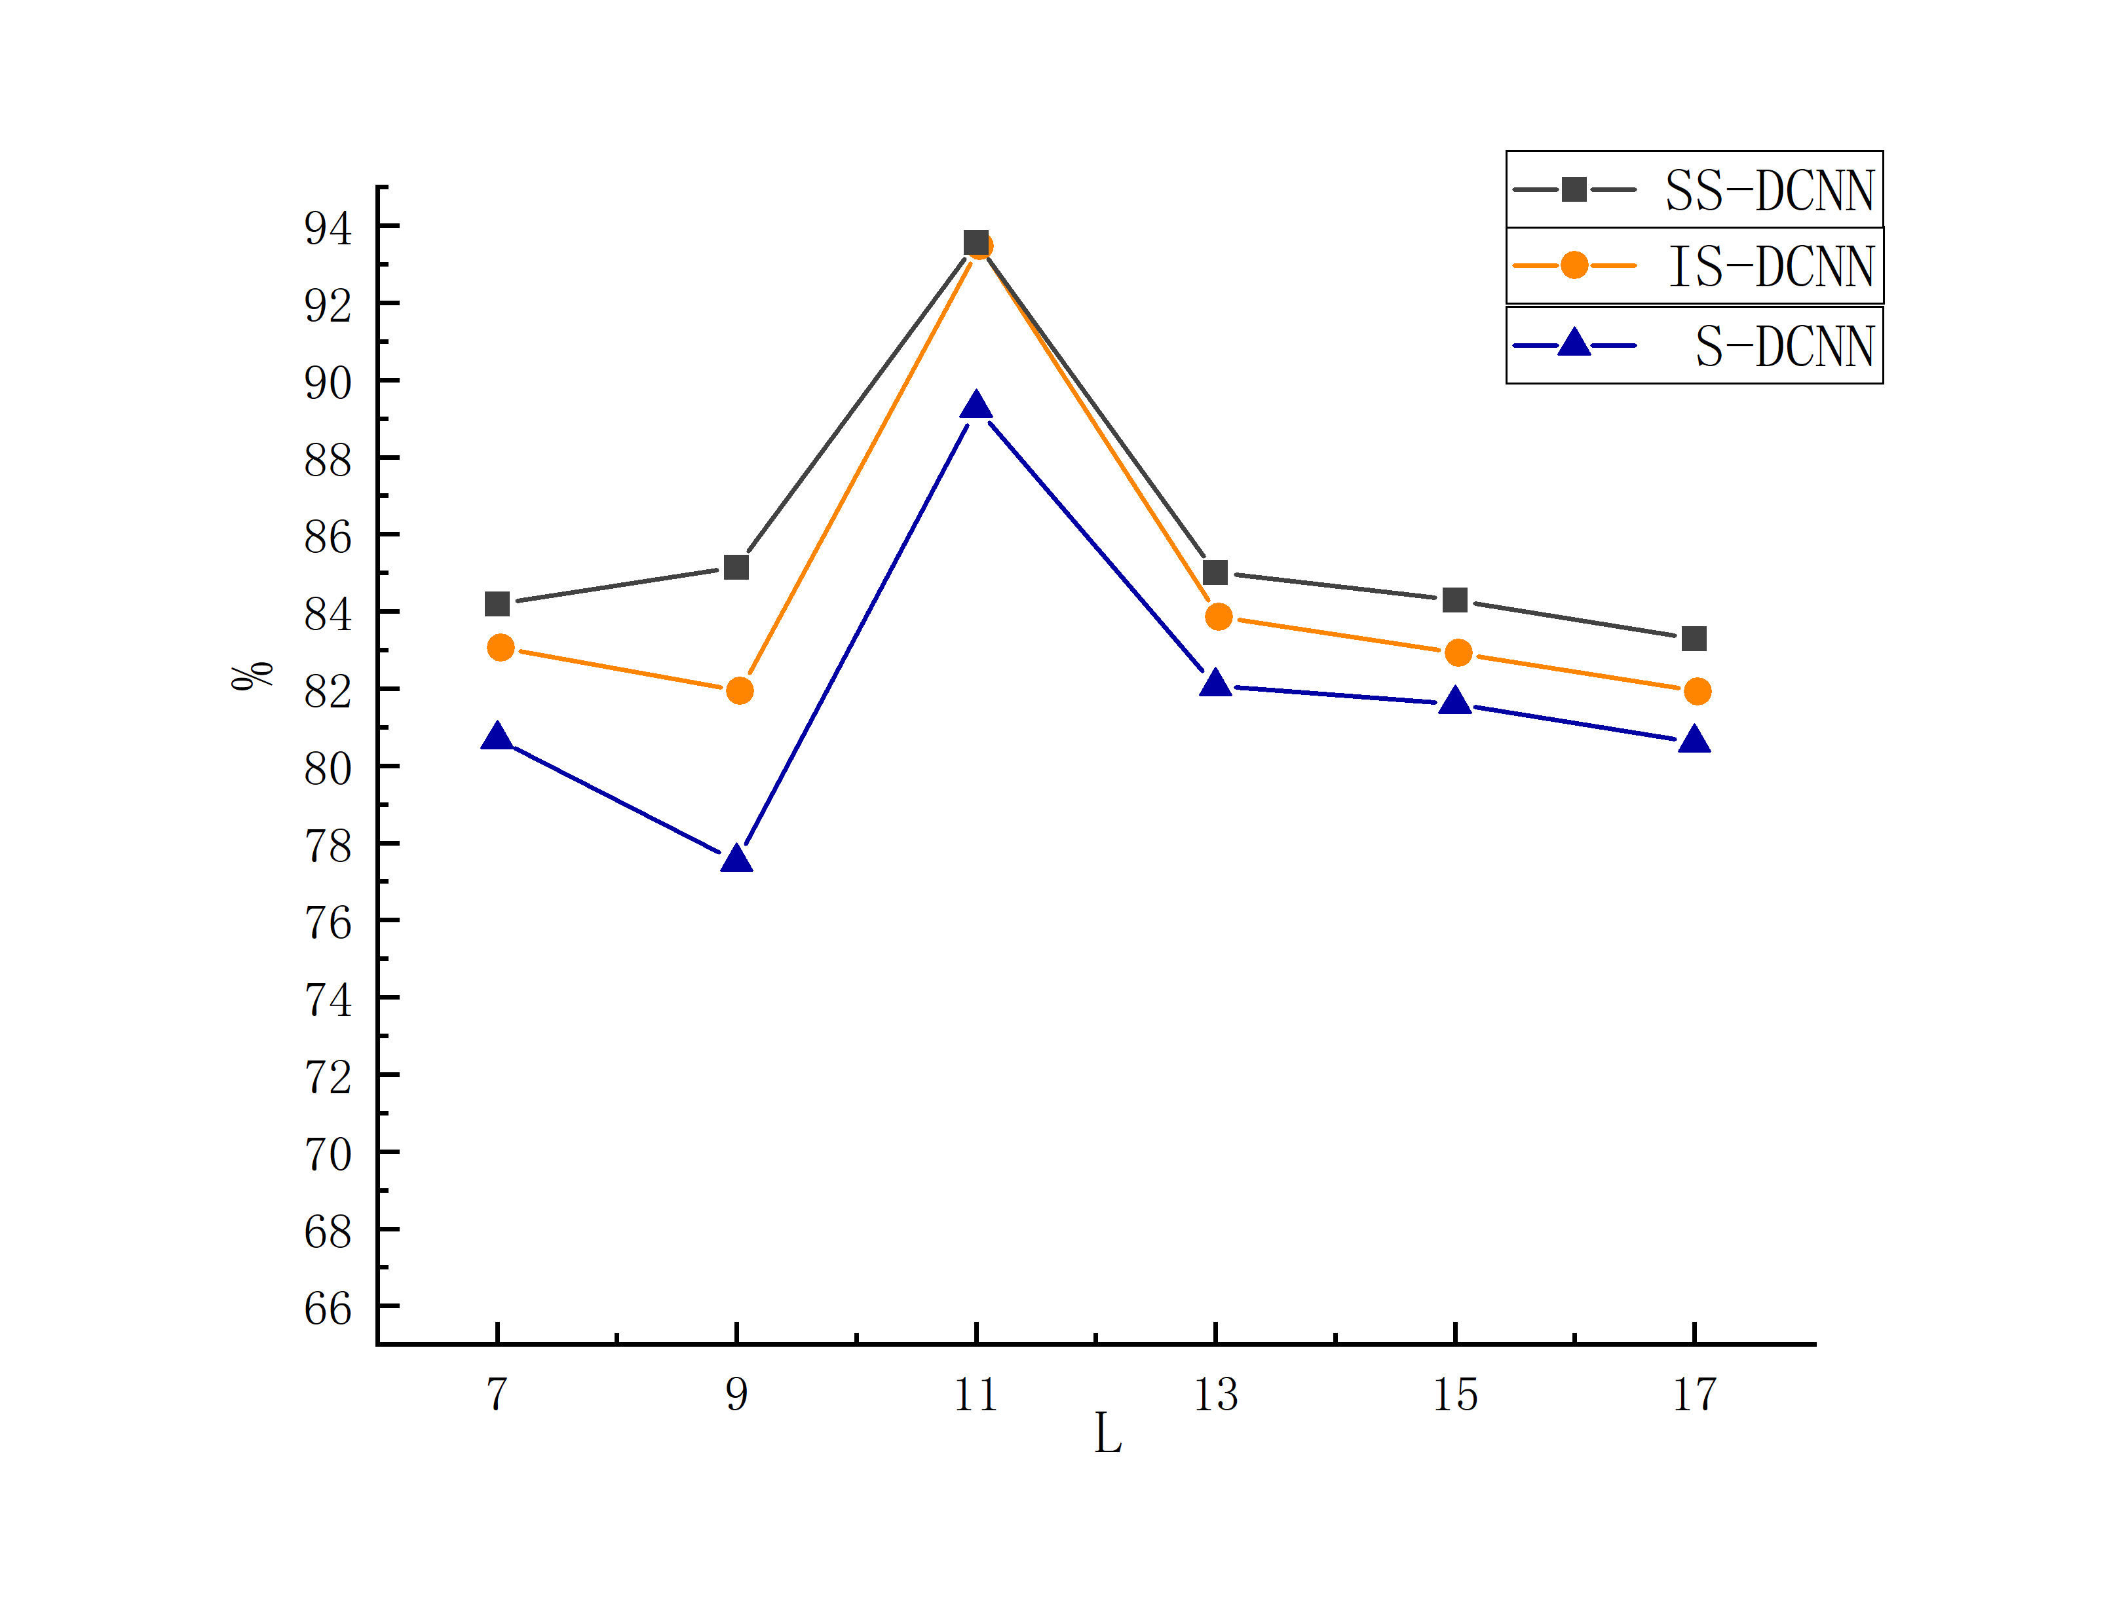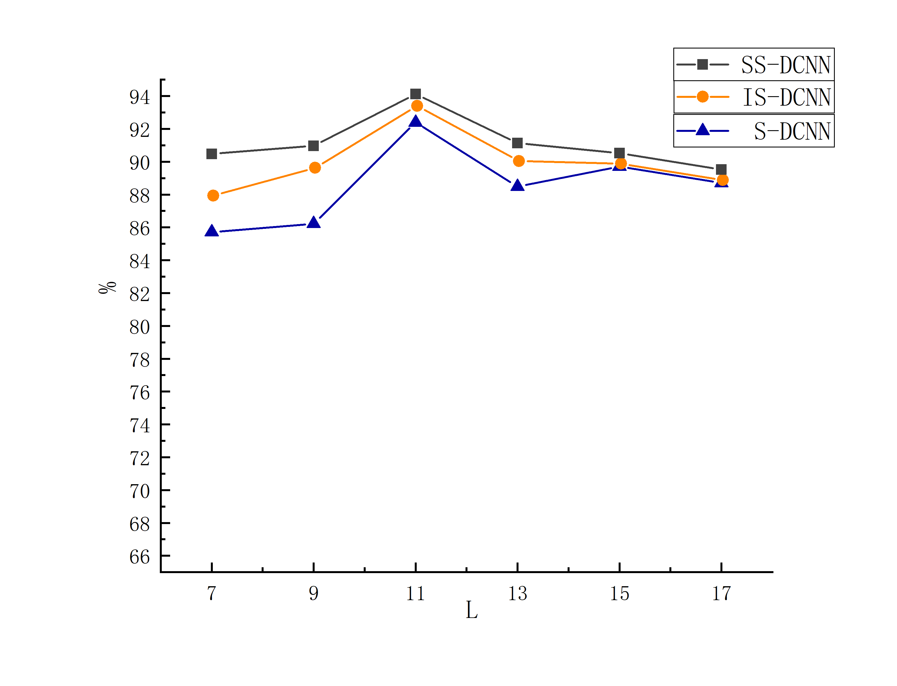

1. Sn (b) Sp

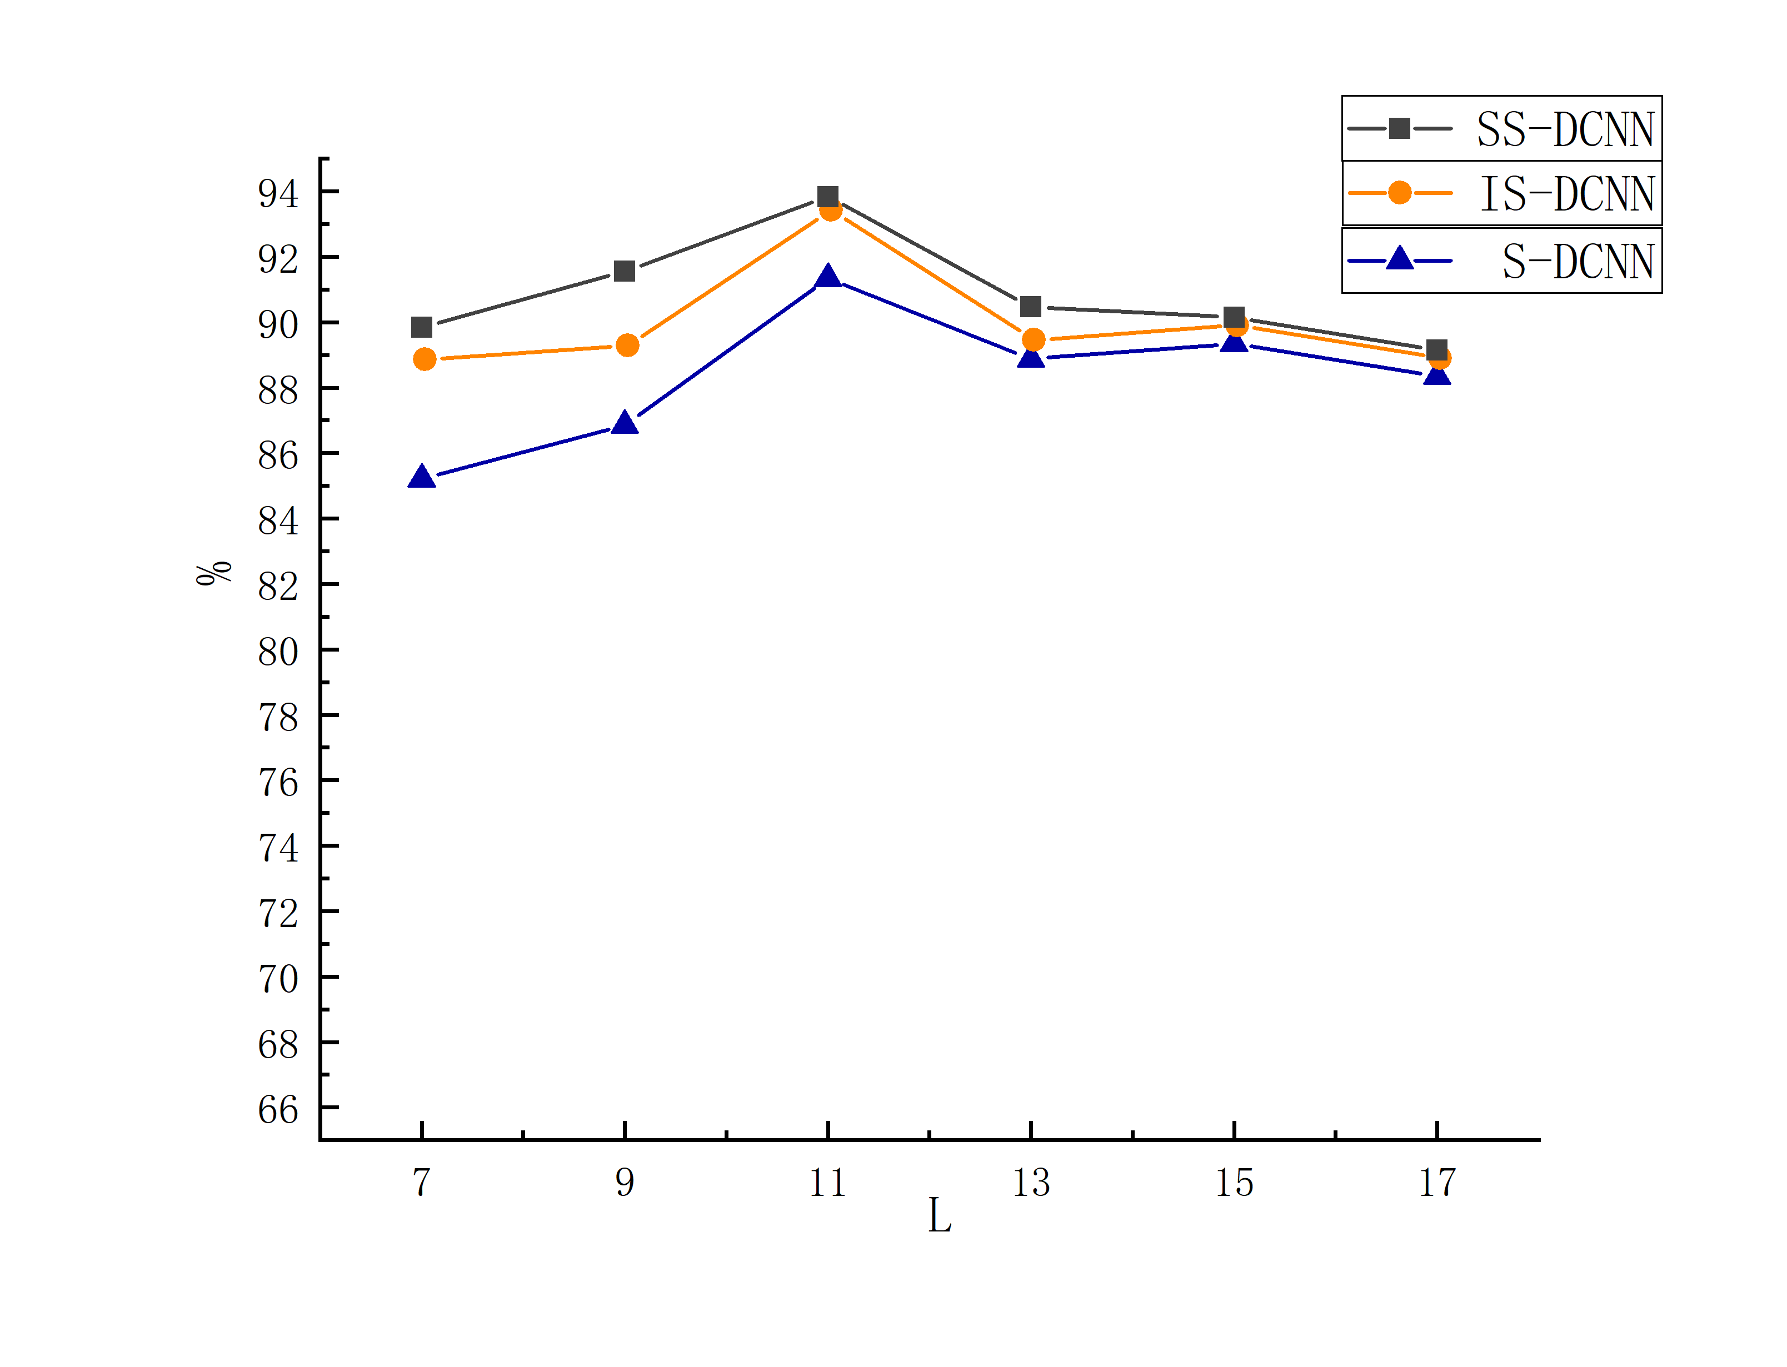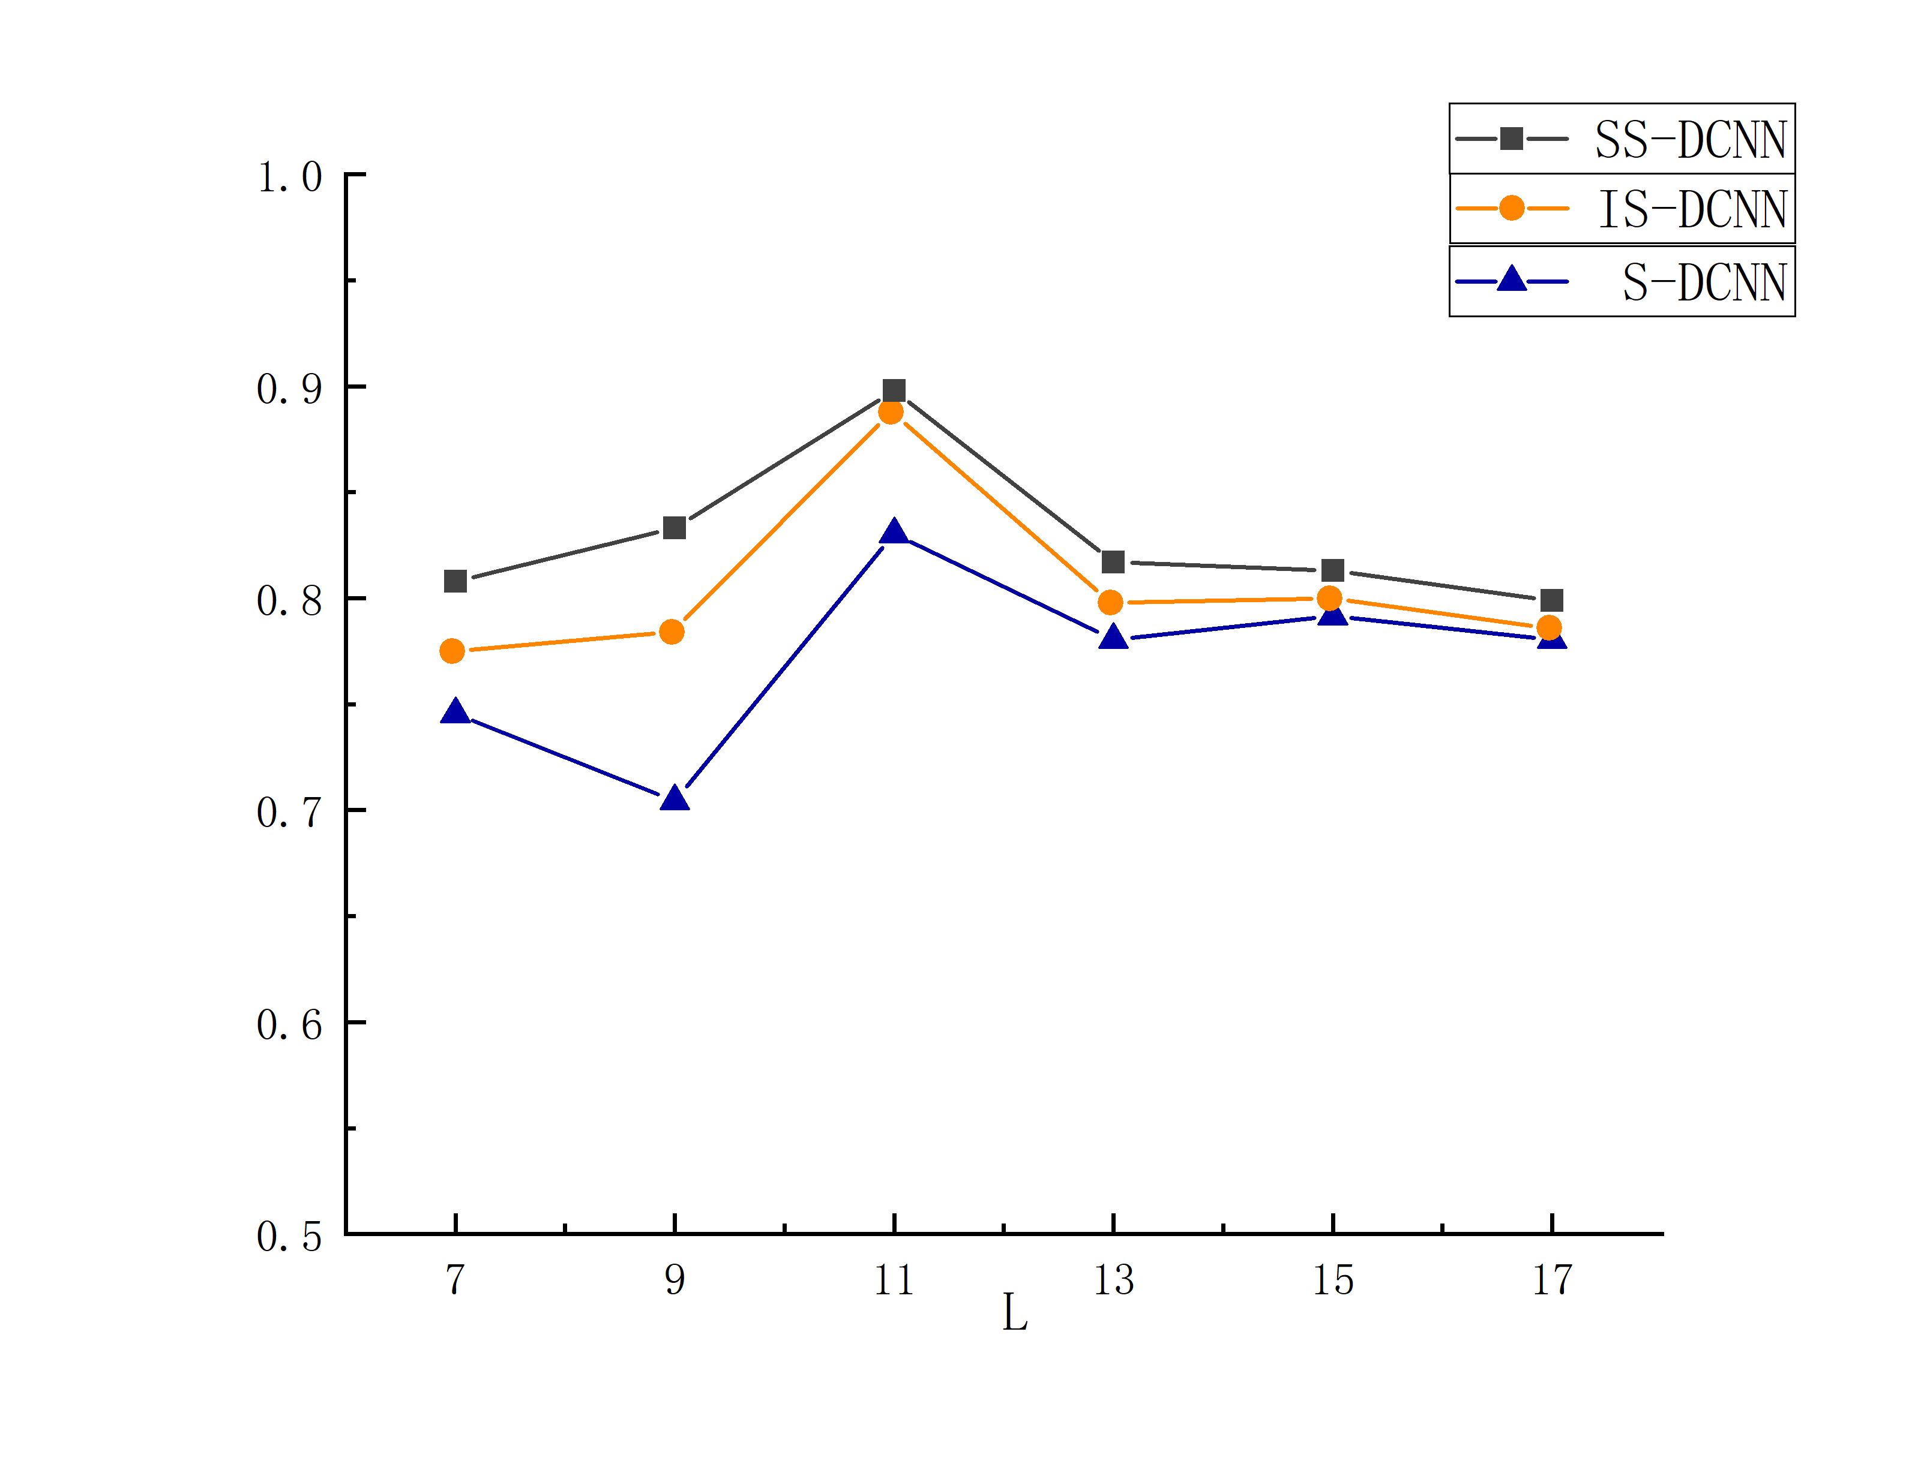

(c) Acc (d) MCC

Fig.S11 The evaluation index values of Mn2+ ligands under three different algorithms with varying window lengths

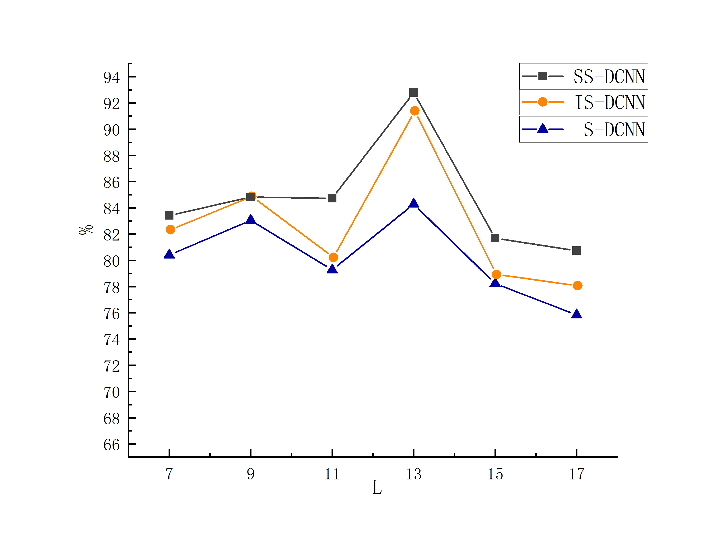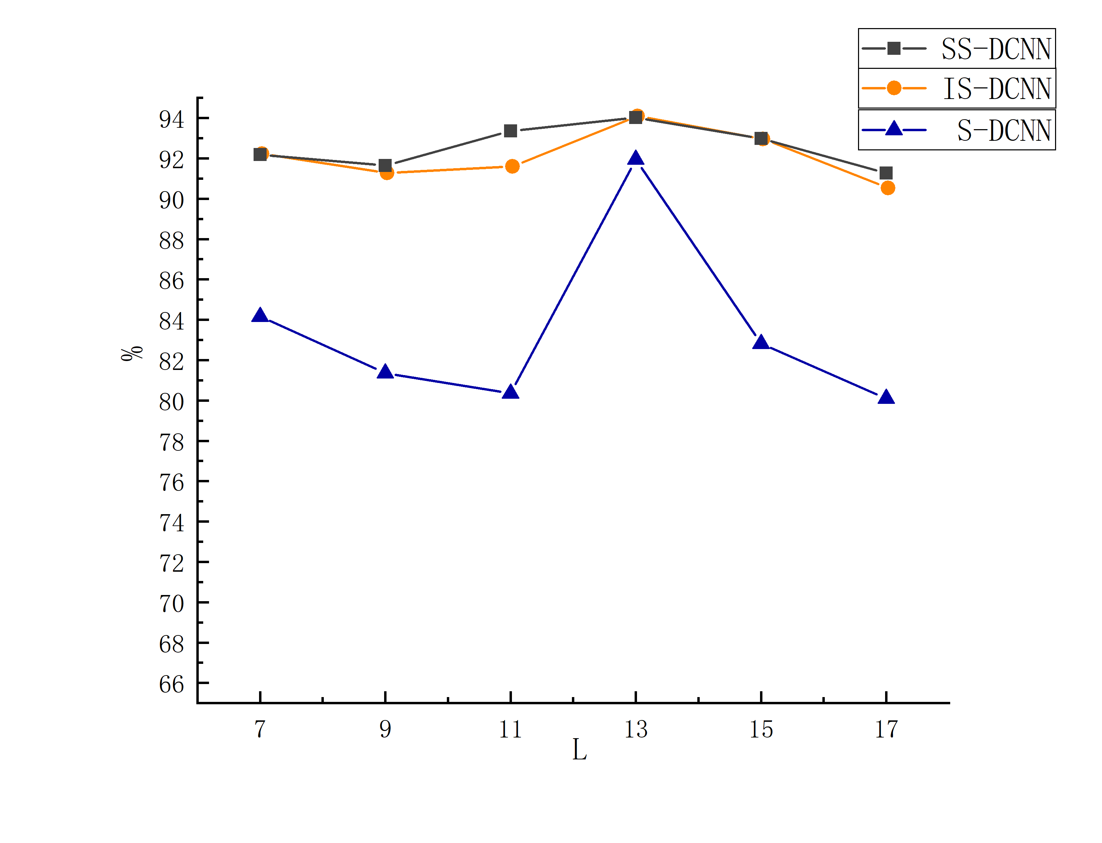

1. Sn (b) Sp

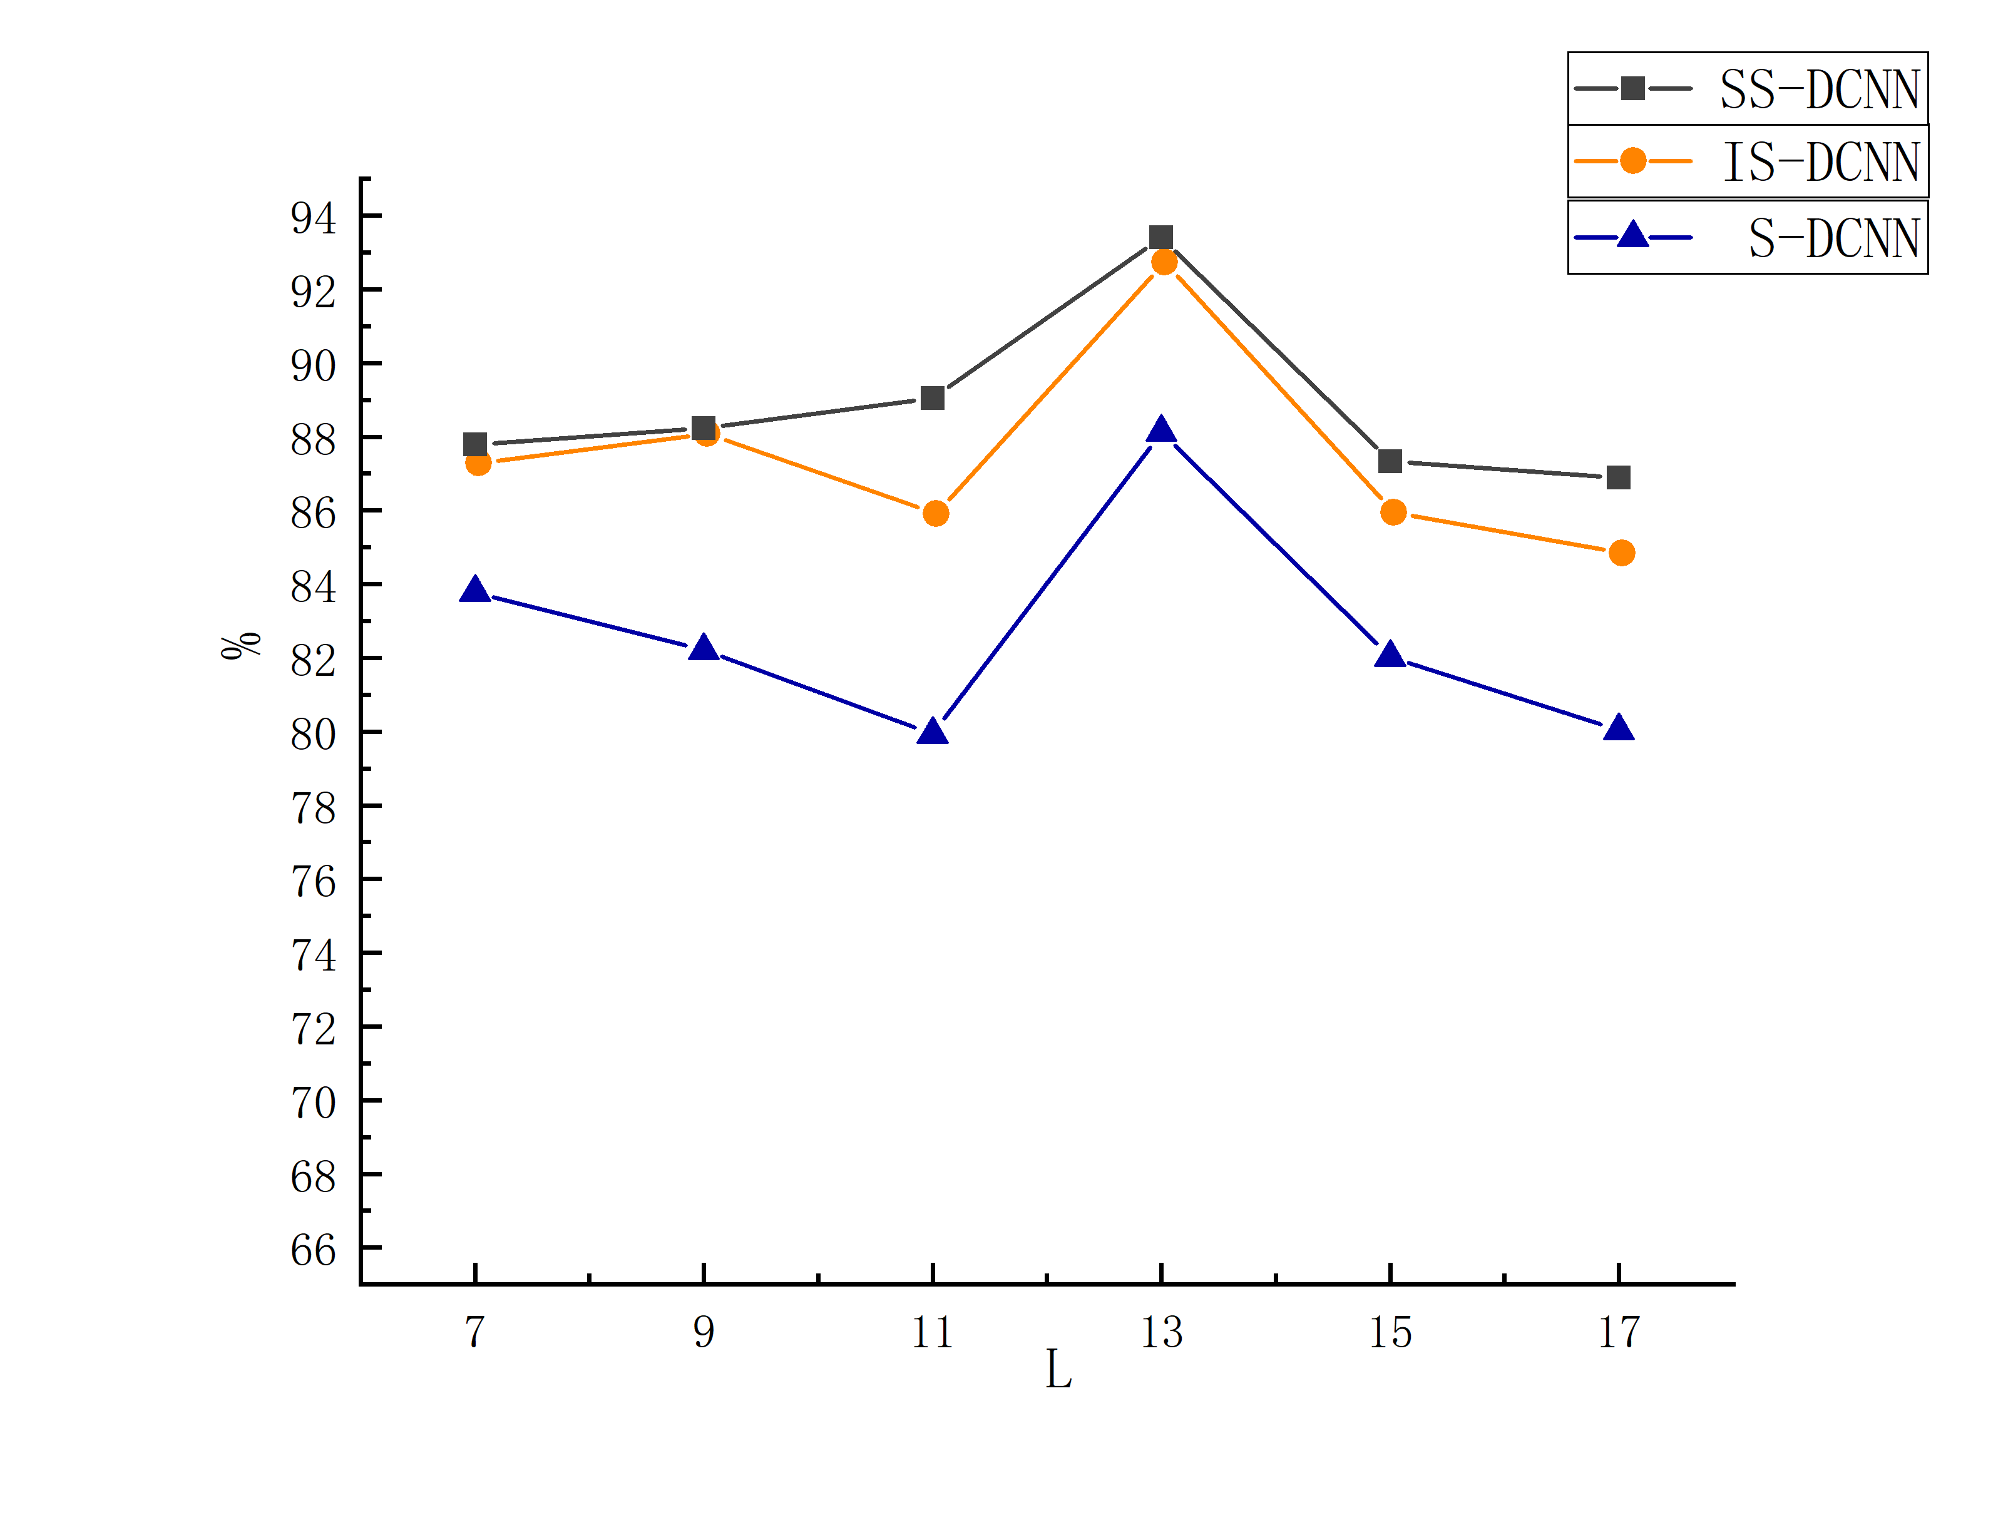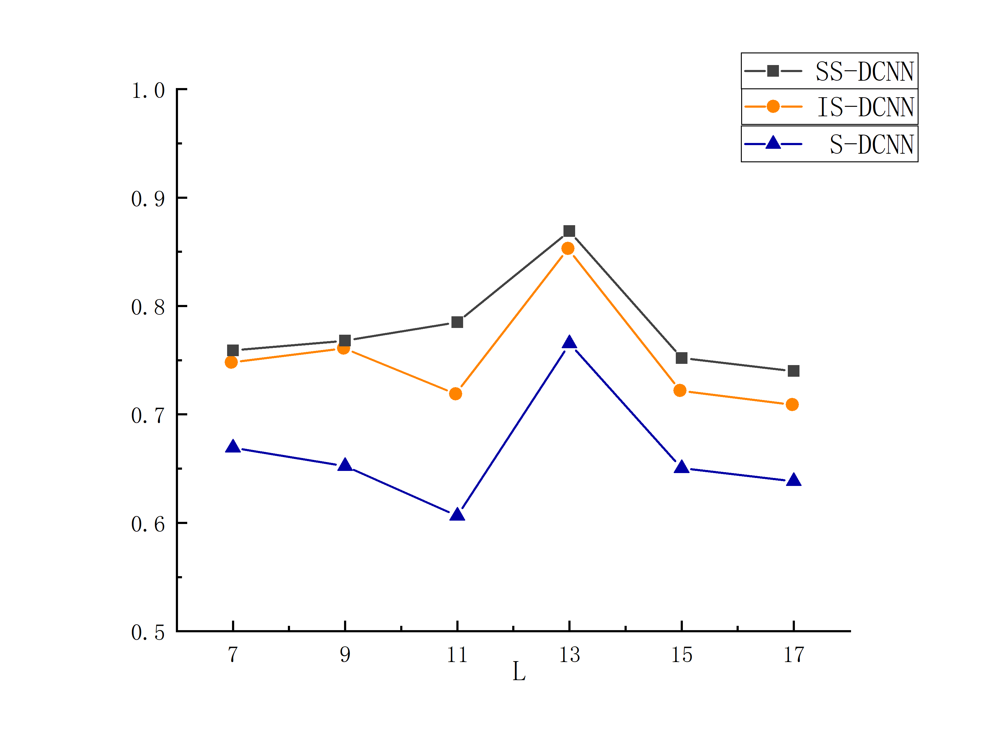

(c) Acc (d) MCC

Fig.S12 The evaluation index values of Zn2+ ligands under three different algorithms with varying window lengths

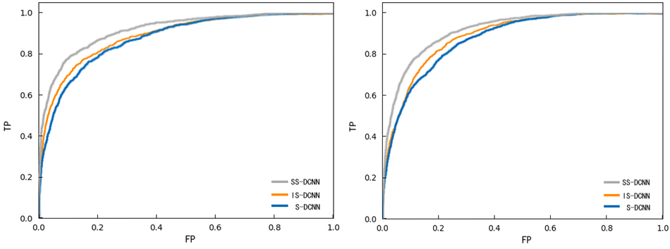

Fig.S13 ROC Curves for Four Types of

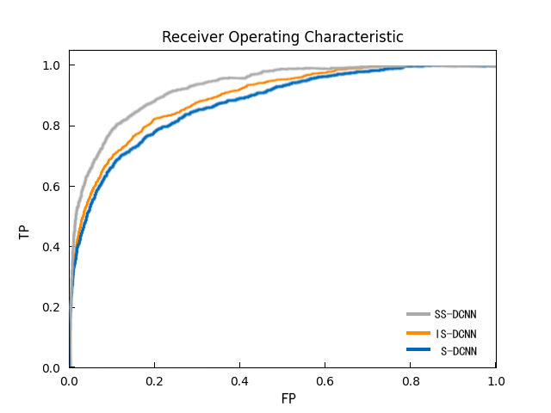

Fig.S14 ROC Curves for Four Types of

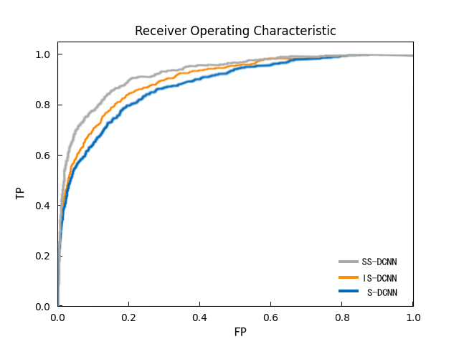

Fig.S15 ROC Curves for Four Types of