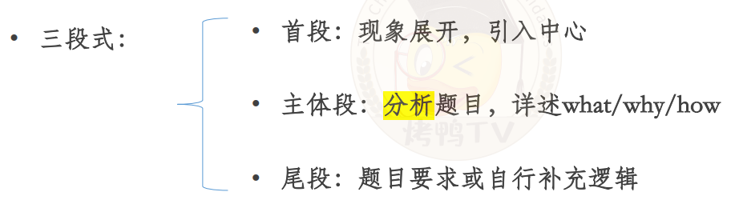

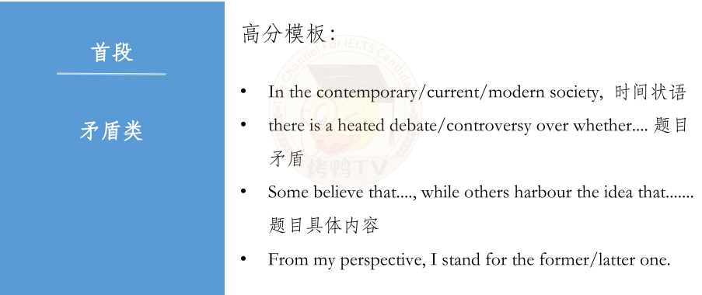

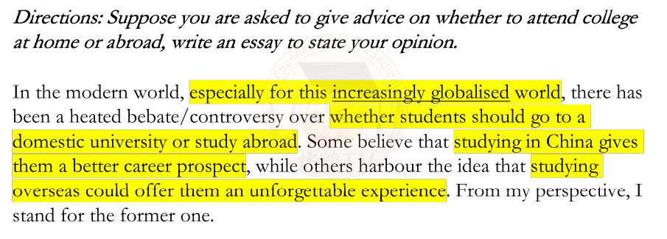

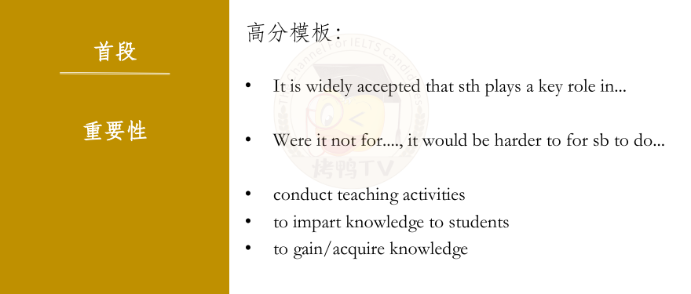

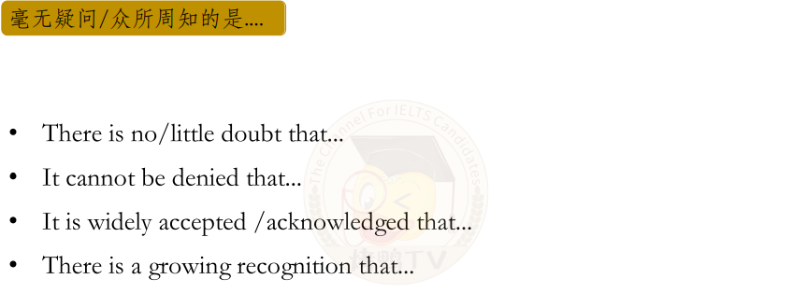

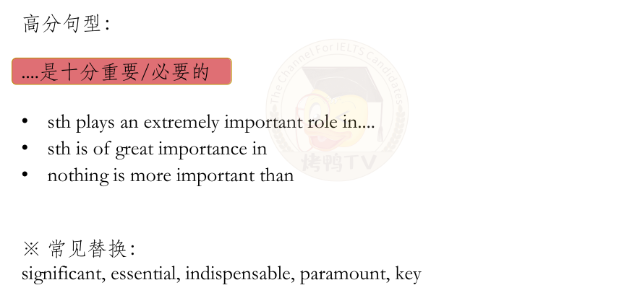

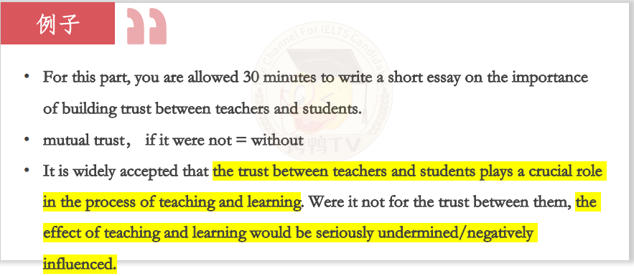

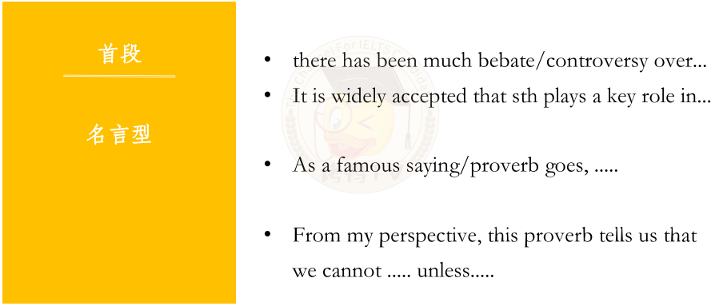

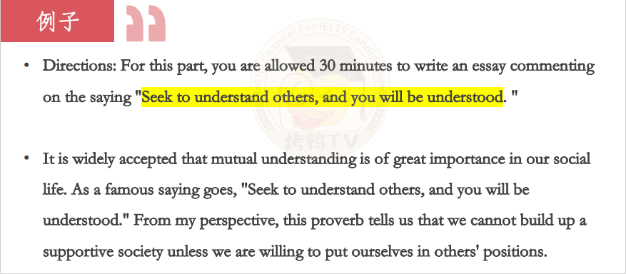

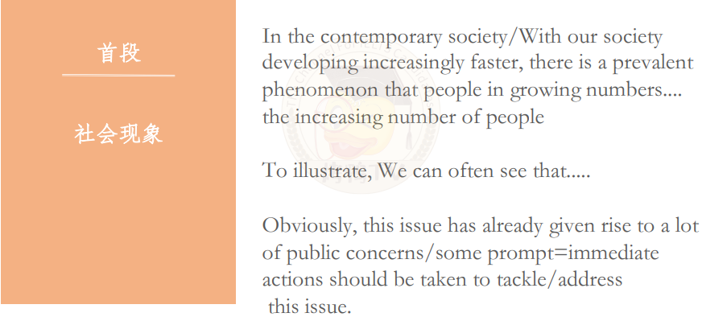

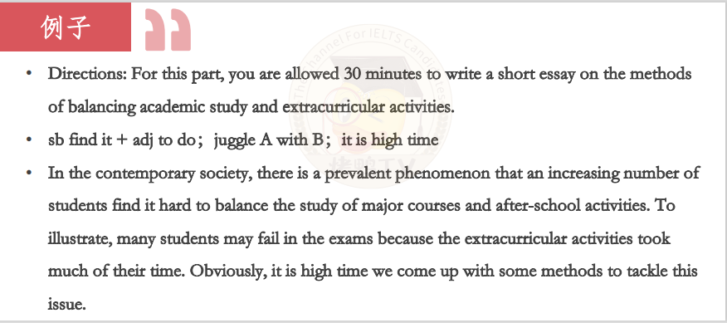

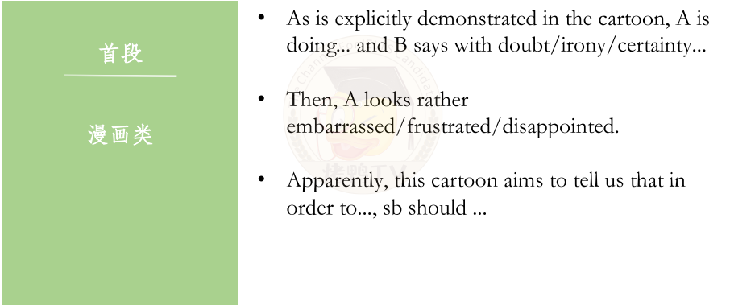

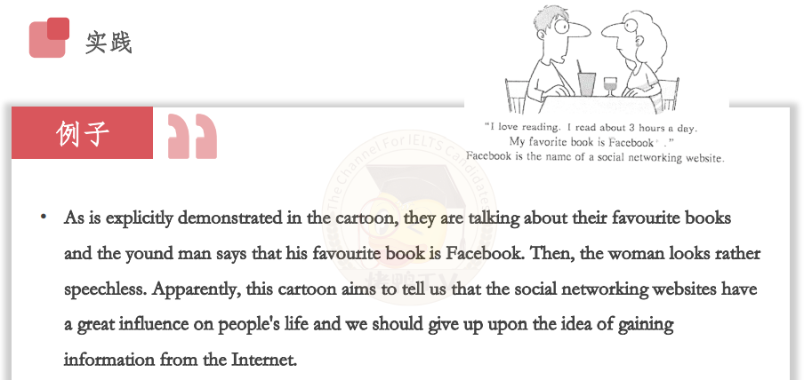

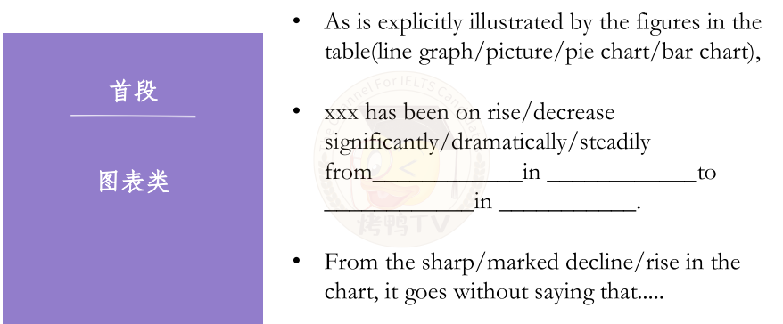

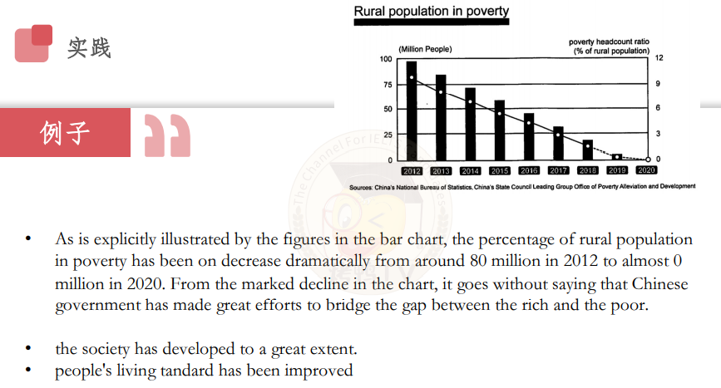

第一句 - 回答原因：

• There are a multitude of reasons accounting for ...

• The are a multitude of reasons that should be responsibile for this alarming trend.

• The reasons why I stand for xxx are as follows.

第一句 - 回答结果：

• There are some potential consequences if sth....

• The potential consequences are as follows.

第一句 - 回答方式：

• There are certainly some measures that can be taken to tackle this issue.

• Some reasonable measures can certainly be taken to help....

第二句： • Firstly/To begin with, 原因1

第三句：• 进一步原因解释/进一步推导结果/反证假设/构成对比

反证假设： If + some groups of people + can have + 题目中主题，this means ...

**未成年人**

1. 学习高效，从而取得学术成就

their efficiency in study will be improved and thus they will become academically successful. At the same time, their aspiration and persistence in study can ensure them a better career prospects, meaning that there is a high possibility for then to find a decent job and earn a high salary.

2. 求知精神，克服求知过程中的困难，同时运用到成人世界

they tend to become more motivated to explore the unknow academic areas and thus they can be cultivated the ability of overcoming difficulties independently. At the same time, this merit can be applied to their working life, which will benefit them a lot in terms of promotion and salary increase.

3. 变得受欢迎，从而变得自信，善于社交，同时运用到成人世界

they will become poplar among their peers and in schools, and thus they can gain more confidence in socializing with different people. At the same time, this merit can be applied to their working life, which will benefit them a lot in terms of promotion and salary increase.

**成年人**

1. 工作高效，从而提高生产力，获得更高的收入

their working efficiency will be improved and thus they can greatly increase the productivity. In this case, on top of helping companies keep costs down, they can bring huge economic benefits, meaning that there is a high possibility for them to be promoted.

1. 创新精神，积极克服工作中的困难，获得更高的收入

they tend to become more motivated and innovative to figure out the demanding problems in their work and thus great efforts will be made by them to overcome difficulties independently. In this case, on top of helping companies keep costs down, they can bring huge economic benefits, meaning that there is a high possibility for them to be promoted.

1. 变得受欢迎，从而变得自信，善于社交，从而获得同事的认可和好的名声

they will become poplar among their peers and in workplace, and thus they can gain more confidence in socializing with different people. At the same time, this merit can gain them a good reputation and recognition from theri colleagues.

有 + 写作主题 + 的人 将会更加积极乐观面对生活，谁不愿意跟一个充满正能量的人做朋友呢？

they will have a positive outlook on life and would always make every endeavour in life. Who would refuse to make friends with such a man with so much positive energy and enthusiasm.

1. technology

• contribute to the development of technology → technological innovations • provide talents for the country and they can contribute to country's development

1. travel

• broaden one's horizons → be more open-minded and embrace the different cultures

1. right/responsibility

• enhance the awareness of law to defend their basic right

• cultivate the sense of responsibility and learn to take up the responsibility independently → grow into a mature individua

1. education

• be equipped with the professional knowledge and practical skills → find a decent job

• narrow the disparity between the rich and the poor

1. environment

• maintain the balance of ecosystem → prevent animals from extinction

• keep the air clean → reduce the incidence of developing respiratory diseases

1. economy

• boost the national economy → people's living standard will be improved and international status will be improved

• governments can allocate more funds to scientific research so as to make technological breakthroughs

1. health

• people's will keep in a good conditions → they can ensure their working efficiency so that the society can operate smoothly.

• if people are all in good conditions, the financial burden of medical services on governments will be greatly reduced

1. culture

• cultural diversity can be enhanced → people will have a colorful life and experience exotic customs and traditions in their own country.

• cultural diversity can be enhanced → reduce the cultural misunderstanding and conflicts, which is a symbol of social progress.

1. crime

• high moral standards so that the crime rates will be controlled → the public will have a sense of security.

**措施**

1. government 政府

• launch a campaign for + 题目主题 + to arouse people's awareness of sth

• invest in sth → + 题目主题

• enact laws to force sb to do

1. individual 个人

• endeavor to form a good habit + 题目主题

• be more passionate and positive about life

1. parents and schools 家长和学校

• parents should set a good example for their children → guide their children in a rght way

• attach great importance to children's moral education and develop their practical skills.

**尾端（逻辑互补）**

万能套句：

In short,+文章主题。

It is high time that people should take full advantage of existing opportunities advocate/curb this social phenomenon.Only in this way can we live in a harmonious and liveable society with supportive atmosphere and loving citizens.

Given the factors that I have just outlined, thefundamental method in which the governmentaddresses the problem/advocates this phenomenonis to raise the public awareness of xxx by launchingcampaigns in society. In addition, the mass mediashould also join in the efforts in educating the citizens to... Only through concerted steps, can oursociety make progress in ....

To sum up, while xxx can ...., it is just like a double-edged sword if people cannot make use of it properly.We must bear in mind that we shouldavoid the undesirable effects of ..., when takingadvantage of it.Only in this way can we...