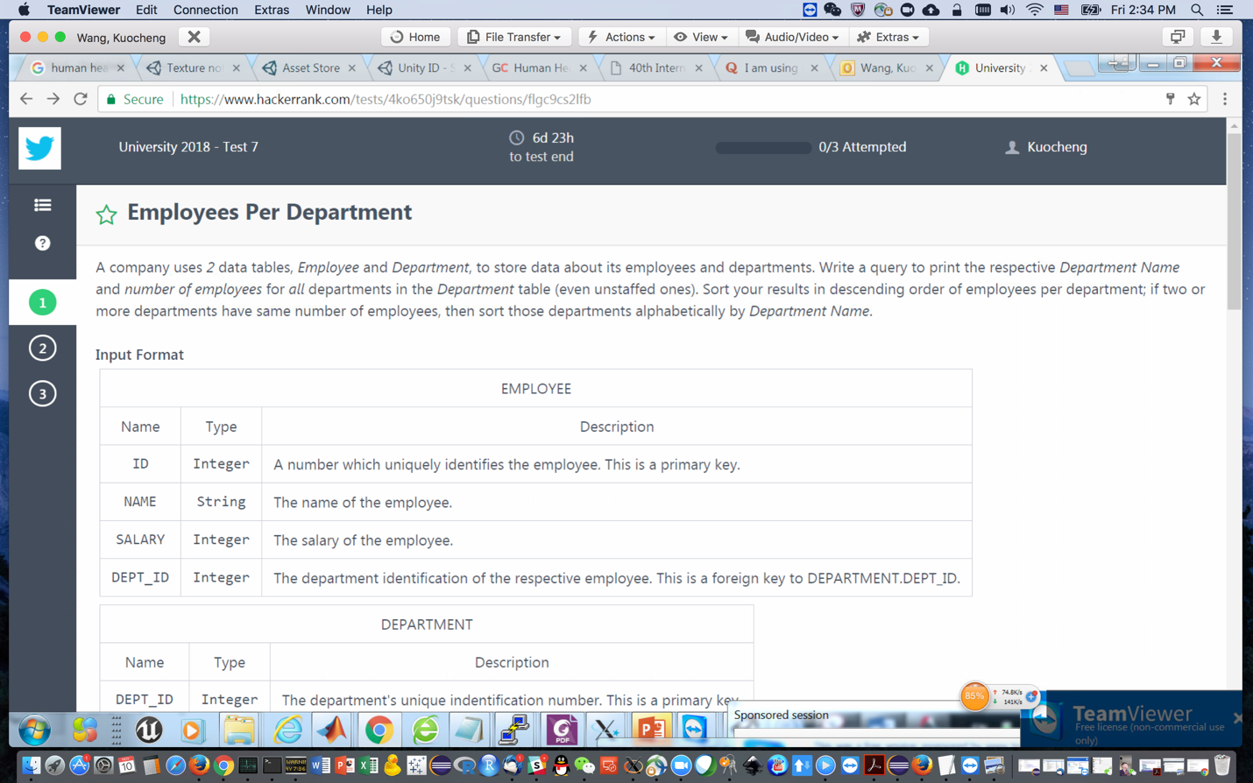

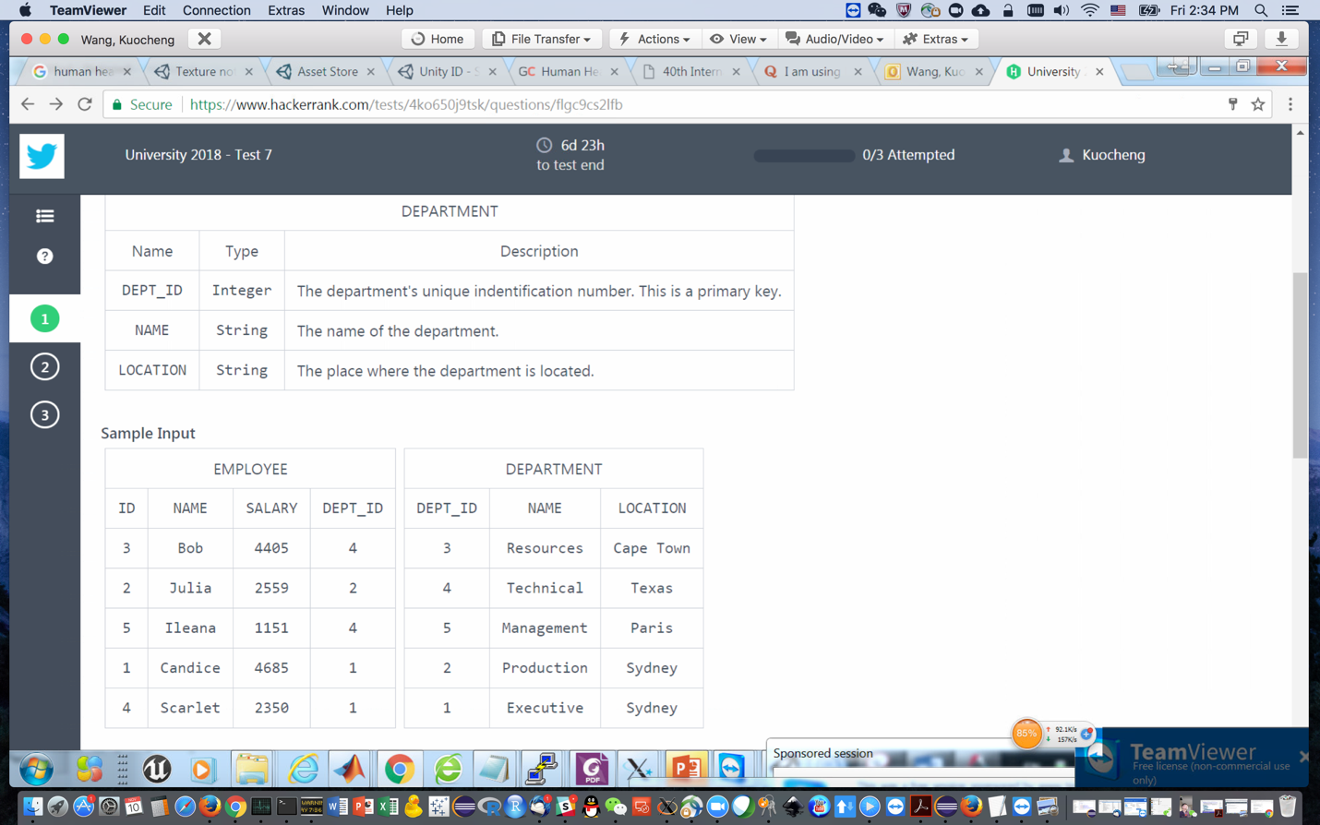

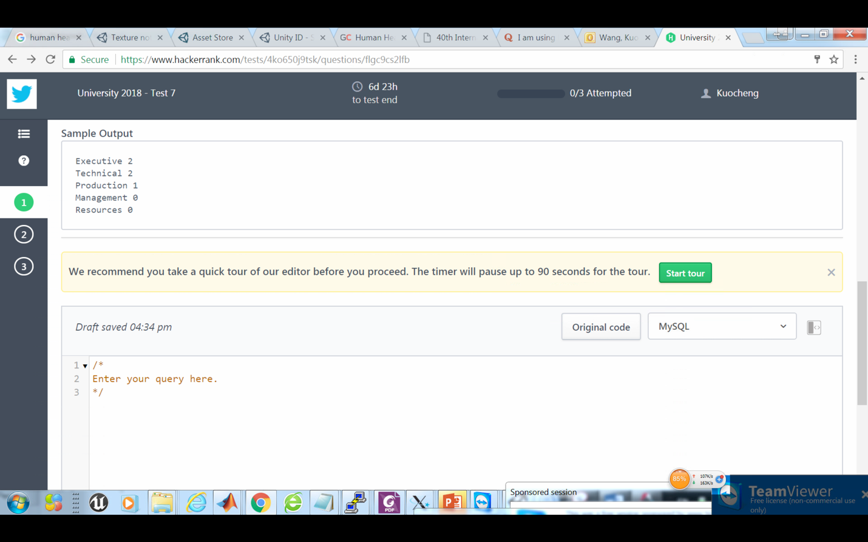

Answer:

SELECT DEPARTMENT.NAME, count(EMPLOYEE.NAME) as EMPLOYEE_COUNT FROM EMPLOYEE

GROUP BY DEPT_ID

ORDER BY EMPLOYEE_COUNT DESC, DEPARTMENT.NAME

INNER JOIN DEPARTMENT ON EMPLOYEE.DEPT_ID==DEPARTMENT.DEPT_ID