Package Delivery Problem

Question 1.

Answer:

Assumptions1: The truck has the map, knowing which node is directly adjacent and which node is not.

Assumption 2: The small truck can load unlimited number of packages.

Idea: Always load all packages in each business. Always access to the directly adjacent businesses which is the destination for packages.

Algorithm: (Use greedy algorithm + DFS)

Data Structure: On the truck, all packages are stored in a priority queue. Unload is the dequeue operation is base the destination of the packages. Load is the enqueue operation which let all packages at that business go to the queue.

Pseudo Code:

While (there is undelivered packages):

1. Each time a truck arrives a business.

2. if (has packages to unload), upload all packages which is destiny on that business.

3. if (There is packages in that location), load all packages in that business.

4. (Look for a package’s destination) and (the destination is a directly adjacent neighboring business).

5. Go to another business.

Note: if no packages destination is a directly adjacent destination, then go to a directly adjacent destination first, then do the load and unload.

The section 3.1 and section 3.2 can be shown as following graph:

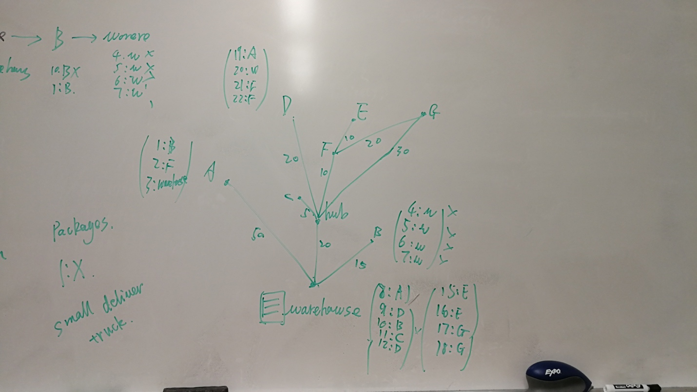

The result would be:

warehouse-> A -> warehouse -> B -> warehouse -> hub ->D ->

hub -> C -> hub -> F -> G -> F -> E -> F -> hub -> warehouse -> A -> warehouse -> B

Question 2.

Pseudo Code:

While (there is undelivered packages):

1. Each time a truck arrives a Business.

2. if (has packages to unload), upload all packages which is destiny on that station.

3. if (There is packages in that location and there is space), load all packages up to 5 in that business.

4. (Look for a package’s destination) and (the destination is a directly adjacent neighboring business).

5. Go to another business.

Question 3.

Pseudo Code:

While (there is undelivered packages):

1. Each time when truck is at the warehouse, check the disctance of the destination and fuel. If it is<= 100 miles and the truck is fully fueled, then drive to that business.

2. if (has packages to unload), upload all packages which is destiny on that station.

3. if (There is packages in that location and there is space), load all packages in that business.

4. (Look for a package’s destination) and (the destination is a directly adjacent neighboring business).

5. Go to another business.

Question 4. What information to make the decision?

Answer: a. The volume of the small truck, the volume of the large truck.

b. The cost of the deliver truck, and fuel price of deliver truck.

c. Whether small truck’s volume is far smaller than big truck’s volume.