**Results**

**Data Preparation**

**CDS II.** Factor analysis was conducted on individual subscales that make up the Causal Dimension Scale II. Five items under the “Locus of causality” dimension of the CDSII were examined via principal components analysis using varimax rotation as the primary purpose was to establish and compute composite variables for each subscale of the CDSII. All five items loaded onto one factor and were retained under a “locus of causality” composite measure (Cronbach’s α = .86). Three items under the “personal” dimension of the CDSII were examined via principal components analysis and were all found to load on one factor (Cronbach’s α = .87). Three items under the “stability” dimension of the CDSII were examined via principal components analysis using varimax rotation, and all loaded on one factor (Cronbach’s α = .73). Six items under the “external” dimension of the CDSII were examined via principal components analysis using varimax rotation. Three items (*“Over which others have control: Over which others have no control”, “Under the power of other people: not under the power of other people”, “Other people can regulate: other people cannot regulate”)* did not load on the first factor and were dropped from the composite “external” measure (Cronbach’s α = 76).

**Social Presence.** Seven items under the Spatial Presence dimension were examined via principal components analysis using varimax rotation. Two items of the Spatial dimension (“*How often when an object seemed to be headed toward you did you want to move to get out of its way?*” and “*How often did you want to or try to touch something you saw/heard?*” did not load on the first factor and were removed from the composite Spatial dimension (Cronbach’s α = .96). Seven items under the Parasocial Social Presence dimension were examined via principal components analysis using varimax rotation. Three items (“*How much did it seem as if you and the people you saw/heard were together in the same place?*”, “*How often did it feel as if someone you saw/heard in the environment was talking directly to you?*”, and “*How often did you want to or did you make eye-contact with someone you saw/heard?*”) of the Parasocial Social Presence dimension did not load on the first factor. The first and second factors for this dimension accounted for 42.82% and 15.3% of the variance of the initial eigenvalues, respectively. That said, all items of this measure had higher reliability when consolidated into one composite than when separated into separate sub-dimensions. The four items that made up the first factor had a reliability of .74, and the three items on the second factor had a particularly low reliability of .58. As such, all items of the original Parasocial Social Presence measure were included in the composite (Cronbach’s α = .77).

Four items in the Passive Interpersonal Social Presence were examined via principal components analysis using varimax rotation. All four items loaded on one factor and were retained under this dimension to form a composite measure (Cronbach’s α = .70). Five items of the Mental Immersion dimension were examined via principal components analysis using varimax rotation. All five items of the loaded on one factor and were retained (Cronbach’s α = .80). Seven items of the Social Richness dimension were examined via principal components analysis using varimax rotation. Two items (“*Impersonal:Personal*” and “*Insensitive:Sensitive*”) did not load on the first factor and were removed from the composite Social Richness measure (Cronbach’s α = .79).

**Acting Self-Efficacy.** Acting self-efficacy loaded on one factor, and was thus collapsed into a composite measure (Cronbach’s α = .96). [DESCRIPTION]

**Manipulation check**

**Negative Affect.** Manipulation checks were performed to verify manipulations were being interpreted accurately and as intended. Critical to the present study was the impact and reception of the negative feedback messages from the Virtual Instructor. As such, we tested the effectiveness of the negative feedback by determining the level of negative affect that the feedback generated. We conducted a series of paired samples t-tests to examine this emotional impact of the negative feedback message. Significant mean differences between pre- and post-test measurements of PANAS-X were observed for the negative affect items of Upset, t(114) = -5.74, p < .001, Guilty, t(114) = -2.252, p = .026, Hostile, t(114) = -4.041, p < .001, Irritable, t(114) = -2.52, p = .013, Ashamed, t(114) = -4.54, p < .001, and Nervous, t(114) = 3.495, p = .001. Here, we see clear indication that the experimental negative feedback was generally successful in communicating its meaning and intent. Significant mean differences were also observed for the positive affect items of Enthusiastic, t(114) = 2.62, p = .01, Proud, t(114) = 2.82, p = .006, but the direction of the mean differences indicate a decrease in enthusiasm and pride, providing further support for that the “negativity” of the feedback was accurately perceived.

**Experiment Authenticity.** Another significant factor in the present study was the degree to which participants truly believed that the negative feedback they were receiving was tailored and specific to each person. Although efforts were made to make the virtual environment and authentic, some participants could pick up on the actual non-intelligent nature of the virtual environment. That is, although participants were (falsely) told that the virtual instructor would be tailoring their feedback to the participants’ performance, not all participants deemed the virtual environment to be authentic. As such, a manipulation check was delivered to the participants in the form of two items on a 7-point Likert scale (anchors *extremely inauthentic* and *extremely authentic*): “*To what extent did you feel that the instructor's feedback was authentic/real?*” and “*To what extent did you feel that the virtual environment was authentic/real?*”

Both items were normally distributed and no outliers were identified, enabling all participants to be included for analysis. Participants generally were mixed in their judgments of the authenticity of the instructor feedback (M= 3.92, SD = 1.7) and generally felt the virtual environment was more authentic than inauthentic (M = 4.43, SD= 1.5). Further, the medians for each of the two items were 5, which corresponds to “Slightly authentic” on the 7-point Likert scale.

A dichotomous Feedback Authenticity variable was constructed by splitting the responses at the median and examined in a 2-way MANOVA with the original independent variables of Proxemic Distance and Virtual Instructor Gender. A main effect of Feedback Authenticity was observed on multiple Ad-hoc items, including task difficulty, F(6,89) = 6.624, p = .012, feedback helpfulness, F(6, 89) = 15.99, p < .001, feedback accuracy, F(6, 89) = 22.126, p < .001, affected by professor’s reactions, F(6, 89) = 4.57, p = .036, feedback attributed to own underperformance, F(6, 89) = 12.433, p < .001, and feedback attributed to professor having a bad day, F(6, 89) = 4.83, p = .031.

Table  
*MANOVA of Feedback Authenticity on Ad-hoc items*

|  |  |  |  |  |  |
| --- | --- | --- | --- | --- | --- |
| Independent Variable(s) | Dependent Variable | *Df* | Mean Square | *F* | Sig. |
| Feedback Authenticity | How easy or difficult was the task? | 1 | 6.542 | 6.624 | .012 |
| How helpful was the feedback you received? | 1 | 9.836 | 15.999 | .000 |
| How accurate was the feedback on your performance? | 1 | 13.464 | 22.126 | .000 |
| To what extent were you affected by the professor’s evaluation of your performance? | 1 | 3.758 | 4.565 | .036 |
| Do you think the professor's reactions were due to your underperformance? | 1 | 25.367 | 12.433 | .001 |
| Do you think the professor's reactions were due to him/her having a bad day? | 1 | 9.770 | 4.843 | .031 |
| Proxemic Distance * Feedback Authenticity | How easy or difficult was the task? | 1 | 4.069 | 4.120 | .046 |
| Proxemic Distance * Feedback Authenticity * Virtual Instructor Gender | How helpful was the feedback you received? | 1 | 3.504 | 5.700 | .019 |
| To what extent were you affected by the professor’s evaluation of your performance? | 1 | 8.333 | 10.124 | .002 |

A univariate interaction effect was observed between Feedback Authenticity and Proxemic Distance on ratings of task difficulty, F(6,89) = 4.120, p = .046. That is, participants in the Far condition who deemed the feedback to be low in authenticity reported low difficulty, whereas participants in the Far condition who deemed the feedback to be high in authenticity reported high difficulty. This was in contrast with the Close condition participants, who regardless of judgments of Feedback Authenticity, did not vary significantly in reported difficulty of the task. This result makes intuitive sense, because those who are not convinced in the authenticity of the “automated” feedback clearly are not as concerned about the difficulty of the task as those who have fully “bought in” to the task. *#Further, we do expect higher ratings of difficulty in the Far condition than in the Close condition. #Why?*

Figure

*Interaction effect between Proxemic Distance and Feedback Authenticity on task difficulty*

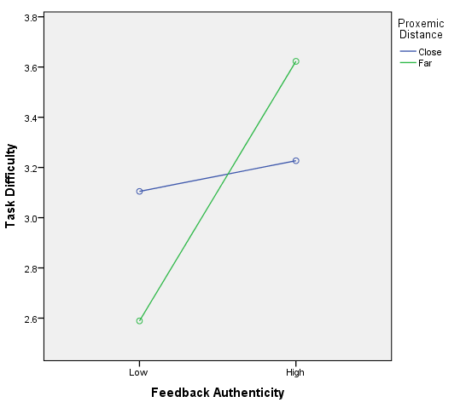

**Statistical Analysis**

**CDSII**. A 2-way MANOVA was conducted examining the effects of Proxemic Distance with the Gender of the Virtual instructor on the factor analyzed composite CDS II Dimensions of Locus of Causality, Personal Control, Stability, and External Control. A multivariate main effect of Proxemic Distance on the CDS Dimensions was observed, F(4, 117) = 7.15, p < .001. No other main effects or interaction effects were found. Univariate main effects of Proxemic Distance were observed for Stability, F(3, 117) = 20.69, p < .001, Personal Control, f(3, 117) = 4.88, p = .029, and External Control, F(3, 117) = 7.91, p = .006. No other main effects or interaction effects were observed. As each independent variable was limited to 2 levels, post-hoc tests were not conducted.

Regardless of Virtual Instructor Gender, those who interacted with a Close instructor reported significantly higher levels of External Control. In other words, the participants in the Close conditions tended to report that people outside of themselves (the professor) had a more impactful role in their performance. Further, those who interacted with a Close instructor reported significantly lower levels of personal control, or one’s own ability to regulate and manage one’s performance, as well as significantly higher levels of stability, deeming the current situation of negative feedback to be more permanent, stable, and unchangeable.

Table

*Main effect for Proxemic Distance on CDS Stability, Personal Control, and External Control*

|  |  |  |  |  |  |
| --- | --- | --- | --- | --- | --- |
| Dependent Variable | Type III Sum of Squares | *df* | Mean Square | *F* | Sig. |
| CDS Stability | 61.322 | 1 | 61.322 | 20.686 | .000 |
| CDS Causality | 1.127 | 1 | 1.127 | .382 | .538 |
| CDS Personal | 20.418 | 1 | 20.418 | 4.879 | .029 |
| CDS External | 25.829 | 1 | 25.829 | 7.910 | .006 |

***Virtual Instructor Gender.***

Interestingly, the above results indicate a lack of any effect of either Proxemic Distance or Virtual Instructor Gender on the Locus of Causality dimension of the CDSII, which is a measure of internal vs. external attribution. This contrasts with previous findings of a tendency to internally attribute when interacting with a Female Virtual Instructor (Feng et al., 2017). In order to more closely examine this lack of an effect, independent sample t-tests were carried out as an ad-hoc analysis. While participants who received negative feedback from Female Virtual Instructors did report lower levels of Locus of Causality (M= 4.63, SD = 1.75) than those who received negative feedback from Male Virtual Instructors (M = 4.81, SD = 1.67), this difference was not significant, (t(115) = .603, p = .548; F(3, 115) = .108, p = .743). As such, this study was unable to replicate the previous finding that negative feedback from Female Virtual Instructors led to significantly greater internal (self) attribution.

**PANAS-X.** A 2-way MANOVA conducted to examine the effects of Proxemic Distance and Gender of the Virtual Instructor on individual post-test measurements of PANAS-X yielded no significant effects. That is, there were no marked differences in the emotional responses of different groups of participants to the negative feedback. There was a small, yet nonsignificant main effect of Proxemic Distance on “Guilty”, F(3, 117) = 3.37, p = .069, meaning Close distance elicited slightly more guilt than Far distance. The only reportable effect in this model was an interaction effect between Proxemic Distance and Virtual Instructor Gender for Strong, F(3, 117) = 8.414, p = .004. See Figure X. Interestingly, the male virtual instructor had the effect of raising ratings of “Strong” at a Close distance, whereas the female virtual instructor had the inverse effect of raising ratings of “Strong” at a Far distance. A rather loose interpretation of this result is that participants felt less empowered and more marginalized by a female instructor delivering negative feedback at a close distance.

Figure X

*Interaction effect of Proxemic Distance and Virtual Instructor Gender on PANAS-X: “Strong”*

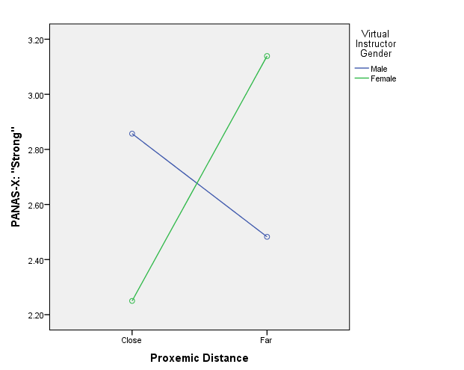

***Ad-hoc analyses.*** In order to provide further insight into the role of emotion in the present study an ad-hoc analysis was conducted few ad-hoc analyses was conducted. Participant Gender was added to the above MANOVA model to examine the 3-way effects of Proxemic Distance, Gender of the Virtual Instructor, and Participant Gender on the individual post-test measurements of PANAS-X. As each independent variable was limited to 2 levels, post-hoc tests were not conducted. Univariate main effects of Participant Gender were found on Interested, F(3, 117) = 4.52, p = .036, Excited, F(3,117) = 7.46, p = .007, Enthusiastic, F(3, 117) = 4.135, p = .044, Inspired, F(3, 117) = 8.39, p = .005, Determined, F(3, 117) = 8.68, p = .004, and Active, F(3,17) = 13.96, p < .001. That is, male participants in general reported being more interested, excited, enthusiastic, determined, and active than female participants after receiving the negative feedback. *This indicates a presence of a gender-based pattern in which male participants seemingly “bounce-back” in reaction to harsh negative feedback.*

Further, an interaction effect between Proxemic Distance and Participant Gender was observed for Irritable, F(3, 117) = 5.57, p = .02. As can be seen in Figure X, male participants were far more irritated by the instructor at a Far distance than were female participants.

Figure X

*Interaction effect of Proxemic Distance and Participant Gender on PANAS-X: “Irritable”*

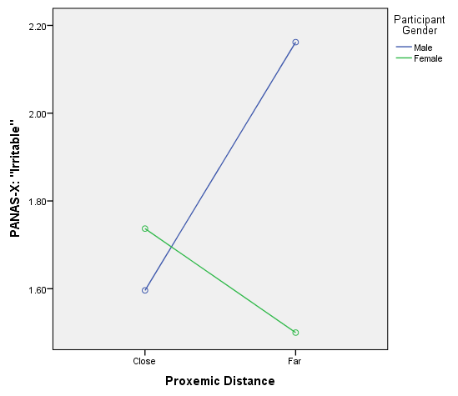

**Ad-Hoc Analyses**

**Participant Gender.** We examined the impact and role of participant gender in the above analyses.

**Ad-Hoc Items.** A 3-way MANOVA was conducted examining the effects of Proxemic Distance, Virtual Instructor Gender, and Participant Gender on the individual Ad-hoc items. As the Ad-hoc items did not constitute a composite measurement scale, each item was examined at the univariate level. Univariate main effects of Proxemic Distance were observed for the helpfulness of the feedback, F(3, 117) = 7.69, p = .007, the likability of the professor, F(3, 117) = 23.74, p < .001, and the level of effort put into the task, F(3, 117) = 27.46, p < .001. That is, participants in the Close condition perceived the feedback to be less helpful, the professor to be less likable, and tried harder to complete the task than participants in the Far condition did. Further, participants in the Close condition attributed the professor’s reactions to his/her personality more so than those in the Far conditions, F(3.117) = 28.23, p < .001.

Table

*Main effect for Proxemic Distance on Ad-hoc items*

|  |  |  |  |  |
| --- | --- | --- | --- | --- |
| Dependent Variable | *df* | Mean Square | *F* | Sig. |
| Helpfulness of feedback | 1 | 9.078 | 7.687 | .007 |
| Accuracy of feedback | 1 | 2.676 | 2.928 | .090 |
| Attribute to professor’s personality | 1 | 88.264 | 28.226 | .000 |
| Attribute to professor having a bad day | 1 | 5.398 | 2.424 | .122 |
| Level of Effort | 1 | 23.509 | 27.460 | .000 |
| Likability of professor | 1 | 39.971 | 23.738 | .000 |

An interaction effect of Participant Gender and Proxemic Distance was observed for the level of effort placed on the acting task, F(3, 117) = 5.304, p = .023. That is, male participants in the Close condition tried much harder on the task than the males in the Far condition. The difference in effort between Close and Far conditions was not as pronounced for the female participants.

See figure below. *Interpretation: the close distance seems to play the role of raising the degree of accountability in the task – particularly for male participants, who demonstrate a sizable drop off in effort when interacting with a far virtual instructor.*

Figure

*Interaction effect of Participant Gender and Proxemic Distance on effort put into the task*

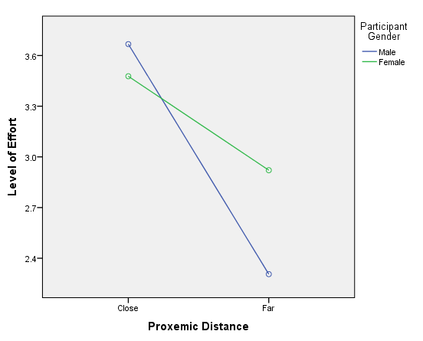

Table

*Correlation matrix of Proximal Distance (Close =1, Far = 2) with Ad-hoc items (n = 117)*

|  |  |  |
| --- | --- | --- |
|  | Pearson *r* | *p* |
| Was the feedback you got on your performance helpful? | .256** | .005 |
| How accurate was the feedback on your performance? | .157 | .092 |
| How likable was the virtual professor? | .415** | .000 |
| To what extent were you trying hard to perform the task? | -.441** | .000 |
| Do you think the professor's reactions were due to his/her personal... | -.448** | .000 |

**Self-Efficacy.** *#Mediating role of self efficacy?*

**Presence.** A 3-way MANOVA was conducted examining the effects of Proxemic Distance, Virtual Instructor Gender, and Participant Gender on the individual dimensions of Social Presence. A multivariate main effect for Proxemic Distance was observed for Social Presence, F(5, 75) = 2.762, p = .024. Further, a multivariate interaction effect of Virtual Instructor Gender and Participant Gender was observed for Social Presence, F(5,75) = 2.455, p = .041.

As can be seen in Table X, univariate main effects for Proxemic Distance were observed for the factor analyzed dimensions of Spatial Presence, F(1, 87) = 7.265, p = .009, Passive Interpersonal Social Presence, F(1, 87) = 8.072, p = .006, and Mental Immersion, F(1, 87) = 5.503, p = .021.

A univariate interaction effect was observed for the Virtual Instructor Gender and participant Gender on the Passive Interpersonal Social Presence dimension, F(1, 87) = 5.603, p = .02. As can be seen in Figure X, participants reported experience greater Passive Interpersonal Social Presence when interacting with an instructor of the opposite gender. To be clear, the items of this dimension asked participants about the degree to which they could observe the facial expressions, observe the changes in tone of voice, observe the style of dress, observe the body language of the virtual instructor.

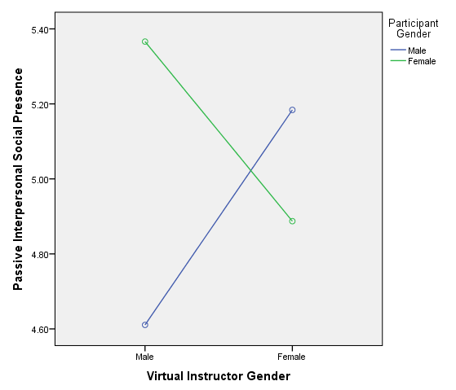

Table

*Main effects for Proxemic Distance on Social Presence dimensions*

|  |  |  |  |  |
| --- | --- | --- | --- | --- |
| Dependent Variable | df | Mean Square | F | Sig. |
| **Spatial Presence** | **1** | **9.989** | **7.265** | **.009** |
| Parasocial Social Presence | 1 | 1.510 | 1.772 | .187 |
| **Passive Interpersonal Social Presence** | **1** | **7.785** | **8.072** | **.006** |
| **Mental Immersion** | **1** | **4.564** | **5.503** | **.021** |
| Social Richness | 1 | .340 | .570 | 453 |

**Discussion**

**Summary of Findings**

**Attribution.**  The most compelling finding in this study must be the transformative effects of Proxemic Distance. Manipulating a controlled negative feedback message according to Far or Close distance had the effect of categorically transforming the social perception of the message.

Specifically, delivering a series of negative feedback messages from a close distance had the effect of lowering one’s sense of personal control and ability to change the present situation while simultaneously raising a sense of the critic’s (the Virtual Instructor) control.

This finding has tremendous implications for learning and pedagogy, suggesting that a unique pattern of attribution exists in response to criticism and negative feedback delivered at different proxemics distances. Quite simply, negative feedback delivered at a proximal distance appears to have the effect of stripping the student of a sense of control and agency, thus debilitating the student from making the necessary adjustments needed to address the purported root of the negative feedback.

Notably, the present study was unable to replicate findings from a previous study (Feng et al., 2017) that receiving negative feedback from female virtual instructors led to greater internal (self) attribution than negative feedback from male virtual instructors. Although these patterns of gendered differences in attributional tendency were not found, gendered differences were observed in the affective responses of the participants to the negative feedback in this study.

**Affect.** The most compelling affect-based findings in the present study were the male participants’ distinct tendency as students to “bounce-back” in response to the negative feedback from the virtual instructor, reporting significantly higher levels of interest, excitement, enthusiasm, determined, and activity. As observed in the initial manipulation check of the negative feedback, the harshly critical nature of the negative feedback had the effect of reducing various positive affect items and raising various negative feedback items from pre to post. That said, male participants exhibited a curiously unexpected pattern of asserting what must be categorized as a defiant resilience, and a refusal to be negatively impacted by the criticisms. This pattern of behavior must be explained by the tendency of negative feedback to enforce a sense of accountability, thereby generating the attention and motivation needed to complete the task successfully. This suggests male participants may require a straightforward, even harsh negative feedback in a learning situation as opposed to a teaching strategy that simply complimenting and reinforcing the student.

An additional interaction effect was observed across Proxemic Distance and Participant gender on ratings of “Irritable”. Specifically, male participants seemed to report feeling far more irritated by instructors providing negative feedback at a far distance than close distances, whereas the inverse effect was seen among female participants. The male effect may be attributable to the cognitive dissonance experienced with an extremely critical message coupled with a perception of a less engaged body language (far distance). This irritation experienced by male participants is likely associated with the tendency for male participants to try harder on the task in the close conditions. This effect is discussed further in the following section.

**Ad-hoc items.** The results of the ad-hoc items demonstrated that the interpersonal distance of the professor had clear impact on perceptions of the likability of the professor, the helpfulness of the feedback, as well as the subsequent effort put into the task. Although participants in the close conditions perceived the instructor to be less likable and the feedback to be less helpful, they did report trying harder in the task than did participants in the far condition. The degree of effort put in by the participants is made even more interesting based on the interaction effect between Participant Gender and Proxemic distance that revealed that the male participants were far more likely than female participants to try harder when interacting with a close professor, than when interacting with a far professor – where a steep drop off in effort could be observed. This pattern of behavior somewhat corroborates the above tendency for the male participants to be being more interested, excited, enthusiastic, determined, and active in response to the instructor’s negative feedback.

**Social Presence.** Proxemic Distance also revealed a clear effect when it came todegree of presence felt by participants across distance conditions. Specifically, participants in the close conditions reported feeling significantly greater feelings of physical transportation into the virtual environment, ability to observe subtle cues such as body language, and a sense of immersion and engagement.

**Implications and Limitations**

The present study has major implications for educational technology, the design of virtual agents, and for presence researchers.

**Teaching Style.** Design of the negative feedback was scripted following the model of cinematic arts courses that invoke a great deal of repetition and straight-forward feedback. In post experiment interviews, many subjects reported feeling that the degree of repetition had an annoying effect. In other words, the participants felt that the repetition was not helpful from a pedagogical standpoint of learning “why” and “how” to improve. The experiment of course, was designed to deny success.

**Suspending Disbelief**. By the end of the experiment, most participants had some inkling of the non-intelligent design of the experiment stimuli. That is, whether due to limitations in the design of the messages or the design of the environment, most came to a gradual realization that the feedback could not be entirely legitimate or authentic. What some participants reported in post-experimental interviews, however, was they could not suppress their emotions regardless of this realization. Indeed, the various effects observed in this study highlight the participants’ inabilities to suspend disbelief over the medium – a significant issue in the presence research. Although presence measures were originally included in this experiment to test for the immersiveness of the virtual environment, an overlooked aspect of the experiment was the presence-based effects of the feedback messages themselves. In other words, the negative feedback in this experiment was designed under the assumption that they would be received at face value. The general sharpness and quick eye of participants to pick up on the inauthentic and non-tailored nature of the feedback in effect revealed an interesting finding about the permanence of negative feedback and negative affect: That is, even in the face of denial and rejection of the legitimacy of the negative feedback, participants ultimately reacted in the expected patterns of causality and emotion associated with authentic negative feedback.

**Distance and Authenticity.** One interesting absent effect was the lack of any distinguishable pattern among the independent variables of distance, participant gender, and instructor gender in dictating the perception of feedback and/or environment authenticity. That is, there were no significant differences in perception of feedback or environment authenticity for any of the independent variables. The lack of a significant difference between close and far conditions was rather surprising as one would intuitively anticipate that the close distance would elicit a more realistic perception of the interaction and in turn, the feedback. What is even more surprising however, was when simply comparing the means of close and far distance in terms of ratings of feedback authenticity/realism, participants in the far condition (M = 4.23, SD = 1.75) rated to the feedback to be greater in authenticity than participants in the close condition (M = 3.71, SD = 1.66). Although the difference is nonsignificant, the perception of greater realism of the far instructor conditions may have two possible explanations.

First, the farther virtual instructor is displayed completely in terms of physical orientation, movements, and gestures whereas the closer virtual instructor requires intentional movement of the head-mounted display to observe different parts of the instructor’s physical orientation and gestures. The full representation of the body and all its inference-generating affordances may have provided participants with a greater sense that the instructor’s feedback was authentic.

Second, the farther virtual instructors may be representing a step prior to reaching the uncanny valley, while the close virtual instructors – with their more closely depicted graphical features—may be representing the uncanny valley itself. When the virtual characters are farther away, some participants noted that they could not make out the facial expressions of the characters. Others noted that the farther characters could not necessarily be definitively identified as virtual characters, suggesting a possibility that the characters may represent an actual human displayed in the virtual environment. [FIGURE of Far character here] In other words, the far distance may have had the unintended effect of eliciting perceptions of greater realism simply by virtue of their lack of realism. As a result of this relative lack of realism in the far conditions, participants would have also had to “fill in” the facial expressions of characters and fixate more-so on the speech and gesture of the character. Essentially, any confounding effect of the uncanny valley of the close distance characters on the perception of the negative feedback message (“This is obviously just a virtual character, so the feedback is probably not real”) would have been nullified by the far distance.