远程服务demo的创建:

-----------------------------------------------------------------------------------------------------------------------------

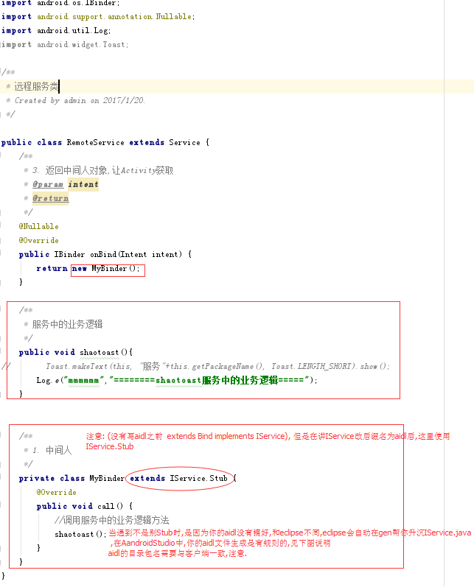

----------------------------------------------------------------------------------------------------------------------------

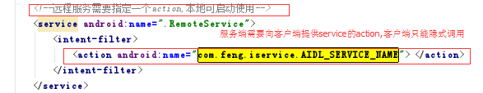----------------------------------------------------------------------------------------------------------------------------

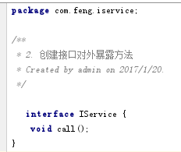生成的aidl文件,不能带public等修饰词

----------------------------------------------------------------------------------------------------------------------------

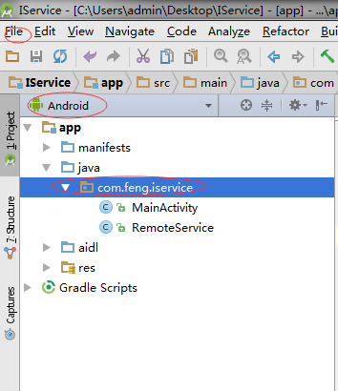

----------------------------------------------------------------------------------------------------------------------------

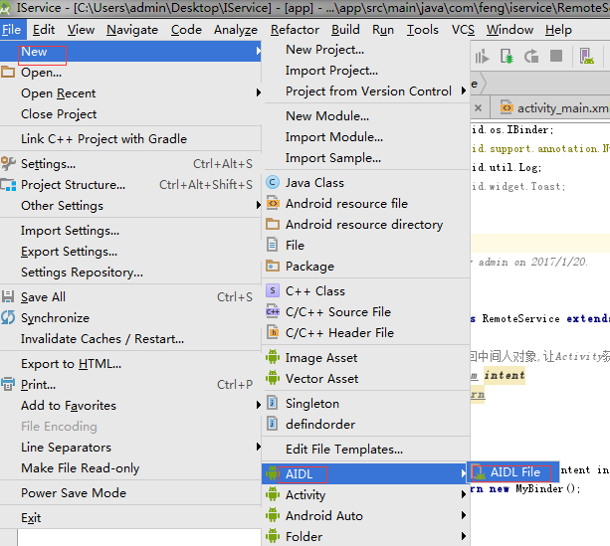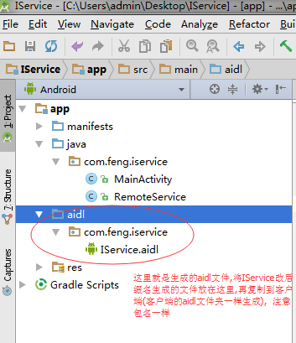

客户端demo实现:

1. 首先aidl文件夹生成方式一样,将服务端的aidl文件复制过来就可以
2. 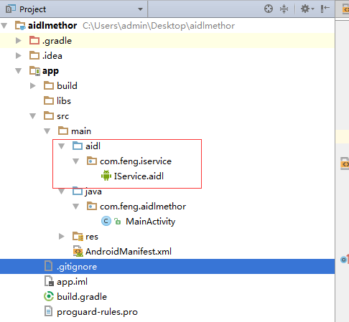

客户端是能隐式调用服务端的服务,利用服务端提供的action

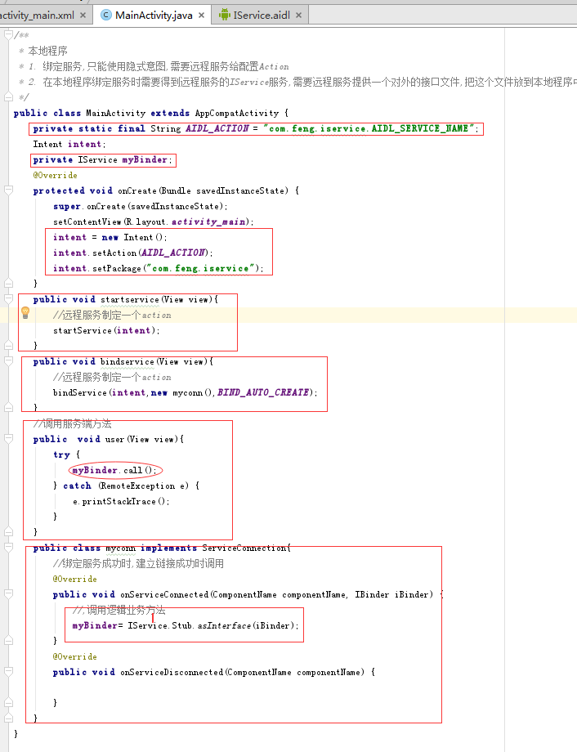

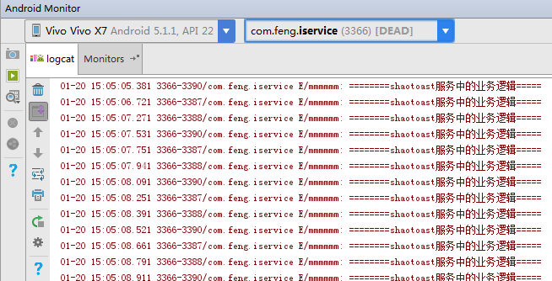

查看log,调用服务端的逻辑业务成功!!!!!!!!!!!!!!!!!!!!!!!!!!!!