Engineering — Modeling
The modelling team built five models for this project. Each one existed to change a decision, and this page records, for each, what we designed, what we built, how we put it at risk, and what the answer changed.
Two of the five went through a full second iteration: the first version returned an answer that looked perfectly reasonable, and testing it revealed that the model had been asked the wrong question rather than asked it badly.

Cycle 1 — The AND gate: from assumption to prediction

Design
Our circuit is an AND gate: hypoxia drives LuxI from pPepT to make AHL, lactate drives LuxR from the native lldPRD promoter, and only the LuxR–AHL complex opens pLux. The whole safety analysis wants to treat that gate as a product of its two arms, because then every tissue site scores as a product of two independent numbers instead of a surface that would have to be measured everywhere.
The honest form of the question is not is it multiplicative? but could we find out that it is not?

Build
A factorised gate, plus a leave-one-corner-out protocol. Working in log-odds $z$, multiplicativity is the statement that the two-way interaction vanishes:
$$Δz_{AB}−Δz_{A}−Δz_{B} = 0 (2.2\text{-}4)$$
The four reporter corners — 21 % / 1 % O₂ × ± 20 mM lactate — are exactly the 2 × 2 this is defined on, so Eq. (2.2-4) rearranges into a prediction: hold out any one corner and the other three determine it.
$$z_{D} = z_{B}+z_{C}−z_{A}$$
Both decision criteria — a ratio bound and a standard-error bound — were declared before the protocol was run, so a pass could not be chosen afterwards.

Test
Each corner was held out in turn and predicted from the other three (Fig. 1). At the 24 h endpoint all four passed, and the fully-on corner — the state the circuit is designed to reach, and so the one that matters — came out within 0.05 percentage points of its measured value.
We then ran the identical protocol at the mid-course sampling points, expecting it to fail. It did. At 9 h not one of the four corners passed, the worst missing by 4.447×. At 6 h none passed the ratio bound either, the worst at 1.600×, although all four stayed inside the standard-error bound — which is why both criteria were declared in advance, and why neither on its own would have been enough.
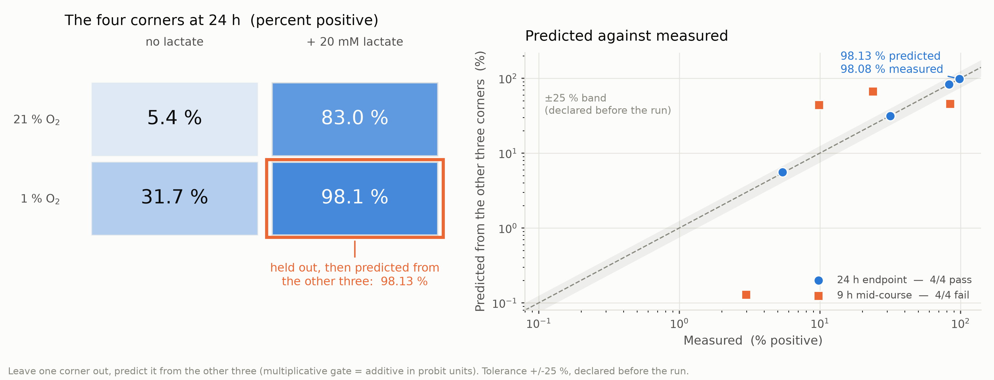 Figure 1. Leave-one-corner-out test of the AND gate at 24 h and at 9 h. Left: the four reporter corners at 24 h, 21 % or 1 % O₂ against 0 or 20 mM lactate, each cell labelled with its percentage of GFP-positive cells and shaded by that value; the outlined cell is the corner held out, and the annotation below it gives the value predicted from the other three. Right: predicted against measured for every held-out corner, both axes logarithmic, with the dashed identity line and the grey ±25 % band declared before the run. Circles are the 24 h endpoint and squares the 9 h mid-course; the legend gives the pass count for each. Percentages are replicate means taken in probit units and mapped back.

Learn
The AND claim is now an out-of-sample result, not an internal check. The corner the model had never seen was predicted to 0.05 percentage points. That licenses the rest of this page to factorise the gate.
The failure is the more valuable half. A protocol that passes everything has no discriminating power and proves nothing. Ours rejects: at 9 h it misses by up to 4.4×, using the same equations and the same data. That is why the 24 h pass means something.
So the validity domain is explicit, and narrower than we assumed. Factorisation holds at the endpoint only, and we wrote a standing prohibition against extrapolating mid-course ON/OFF ratios into any site score. One licence and one restriction, from one experiment.

Next iteration
This is internal cross-validation — there is one dataset, so it cannot be external validation and we do not call it that. The next version needs a second dataset; the cheapest candidate is the lactate gradient in Cycle 5.

Cycle 2 — The tissue-site model: the site list was the bug

Design (v1)
Cycle 1 established that the gate factorises, so each site can be scored as a product of arms. The question this model exists to answer: at which non-tumour sites are the inputs simultaneously true?

Build (v1)
Two monotone sensor responses — lactate induces, oxygen represses:
$$f_{L}(L)=b_{L}+(1−b_{L}) \frac{L^{ n_{L}}}{EC_{50}^{ n_{L}}+L^{ n_{L}}} (3.1\text{-}1)$$
$$f_{O}(C)=b_{O}+(1−b_{O}) \frac{K_{O_{2}}^{ n_{O}}}{K_{O_{2}}^{ n_{O}}+C^{ n_{O}}} (3.1\text{-}2)$$
combined into a site score relative to the tumour core:
$$R_{\text{margin}}(\text{site})=\overset{\text{lactate arm}}{\left(\frac{f_{L}(L_{t})}{f_{L}(L_{s})}\right)}⋅\overset{\text{hypoxia arm}}{\left(\frac{f_{O}(C_{t})}{f_{O}(C_{s})}\right)}⋅\overset{\text{quorum arm}}{{\left(\frac{f_{O}(C_{t})/f_{O}(C_{s})}{N_{s}/N_{t}}\right)}^{n_{Q}}}⋅\overset{\text{native repression}}{\left(ρ_{\text{anox}}ρ_{\text{glu}}\right)} (3.1\text{-}4)$$
with a site table giving lactate and oxygen per site, each with bounds, a literature source and an evidence grade.

Test (v1)
We scored every site on the list — tumour rim, colonic mucosa, well-perfused tissue — against the tumour core, and swept the quorum Hill coefficient over its whole plausible range rather than trusting one value. Every site came out in the tumour's favour, with margin to spare, across the whole sweep. By its own criterion the model passed, and we were ready to report it.

Learn (v1)
Then someone asked what was on the list. The answer was: the sites we had inherited — and no gut lumen. The delivery route is oral, so the colonic lumen is where this organism spends most of its life, and it was the one place the model had never been asked about. A site list that leaves out the organism's own habitat returns a reassuring answer whatever the equations do.
The bug was not in the equations. It was in the list of things the model was asked about — the most dangerous kind, because nothing in the output looks wrong.

Design (v2)
The v1 Learn located the fault in the site list, not in the equations — so the v2 design changes the list and nothing else. Eqs. (3.1-1), (3.1-2) and (3.1-4) are kept exactly as they were, deliberately: if the answer moves, we need to be able to say it moved because of the sites we added, and not because we re-tuned a model at the same time.
What goes in are the luminal sites, with their real numbers. A healthy rectal lumen carries about 0.5 mM L-lactate (range 0–1.6) and 0.1 mM D-lactate (0–0.8) (Crit Care 2006, PMC1794470), and healthy faeces stay below 5 mM (Duncan et al., AEM 2004). Against the tumour reference of 8 mM those look harmless. But in ulcerative colitis or short bowel syndrome luminal lactate reaches 100 mM (Mayeur et al., PLoS ONE 2013; Hove & Mortensen 1994) — twelve times the tumour value, and that is the case the first site list never asked about.

Build (v2)
The same scoring code, re-run over the extended site table. No parameter was re-fitted and no term was added; the only difference from v1 is four more rows, each with its own bounds, literature source and evidence grade.

Test (v2)
Analytically first. Both arms are monotone in their own stimulus, so the lactate arm's discriminating power has a closed-form ceiling — set either by the concentration ratio or by basal expression, whichever binds first:
$$\text{discrimination} ≤ min​\left({\left(\frac{L_{\text{target}}}{L_{\text{off-target}}}\right)}^{n_{L}}, \frac{1}{b_{L}}\right)$$
Wild-type lldPRD has $b_{L}≈1/7$, so the lactate arm cannot discriminate better than 7×, for any Hill coefficient and any EC50. No amount of tuning rescues it.
Then numerically, on the designed arms alone (Fig. 2):
- The colonic lumen is anoxic (0 % O₂); a tumour core is merely hypoxic (≈0.5 %). By Eq. (3.1-2) the hypoxia arm is counter-selective at all three luminal sites.
- Under dysbiosis, luminal lactate reaches 12× the tumour value — so both arms are counter-selective at once.
- All three luminal sites score below 1.0: the gate prefers the gut to the tumour.
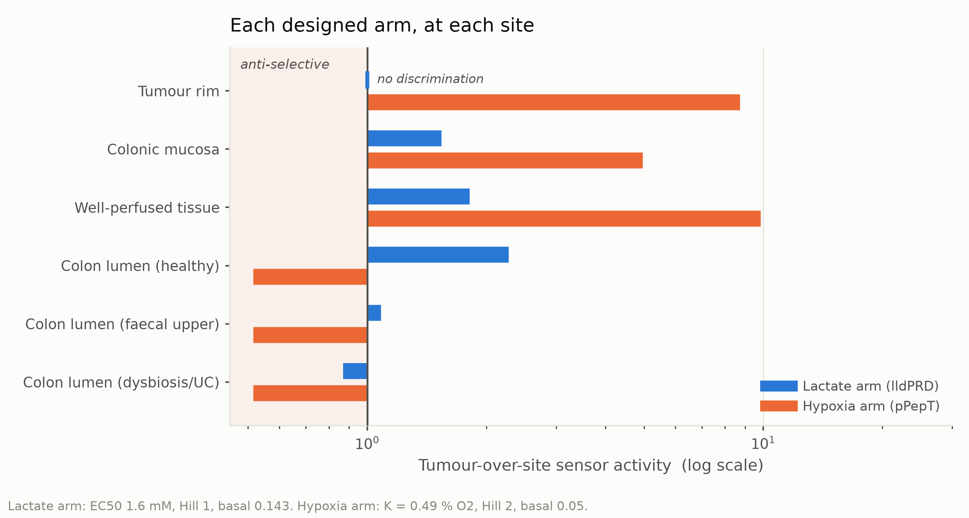 Figure 2. Tumour-over-site output ratio of each designed sensor arm at six off-target sites. Each pair of bars gives the ratio of that arm's output in the tumour core to its output at the site named on the left, on a logarithmic axis: blue is the lactate arm, orange the hypoxia arm. The vertical line marks a ratio of 1, labelled "no discrimination", and the shaded band to its left marks ratios below it, labelled "anti-selective"; where a ratio is 1 a tick replaces the bar. The native lldPRD repression is not included in either arm. The lactate arm is drawn at EC50 1.6 mM and Hill 1, the hypoxia arm at K = 0.49 % O₂ and Hill 2.

Learn (v2)
The circuit survives, because of a property of the part we had not been crediting. BBa_M36021 is the native E. coli lldPRD operon promoter, so its anaerobic and glucose repression are intact — the $ρ_{\text{anox}}ρ_{\text{glu}}$ term of Eq. (3.1-4), which we had been carrying as 1. The colonic lumen is anoxic and proximally glucose-rich; a tumour core is hypoxic-but-not-anoxic and glucose-depleted by the Warburg effect. The repression therefore engages in the lumen and releases in the tumour: 87–228× luminal discrimination, where the designed arms alone give 0.87–2.28×. The worst site needs only ≈12-fold repression.
🔴 This reversed a planned build decision. Our July route-map said "replace with a lactate sensor optimised for hypoxic, glucose-rich conditions" — i.e. swap in a de-repressed variant to raise intratumoural expression. That would delete the $ρ_{\text{anox}}ρ_{\text{glu}}$ term, which is the only thing holding the colonic lumen off. We rejected the optimisation.
And one claim here needs no calibration at all. With $d_{O_{2}}$ the oxygen penetration depth, the hypoxic core radius and volume fraction are pure geometry:
$$r_{\text{core}}(R)=max​\left(R−d_{O_{2}}, 0\right), ϕ_{\text{hyp}}(R)={\left(\frac{r_{\text{core}}(R)}{R}\right)}^{3} (3.2\text{-}1)$$
from which, immediately:
$$R<d_{O_{2}} ⇒ ϕ_{\text{hyp}}(R)≡0 ⇒ {\overline{f}}_{O}(R)≡f_{O}(C_{\text{rim}})=\text{const} (3.2\text{-}5)$$
We take $d_{O_{2}}=178$ µm. A lesion smaller than 178 µm has no hypoxic volume at all, so the hypoxia arm cannot fire — for any parameter set, any sensor, any calibration. It is also the one number in the project an independent measurement confirms: 178 µm falls inside the 160–200 µm bracket Thomlinson & Gray measured histologically in 1955, by a different method on different tissue.
A note on what this cycle does not rest on. We had internally reported a protein-level selectivity index of 11.4× for the effector; checking it against our own data conventions showed it was built from a numerator and a denominator measured in two different experiments, and we withdrew it. The only valid figure is 3.33× (4.77 ± 0.80 / 1.43 ± 0.49, n = 3, p < 0.001), paired within one experiment. So the safety argument has to come from the circuit's tissue selectivity — this cycle — and not from any preference the effector has for cancer cells.

Next iteration
The v2 conclusion rests on one unmeasured quantity: whether $ρ_{\text{anox}}$ really is small at 0 % O₂ and ≈1 at 1 %. That is Cycle 5, and it is the only open item we would call load-bearing.

Cycle 3 — The multi-lesion model we did not need to build

Design (v1)
Micro-metastases occur in clusters, and AHL from neighbouring lesions might push a cluster over a quorum threshold that no single lesion reaches. We specified a 2D axisymmetric finite-difference model on a diffusion–reaction grid.

Build (v1)
We started the grid and stopped partway. Writing the steady state down in order to discretise it is what exposed the problem — the equation we were about to spend a week approximating is this one:
$$D∇^{2}C−δC+q(x)=0 (4.4\text{-}1)$$

Test (v1)
Before discretising anything we checked the one thing a converged grid can never tell you afterwards: whether Eq. (4.4-1) needs a grid at all. The test is a single question put to the source term — does $q$ depend on $C$? — because if it does not, the equation is linear and the numerical scheme is redundant.

Learn (v1)
LuxI sits on pPepT, not on pLux. There is therefore no AHL autoinduction feedback, so $q$ does not depend on $C$, and Eq. (4.4-1) is linear — which means superposition is exact.
With $λ=\sqrt{D/δ}$ and $α=R/λ$, a single spherical source has a closed-form centre value:
$$Ψ_{\text{centre}}(R)=1−(1+α)e^{−α} (4.4\text{-}3)$$
So summing closed-form single-sphere solutions over an arbitrary 3D arrangement is not an approximation to the finite-difference answer — it is the answer, and the 2D grid would have been the approximation. Cheaper to compute and more accurate, in one move.

Design (v2)
The v1 Learn removed the reason for the grid, so the v2 design removes the grid. Since $q$ is independent of $C$, superposition is exact, and the design becomes: evaluate the closed-form single-sphere solution at every source and add the contributions over whatever arrangement we want to ask about.

Build (v2)
A few lines over an array of sphere centres — no mesh, no convergence study, no time stepping. That cheapness is itself a result: the v2 model is quick enough to sweep every cluster size and spacing we care about, which the grid would not have been.

Test (v2)
Equivalent isolated radius for clustered 150 µm micro-lesions, against our own 150 µm OFF → 1000 µm ON bracket (Fig. 3). Packed touching, at 300 µm spacing, thirteen lesions behave like a single lesion of 333 µm and 125 of them like one of 652 µm. At the realistic 1000 µm spacing the same two clusters fall to 207 µm and 303 µm, and at 2000 µm to 173 µm and 201 µm.
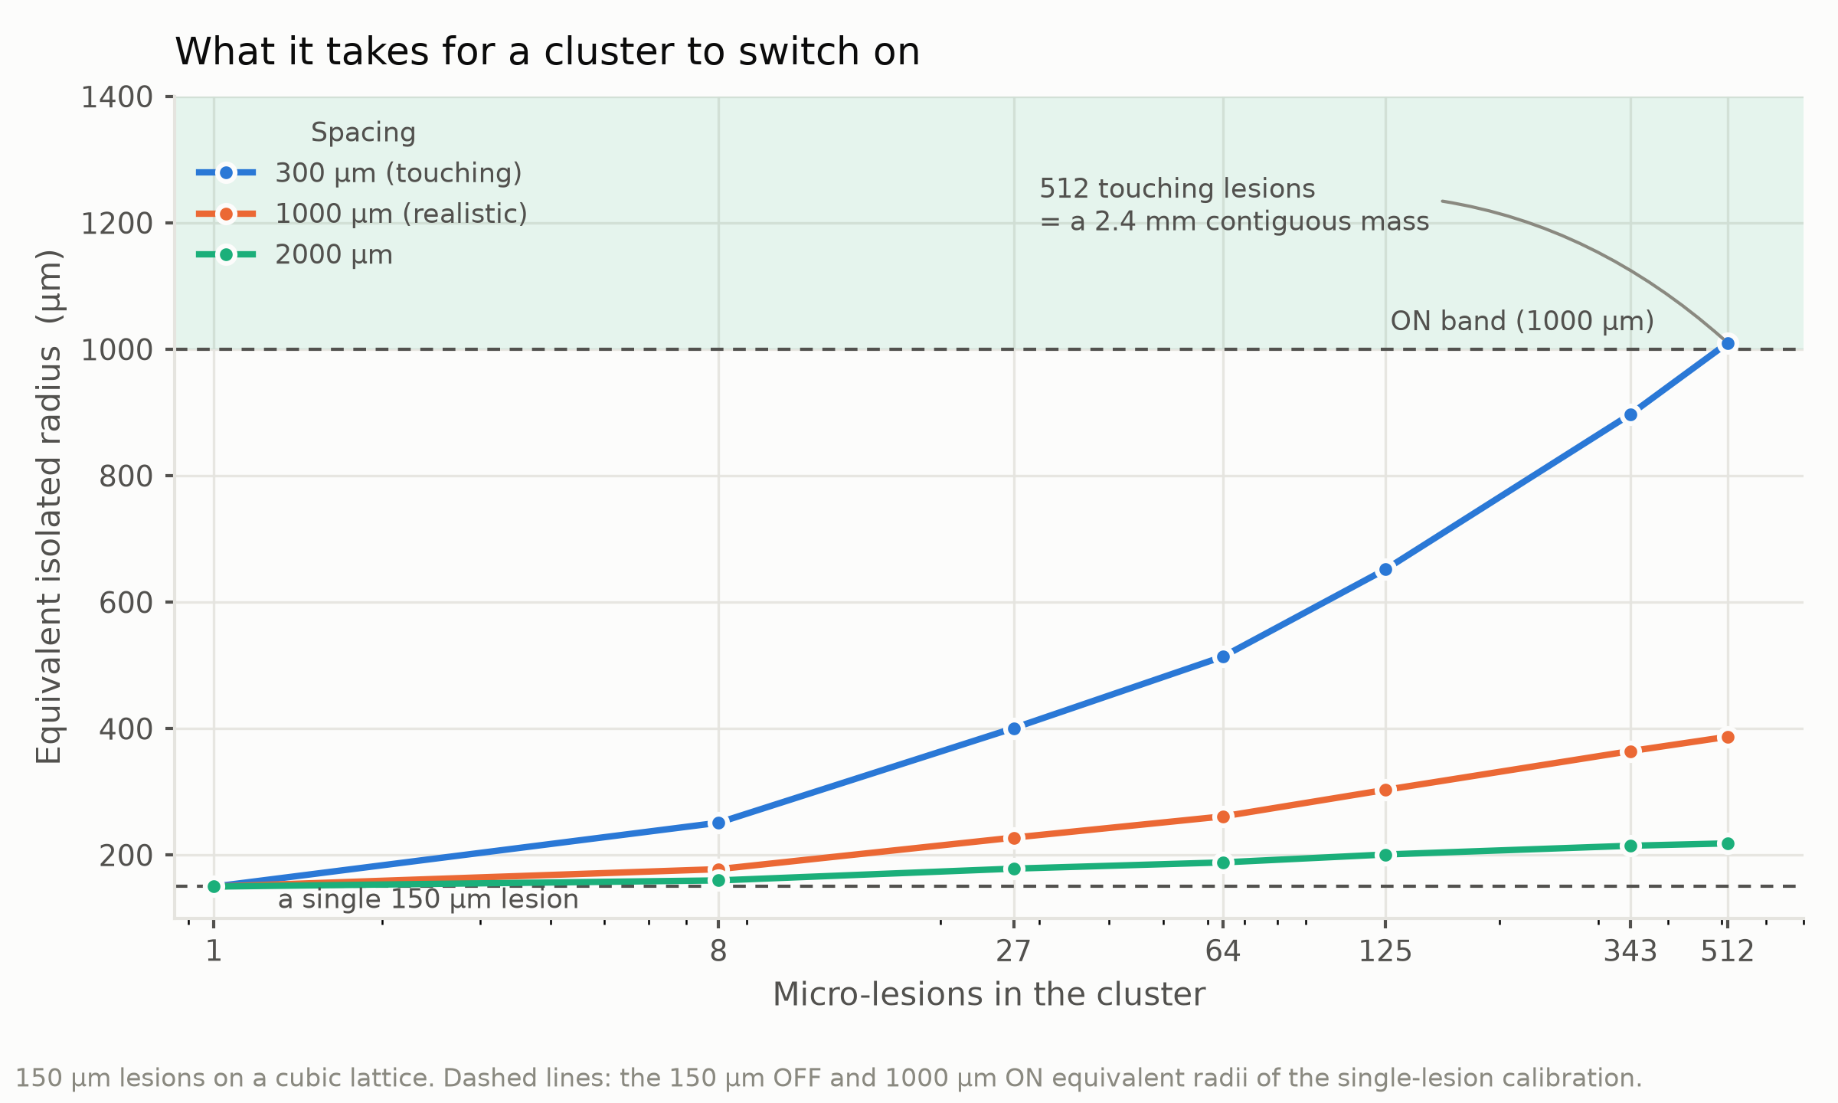 Figure 3. Equivalent isolated radius of a cluster of 150 µm micro-lesions against the number of lesions in it. Clusters of 1 to 512 lesions are arranged on a cubic lattice at three centre-to-centre spacings, one series each; the horizontal axis is logarithmic. The two dashed lines are the 150 µm OFF and 1000 µm ON equivalent radii of the single-lesion calibration, and the shaded band above the upper one is labelled "ON band". The annotation records that the 512-lesion touching cluster is a 2.4 mm contiguous mass.

Learn (v2)
No cluster reaches 1000 µm. Reaching it would take 512 touching lesions — a continuous 2.4 mm mass, which is no longer a micrometastasis.
Dispersal is always worse than aggregation, and the closed form says why. In the small-$α$ limit the two contributions scale differently:
$$\overset{\text{own}, ∝R^{2}}{\left(Ψ_{\text{centre}}∼\frac{α^{2}}{2}\right)} \text{vs} \overset{\text{neighbour}, ∝R^{3}/d}{\left(Ψ_{\text{out}}∼\frac{R^{3}}{3λ^{2}d}\right)} (4.4\text{-}8)$$
Split a volume into smaller pieces and the self term falls faster than the neighbour term compensates — 0.84–0.95× equivalent-over-equal-volume. A numerical grid would have produced this number without producing the reason.
The quorum module is a colonised-volume integrator, not a bistable switch. Because there is no autoinduction there is no hysteresis and no switch-like transition, only a graded response. Every informal description of the circuit we had used the word "switch".
This redirected the project. On safety, the 178 µm floor survives extension to many lesions and gets harder. On efficacy, this circuit cannot clear true micrometastases — distal killing can only come from the immune cascade, which is why our immune module is not optional decoration but the only mechanism that addresses disseminated disease.

Next iteration
Superposition assumes identical spherical sources, and real lesion size distributions are broad. A v3 would carry a size distribution rather than a single radius. The conclusion is robust to this — dispersal already loses by Eq. (4.4-8) — so we did not prioritise it.

Cycle 4 — The dose model: changing the question

Design
Dose had only ever been asked as a potency comparison — which construct kills more. That is not an engineering specification. We reframed it: what fraction of a lesion must be cleared per day for the lesion not to grow, and what dose delivers that?

Build
A closed-form criterion that assumes no dose–response shape — it follows from the doubling time alone:
$$f = 1−exp​\left(−\frac{ln2⋅24}{T_{\text{doubling}}}\right)$$
plus a power-law fit to the measured dose series with the plasmid control subtracted (at the top dose the chassis accounts for 27 % of the raw reading).

Test
Leave-one-out, against the same pre-declared criteria as Cycle 1. All six held-out doses passed, the worst at 0.835×. Separately, all eight 24 h capacity values forecast from the first 12 hours passed, running 0–8 % high with a mean bias of 1.0500.
With Cycle 1's corners, that is 28 held-out predictions in total.
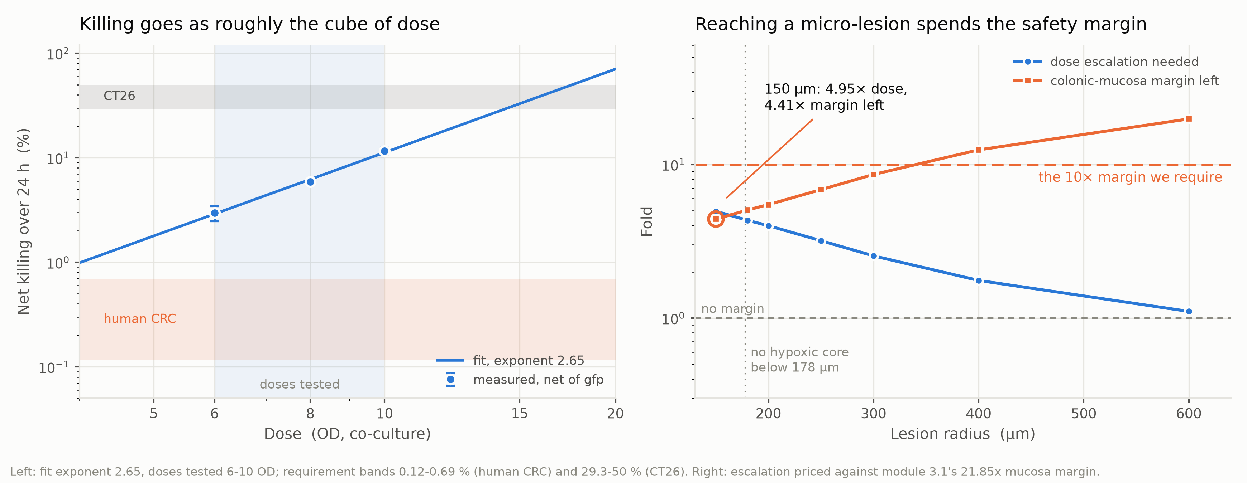 Figure 4. Dose–kill relation, and the escalation and remaining margin against lesion radius. Left: net CT26 killing over 24 h against co-culture dose, logarithmic axes. Points are measurements net of the GFP control with standard-error bars, the shaded band the doses tested, the line a power-law fit of exponent 2.65, and the horizontal bands the target effect sizes, 0.12–0.69 % (human) and 29.3–50 % (CT26). Right: fold change against lesion radius, logarithmic — circles the escalation that radius needs, squares the colonic-mucosa margin left, priced on 21.85-fold. The dashed line at 10 is the required margin, that at 1 none left, the dotted vertical at 178 µm the smallest radius with a hypoxic core; the circled 150 µm point reads 4.95-fold dose, 4.41-fold margin left.

Learn
Killing follows a near-cubic dose law (Fig. 4): killing ∝ dose^b, with b = 2.65–3.38 and r² > 0.995.
A CT26 lesion, doubling every 24–48 h, has to lose 29–50 % of itself a day, which on that relation costs 1.30–1.76× the highest dose we tested — more than we have. Human colorectal cancer doubles in 100–600 days and needs only 0.12–0.69 %, which costs 0.18–0.43× — already met below the lowest dose tested.
The human half does not depend on the fit at all. Measured net killing at the lowest dose is 2.97 % against a requirement of 0.69 % — a direct comparison, exceeding it 4.3×. All three measured doses satisfy the clinical indication. CT26 doubles two orders of magnitude faster than human CRC, so "insufficient in mice" does not imply insufficient in humans; it means the mouse is the harder target.
The cubic law takes the cube root of every unknown. A 600-fold spread in doubling time becomes a 9.9-fold spread in required dose, and the 3.7-fold delivery loss from spatial coverage needs only 1.64-fold dose compensation. This back-calculation is least sensitive to its most uncertain parameter, which is the opposite of the usual situation.

Next iteration
The criterion treats a lesion as well-mixed. Coupling it to Cycle 3's spatial result is the obvious v2: at 150 µm the required escalation is 4.95×, which leaves only 4.41× of the mucosal margin — so dose and safety stop being independent. That coupling is stated but not yet modelled jointly.

Cycle 5 — Open: anoxia vs. hypoxia at the lactate sensor
We report this one unfinished, because the alternative is to overstate Cycle 2.

Design
Cycle 2's safety conclusion rests on the $ρ_{\text{anox}}$ term of Eq. (3.1-4): that native lldPRD anaerobic repression is engaged at 0 % O₂ (gut lumen) and released at ~1 % O₂ (tumour core). This is the single structural assumption in the project, and it is not in the same class as our other open parameters:
Every other unmeasured parameter only widens an interval. This one changes a sign.
On the full-gate measure, with repression the three luminal sites score 23–60×; without it, 0.23–0.60× — which also flips which element is the bottleneck, and flips Cycle 2's "do not swap the promoter" recommendation.
- The measured half: 1 % O₂ + lactate is the highest of the four corners (98.1 %, Fig. 1), so the sensor is not repressed at 1 %, which is what the tumour side requires.
- The unmeasured half: our dataset contains no 0 % O₂ condition at all.
- Why we nonetheless think it holds (neither reason is a measurement): the required repression is modest — 4.4× / 9.2× / 11.5× at the three sites — and the switching range of FNR-type oxygen regulation is 0–1 %, exactly the interval separating the two sites.

Build — specified, not yet run
An lldPRD-only reporter construct, assayed at 0 % and at 1 % O₂ with lactate held at the tumour value. Nothing else varies between the two conditions, so their ratio is $ρ_{\text{anox}}$ — the term Cycle 2 had to carry as an assumption.

Test — the decision rule, declared now
One plate closes it: lldPRD-only reporter, 0 % vs 1 % O₂.
We write the criterion down before the plate exists, for the same reason Cycle 1 declared its bounds in advance. A repression ratio above 11.5× sustains Cycle 2's conclusion at all three luminal sites. Below 4.4× none of them hold, and the recommendation not to swap the promoter has to be withdrawn. Between the two the sites separate, and the page will say which ones survive.

Learn — what specifying it has already settled
Two things, before any plate is poured. First, our global sensitivity analysis picked out the same parameter independently as the cheapest and most valuable to measure (repression_fold, ST = 0.457 at the bottleneck): two methods, arrived at separately, pointing at one plate. Second, having to state the criterion is what forced Cycle 2 to be written as a requirement on the parameter rather than a claim about its value — which is what keeps that cycle honest while this one stays open.

Next iteration
Cycle 2 was deliberately written to ask where the parameter must lie rather than to depend on a value we do not have. If the plate comes back as expected, the v3 tissue model replaces an interval with a measurement; if it comes back the other way, Cycle 2's recommendation inverts, and we have already written down that it would.

