FLAME 完整视频演讲稿

分时安排
时间 | 介绍内容
00:00–01:24 | 项目背景与三个关键问题
01:24–02:06 | 问题一 口服应用为什么选择 EcN
02:06–03:32 | 问题二 组合感应的设计与实验反馈
03:32–06:12 | 问题二 建模检验与启动子决策
06:12–09:19 | 问题三 释放方式 效应构型与建模边界
09:19–11:14 | 教育工作的反思与调整
11:14–12:37 | 患者 医生与公众的反馈
12:37–13:59 | 贡献 后续工作与核心结论

English Script
We are Suda-ICPI-China. Our project, FLAME, explores an engineered bacterial approach to treat colorectal cancer.
According to the World Health Organization, an estimated 1.9 million new colorectal cancer cases and more than 900,000 deaths occurred worldwide in 2022. Colorectal cancer is the second leading cause of cancer-related death globally. Behind these numbers are patients facing illness and families accompanying them through treatment.
Against this backdrop, we began our project: FLAME.
FLAME is an engineered probiotic system designed to deliver a therapeutic payload directly to colorectal cancer. Our goal is to create an orally administered bacterial platform that can selectively colonize the tumor region, sense the tumor microenvironment, and produce an anti-tumor effector only when it reaches the right place.
The effector we chose is GSDMD-N, the N-terminal pore-forming fragment of gasdermin D. When delivered into cancer cells, GSDMD-N induces pyroptosis, a form of inflammatory cell death. This not only kills tumor cells directly, but also releases inflammatory signals, which can help activate anti-tumor immune responses.
But building FLAME is not simply a matter of adding GSDMD-N to a bacterium. The central challenge is that GSDMD-N is a double-edged sword. It can kill cancer cells, but it can also damage the bacteria that produce it. If GSDMD-N activity begins too early, the bacterial population may collapse before it can deliver enough effector. If expression is too weak, the tumor-cell effect may be inadequate. And if expression occurs outside the tumor, it raises serious safety concerns.
Developing FLAME requires balancing bacterial survival with effector activity. GSDMD-N can also damage the bacteria that produce it. If activity begins too early, the bacterial population may be lost before sufficient delivery; if expression is too weak, the tumor-cell effect may be inadequate. Unwanted expression elsewhere also raises safety concerns.
These constraints shaped three questions. First, which bacterial chassis is suitable for oral delivery and colonization? We need a strain that is safe, can survive the gut, colonize the colon, and respond to tumor-associated signals. Second, how can we control expression to favor tumor-associated conditions and limit unwanted effects? We need precise regulation that activates GSDMD-N expression only in the tumor microenvironment and stays quiet in normal tissue. Third, how can GSDMD-N be released and reach the cells it is intended to affect? We need to consider not only expression, but also release and delivery to cancer cells.
For the chassis, we selected Escherichia coli Nissle 1917 (EcN), a probiotic that is orally deliverable.
Published research on its lesion colonization further supported this choice. Our own work established genetically engineered EcN strains for circuit and effector testing.
This choice brought the second question into focus: how should EcN regulate a protein that may damage its own membrane as well as target cells?
At the design stage, we considered hypoxia-responsive control. However, relying on a single cue gave us reason to question selectivity. We therefore combined hypoxia and lactate sensing with quorum sensing.
The hypoxia-responsive promoter pPepT controls LuxI, which produces AHL. The lactate-responsive lldPRD promoter controls LuxR. AHL and LuxR together activate pLux and downstream expression.
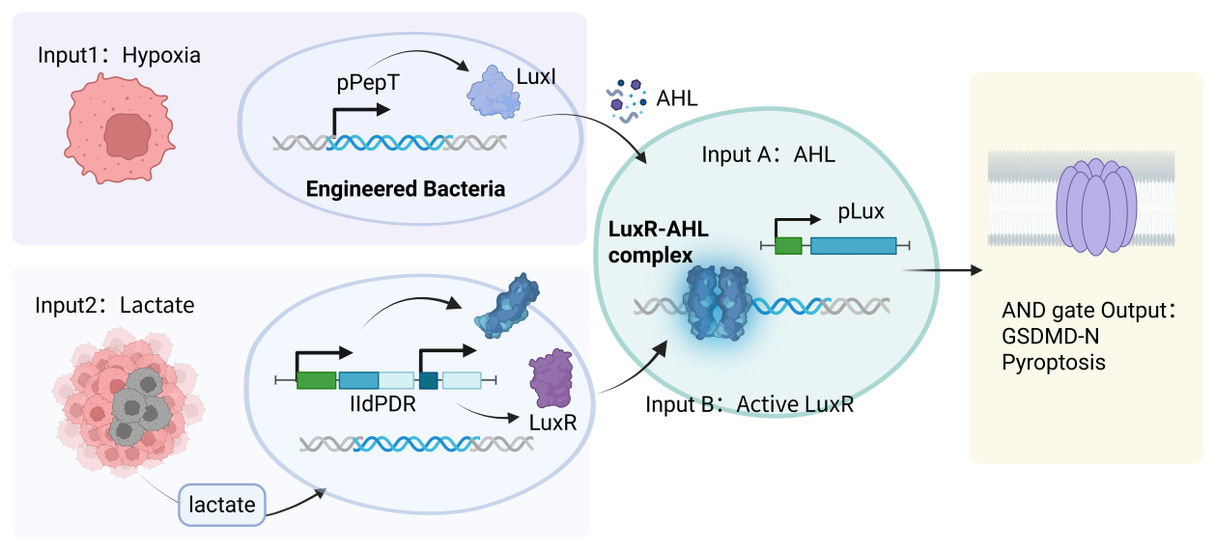
【配图 1】the two sensing arms, and the AND gate they feed.
We assembled the circuit, verified it by sequencing, and introduced it into EcN. GFP replaced GSDMD-N so that regulation could be tested separately from toxicity.

We compared aerobic and low-oxygen conditions, each with or without added lactate.
Our results showed the strongest reporter response under low oxygen with lactate, supporting the AND-gate logic. To further limit unwanted effector activity in normal tissues, a degron, SsrA, is added at the N-terminus of GSDMD-N as an extra safety control, which is tested later.

Modeling examined how the two inputs combine, where else the circuit might switch on, and whether the model survives a test.
First, it tested whether the AND gate acts as a true product of its inputs. At 24 h, the four-condition reporter data support multiplicativity; at 9 h, they do not. The AND logic therefore holds at the endpoint, not mid-course, so early-time ratios should not be extrapolated. The model also predicted a condition we had hidden from it—98.13% against 98.08% measured—while the same check at 9 h failed, which is what makes it a test.
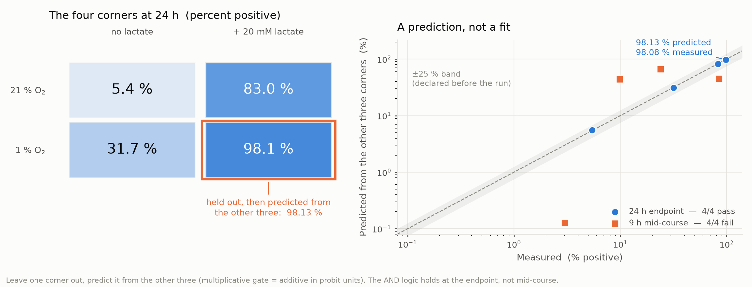
【配图 2】hold one corner out and predict it from the other three: 98.13 % predicted against 98.08 % measured at 24 h, while the same check fails at 9 h.
Second, modeling asked where else the circuit might activate. With the gut lumen included, the designed sensors alone are anti-selective there—they respond more strongly than in the tumor—and that holds for any sensor parameters. The lumen stays off because the native lactate promoter is repressed by glucose and anoxia, which makes the colonic mucosa our safety bottleneck, at 21.85×. Replacing it with a de-repressed version would collapse tumor-versus-lumen discrimination from nearly a hundredfold to almost nothing, destroying the safety argument. We therefore kept the native lldPRD promoter and abandoned the planned replacement.
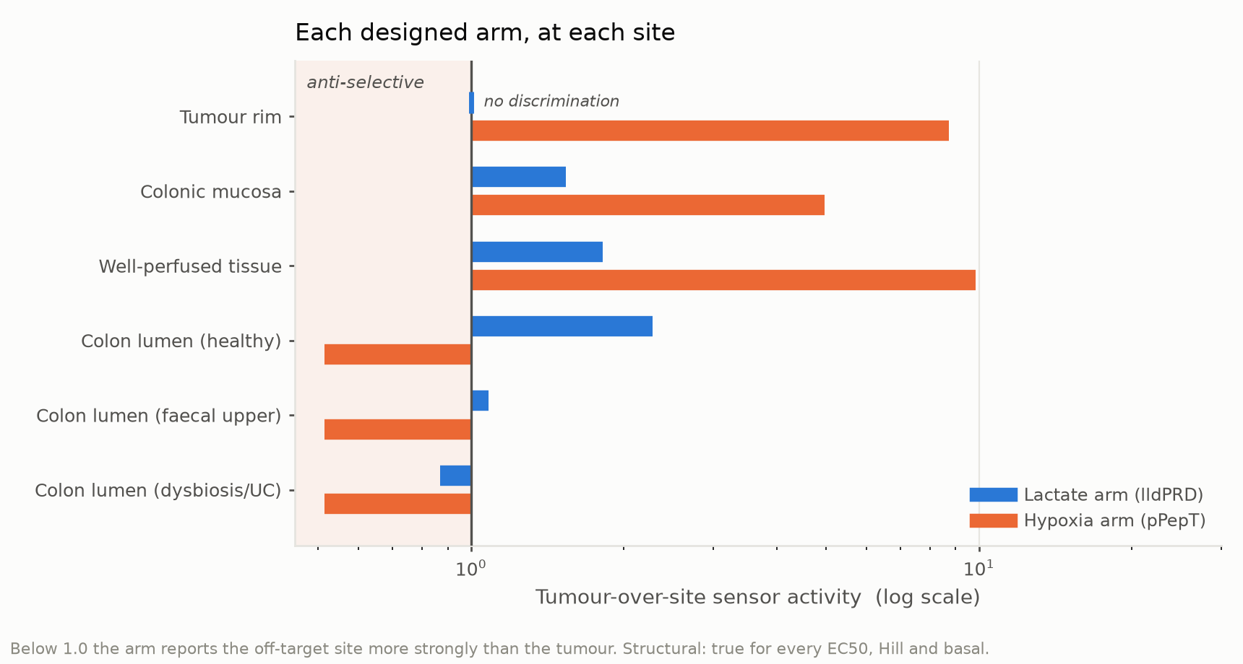
【配图 3】each designed arm on its own is anti-selective in the lumen: below 1.0 it reports the off-target site more strongly than the tumour.
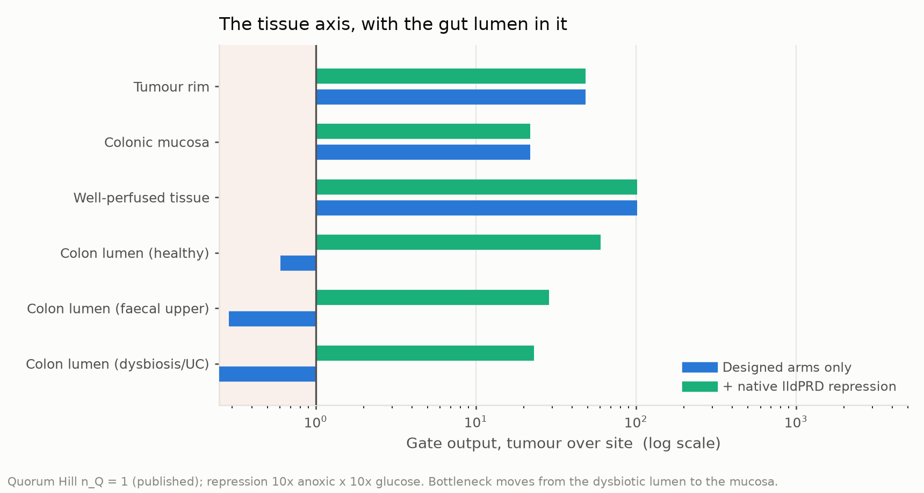
【配图 4】with the native lldPRD repression included, the bottleneck moves from the lumen to the colonic mucosa, at 21.85×.
Modeling also identified a geometric safety floor: lesions with a radius below ~178 μm have no hypoxic core, so the hypoxia arm cannot be induced and falls back to its basal level. This threshold comes from oxygen penetration depth and agrees with histological measurements (160–200 μm). Below this size, the circuit cannot be triggered by hypoxia, so distant disease must be addressed by other means, such as the immune cascade.
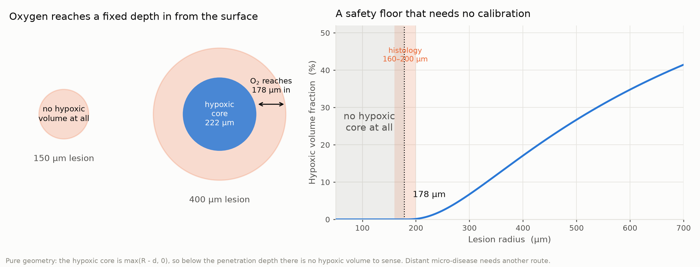
【配图 5】oxygen reaches a fixed depth, so a lesion below 178 µm has no hypoxic volume at all. Pure geometry, no calibration.
Our third question connected expression, release, and cellular activity. We hypothesize that bacterial establishment and expansion precede population-dependent GSDMD-N expression and release through bacterial lysis. Quorum sensing is intended to delay activity until a population has accumulated. We have experimental evidence concerning bacterial lysis, GSDMD-N release, and effects of GSDMD-N expression on bacterial survival. Establishing the full sequence in vivo remains future work.
For activity after release, our initial hypothesis exploited phosphatidylserine exposed on tumor cells, a tumor-specific feature, to support targeting. However, membrane contact and access could limit this route. We therefore explored a TAT-tagged version intended to promote cellular entry and intracellular action.
We compared untagged GSDMD-N, GSDMD-N-TAT, and GSDMD-N carrying FLAG and the degradation tag SsrA. The untagged protein provided a baseline; TAT was used to explore intracellular interaction; SsrA was used to address protein stability.
Engineered bacteria were co-cultured with CT26 mouse colon cancer cells at three input levels, with EcN and GFP-related controls. PI staining and microscopy assessed membrane damage. TAT produced the strongest CT26 effect, untagged GSDMD-N followed, and SsrA showed lower activity. Differences were more pronounced at the highest input.
In L929 non-tumor cells, TAT also produced greater effects, while SsrA showed lower overall cytotoxicity. Considering these comparisons alongside safety, we prioritized GSDMD-N-SsrA for further evaluation. Untagged and TAT constructs remain alternatives. The results support a provisional choice; they do not establish the optimal therapeutic balance or immune benefit.
Modeling added a separate perspective on activity.

First, modeling compared dose requirements with safety margins. The clinical indication is met at the lowest dose tested, with about 4× to spare; CT26 in mice, which doubles two orders of magnitude faster, needs 1.3–1.8× the highest. Reaching a 150 μm lesion would require about 5× more dose, which spends the mucosa margin down to 4.41×—below the 10× we require.
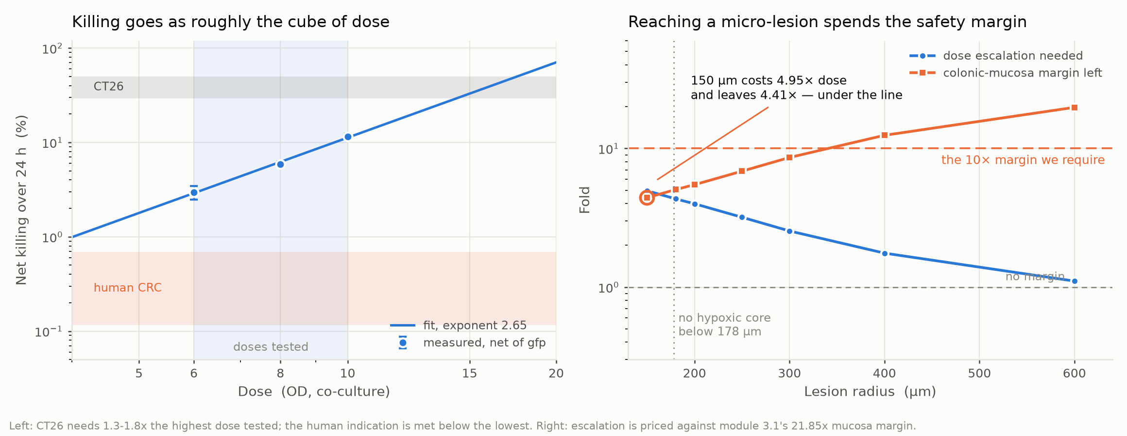
【配图 6】reaching a 150 µm lesion costs 4.95× dose and leaves 4.41× mucosa margin, under the 10× we require.
A second model, built on completely different data, hits that same wall from the other side: quorum sensing cannot fire inside a micrometastasis at all—even 125 of them clustered together stay below the threshold. So micrometastasis is not a problem a larger dose can solve.
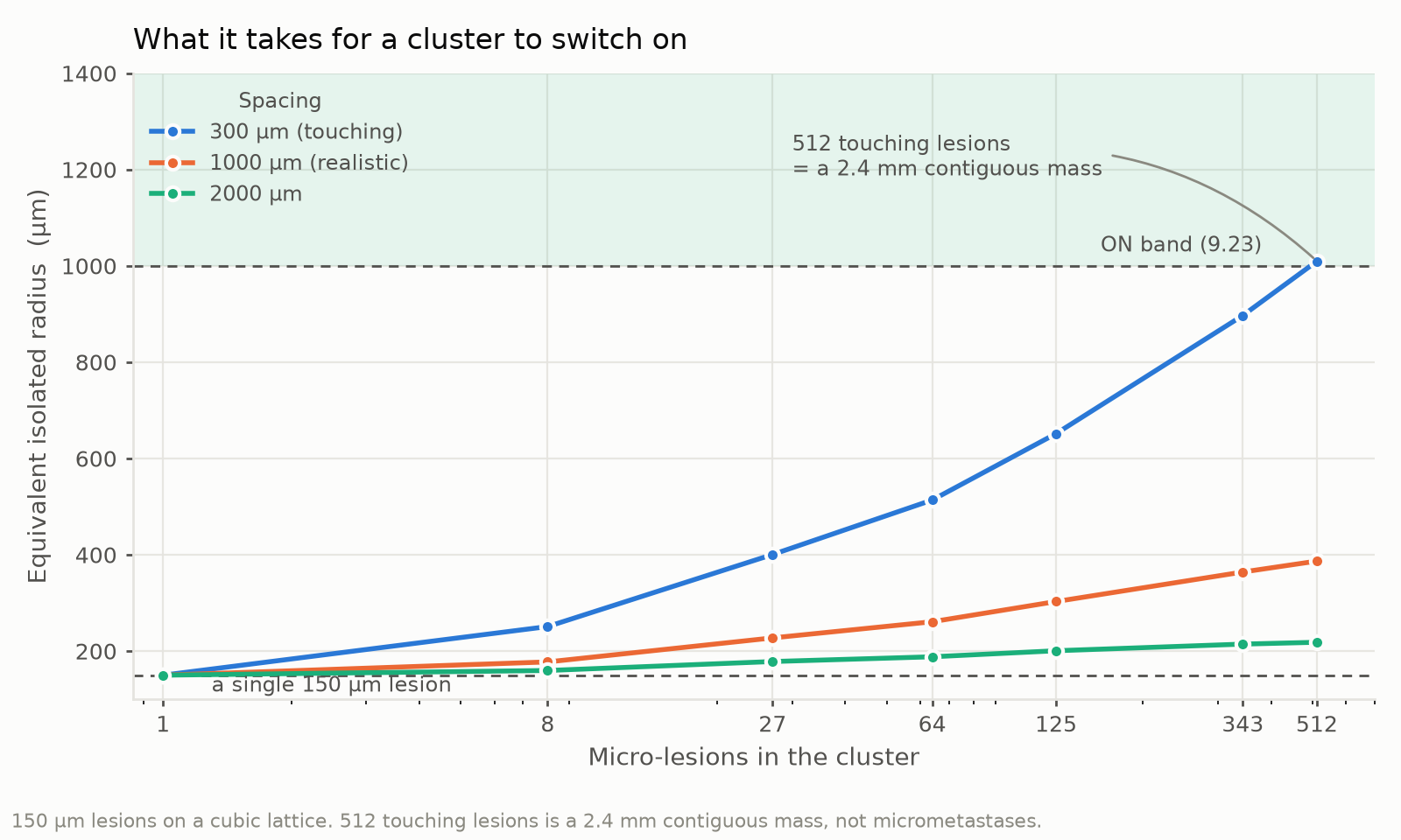
【配图 7】even 125 micro-lesions clustered together stay below the quorum threshold: not a problem a larger dose can solve.
Finally, modeling explored whether an immune response could extend the effect to distant lesions. It gives a feasibility boundary, not a prediction: in MSS/pMMR tumors, the immune cascade must exceed a certain gain—below that, no pyroptotic flux whatsoever is enough—and there is also a maximum treatable burden, so early treatment matters more than larger doses. Together, these results connect the third question to a clear conclusion: direct bacterial delivery works for larger lesions, while distant disease must rely on the immune response, which remains to be tested.
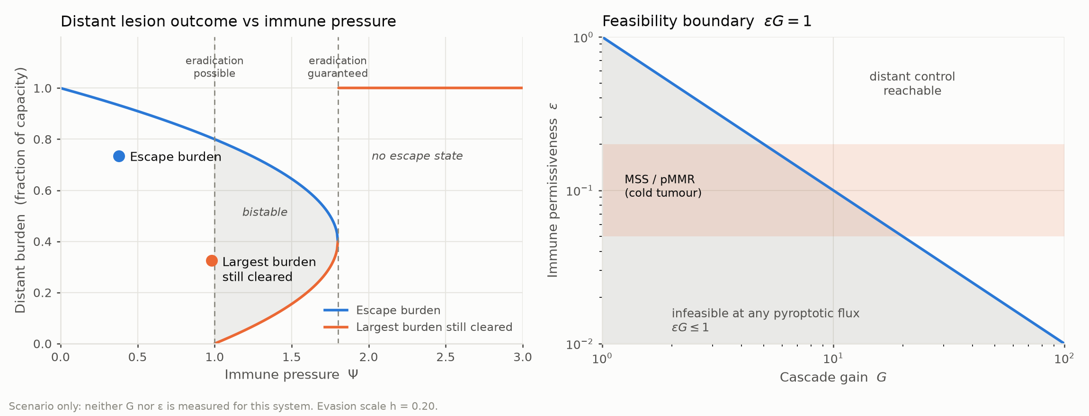
【配图 8】a feasibility boundary, not a prediction: below εG = 1 no pyroptotic flux is enough, and a maximum treatable burden exists.

Across the second and third questions, modeling contributed a mathematical interpretation, internal predictive checks, regulatory comparisons, and priorities for experiments. Its connection to wet-lab work is specific: measured data informed the analyses, and those analyses informed interpretation, a promoter decision, and the next questions to test.
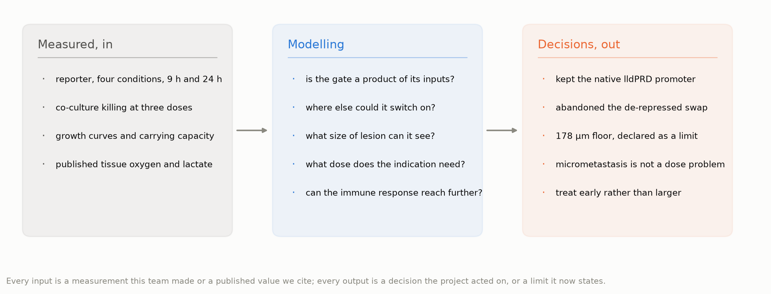
【配图 9】measured data in, decisions out.
Our education activities also changed through reflection on how students could participate. We first invited high school students to our university and laboratories, followed by a lecture on cancer, treatment, and iGEM. Before-and-after questionnaires explored their understanding and attitudes toward bacteria.
Our team review identified a limitation in the format: beyond the questionnaires, we had provided too few opportunities for students to interact. Participation was largely centered on listening. Delivering information alone did not give students enough opportunities to develop and express their own ideas.
We therefore revised our approach. We adapted content to different ages and introduced more hands-on participation and discussion.
In primary school, building blocks helped children explore how components can be combined for a purpose. Each child developed a creation and had an opportunity to explain it. At junior high school, we incorporated questions, answers, and interactive activities into a lecture on tumor treatment.
The change was from a predominantly lecture-based format toward activities that invited students to build, respond, and explain. Activity records and photographs document these changes. Students' creations and explanations offer opportunities to examine understanding beyond attendance.
We have collected the high school questionnaires and completed an initial analysis. Alongside activity records, these responses help us examine what students understood. Our experience has taught us to adapt both content and participation to the audience, and to keep evaluating learning as we improve the activities.
Alongside education, conversations with doctors and patients brought us back to the practical questions of using FLAME. Doctors raised cost and patient acceptance. Community interviews included people with colorectal cancer and people who had undergone cancer surgery. Among the older patients interviewed, willingness to consider the approach was limited.
These accounts made cost and willingness to consider engineered bacteria important questions for future development. They reminded us that acceptance needs investigation alongside biological performance.
On campus, a welcome activity invited students to imagine an organism they could modify and the function they would give it.
Our open science exhibition extends participation further. Four panels introduce synthetic biology and iGEM, with sticky notes and tick-box responses inviting questions and opinions. We have created a group for interested students and are preparing a follow-up lecture.
This provides a continuing route for feedback. As we prepare the lecture, we can use the exhibition's questions to guide what we explain next. The lecture and its evaluation remain work ahead.
These three questions define FLAME's progress. We selected EcN, built and tested an environmentally responsive circuit, and compared effector constructs. Modeling refined our interpretation and informed a promoter decision. Our additional lysis-and-release work supports investigating the delivery route, while education improved through reflection.
For future teams, the comparative experiments, analysis methods, and educational formats offer a basis to build upon. Separating reporter characterization from effector evaluation, documenting model assumptions, and recording why a design was retained or revised can help others interpret and extend the work.
Next, we need to evaluate oral colonization and expression timing in relevant settings, quantify release and intracellular action, and distinguish membrane damage from a demonstrated pyroptotic mechanism. Immune responses, unwanted effects, and independent model validation remain priorities.
Our direction is to connect controlled bacterial delivery with meaningful biological effects. For full methods, results, and modeling details, please visit our team Wiki. We look forward to discussing FLAME and answering your questions during the judging session. Thank you.

中文演讲稿
我们是 Suda-ICPI-China。我们的项目 FLAME，通过工程菌探索结直肠癌治疗的新思路。
根据世界卫生组织的数据，2022 年，全球估计有约 190 万例结直肠癌新发病例，超过 90 万人因这一疾病死亡。结直肠癌是全球第二大癌症死亡原因。这些数字背后，是正在面对疾病的患者，也是陪伴他们经历治疗的家庭。
在这个时代的背景下，我们开始了我们的项目——FLAME。
在推进 FLAME 的过程中，需要协调细菌的存活与效应蛋白的活性。GSDMD-N 也可能损伤产生它的细菌：如果作用开始得太早，菌群可能在完成足够递送之前就已死亡；如果表达太弱，对肿瘤细胞的作用又可能不足。其他位置的非预期表达，也会带来安全性问题。
这些制约因素，引出了我们需要解决的三个问题。第一，什么底盘适合口服递送与定植？第二，怎样控制表达，使其更倾向于肿瘤相关条件，并限制非预期影响？第三，GSDMD-N 怎样释放，并接触到希望作用的细胞？
第一个问题是底盘选择。我们选用大肠杆菌 Nissle 1917，也就是 EcN。它作为益生菌以及结直肠肿瘤口服递送平台，已有研究基础。
已发表的口服递送与病灶定植研究，为这一选择提供了依据。我们自己的工作则构建了用于线路和效应模块测试的工程化 EcN。
底盘确定后，第二个问题随之明确：EcN 应当怎样调控一种既可能损伤自身膜、也能作用于目标细胞的蛋白？
在设计阶段，我们考虑过低氧响应调控。但依赖单一信号，让我们对选择性产生了疑问。因此，我们将低氧、乳酸感应与群体感应结合起来。
低氧响应型启动子 pPepT 控制 LuxI，后者产生 AHL；乳酸响应型 lldPRD 启动子控制 LuxR。AHL 与 LuxR 共同激活 pLux，调控下游表达。
【配图 1】两条传感臂，以及它们汇成的 AND 门。
我们完成线路组装、测序验证，并将其导入 EcN。用 GFP 替代 GSDMD-N，使我们能够将调控响应与毒性分开评价。
我们比较有氧与低氧条件，分别添加或不添加乳酸，并结合生长、荧光测量、显微镜与流式细胞术进行评价。
较晚的测量显示，低氧加乳酸组报告响应最高，但有氧加乳酸组也存在明显表达。低氧加乳酸组的生长最慢。
这些实验修正了我们的理解：系统呈现连续响应的准 AND 特征，在联合条件之外仍有背景表达。因此，需要结合细菌生理状态，以及非预期效应活性的后果评价调控。SsrA 则提供了值得进一步研究的蛋白稳定性控制手段。
围绕这一问题，建模考察了两种输入如何共同作用、线路还可能在哪里开启，以及模型自身能否通过检验。
第一，建模检验 AND 门是否真是两个输入的乘积。24 小时的四条件报告数据支持乘性关系，9 小时的数据不支持。因此 AND 逻辑在终点成立，而不是全程成立，早期的比值不能外推。模型还预测了一个我们对它隐藏起来的条件——98.13% 对实测 98.08%——而同一检验在 9 小时失败，这正说明它是一次真正的检验。
【配图 2】扣掉一个角，用另外三个角把它预测出来：24 h 预测 98.13 %，实测 98.08 %；同一检验在 9 h 失败。
第二，建模追问线路还可能在哪里开启。把肠腔计入之后，我们设计的两条传感臂在那里是反向选择的——它们在肠腔的响应比在肿瘤更强，而且这一点对任何传感器参数都成立。肠腔之所以保持关闭，是因为天然乳酸启动子受葡萄糖与厌氧抑制，这也使结肠黏膜成为我们的安全瓶颈，为 21.85×。若换成去抑制的版本，肿瘤与肠腔的判别会从近百倍塌到几乎没有，安全性论证随之崩塌。因此我们保留了天然 lldPRD 启动子，放弃了原先的更换计划。
【配图 3】单看每条设计臂，在肠腔都是反向选择：低于 1.0 即对非靶位点的响应强于肿瘤。
【配图 4】计入天然 lldPRD 抑制后，瓶颈从肠腔移到结肠黏膜，为 21.85×。
建模还给出一条几何安全底线：半径小于约 178 μm 的病灶没有缺氧核，低氧臂无法被诱导，只能停在基础水平。这条阈值来自氧穿透深度，并与组织学测量（160–200 μm）一致。低于这个尺寸，线路无法被低氧触发，因此远处病灶必须靠其他途径解决，例如免疫级联。
【配图 5】氧只穿透固定深度，半径低于 178 µm 的病灶根本没有缺氧体积。纯几何，不需要标定。

第三个问题，将表达、释放与细胞作用联系起来。我们设想的过程是：细菌先建立并扩增种群，随后通过群体依赖的表达，在细菌裂解后释放 GSDMD-N。群体感应旨在将作用延后到菌群积累之后。我们已有涉及细菌裂解、GSDMD-N 释放，以及 GSDMD-N 表达影响细菌存活的实验证据；完整过程在体内的实现，仍是后续工作。
对于释放后的作用，我们最初的假设考虑了部分肿瘤细胞表面暴露的磷脂酰丝氨酸，也就是 PS。它可能支持细胞外相互作用，但膜接触与进入细胞的能力可能限制效应。因此，我们探索带 TAT 标签的版本，希望促进细胞进入和细胞内作用。这些作用路径仍需要机制检验。
我们比较不带标签的 GSDMD-N、GSDMD-N-TAT，以及带 FLAG 和 SsrA 降解标签的 GSDMD-N。基础构型提供基线，TAT 探索增强细胞相互作用，SsrA 则针对蛋白稳定性。
我们将工程菌与 CT26 小鼠结肠癌细胞共培养，比较三个细菌用量水平，并设置 EcN 与 GFP 相关对照。PI 染色和显微镜评价膜损伤。TAT 对 CT26 的作用最强，基础构型次之，SsrA 构型较低；最高用量下差异更明显。
在 L929 非肿瘤细胞中，TAT 同样带来更明显影响，SsrA 的整体细胞毒性较低。结合背景表达，我们优先选择 GSDMD-N-SsrA 继续评价，同时保留基础构型与 TAT 作为备选。这些结果支持阶段性选择，尚不能确定最优治疗平衡或免疫收益。
建模则从另一角度考察作用强度。
第一，建模把所需剂量与安全余量放在一起比较。人体适应症在测过的最低剂量下即已满足，还有约 4× 余量；小鼠 CT26 的倍增速度快两个数量级，需要最高剂量的 1.3–1.8×。要够到 150 μm 的病灶则需要约 5× 剂量，这会把黏膜余量花到 4.41×，低于我们自己要求的 10×。
【配图 6】够到 150 µm 病灶要 4.95× 剂量，黏膜余量只剩 4.41×，低于我们自己要求的 10×。
另一个建立在完全不同数据上的模型，从另一侧撞上同一面墙：群体感应在微转移灶里根本开不起来——哪怕 125 个这样的病灶聚在一起，仍低于开启阈值。所以微转移灶不是靠加大剂量能解决的问题。
【配图 7】哪怕 125 个微转移灶聚在一起，仍低于群体感应阈值：加大剂量解决不了。
最后，建模考察了免疫反应能否把作用延伸到远处病灶。它给出的是可行性边界，而不是预测：在 MSS/pMMR 肿瘤中，免疫级联必须超过某个增益——低于它，无论焦亡通量多大都不够——并且还存在一个最大可治负荷，因此早治比加大剂量更重要。直接的细菌递送适用于较大的病灶，而远处病灶只能依靠免疫反应，这一点仍有待验证。
【配图 8】给出的是可行性边界而非预测：低于 εG = 1 时无论焦亡通量多大都不够，且存在一个最大可治负荷。
围绕第二和第三个问题，建模贡献了数学解释、内部预测检验、调控比较和实验优先事项。它与湿实验的联系是具体的：实测数据进入分析，分析再推动结果解释、启动子决定，以及下一步待检验的问题。
【配图 9】实测数据进，项目决定出。
我们的教育活动，也随着对学生参与机会的反思而不断调整。首先，我们邀请高中生走进大学和实验室，并开展癌症、治疗与 iGEM 主题讲座。讲座前后发放问卷，了解他们的认识以及对细菌的态度。
团队复盘发现，活动形式存在一个不足：除了问卷，我们为学生设计的互动机会太少，参与主要集中在听讲。仅仅传递信息，没有给学生留下足够的机会发展和表达自己的想法。
因此，我们调整了教育方式，根据不同年龄修改内容，并增加动手参与与讨论。
在小学，积木帮助孩子探索怎样组合不同元件来实现某种目的。每个孩子创作自己的作品，并有机会解释想法。在初中，我们将问答与互动活动融入肿瘤治疗主题讲座。
我们从以讲授为主，逐步转向邀请学生构建、回应和解释的活动形式。活动记录与照片记录了这些改变。学生的作品和讲解，也提供了考察理解程度的机会，让我们能够关注参与人数之外的学习情况。
高中生问卷已经回收，并完成初步分析。结合活动记录，这些回答帮助我们考察学生实际理解了什么。这些经历让我们学会，根据受众调整内容和参与方式，并在改进活动时持续评估学习情况。
在教育活动之外，与医生和患者的交流，让我们进一步关注 FLAME 应用中需要面对的现实问题。医生提出成本与患者接受度。社区访谈包括结直肠癌患者，以及曾接受癌症手术的人。在接受采访的老年患者中，愿意考虑这一思路的人较少。
这些反馈让成本与患者考虑工程菌方案的意愿，成为未来发展需要面对的重要问题。它们提醒我们，需要在研究生物学表现的同时，调查患者的接受意愿。
在大学迎新活动中，我们邀请同学设想：如果可以改造一种生物，希望赋予它什么功能？
已经开放的科普展览进一步拓展了参与方式。四块展板介绍合成生物学与 iGEM，参观者可以通过便利贴和勾选选项留下问题与观点。我们建立了面向感兴趣同学的交流群，正在筹备后续讲座。
这为持续收集反馈提供了渠道。在筹备讲座时，我们可以用展览中收集的问题指导下一步讲解。讲座及其评估，仍是接下来需要完成的工作。
这三个问题勾勒出 FLAME 的进展：选择 EcN，构建并测试环境响应线路，比较效应蛋白构型；建模修正解释并推动启动子决策，补充的裂解与释放工作支持继续研究递送路径，教育则在复盘中改进。
比较实验、分析方法与教育形式，也为未来团队提供了可以借鉴的基础。 将报告系统表征与效应模块评价分开、记录模型假设，以及说明保留或修改设计的原因，可以帮助其他团队理解并延伸这些工作。
接下来，需要在相关条件下评价口服定植与表达时序，定量研究释放和细胞内作用，并区分膜损伤与已经证实的焦亡机制。免疫反应、非预期影响，以及模型独立验证，仍是重点。
我们的方向，是将可控的细菌递送与有意义的生物学效应联系起来。如需了解完整方法、结果和建模细节，欢迎访问团队 Wiki。期待在评审交流中与大家讨论 FLAME，并回答大家的问题。谢谢。

