建模三个模块的图注（改写稿）
覆盖 Model 模块（wiki 七页）、Engineering、Description §1.5 三处的全部图片。每张图一条图注：Figure n. 与标题句粗体不斜体，其后说明不粗不斜，只陈述图里有的内容（坐标轴、标度、系列与颜色、色带、参考线、图上标出的数值、固定住的参数），不写推断。三处共用的 4 张图用同一条图注，唯一允许的差别是方程编号（只有 Model 页给方程编号）。六张图片内部原本带推断句或失效引用，已重出，新图附在对应图注上方。本仓库画的每一张图现在都同时输出 SVG 与 PDF 矢量图，三份 Word 里嵌的是“PNG + SVG”两层，Word 2016 以上与 WPS 按矢量渲染，旧版本退回 300 dpi 的 PNG。
一、Model 模块（wiki 七页）
Gate Calibration
https://2026.igem.wiki/suda-icpi-china/model/
top summary chart, “Gate interaction by timepoint” (currently uncaptioned) ｜ 原编号：—
Figure 1. Gate interaction estimate at each measurement time. Bars give the interaction term of the probit-additive gate model at 6, 9 and 24 h, with standard-error whiskers and the estimate printed at each bar: +0.284 ± 0.240, +1.135 ± 0.350 and −0.011 ± 0.157. The vertical axis is the interaction term in probit units, and zero on it is exact multiplicative behaviour.
circuit schematic under “Circuit and measured inputs” ｜ 原编号：Figure 1
改好的图（需上传替换 wiki 上的旧图）：乳酸构件下面原来印的是“lldPDR”，操纵子与零件都是“lldPRD”（lldP、lldR、lldD），全项目其余文档都这么写，图与自己的图注打架。这张图是别处做的位图，仓库里没有矢量源，所以只把那一个标签按原底色、原位置重排（`fix_circuit_label.py`），别处一个像素没动；收到时的原图留在 outputs/figures/source/ 备查。要矢量仍得找做图的同学导出 SVG。
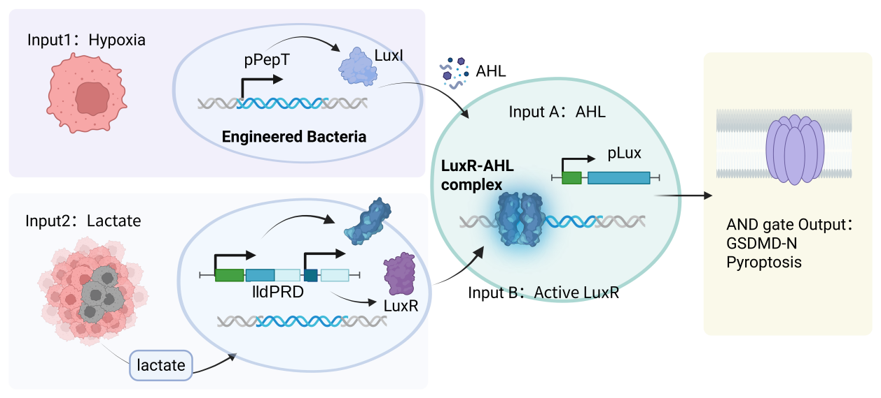
Figure 2. The two-input AND gate. Hypoxia (Input 1) drives LuxI from pPepT, and LuxI makes the diffusible AHL that enters the integration step as Input A; lactate (Input 2) drives LuxR from the native lldPRD operon promoter, entering as Input B. The two together form the LuxR–AHL complex, which opens pLux on the effector, and the output is GSDMD-N and pyroptosis. Arrows are transcription or diffusion; the chassis drawn throughout is E. coli Nissle 1917.
Growth & SsrA
https://2026.igem.wiki/suda-icpi-china/model/growth-ssra/
top summary chart, “SsrA biomass–potency decision” (currently uncaptioned) ｜ 原编号：—
Figure 3. Measured potency ratios against the keep-tag threshold. Bars give the untagged-over-tagged potency ratio in the three same-dose co-culture comparisons, printed at each bar: 0.888 at 6 OD, 1.062 at 8 OD and 1.414 at 10 OD. The horizontal axis is that ratio on a linear scale, and the marked line at 1.710 is the threshold of Eq. (23), the reciprocal of the measured untagged-to-tagged biomass ratio 0.585.
Safety
https://2026.igem.wiki/suda-icpi-china/model/safety/
first figure, “The tissue axis, with the gut lumen in it” ｜ 原编号：Figure 2
新图（已重出，需上传替换 wiki 上的旧图）：底注删去“Bottleneck moves from the dysbiotic lumen to the mucosa.”，只保留图所用的参数；数据未变。
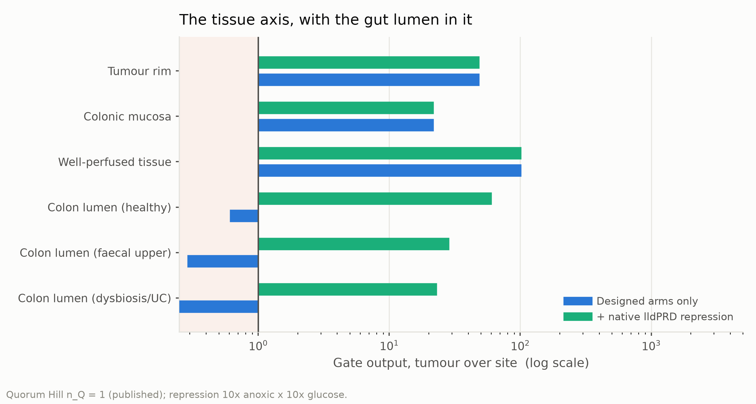
矢量图：outputs/figures/vector/fig3_1_tissue_axis.svg（另有同名 .pdf）
Figure 4. Modelled gate output at six tissue sites, with and without the native lldPRD repression. Each bar is the ratio of gate output in the tumour core to gate output at that site (Eq. (11)), on a logarithmic axis; the vertical line marks a ratio of 1 and the shaded band to its left marks ratios below it, where a site's output equals or exceeds the tumour's. Blue bars are the designed hypoxia and lactate arms alone; green bars add the native repression of the lldPRD promoter by anoxia and by glucose, entered as 10-fold each. The quorum Hill coefficient is held at the published value of 1 and the oxygen sensor constant at 0.49 % O₂.
second figure, “Each designed arm, at each site” ｜ 原编号：Figure 3
新图（已重出，需上传替换 wiki 上的旧图）：底注删去“Structural: true for every EC50, Hill and basal.”，改为两条臂各自的参数；数据未变——逐像素比对过，wiki 上那张的缺氧臂比值与现行计算一致，原图注里“oxygen-arm ratios reflect earlier values”那句是错的。
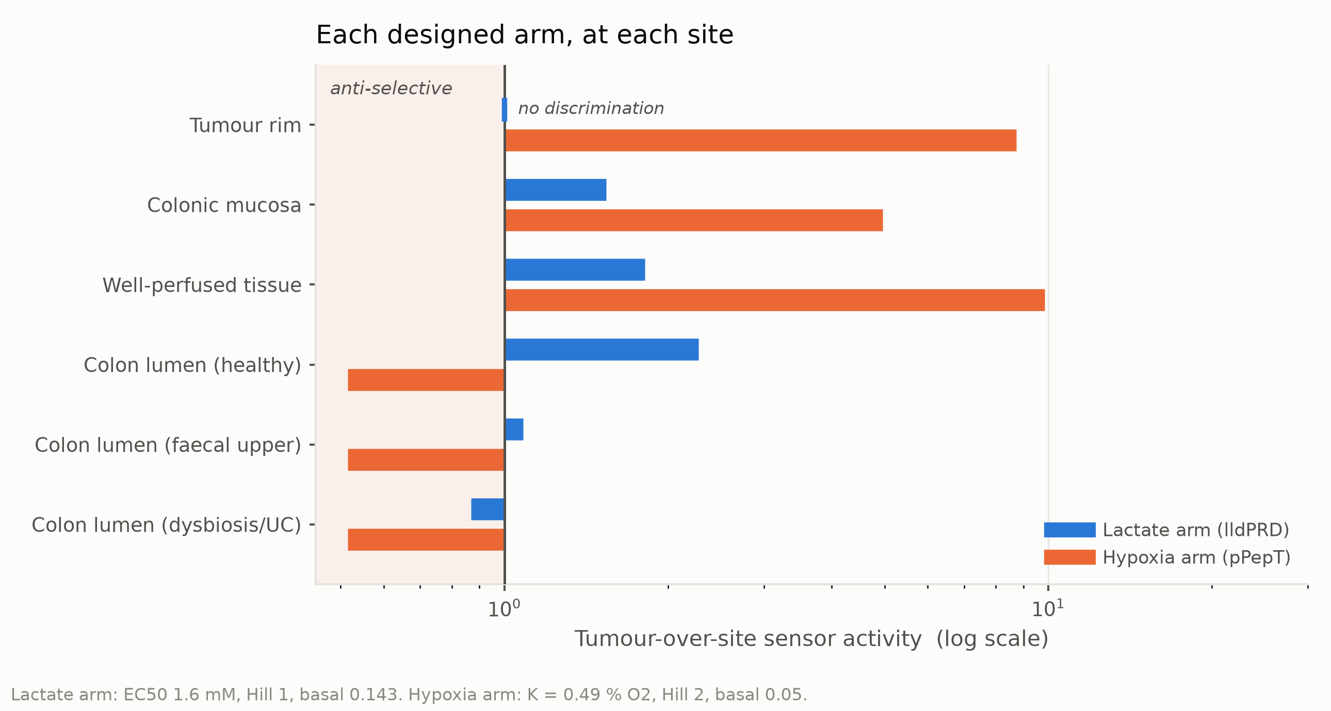
矢量图：outputs/figures/vector/fig3_3_arm_direction.svg（另有同名 .pdf）
Figure 5. Tumour-over-site output ratio of each designed sensor arm at six off-target sites. Each pair of bars gives the ratio of that arm's output in the tumour core to its output at the site named on the left, on a logarithmic axis: blue is the lactate arm, orange the hypoxia arm. The vertical line marks a ratio of 1, labelled "no discrimination", and the shaded band to its left marks ratios below it, labelled "anti-selective"; where a ratio is 1 a tick replaces the bar. The native lldPRD repression is not included in either arm. The lactate arm is drawn at EC50 1.6 mM and Hill 1, the hypoxia arm at K = 0.49 % O₂ and Hill 2.
third figure, “What decides the bottleneck margin” / “The driver set swaps between sites” ｜ 原编号：Figure 4
新图（已重出，需上传替换 wiki 上的旧图）：左图标注“$S_T$ three times $S_1$: it sets how much the rest matters”改为只给比值“$S_T$ = 3.4 × $S_1$”；数据未变。
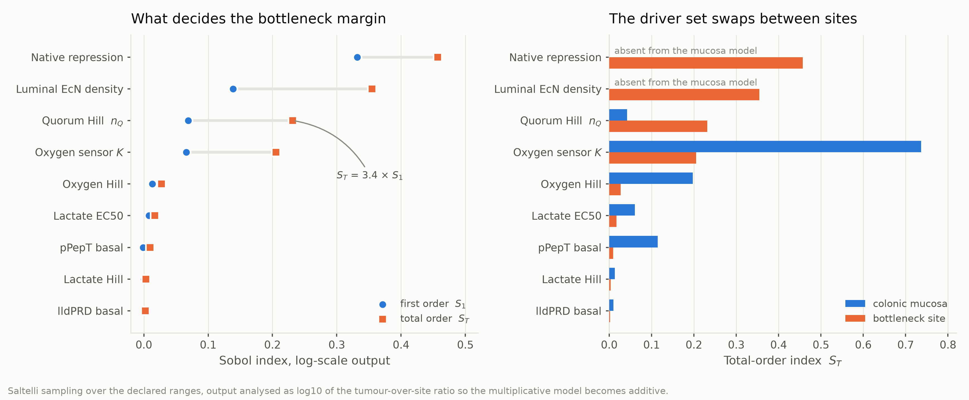
矢量图：outputs/figures/vector/fig3_5_sobol_drivers.svg（另有同名 .pdf）
Figure 6. Sobol indices for the bottleneck margin and for the colonic-mucosa margin. Left: first-order (circles) and total-order (squares) indices for nine parameters, computed on log10 of the tumour-over-site ratio so that the multiplicative model becomes additive (Eq. (28)), under Saltelli sampling of the declared ranges; the grey segment is the gap between the two markers, and the annotation gives S_T = 3.4 × S_1 for the quorum Hill coefficient. Right: the same total-order index at the colonic mucosa (blue) against the bottleneck site (orange), with native repression and luminal EcN density labelled absent from the mucosa model.
Spatial Modeling
https://2026.igem.wiki/suda-icpi-china/model/spatial/
the figure, “What it takes for a cluster to switch on” ｜ 原编号：Figure 5
新图（已重出，需上传替换 wiki 上的旧图）：底注删去“, not micrometastases”，改为两条虚线各自是什么；图内“ON band (9.23)”里那个 9.23 是已废弃的9.23 文档编号，读者无从理解，改成“ON band (1000 µm)”。数据未变。
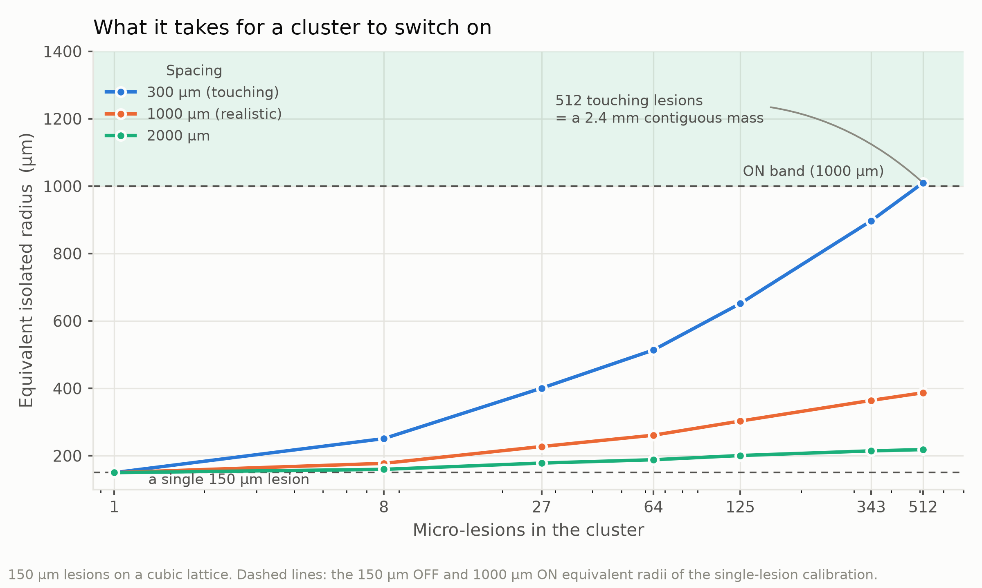
矢量图：outputs/figures/vector/fig4_4_cluster.svg（另有同名 .pdf）
Figure 7. Equivalent isolated radius of a cluster of 150 µm micro-lesions against the number of lesions in it. Clusters of 1 to 512 lesions are arranged on a cubic lattice at three centre-to-centre spacings, one series each; the horizontal axis is logarithmic. The two dashed lines are the 150 µm OFF and 1000 µm ON equivalent radii of the single-lesion calibration, and the shaded band above the upper one is labelled "ON band". The annotation records that the 512-lesion touching cluster is a 2.4 mm contiguous mass. Radii are computed by Eq. (39).
Dose & Efficacy
https://2026.igem.wiki/suda-icpi-china/model/efficacy/
first figure, “Killing goes as roughly the cube of dose” / “Reaching a micro-lesion spends the safety margin” ｜ 原编号：Figure 6
新图（已重出，需上传替换 wiki 上的旧图）：底注删去“CT26 needs 1.3-1.8x the highest dose tested…”，改为两幅图各自的参数与band；右图标注去掉“— under the line”；旧图底注的 19.6× 已更新为 21.85×，并补上 10× 要求线与 150 µm 标注点。
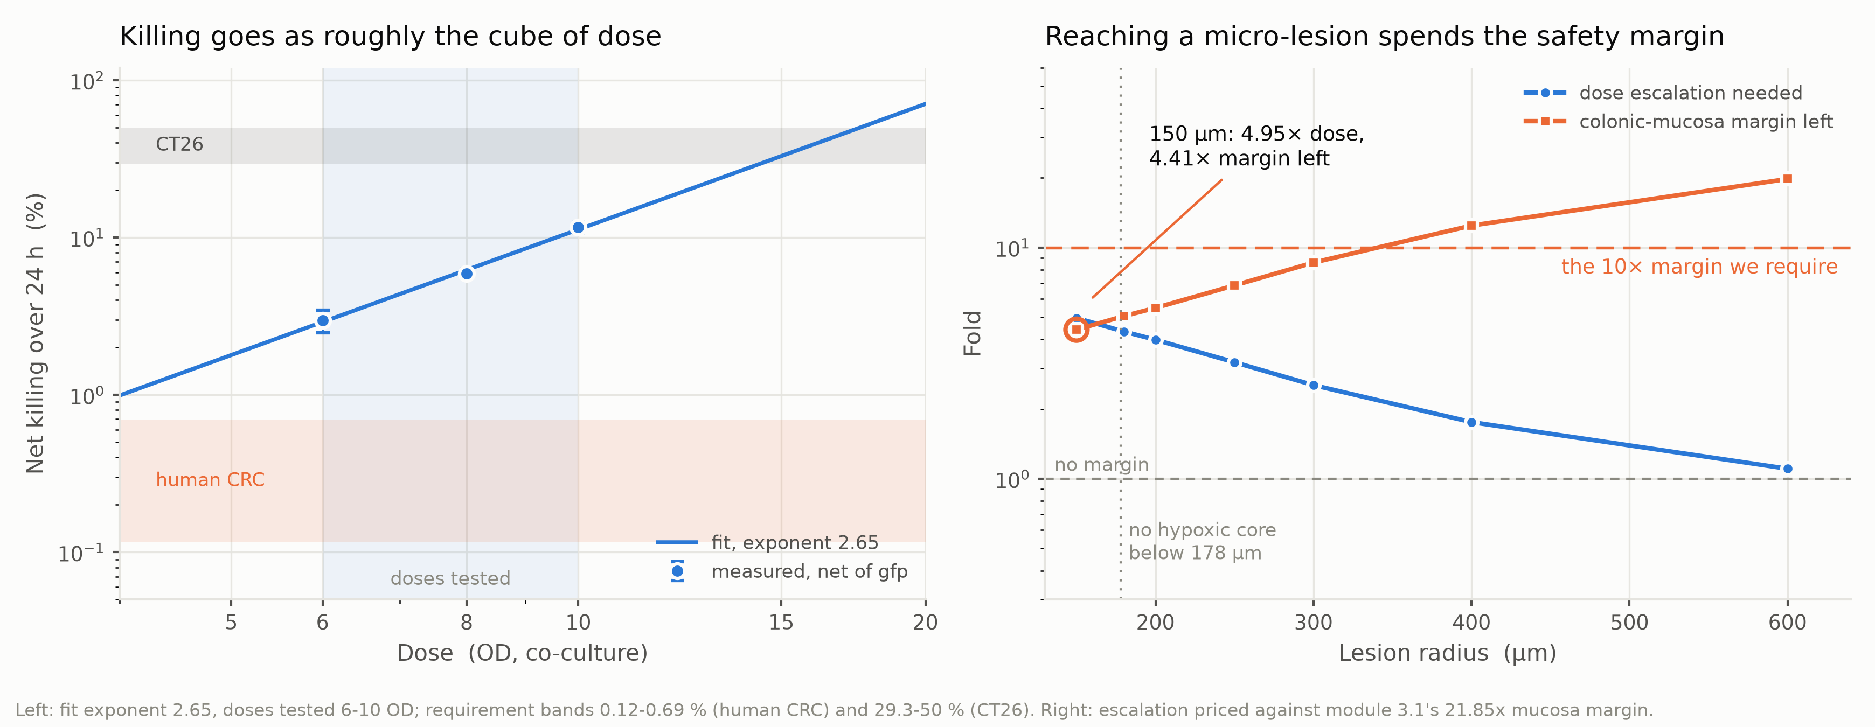
矢量图：outputs/figures/vector/fig4_6_dose_requirement.svg（另有同名 .pdf）
Figure 8. Dose–kill relation, and the escalation and remaining margin against lesion radius. Left: net CT26 killing over 24 h against co-culture dose, logarithmic axes. Points are measurements net of the GFP control with standard-error bars, the shaded band the doses tested, the line a power-law fit of exponent 2.65 (Eq. (43)), and the horizontal bands the target effect sizes (Eq. (44)), 0.12–0.69 % (human) and 29.3–50 % (CT26). Right: fold change against lesion radius, logarithmic — circles the escalation that radius needs, squares the colonic-mucosa margin left, priced on 21.85-fold. The dashed line at 10 is the required margin, that at 1 none left, the dotted vertical at 178 µm the smallest radius with a hypoxic core; the circled 150 µm point reads 4.95-fold dose, 4.41-fold margin left.
second figure, “Distant lesion outcome vs immune pressure” / “Feasibility boundary” ｜ 原编号：Figure 7
矢量图：outputs/figures/vector/fig6_immune_feasibility.svg（另有同名 .pdf）
Figure 9. Equilibria against immune pressure, and the feasibility boundary at εG = 1. Left: steady states of Eq. (51) at h = 0.20, the escape burden (blue) and the largest burden still cleared (orange) as fractions of capacity, against immune pressure Ψ. Dashed verticals at Ψ = 1 and Ψ_crit = 1.80 bound the shaded region labelled bistable, and are labelled eradication possible and eradication guaranteed; the region to their right is labelled no escape state. Right: the εG = 1 boundary (Eq. (52)) on logarithmic axes of cascade gain G and immune permissiveness ε; the grey region below it is labelled infeasible at any pyroptotic flux, and the shaded horizontal band marks the MSS/pMMR range. Neither G nor ε is measured for this system.
Validation
https://2026.igem.wiki/suda-icpi-china/model/validation/
top summary chart, “Reported internal holdouts” (currently uncaptioned) ｜ 原编号：—
Figure 10. Held-out predictions tested and passed, by test. Paired bars give, for each of the five internal tests, the number of held-out predictions or refits tested and the number that passed, with the count printed at each pair: 6/6 for the dose–kill holdout, 4/4 for the gate at 24 h, 0/4 for the gate at 9 h, 8/8 for the 24 h capacity forecast and 6/6 for the per-construct exponent refit. The horizontal axis is the number of held-out predictions or refits.
Parameters & Sources
https://2026.igem.wiki/suda-icpi-china/model/parameters/
本页无图片。
二、Engineering 模块
Engineering.docx（全篇一套图号）
model_v2/Engineering.docx ← ENGINEERING_DRAFT.md
Test (v1) 下，outputs/figures/video/fig2_2_gate_holdout.png ｜ 原编号：Figure 1（号不变）
新图（已重出，Engineering.docx 已重建，嵌的就是这张）：右图标题“A prediction, not a fit”是论断，改成“Predicted against measured”；底注的“The AND logic holds at the endpoint, not mid-course.”改成只写容差。数据未变。
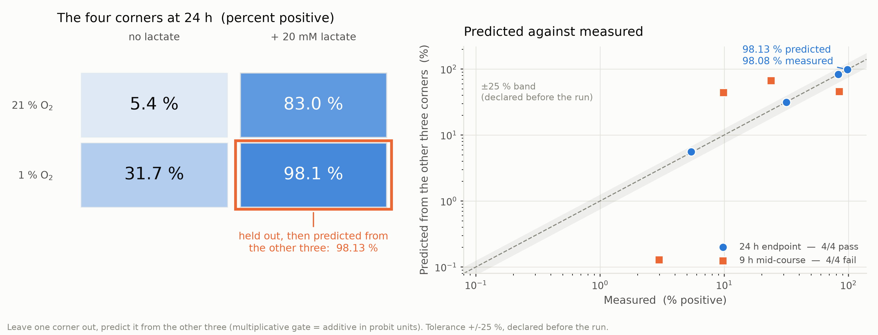
矢量图：outputs/figures/vector/fig2_2_gate_holdout.svg（另有同名 .pdf）
Figure 1. Leave-one-corner-out test of the AND gate at 24 h and at 9 h. Left: the four reporter corners at 24 h, 21 % or 1 % O₂ against 0 or 20 mM lactate, each cell labelled with its percentage of GFP-positive cells and shaded by that value; the outlined cell is the corner held out, and the annotation below it gives the value predicted from the other three. Right: predicted against measured for every held-out corner, both axes logarithmic, with the dashed identity line and the grey ±25 % band declared before the run. Circles are the 24 h endpoint and squares the 9 h mid-course; the legend gives the pass count for each. Percentages are replicate means taken in probit units and mapped back.
Test (v2) 下，fig3_3_arm_direction.png ——与 Model Figure 5 同一张图 ｜ 原编号：Figure 2（号不变）
新图（已重出，Engineering.docx 已重建，嵌的就是这张）：底注删去“Structural: true for every EC50, Hill and basal.”，改为两条臂各自的参数；数据未变——逐像素比对过，wiki 上那张的缺氧臂比值与现行计算一致，原图注里“oxygen-arm ratios reflect earlier values”那句是错的。
矢量图：outputs/figures/vector/fig3_3_arm_direction.svg（另有同名 .pdf）
Figure 2. Tumour-over-site output ratio of each designed sensor arm at six off-target sites. Each pair of bars gives the ratio of that arm's output in the tumour core to its output at the site named on the left, on a logarithmic axis: blue is the lactate arm, orange the hypoxia arm. The vertical line marks a ratio of 1, labelled "no discrimination", and the shaded band to its left marks ratios below it, labelled "anti-selective"; where a ratio is 1 a tick replaces the bar. The native lldPRD repression is not included in either arm. The lactate arm is drawn at EC50 1.6 mM and Hill 1, the hypoxia arm at K = 0.49 % O₂ and Hill 2.
Learn 前，fig4_4_cluster.png ——与 Model Figure 7 同一张图 ｜ 原编号：Figure 3（号不变）
新图（已重出，Engineering.docx 已重建，嵌的就是这张）：底注删去“, not micrometastases”，改为两条虚线各自是什么；图内“ON band (9.23)”里那个 9.23 是已废弃的9.23 文档编号，读者无从理解，改成“ON band (1000 µm)”。数据未变。
矢量图：outputs/figures/vector/fig4_4_cluster.svg（另有同名 .pdf）
Figure 3. Equivalent isolated radius of a cluster of 150 µm micro-lesions against the number of lesions in it. Clusters of 1 to 512 lesions are arranged on a cubic lattice at three centre-to-centre spacings, one series each; the horizontal axis is logarithmic. The two dashed lines are the 150 µm OFF and 1000 µm ON equivalent radii of the single-lesion calibration, and the shaded band above the upper one is labelled "ON band". The annotation records that the 512-lesion touching cluster is a 2.4 mm contiguous mass.
Test 下，fig4_6_dose_requirement.png ——与 Model Figure 8、Description Figure 3 同一张图 ｜ 原编号：Figure 4（号不变）
新图（已重出，Engineering.docx 已重建，嵌的就是这张）：底注删去“CT26 needs 1.3-1.8x the highest dose tested…”，改为两幅图各自的参数与band；右图标注去掉“— under the line”；旧图底注的 19.6× 已更新为 21.85×，并补上 10× 要求线与 150 µm 标注点。
矢量图：outputs/figures/vector/fig4_6_dose_requirement.svg（另有同名 .pdf）
Figure 4. Dose–kill relation, and the escalation and remaining margin against lesion radius. Left: net CT26 killing over 24 h against co-culture dose, logarithmic axes. Points are measurements net of the GFP control with standard-error bars, the shaded band the doses tested, the line a power-law fit of exponent 2.65, and the horizontal bands the target effect sizes, 0.12–0.69 % (human) and 29.3–50 % (CT26). Right: fold change against lesion radius, logarithmic — circles the escalation that radius needs, squares the colonic-mucosa margin left, priced on 21.85-fold. The dashed line at 10 is the required margin, that at 1 none left, the dotted vertical at 178 µm the smallest radius with a hypoxic core; the circled 150 µm point reads 4.95-fold dose, 4.41-fold margin left.
三、Description §1.5 建模插入段
Description_Modeling_Insert.docx（§1.5，接湿实验组那页的图号）
model_v2/Description_Modeling_Insert.docx ← DESCRIPTION_DRAFT.md
fig3_1_tissue_axis.png ——与 Model Figure 4 同一张图 ｜ 原编号：Figure 2（号不变）
新图（已重出，Description_Modeling_Insert.docx 已重建，嵌的就是这张）：底注删去“Bottleneck moves from the dysbiotic lumen to the mucosa.”，只保留图所用的参数；数据未变。
矢量图：outputs/figures/vector/fig3_1_tissue_axis.svg（另有同名 .pdf）
Figure 2. Modelled gate output at six tissue sites, with and without the native lldPRD repression. Each bar is the ratio of gate output in the tumour core to gate output at that site, on a logarithmic axis; the vertical line marks a ratio of 1 and the shaded band to its left marks ratios below it, where a site's output equals or exceeds the tumour's. Blue bars are the designed hypoxia and lactate arms alone; green bars add the native repression of the lldPRD promoter by anoxia and by glucose, entered as 10-fold each. The quorum Hill coefficient is held at the published value of 1 and the oxygen sensor constant at 0.49 % O₂.
fig4_6_dose_requirement.png ——与 Model Figure 8、Engineering Figure 4 同一张图 ｜ 原编号：Figure 3（号不变）
新图（已重出，Description_Modeling_Insert.docx 已重建，嵌的就是这张）：底注删去“CT26 needs 1.3-1.8x the highest dose tested…”，改为两幅图各自的参数与band；右图标注去掉“— under the line”；旧图底注的 19.6× 已更新为 21.85×，并补上 10× 要求线与 150 µm 标注点。
矢量图：outputs/figures/vector/fig4_6_dose_requirement.svg（另有同名 .pdf）
Figure 3. Dose–kill relation, and the escalation and remaining margin against lesion radius. Left: net CT26 killing over 24 h against co-culture dose, logarithmic axes. Points are measurements net of the GFP control with standard-error bars, the shaded band the doses tested, the line a power-law fit of exponent 2.65, and the horizontal bands the target effect sizes, 0.12–0.69 % (human) and 29.3–50 % (CT26). Right: fold change against lesion radius, logarithmic — circles the escalation that radius needs, squares the colonic-mucosa margin left, priced on 21.85-fold. The dashed line at 10 is the required margin, that at 1 none left, the dotted vertical at 178 µm the smallest radius with a hypoxic core; the circled 150 µm point reads 4.95-fold dose, 4.41-fold margin left.

四、三个模块之间重复的图
共 4 张图被两处或三处共用。图片本身已核对为同一版本（与本次重出的新图逐像素一致），图注已统一。
fig3_1_tissue_axis.png
Model Figure 4（Safety 页）｜Description Figure 2
两处图注同文，只有 Model 那条多一个 (Eq. (11))；Description 那条原来缺“oxygen sensor constant at 0.49 % O₂”，已补齐。嵌在 Description_Modeling_Insert.docx 里的图与新图逐像素一致。
fig3_3_arm_direction.png
Model Figure 5（Safety 页）｜Engineering Figure 2
以 Engineering 那条为准统一：原 Model 图注少了“anti-selective”带与“native lldPRD repression is not included”，原 Engineering 图注少了两条臂的参数，现在都写进同一条。Engineering.docx 里原先嵌的是旧图，已重建换成新图。
fig4_4_cluster.png
Model Figure 7（Spatial 页）｜Engineering Figure 3
统一为同一条，Model 那条末尾多一句 Eq. (39)。原 Engineering 图注写的“the only cluster plotted that reaches the threshold”是读图结论，换成标注原话。Engineering.docx 已重建换成新图。
fig4_6_dose_requirement.png
Model Figure 8（Dose & Efficacy 页）｜Engineering Figure 4｜Description Figure 3
三处同文，Model 那条多 (Eq. (43))、(Eq. (44))。三条原来都没写新图里的150 µm 标注点与 21.85× 定价，已补；为守住“图注不超过 130 词”又压掉了几处冗词。Engineering 与 Description 的 docx 都已重建，嵌的图与新图逐像素一致。

