**User Guide**

**1 Technology**

React(port 3000), Redux, antd-mobile(UI framework which make web application running in the mobile), wiremock(port 8080)

**2 Env required. Nodejs and Java**

**3 How to Run**

1. Download from the github, unzip it.

https://github.com/fengg5241/ANZ-interview-accountview-UI

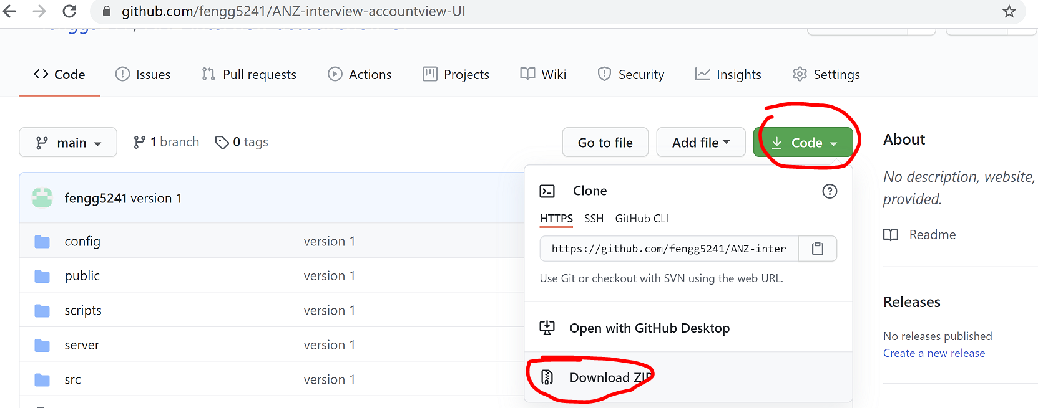

1. Run the wiremock server. Go to <download folder>/ANZ-interview-accountview-UI-main/ server in CMD, then run the command: java -jar wiremock-standalone-2.26.3.jar --port=8080 –verbose. If can see below screenshot, means start up successfully.

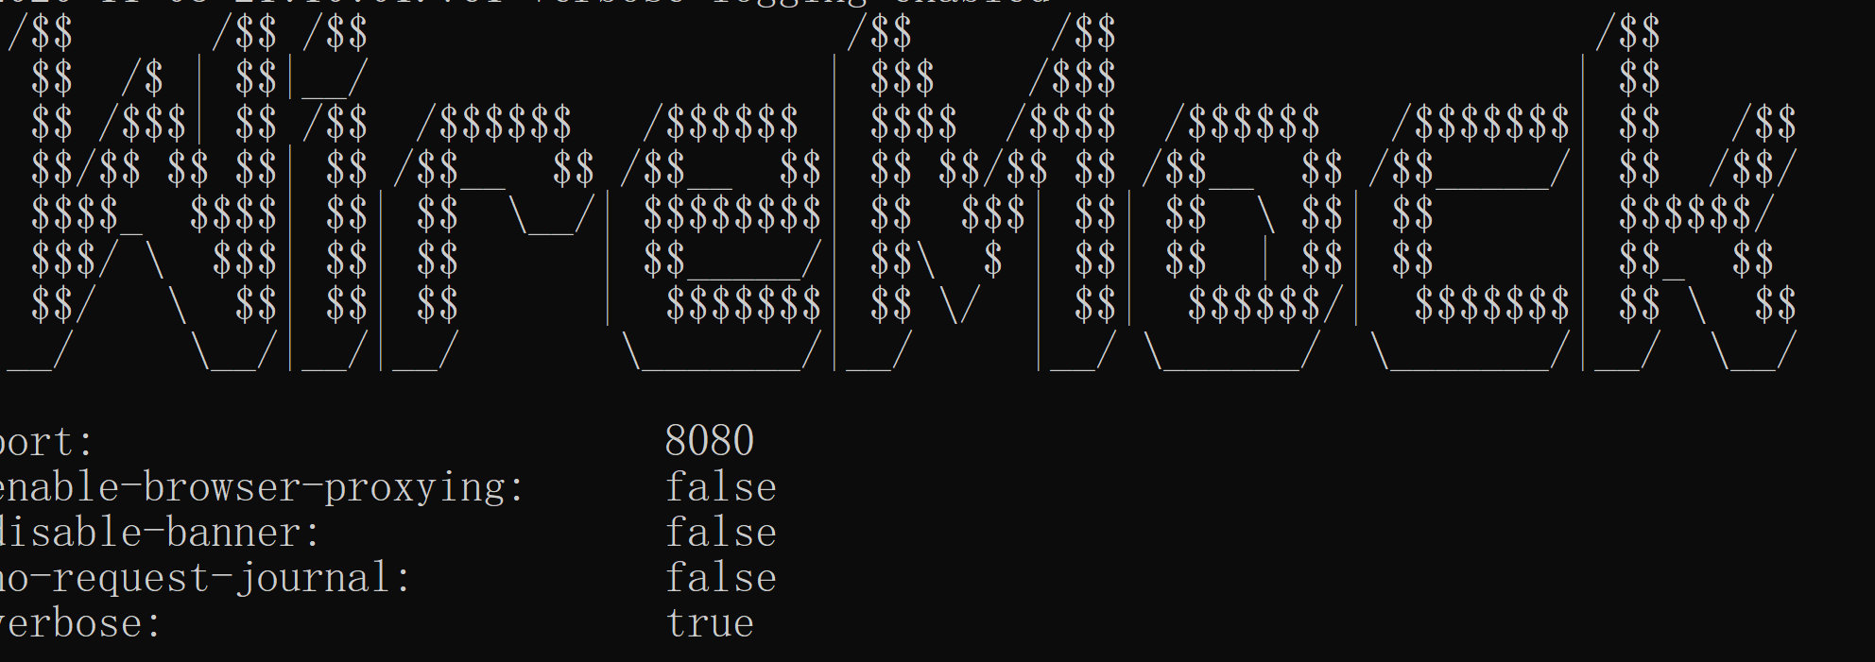

1. Install the dependency lib for the react. Go to <download folder>/ANZ-interview-accountview-UI-main in the CMD, then run “npm install”



1. Run the react . Go to <download folder>/ANZ-interview-accountview-UI-main in the CMD,then run “npm start”, after for a while , should see the logon view.



**4 Logon View (username and password).**

No username and password validation, can input anything then click Login button can go to Account List View.

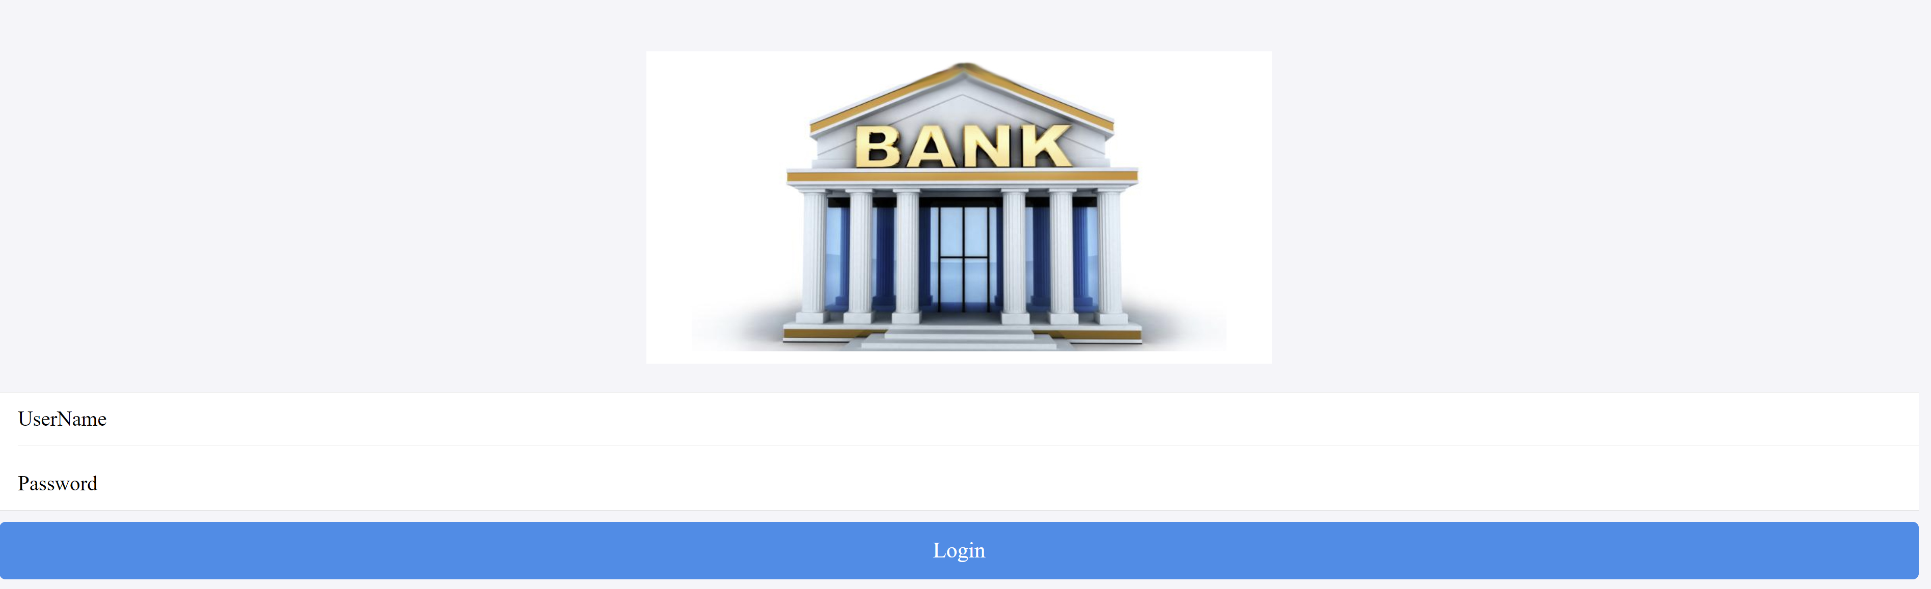

**5 Account List View**

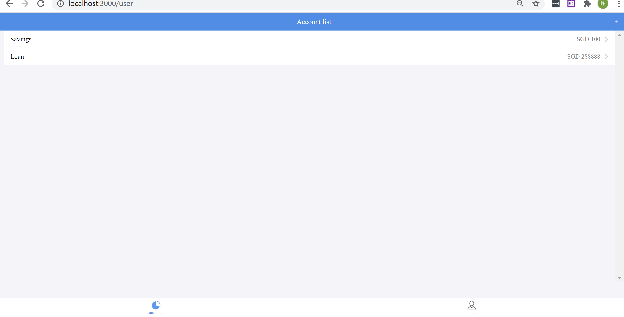

Currently only have two accounts data, they are config in the get_accounts_response.json file under the <download folder>/ANZ-interview-accountview-UI-main/ server/__files.

**6 Transactions List View (transactions belongs to an account)**

Click any one of account record on the Account List View, will go to Transaction list View. The red font color indicates pay out, green color font indicates get money.

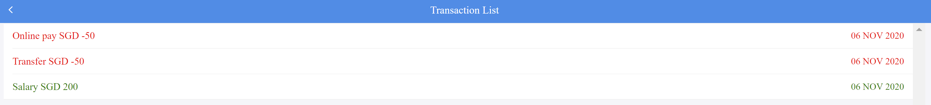

Can click  button to go back previous screen.

**7 New Account Form**

On Account List View screen, can click right top  button to open New Account From screen.

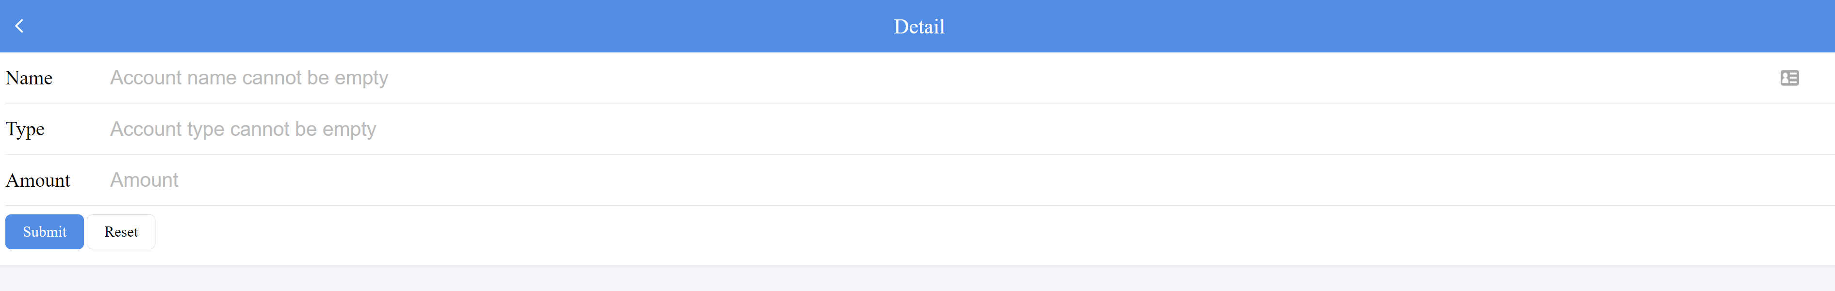

There are some validations here:

1. All of them are mandatory.

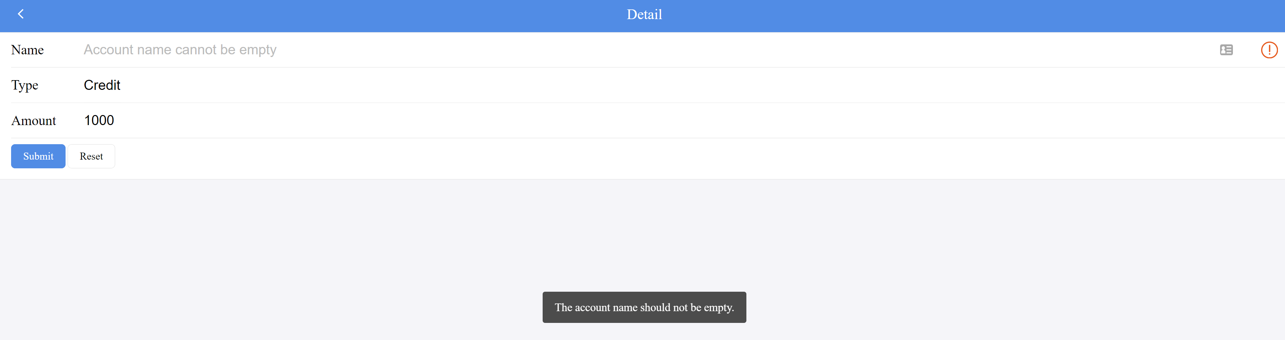

1. Name (alpha numeric only)

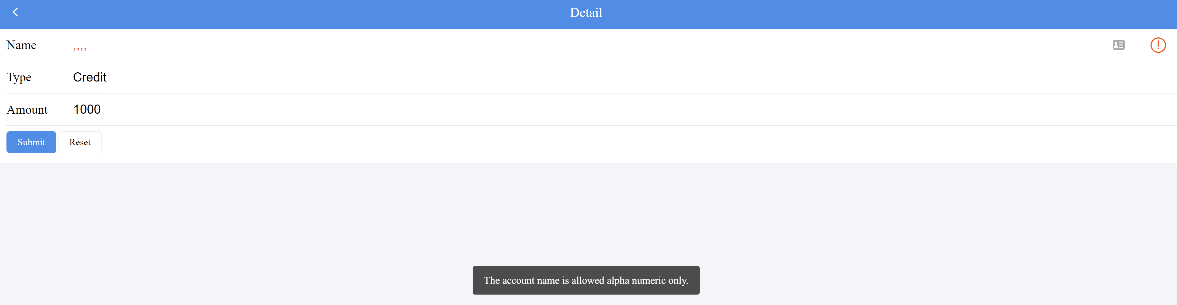

Once click Submit button and pass all the validations , will create new account with pending status like below :

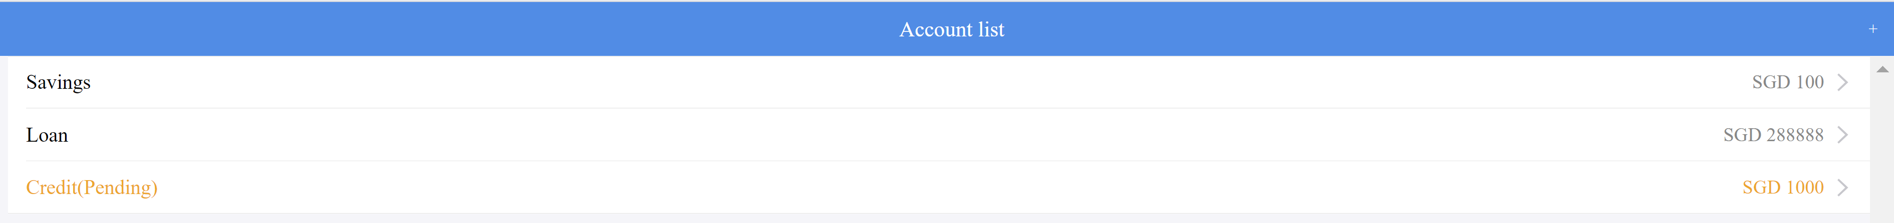

**8 Logout. Can click 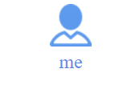 to go to logout screen, then click Logout button to logout.**

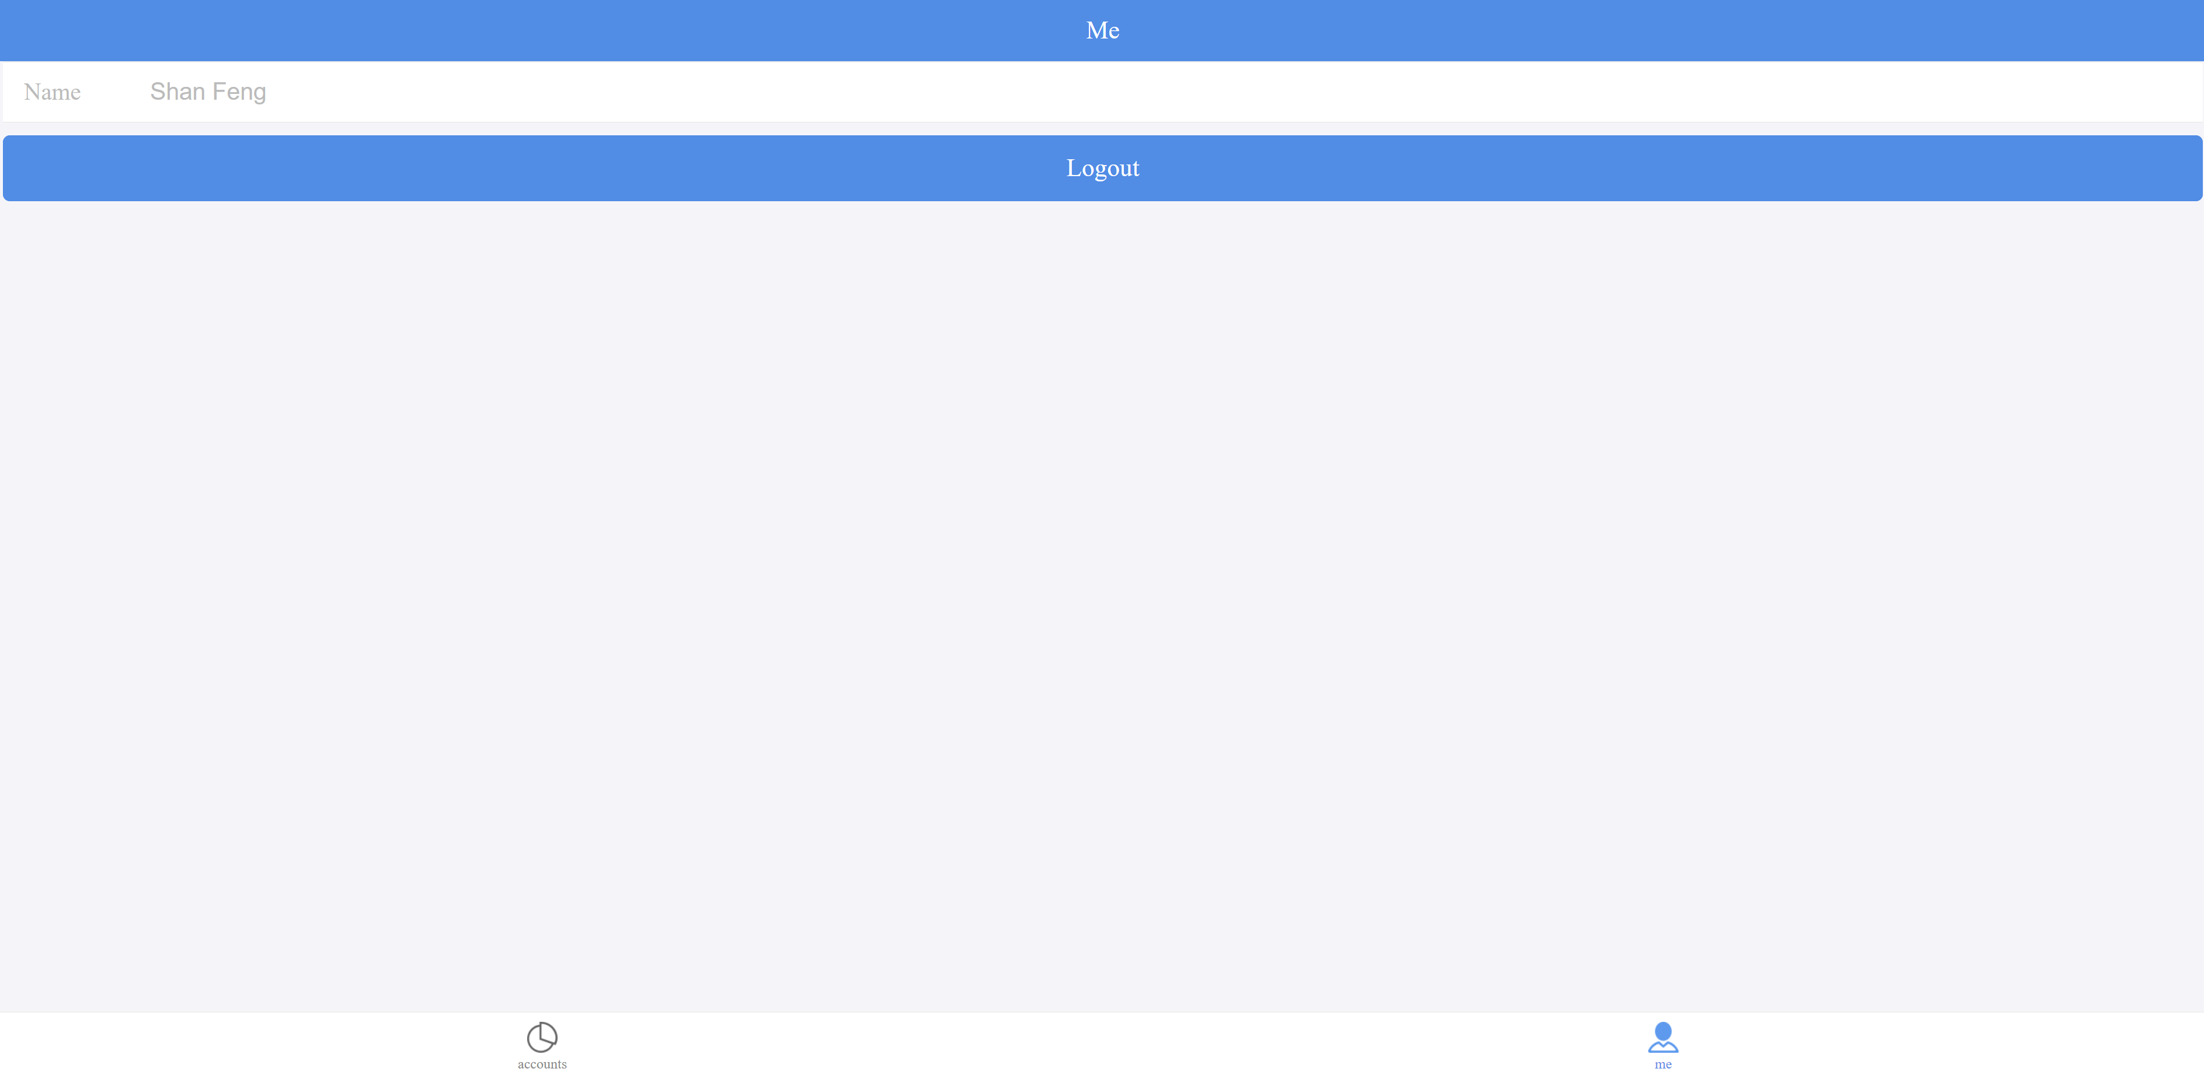

Note: The application has handled http bad request :

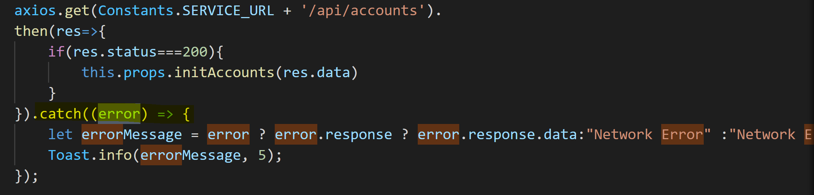

For example, if stop the wiremock server, then load account list view, will see the error like below:

