SUN YIHAN Sylvia
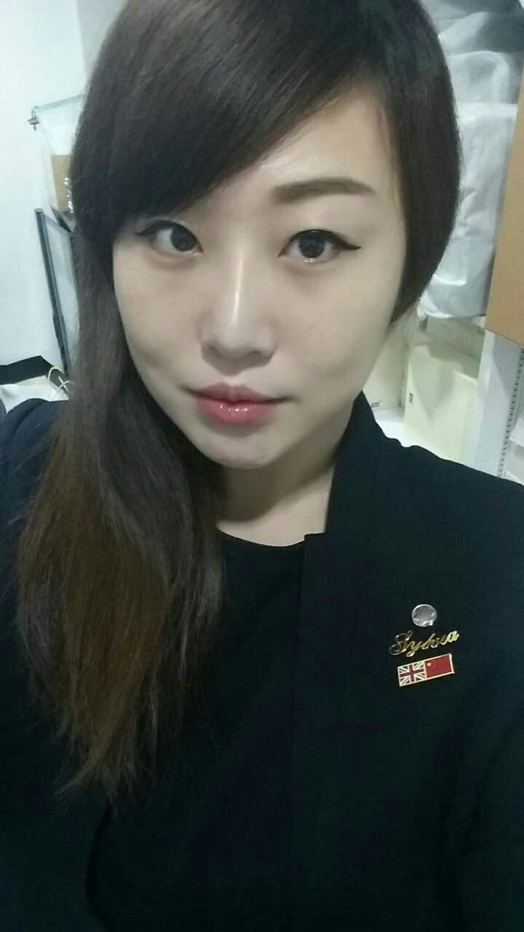
Address: Tampines Street 42 450F #10-394 Singapore 526450
Contact: 6583388437
Email: xufansylvia1986@aliyun.com

Personal Information
Nationality: Chinese
Visit pass: PR
Gender: Female
Date of Birth: 06 May 1986
Qualification: Diploma in Hospitality and tourism Management
Work experience: 10 years
Notice Period: 1 Month

Career Objective
Keen on pursuing a challenging and engaging career that provides the opportunity to proactively utilize skills and knowledge gained. Inculcate innovative ideas to maximise the ingenuity of the task given, thus ensuring an execution that is seamless with perfection. Being a productive and pro-active individual, that would be an asset to the organization itself.

Attributes
- Enthusiastic and self-motivated.
- Extensive customer service experience, actively calling on clients daily with market updates and forecasts, Owns a portfolio of strong relationships, Strong sales experience.
- Good interpersonal communication skills and problem solving skill,
- Experience in general management, business operations and administrative support.
- Ability to remain calm and adopt good judgement in unexpected situations.
- Willing to learn and accept new ideas
- Strong Team Player
- FX and Rates product knowledge

Professional Experience
Louis Vuitton Singapore (Oct 2017 - Current)
Client Advisor
Primary Objective

- Be an ambassador of Louis Vuitton, ensuring that every client is treated according to our promise.
- To strive to discover our clients and their every need, to guide them across the Brand and proactively reach out to them to achieve individual and team goals.

Job Duties & Responsibilities

- Drive and achieve individual and team objectives and be accountable for sales results
- Welcome every Client and provide the best Client experience through the delivery of premium customer service, product knowledge and expertise
- Engage with clients to develop long term relationships and confidence in Louis Vuitton products and services
- Perform as a team player and participate in all activities contributing to the overall objectives of the store.

Richemont Luxury Singapore (Nov 2011 – Oct 2017)
Senior Sales Associate - Montblanc

- Building up a customer data base to keep track of regular clients, thus providing networking opportunities to expand our clientele.
- Weekly reporting of sales target and estimates and ways to boost sales figure.
- Customer analysis and Client data analysis
- Monitor Visual Merchandising
- Control and Maintain stock ( Defective reports)
- Provide Marketing and Promotion support.

Richemont Luxury Singapore (Nov 2007 - Nov 2011)
Sales Associate - Montblanc

- In depth knowledge of a complex range of luxury merchandise ranging from writing instruments, watches, leather goods, jewellery, men's accessories and leather goods.
- Constant product and customer service training to ensure that we are well equipped in delivering an exceptional sales experience.
- Providing after sales service with regards to warranty coverage and engraving/embossing of products.
- Maintaining stock inventory and replenishiment and stock taking.
- Meeting sales target and upselling /cross selling of the products.
- Perform point-of-sales operations

Mandarin Oriental Hotel Singapore (July 2006 – Aug 2007)
Guest Services Associate
- Make sure the food and drinks are well served to hotel and walk-in guests..
- Welcome every single guest and make them feel home..
- Maintain the hygiene of the pantry and environment.
- Consistently work in accordance with established gudelines, procedures and performance standards.

Education Background
Nanyang Institute of Management (2003 – 2005)
- Diploma in Hospitality and tourism Managment
Languages Spoken/Writing Skills
- Proficient in Mandarain and English
Skills
- First Aid Course
- Basic Excel skill
- Microsoft office

Certification
- Customer service skills programme -- Changi Airport Group
- Effective retail selling skill programme -- Singapore retailers assoiation
- Work experience attachment in Front office and Food& beverage Departments -- Shangri-La Hotels and Resorts
- Basic food hygiene test -- Singapore Enviorment Institute

Hobbies
- Lanuguages learning
- Fashion
- Swimming and outdoor activity
- Travel &Culture

