User guidelines

1 How to run application.

Open the index.html file can under the src folder of SCB-Prize then can see the home page.

2 Home Page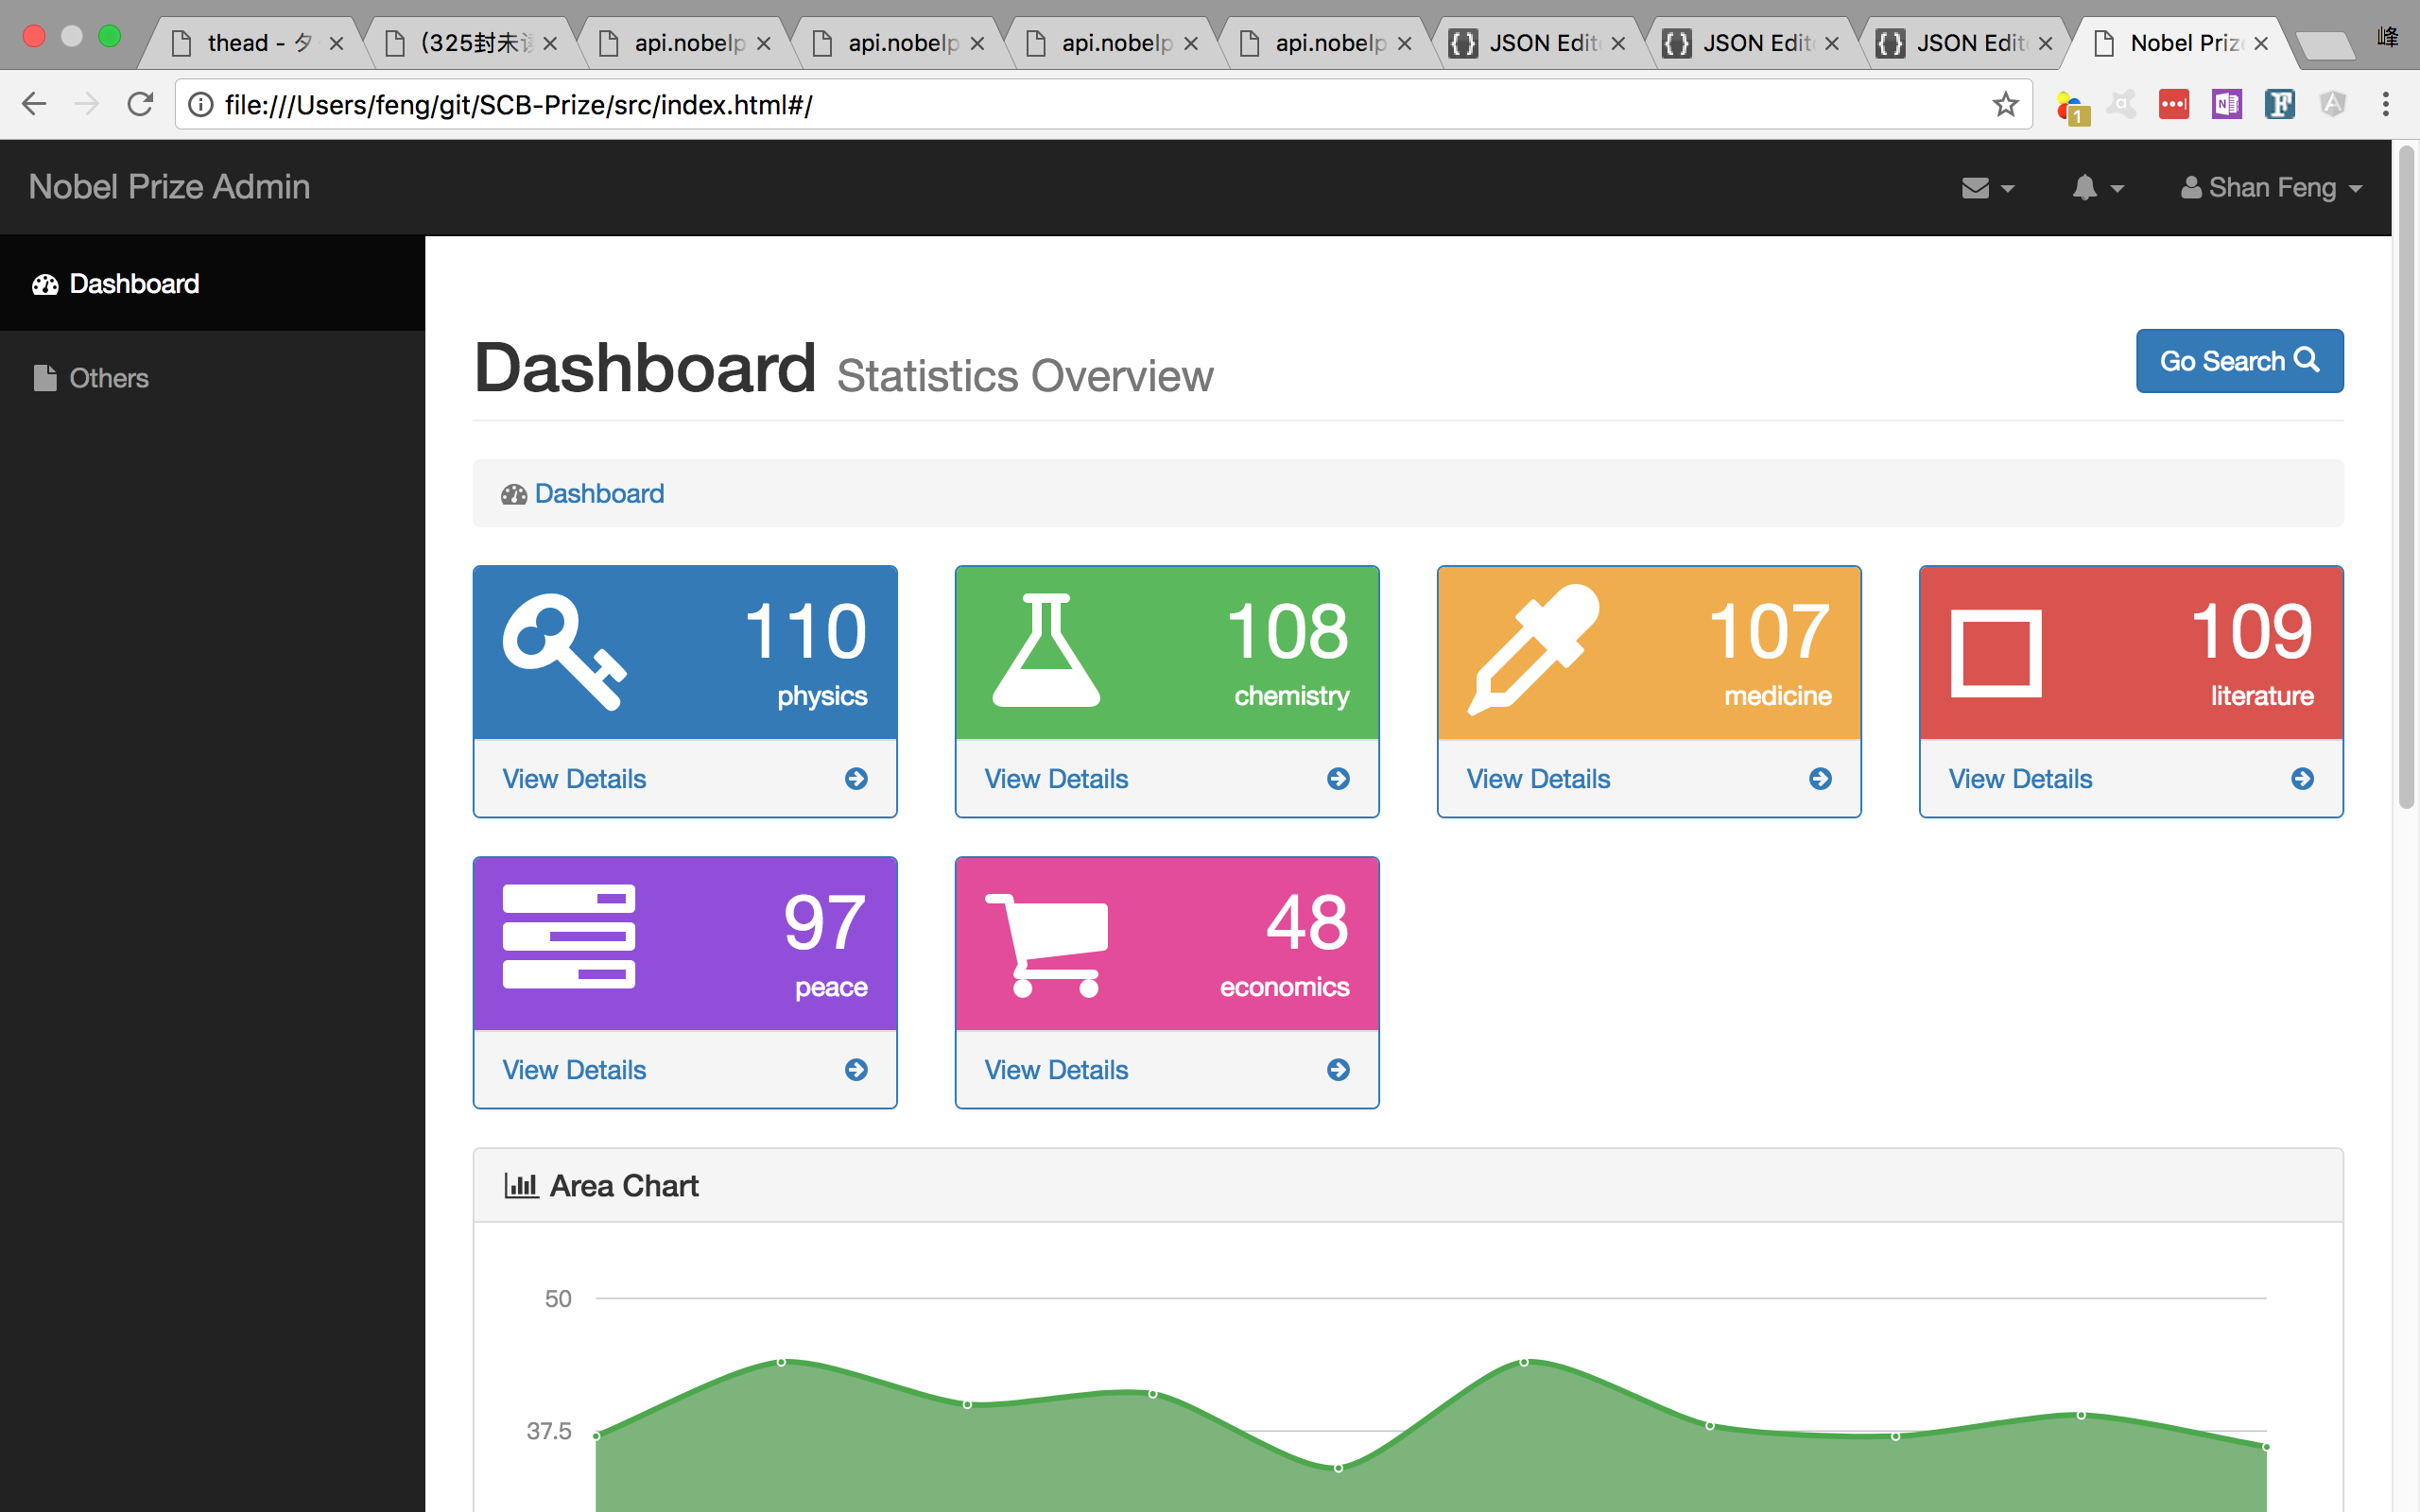

1

2

3

4

part 1 is left menu , so far only Dashboard menu item is working, others is used for new feature extension. When click Dashboard, will display home page.

part 2 is header area to display current page name . The Go Search button on the right is used for navigating the search page.

part 3 is breadcrumb to track the path.

part 4 is category list view. Please refer to below pic :

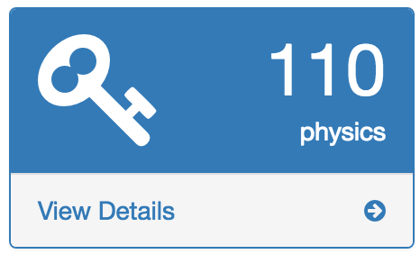

4.1

4.2

4.3

Different category view has different color.

Part 4.1 is icon to indicate this category.

The top of part 4.2 is the number of laureates till date. the bottom of part 4.2 is category name;

Clicking part 4.3 area will navigate to Prize List Page.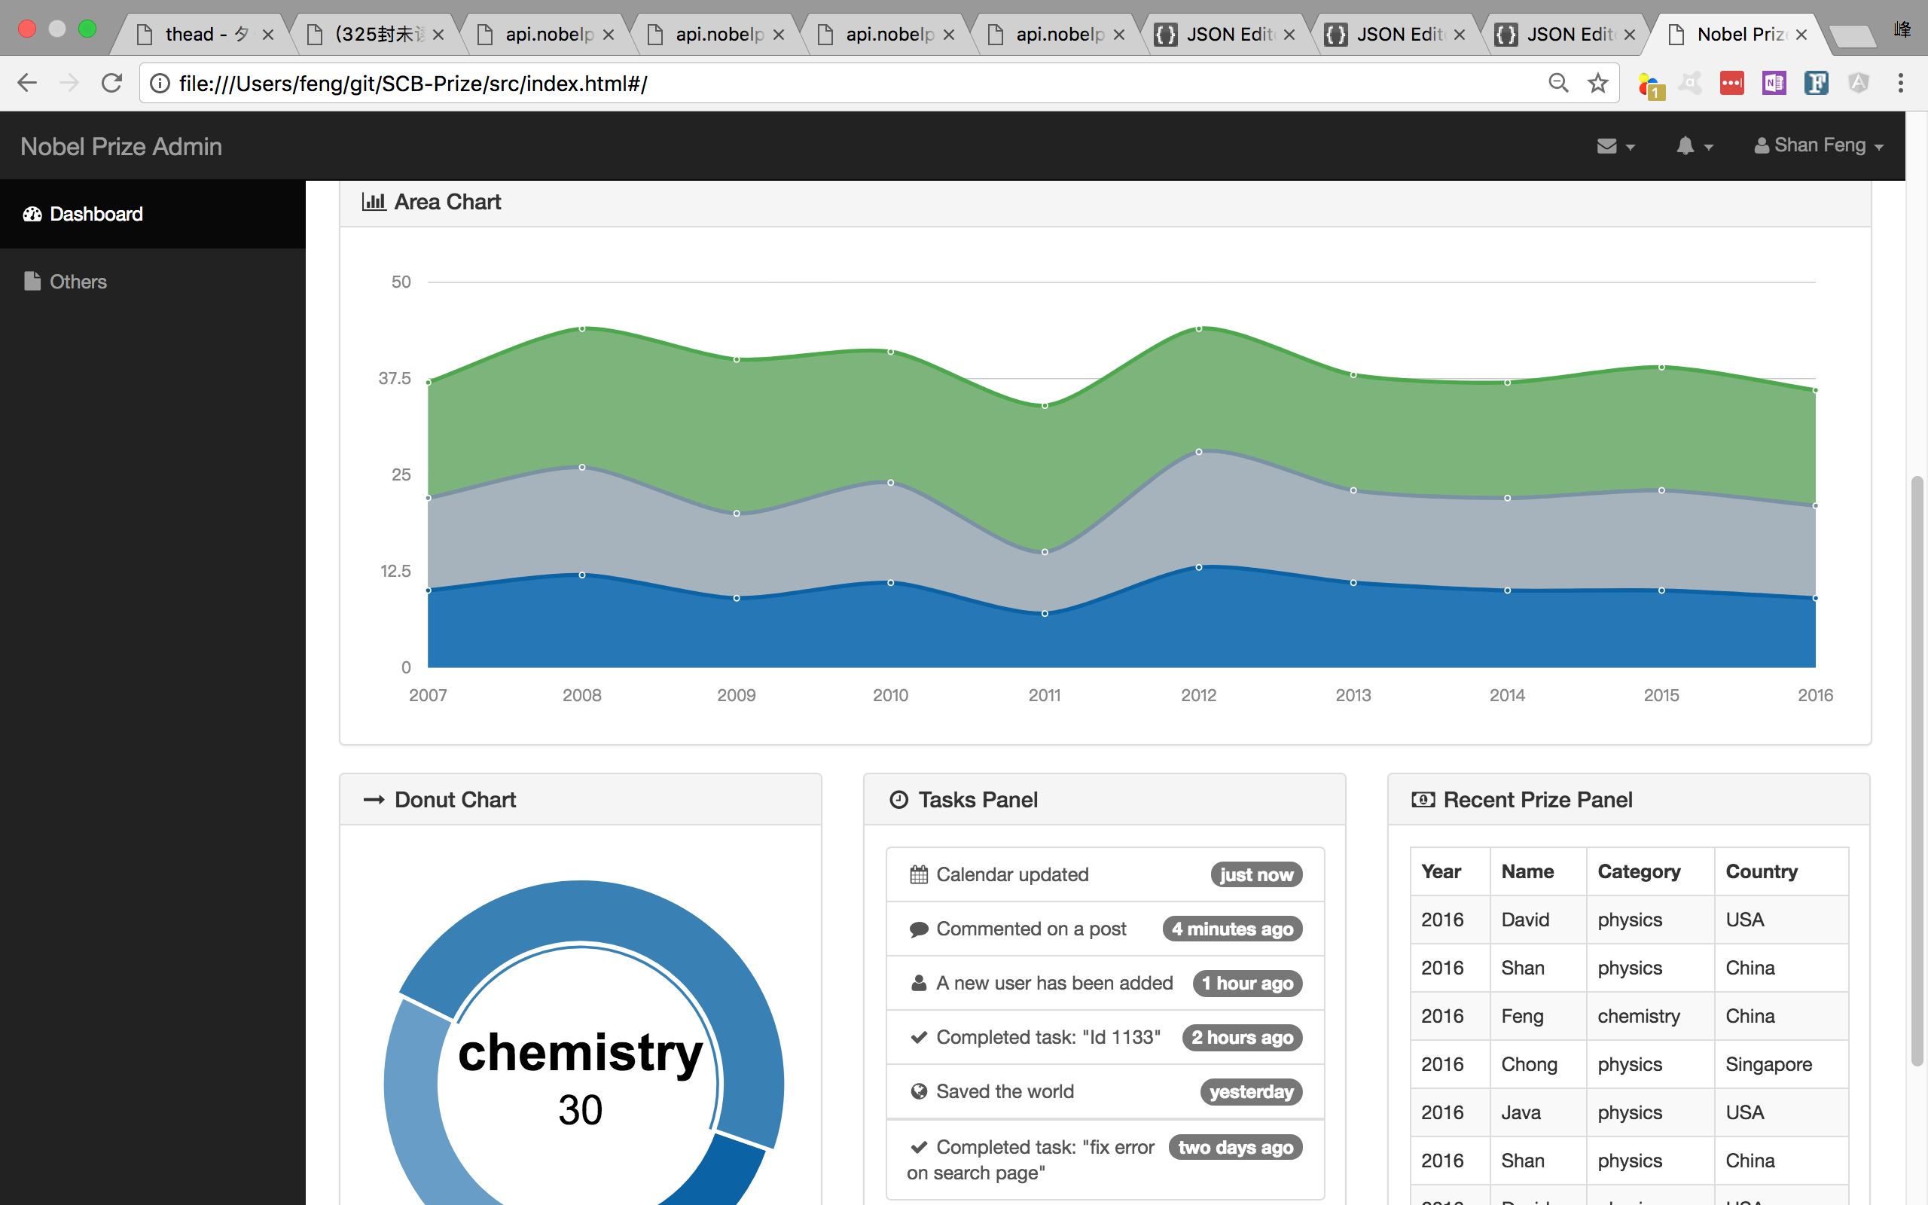

5

6

7

8

part 5-8 are not in the scope of requirements, i just add them to display more info from different view for category list and so I just use dummy date, not from json request.

3 Prize List Page

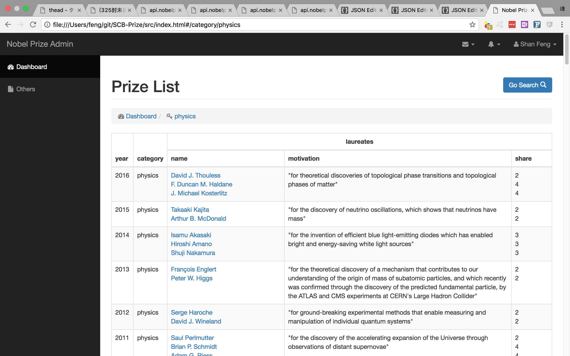

2

1

Part 1 is breadcrumb. Can toggle between the categories and results list.

Part 2 is prize list table. It load all the laureates in the category by year with the latest on top

The laureate name with a hyperlink that can navigate to Laureate Detail Page.

4 Laureate Detail Page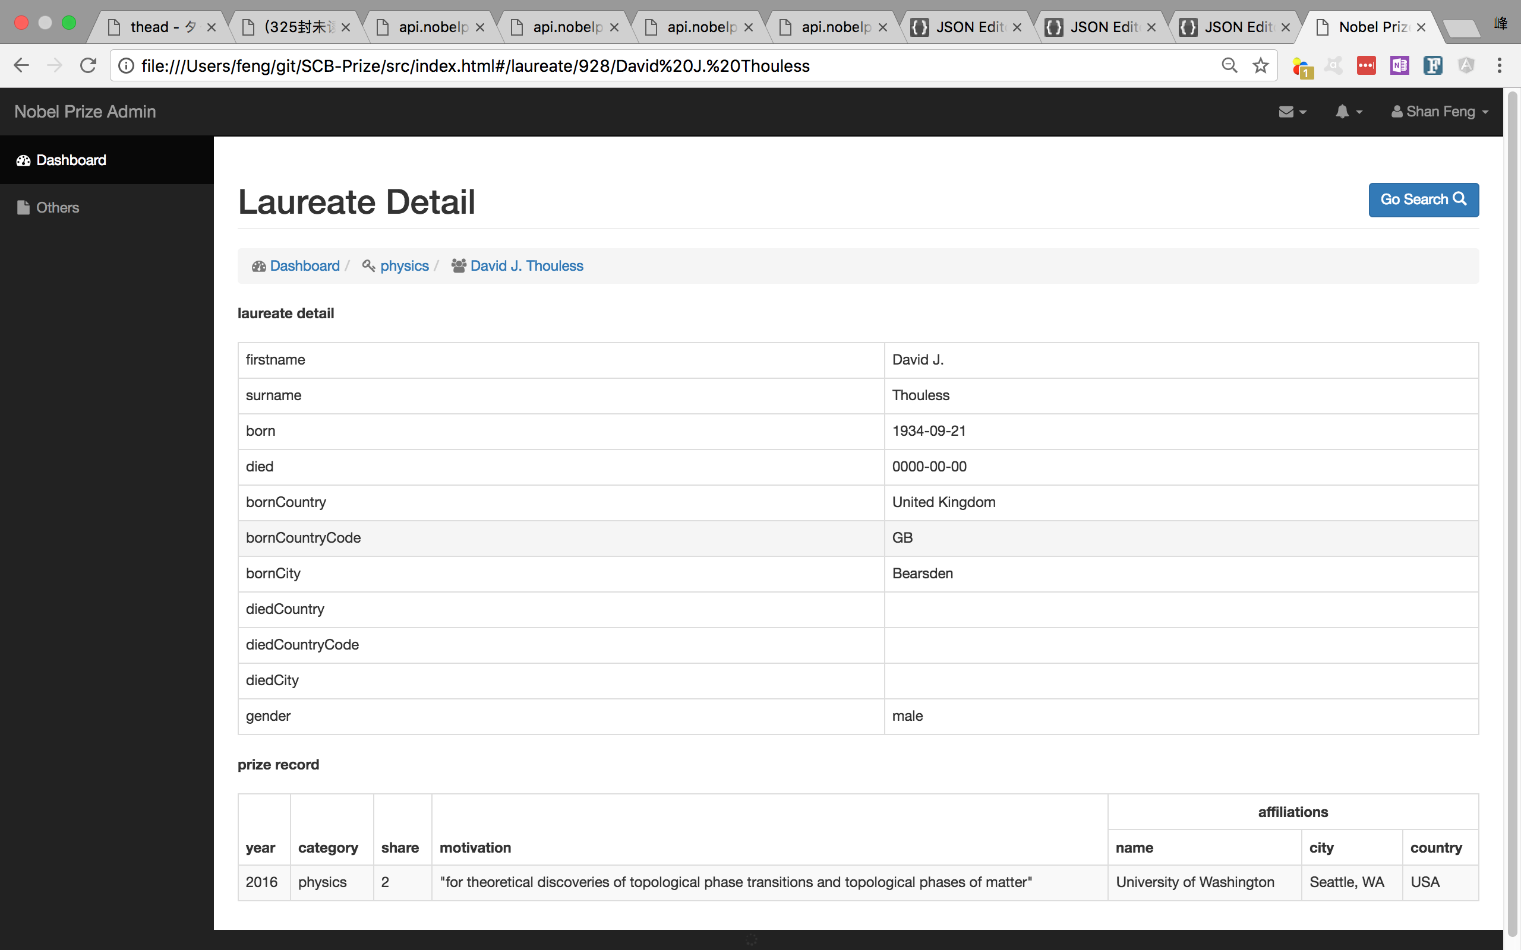

1

2

Part 1 is breadcrumb. Can toggle between the categories , results list and the laureate details without having to reload.

Part 2 is to display detail info of laureate.

**5 Search Page**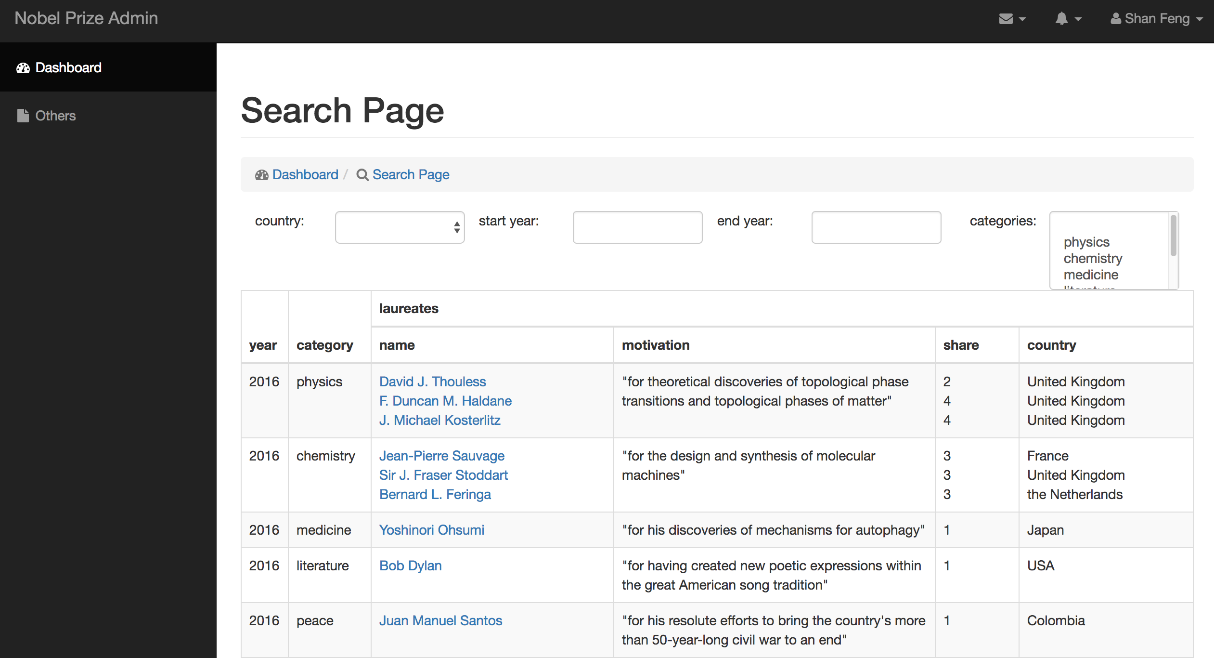

1

1

2

Part1 is search condition area which is a search interface to search by Country, year range, categories (multi-select).

Search by Country: Select from country dropdown list which includes all the available countries.

Clear country search : choose the top option which is empty in the dropdown list .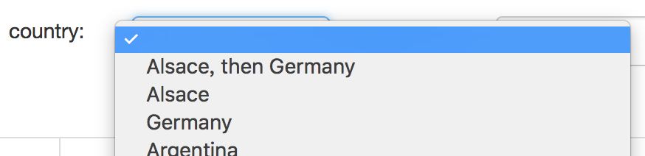

Search by Year Range: Enter year in start year input box as minimum value of Year Range and enter year in end year input box as maximum value of Year Range. Two values are optional.

Clear Year Range search: Clear value in these two input boxes.

Search by categorise(multi-select): Multi-Select from categories list box which includes all the available categories.

Clear categorise search : choose the top value which is empty in the this list box .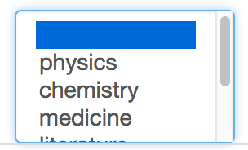

Note: The search interface is created based on angular filter, so no need to click any button or enter any key , will trigger to filter the result if you change the search condition.

Part2 is display search result.

6 Code

**1) Code structure.**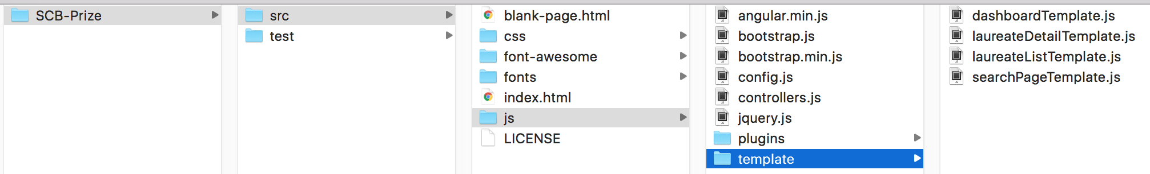

Use anguarjs 1.5.3 and bootstrap css framework which can support responsive UI layout.

All the controller info wrote in the controllers.js

The route config is wrote in the config.js

The used template html are wrote in the *Template.js under the template folder.(It is not a good practice, I will explain at the latter(2) need to improve)

The unit test is wrote in the test folder, as limited time , I only write one test for the one controller by Jasmine.

I use some Jquery plugins to render some charts in order to prove i am familiar with Jquery as well.

**2) Need to improve**

a. The template issue. As I run the application in my file location, not by web server, in this scenario , cannot load html file by “templateurl" of angular route, only support for loading html string by “template”, so I have to convert the related template html to string and store in the js file.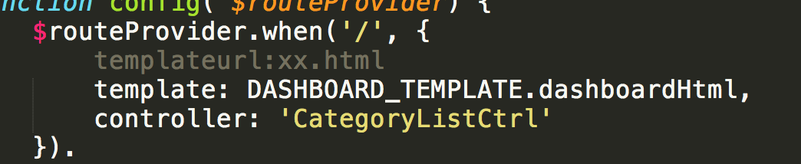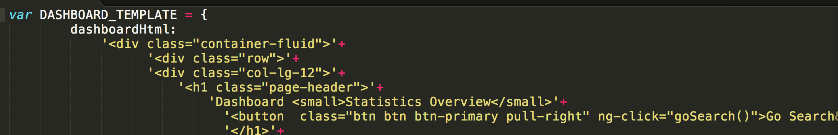

b. Add angular spinner while loading for better user experience.

c. Write more unit test code to make sure the coverage high enough.