1、SRIO和DDR连接示意图 dsp_top.h



2、DSP调用DDR的nb_transport_fw()函数

bool DMAC::SRIOTRANS2OTHER(tlm::tlm_phase PHASE, DMAC_CMD CMD,unsigned int CH_ID, unsigned char* DATA_PTR , sc_time DELAY){

tlm::tlm_generic_payload p_trans2other;

p_trans2other.set_data_ptr(DATA_PTR);

p_trans2other.set_address(CMD);

p_trans2other.set_data_length(CH_ID); //use data length to label the core id

p_trans2other.set_streaming_width(1); //use streaming_width 1 to label the SRIO transport

init_socket2ddr->nb_transport_fw(p_trans2other, PHASE, DELAY);//trans2ddr

if(p_trans2other.get_response_status() == tlm::TLM_OK_RESPONSE){

return true;

}else{

return false;

}

}

其中DATA_PTR数据格式为SRIO_FRAME

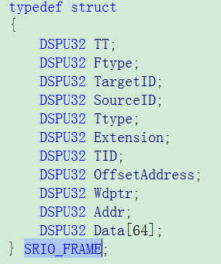

3、DDR调用DSP的nb_transport_fw()函数

if(!srio_rd_data_vec[coreid].empty() && srio_rd_data_vec[coreid][0].second == 0)

{

//last accept, trans new if there is

p_trans2core.set_streaming_width(1); //use streaming_width 1 to label the SRIO transport

p_trans2core.set_data_ptr((unsigned char*)&srio_rd_data_vec[coreid][0].first);

init_socket2dmac0->nb_transport_fw(p_trans2core, ph, tt);

if(p_trans2core.get_response_status() == tlm::TLM_OK_RESPONSE ){

srio_rd_data_vec[coreid].erase(srio_rd_data_vec[coreid].begin()); //accept then erase

}

}

srio_rd_data_vec[]的数据结构为



第一个SRIO_FRAME为传输的帧，第二个int为延时。