DS HW2 notes

1. state graph
2. request-send-ack
blocked client always wait for the end of input stream
3. when receive:
when it is correctly received
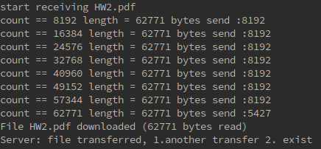

when it is corrupted:

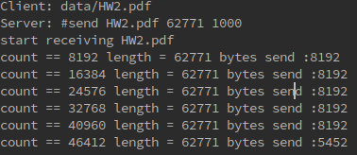

fix: retry:
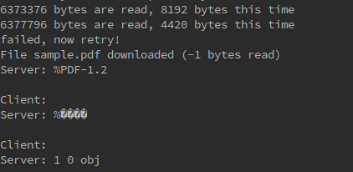

if retry: Use different sockets?

