创建存储过程：

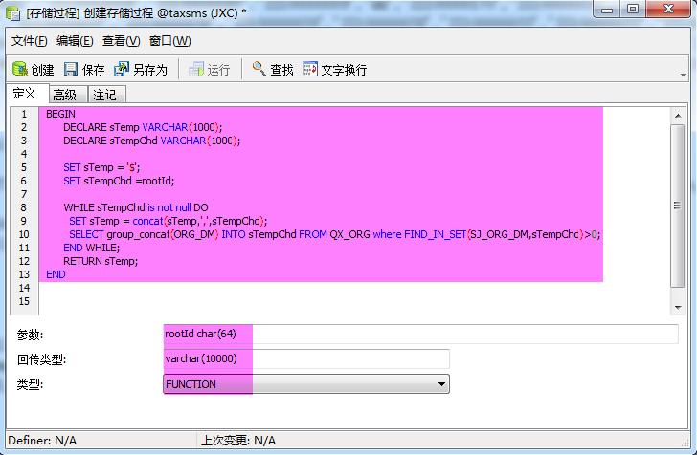

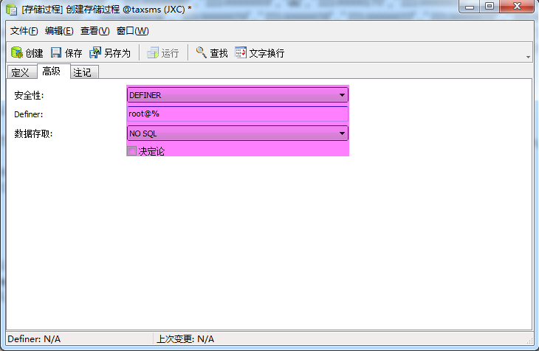

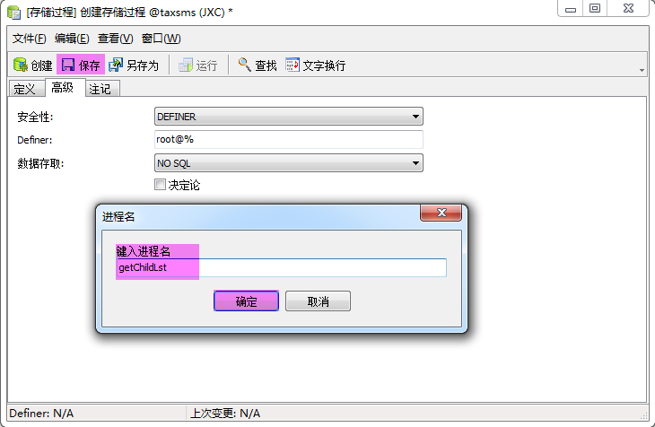

同样方式增加存储过程：getParentLst

注：
存储过程全部函数为
-- Function "getChildLst" DDL

CREATE DEFINER=`root`@`%` FUNCTION `getChildLst`(rootId char(64)) RETURNS varchar(10000) CHARSET utf8 COLLATE utf8_unicode_ci
NO SQL
BEGIN

DECLARE sTemp VARCHAR(1000);

DECLARE sTempChd VARCHAR(1000);

SET sTemp = '$';

SET sTempChd =rootId;

WHILE sTempChd is not null DO

SET sTemp = concat(sTemp,',',sTempChd);

SELECT group_concat(ORG_DM) INTO sTempChd FROM QX_ORG where FIND_IN_SET(SJ_ORG_DM,sTempChd)>0;

END WHILE;

RETURN sTemp;

END;

-- Function "getParentLst" DDL

CREATE DEFINER=`root`@`%` FUNCTION `getParentLst`(rootId char(64)) RETURNS varchar(1000) CHARSET utf8 COLLATE utf8_unicode_ci
NO SQL
BEGIN

DECLARE sTemp VARCHAR(1000);

DECLARE sTempChd VARCHAR(1000);

SET sTemp = '$';

SET sTempChd =rootId;

WHILE sTempChd is not null DO

SET sTemp = concat(sTemp,',',sTempChd);

SELECT group_concat(SJ_ORG_DM) INTO sTempChd FROM QX_ORG where FIND_IN_SET(ORG_DM,sTempChd)>0;

END WHILE;

RETURN sTemp;

END;

