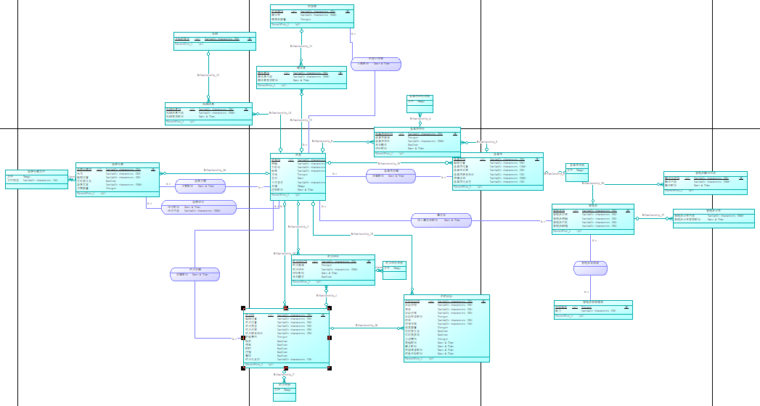

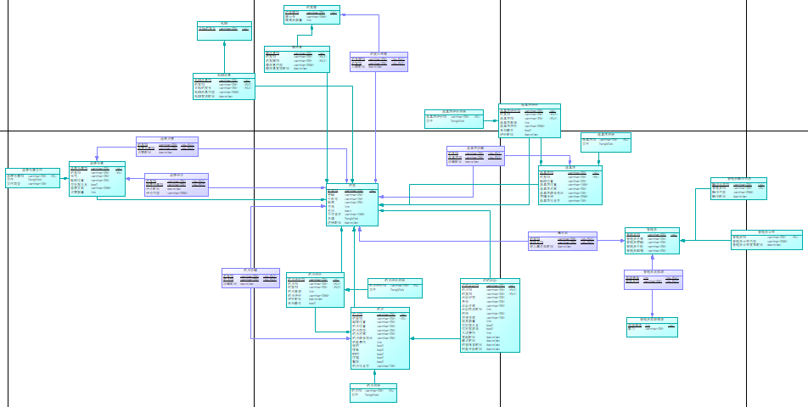

|  |  |  |  |  |  |  |  |
| --- | --- | --- | --- | --- | --- | --- | --- |
| 数据表名 | | 钓友群 | | |  |  |  |
| 表code | | fisherman_group | | |  |  |  |
| 序号 | 字段名 | 字段code | 数据类型 | 宽度 | 主键 | 能否为空 | 外键 |
| 1 | 钓友群ID | fisherman_groupID | varchar | 50 | 1 | 否 |  |
| 2 | 群公告 | group_post | varchar | 500 |  |  |  |
| 3 | 群成员数量 | group_fisherman_number | int |  |  | 否 |  |

|  |  |  |  |  |  |  |  |
| --- | --- | --- | --- | --- | --- | --- | --- |
| 数据表名 | | 群消息 | | |  |  |  |
| 表code | | group_message | | |  |  |  |
| 序号 | 字段名 | 字段code | 数据类型 | 宽度 | 主键 | 能否为空 | 外键 |
| 1 | 群消息ID | group_messageID | varchar | 50 | 1 | 否 |  |
| 2 | 钓友ID | fishermanID | varchar | 50 |  | 否 | 1 |
| 3 | 钓友群ID | fisherman_groupID | varchar | 50 |  | 否 | 1 |
| 4 | 群消息内容 | groupmessage | varchar | 500 |  | 否 |  |
| 5 | 群消息发送时间 | groupmessage_sendtime | datetime |  |  | 否 |  |

|  |  |  |  |  |  |  |  |
| --- | --- | --- | --- | --- | --- | --- | --- |
| 数据表名 | | 钓友所在群 | | |  |  |  |
| 表code | | groupandfisherman | | |  |  |  |
| 序号 | 字段名 | 字段code | 数据类型 | 宽度 | 主键 | 能否为空 | 外键 |
| 1 | 入群时间 | joingrouptime | datetime |  |  | 否 |  |
| 2 | 钓友ID | fishermanID | varchar | 50 |  | 否 | 1 |
| 3 | 钓友群ID | fisherman_groupID | varchar | 50 |  | 否 | 1 |

|  |  |  |  |  |  |  |  |
| --- | --- | --- | --- | --- | --- | --- | --- |
| 数据表名 | | 私聊消息 | | |  |  |  |
| 表code | | onlytalk_message | | |  |  |  |
| 序号 | 字段名 | 字段code | 数据类型 | 宽度 | 主键 | 能否为空 | 外键 |
| 1 | 私聊消息ID | messageID | varchar | 50 | 1 | 否 |  |
| 2 | 钓友ID | fishermanID | varchar | 50 |  | 否 | 1 |
| 3 | 目的钓友ID | targetfishermanID | varchar | 50 |  | 否 | 1 |
| 4 | 私聊消息内容 | onlytalkmessage | varchar | 500 |  | 否 |  |
| 5 | 私聊发送时间 | onlytalksendtime | datetime |  |  | 否 |  |

|  |  |  |  |  |  |  |  |
| --- | --- | --- | --- | --- | --- | --- | --- |
| 数据表名 | | 私聊 | | |  |  |  |
| 表code | | onlytalk | | |  |  |  |
| 序号 | 字段名 | 字段code | 数据类型 | 宽度 | 主键 | 能否为空 | 外键 |
| 1 | 目标钓友ID | targetfishermanID | varchar | 50 | 1 | 否 |  |

|  |  |  |  |  |  |  |  |
| --- | --- | --- | --- | --- | --- | --- | --- |
| 数据表名 | | 渔具店 | | |  |  |  |
| 表code | | fishshop | | |  |  |  |
| 序号 | 字段名 | 字段code | 数据类型 | 宽度 | 主键 | 能否为空 | 外键 |
| 1 | 渔具店ID | fishshopID | varchar | 50 | 1 | 否 |  |
| 2 | 钓友ID | fishermanID | varchar | 50 |  | 否 | 1 |
| 3 | 地理位置 | location | varchar | 50 |  | 否 |  |
| 4 | 渔具店位置 | fishermanlocation | varchar | 100 |  | 否 |  |
| 5 | 渔具店名称 | fishshopname | varchar | 50 |  | 否 |  |
| 6 | 渔具店联系电话 | fishshopphone | varchar | 20 |  | 否 |  |
| 7 | 店铺介绍 | fishshoptext | varchar | 500 |  |  |  |
| 8 | 渔具店可见性 | fishshopvisibility | varchar | 20 |  | 否 |  |

|  |  |  |  |  |  |  |  |
| --- | --- | --- | --- | --- | --- | --- | --- |
| 数据表名 | | 渔具店相册 | | |  |  |  |
| 表code | | fishshop_photo | | |  |  |  |
| 序号 | 字段名 | 字段code | 数据类型 | 宽度 | 主键 | 能否为空 | 外键 |
| 1 | 渔具店ID | fishshopID | varchar | 50 | 1 | 否 | 1 |
| 2 | 照片 | photo | longblob |  |  |  |  |

|  |  |  |  |  |  |  |  |
| --- | --- | --- | --- | --- | --- | --- | --- |
| 数据表名 | | 渔具店评价 | | |  |  |  |
| 表code | | fishshop_assess | | |  |  |  |
| 序号 | 字段名 | 字段code | 数据类型 | 宽度 | 主键 | 能否为空 | 外键 |
| 1 | 渔具店评价ID | fishshopassessID | varchar | 50 | 1 | 否 |  |
| 2 | 渔具店ID | fishshopID | varchar | 50 |  | 否 | 1 |
| 3 | 钓友ID | fishermanID | varchar | 50 |  | 否 | 1 |
| 4 | 渔具店星级 | fishshopstar | int |  |  | 否 |  |
| 5 | 渔具店评价 | fishshopassess | varchar | 500 |  |  |  |
| 6 | 评价时间 | assesstime | datetime |  |  |  |  |
| 7 | 是否匿名 | anonymity | boolean |  |  |  |  |

|  |  |  |  |  |  |  |  |
| --- | --- | --- | --- | --- | --- | --- | --- |
| 数据表名 | | 渔具店评价相册 | | |  |  |  |
| 表code | | fishshop_assess_photo | | |  |  |  |
| 序号 | 字段名 | 字段code | 数据类型 | 宽度 | 主键 | 能否为空 | 外键 |
| 1 | 渔具店评价ID | fishshopassessID | varchar | 50 | 1 | 否 | 1 |
| 2 | 照片 | photo | longblob |  |  |  |  |

|  |  |  |  |  |  |  |  |
| --- | --- | --- | --- | --- | --- | --- | --- |
| 数据表名 | | 渔具店收藏 | | |  |  |  |
| 表code | | fishshopcollect | | |  |  |  |
| 序号 | 字段名 | 字段code | 数据类型 | 宽度 | 主键 | 能否为空 | 外键 |
| 1 | 钓友ID | fishermanID | varchar | 50 | 1 | 否 | 1 |
| 2 | 渔具店ID | fishshopID | varchar | 50 | 1 | 否 | 1 |
| 3 | 收藏时间 | collecttime | datetime |  |  |  |  |

|  |  |  |  |  |  |  |  |
| --- | --- | --- | --- | --- | --- | --- | --- |
| 数据表名 | | 钓点 | | |  |  |  |
| 表code | | fish_location | | |  |  |  |
| 序号 | 字段名 | 字段code | 数据类型 | 宽度 | 主键 | 能否为空 | 外键 |
| 1 | 钓点ID | fishlocationID | varchar | 50 | 1 | 否 |  |
| 2 | 钓友ID | fishermanID | varchar | 50 |  | 否 | 1 |
| 3 | 地理位置 | location | varchar | 50 |  | 否 |  |
| 4 | 钓点位置 | fishlocation | varchar | 50 |  | 否 |  |
| 5 | 钓点类型 | fishlocationtype | varchar | 50 |  | 否 |  |
| 6 | 钓点名称 | fishlocationname | varchar | 50 |  |  |  |
| 7 | 钓点联系电话 | fishlocationphone | varchar | 50 |  |  |  |
| 8 | 钓鱼费用 | fishlocationcost | int |  |  |  |  |
| 9 | 夜钓 | nightfish | boolean |  |  |  |  |
| 10 | 停车 | parking | boolean |  |  |  |  |
| 11 | WIFI | WIFI | boolean |  |  |  |  |
| 12 | 住宿 | room | boolean |  |  |  |  |
| 13 | 餐饮 | eat | boolean |  |  |  |  |
| 14 | 钓点可见性 | fishlocationvisibility | varchar | 20 |  |  |  |

|  |  |  |  |  |  |  |  |
| --- | --- | --- | --- | --- | --- | --- | --- |
| 数据表名 | | 钓点相册 | | |  |  |  |
| 表code | | fishlocationphoto | | |  |  |  |
| 序号 | 字段名 | 字段code | 数据类型 | 宽度 | 主键 | 能否为空 | 外键 |
| 1 | 钓点ID | fishlocationID | varchar | 50 | 1 | 否 | 1 |
| 2 | 照片 | photo | longblob |  |  |  |  |

|  |  |  |  |  |  |  |  |
| --- | --- | --- | --- | --- | --- | --- | --- |
| 数据表名 | | 钓点评价 | | |  |  |  |
| 表code | | fishlocation_assess | | |  |  |  |
| 序号 | 字段名 | 字段code | 数据类型 | 宽度 | 主键 | 能否为空 | 外键 |
| 1 | 钓点评价ID | fishlocationassessID | varchar | 50 | 1 | 否 |  |
| 2 | 钓点ID | fishlocationID | varchar | 50 |  | 否 | 1 |
| 3 | 钓友ID | fishermanID | varchar | 50 |  | 否 | 1 |
| 4 | 钓点星级 | fishlocationstar | int |  |  |  |  |
| 5 | 钓点评价 | fishlocationassess | varchar | 500 |  |  |  |
| 6 | 评价时间 | assesstime | datetime |  |  |  |  |
| 7 | 是否匿名 | anonymity | boolean |  |  |  |  |

|  |  |  |  |  |  |  |  |
| --- | --- | --- | --- | --- | --- | --- | --- |
| 数据表名 | | 钓点评价相册 | | |  |  |  |
| 表code | | fishlocation_assess_photo | | |  |  |  |
| 序号 | 字段名 | 字段code | 数据类型 | 宽度 | 主键 | 能否为空 | 外键 |
| 1 | 钓点评价ID | fishlocationassessID | varchar | 50 | 1 | 否 | 1 |
| 2 | 照片 | photo | longblob |  |  |  |  |

|  |  |  |  |  |  |  |  |
| --- | --- | --- | --- | --- | --- | --- | --- |
| 数据表名 | | 约钓活动 | | |  |  |  |
| 表code | | fishtogether | | |  |  |  |
| 序号 | 字段名 | 字段code | 数据类型 | 宽度 | 主键 | 能否为空 | 外键 |
| 1 | 钓点活动ID | fishtogetherID | varchar | 50 | 1 | 否 |  |
| 2 | 钓点ID | fishlocationID | varchar | 50 |  | 否 | 1 |
| 3 | 钓友ID | fishermanID | varchar | 50 |  | 否 | 1 |
| 4 | 活动状态 | fishtogetherstatus | varchar | 50 |  | 否 |  |
| 5 | 身份 | level | varchar | 50 |  | 否 |  |
| 6 | 活动名称 | fishtogethername | varchar | 50 |  | 否 |  |
| 7 | 活动持续时间 | duration | int |  |  | 否 |  |
| 8 | 钓法 | fishmethod | varchar | 50 |  | 否 |  |
| 9 | 交通方式 | transportation | varchar | 20 |  | 否 |  |
| 10 | 钓友数量 | fishermannumber | int |  |  | 否 |  |
| 11 | 仅好友参与 | onlyfriendjoin | boolean |  |  |  |  |
| 12 | 仅好友可见 | onlyfriendsee | boolean |  |  |  |  |
| 13 | 人均费用 | cost | int |  |  |  |  |
| 14 | 发起时间 | initiatetime | datetime |  |  | 否 |  |
| 15 | 截止时间 | deadline | datetime |  |  | 否 |  |
| 16 | 钓前准备时间 | readytime | datetime |  |  | 否 |  |
| 17 | 钓鱼开始时间 | fishstarttime | datetime |  |  | 否 |  |

|  |  |  |  |  |  |  |  |
| --- | --- | --- | --- | --- | --- | --- | --- |
| 数据表名 | | 钓点收藏 | | |  |  |  |
| 表code | | fishlocationcollect | | |  |  |  |
| 序号 | 字段名 | 字段code | 数据类型 | 宽度 | 主键 | 能否为空 | 外键 |
| 1 | 钓点ID | fishlocationID | varchar | 50 | 1 | 否 | 1 |
| 2 | 钓友ID | fishermanID | varchar | 50 | 1 | 否 | 1 |
| 3 | 收藏时间 | collecttime | datetime |  |  | 否 |  |

|  |  |  |  |  |  |  |  |
| --- | --- | --- | --- | --- | --- | --- | --- |
| 数据表名 | | 渔获分享 | | |  |  |  |
| 表code | | fishshare | | |  |  |  |
| 序号 | 字段名 | 字段code | 数据类型 | 宽度 | 主键 | 能否为空 | 外键 |
| 1 | 渔获分享ID | fishshareID | varchar | 50 | 1 | 否 |  |
| 2 | 钓友ID | fishermanID | varchar | 50 |  | 否 | 1 |
| 3 | 天气 | weather | varchar | 50 |  |  |  |
| 4 | 位置 | location | varchar | 50 |  |  |  |
| 5 | 仅好友可见 | onlyfriendsee | boolean |  |  |  |  |
| 6 | 渔获文本 | fishsharetext | varchar | 500 |  | 否 |  |
| 7 | 点赞数量 | goodnumber | int |  |  | 否 |  |

|  |  |  |  |  |  |  |  |
| --- | --- | --- | --- | --- | --- | --- | --- |
| 数据表名 | | 渔获分享文件 | | |  |  |  |
| 表code | | fishsharefile | | |  |  |  |
| 序号 | 字段名 | 字段code | 数据类型 | 宽度 | 主键 | 能否为空 | 外键 |
| 1 | 渔获分享ID | fishshareID | varchar | 50 | 1 | 否 | 1 |
| 2 | 文件 | file | longblob |  |  |  |  |
| 3 | 文件类型 | filetype | varchar | 20 |  |  |  |

|  |  |  |  |  |  |  |  |
| --- | --- | --- | --- | --- | --- | --- | --- |
| 数据表名 | | 渔获点赞 | | |  |  |  |
| 表code | | fishsharegood | | |  |  |  |
| 序号 | 字段名 | 字段code | 数据类型 | 宽度 | 主键 | 能否为空 | 外键 |
| 1 | 渔获分享ID | fishshareID | varchar | 50 | 1 | 否 | 1 |
| 2 | 钓友ID | fishermanID | varchar | 50 | 1 | 否 | 1 |
| 3 | 点赞时间 | fishsharegoodtime | datetime |  |  | 否 |  |

|  |  |  |  |  |  |  |  |
| --- | --- | --- | --- | --- | --- | --- | --- |
| 数据表名 | | 渔获评价 | | |  |  |  |
| 表code | | fishshareassess | | |  |  |  |
| 序号 | 字段名 | 字段code | 数据类型 | 宽度 | 主键 | 能否为空 | 外键 |
| 1 | 渔获分享ID | fishshareID | varchar | 50 | 1 | 否 | 1 |
| 2 | 钓友ID | fishermanID | varchar | 50 | 1 | 否 | 1 |
| 3 | 评论时间 | fishshareassesstime | datetime |  |  | 否 |  |
| 4 | 评论内容 | fishshareassesstext | varchar | 500 |  | 否 |  |

|  |  |  |  |  |  |  |  |
| --- | --- | --- | --- | --- | --- | --- | --- |
| 数据表名 | | 钓友 | | |  |  |  |
| 表code | | fisherman | | |  |  |  |
| 序号 | 字段名 | 字段code | 数据类型 | 宽度 | 主键 | 能否为空 | 外键 |
| 1 | 钓友ID | fishermanID | varchar | 50 | 1 | 否 | 1 |
| 2 | 密码 | password | varchar | 50 | 1 | 否 | 1 |
| 3 | 手机号 | phone | varchar | 20 |  | 否 |  |
| 4 | 昵称 | nick | varchar | 50 |  | 否 |  |
| 5 | 性别 | sex | int |  |  |  |  |
| 6 | 生日 | birthday | date |  |  |  |  |
| 7 | 个性签名 | fishermantext | varchar | 100 |  |  |  |
| 8 | 头像 | avatar | longblob |  |  |  |  |
| 9 | 注册时间 | registertime | datetime |  |  |  |  |

|  |  |  |  |  |  |  |  |
| --- | --- | --- | --- | --- | --- | --- | --- |
| 数据表名 | | 管理员 | | |  |  |  |
| 表code | | Manager | | |  |  |  |
| 序号 | 字段名 | 字段code | 数据类型 | 宽度 | 主键 | 能否为空 | 外键 |
| 1 | 管理员ID | ManagerID | varchar | 50 | 1 | 否 | 1 |
| 2 | 管理员名称 | ManagerName | varchar | 50 |  | 否 |  |
| 3 | 管理员密码 | ManagerPassword | varchar | 20 |  | 否 |  |
| 4 | 管理员手机 | ManagerPhone | varchar | 50 |  | 否 |  |
| 5 | 管理员邮箱 | ManagerEmail | varchar | 50 |  |  |  |

|  |  |  |  |  |  |  |  |
| --- | --- | --- | --- | --- | --- | --- | --- |
| 数据表名 | | 管理员与权限 | | |  |  |  |
| 表code | | ManagerAndPower | | |  |  |  |
| 序号 | 字段名 | 字段code | 数据类型 | 宽度 | 主键 | 能否为空 | 外键 |
| 1 | 管理员ID | ManagerID | varchar | 50 | 1 | 否 | 1 |
| 2 | 权限等级 | PowerLevel | int |  | 1 | 否 | 1 |

|  |  |  |  |  |  |  |  |
| --- | --- | --- | --- | --- | --- | --- | --- |
| 数据表名 | | 管理员权限等级 | | |  |  |  |
| 表code | | ManagerPowerLevel | | |  |  |  |
| 序号 | 字段名 | 字段code | 数据类型 | 宽度 | 主键 | 能否为空 | 外键 |
| 1 | 权限等级 | PowerLevel | int |  | 1 | 否 | 1 |
| 2 | 能力 | Ability | varchar | 50 |  | 否 |  |

|  |  |  |  |  |  |  |  |
| --- | --- | --- | --- | --- | --- | --- | --- |
| 数据表名 | | 黑名单 | | |  |  |  |
| 表code | | blacklist | | |  |  |  |
| 序号 | 字段名 | 字段code | 数据类型 | 宽度 | 主键 | 能否为空 | 外键 |
| 1 | 钓友ID | fishermanID | varchar | 50 | 1 | 否 | 1 |
| 2 | 管理员ID | ManagerID | varchar | 50 | 1 | 否 | 1 |
| 3 | 进入黑名单时间 | blacklist_jointime | datetime | 50 |  | 否 |  |

|  |  |  |  |  |  |  |  |
| --- | --- | --- | --- | --- | --- | --- | --- |
| 数据表名 | | 管理员公告 | | |  |  |  |
| 表code | | managerpost | | |  |  |  |
| 序号 | 字段名 | 字段code | 数据类型 | 宽度 | 主键 | 能否为空 | 外键 |
| 1 | 管理员ID | ManagerID | varchar | 50 | 1 | 否 | 1 |
| 2 | 管理员公告内容 | managerposttext | varchar | 500 |  | 否 |  |
| 3 | 管理员公告发布时间 | managerpost_sendtime | datetime |  |  | 否 |  |