

docker start 这两个

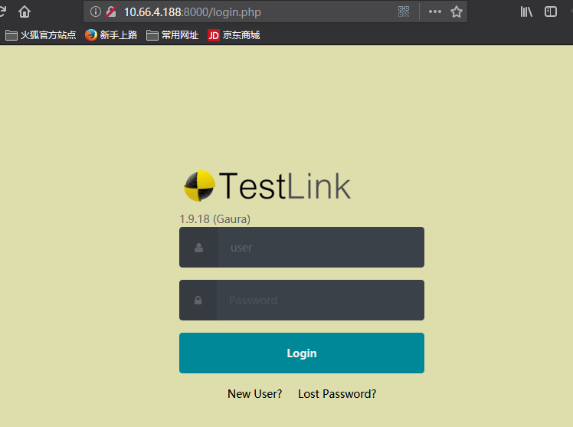



https://blog.csdn.net/hualusiyu/article/details/80988957