ECE 449 Project Bonus (Language Extension)
- Tri-State Buffers and Four-Valued Logic
  - ‘Z’ is set to be -2 in this case, X not implemented.
  - In simulate.cpp , upgrade all bool compute() to be int compute(int), argument represents the net index in a pin
  - In netlist.cpp, upgrade bool pin::get_value() to be int pin::get_value(int) , upgrade bool net::retrieve_logic_value() to return int, find which net of a pin and take case of ‘Z’ value when occurs.
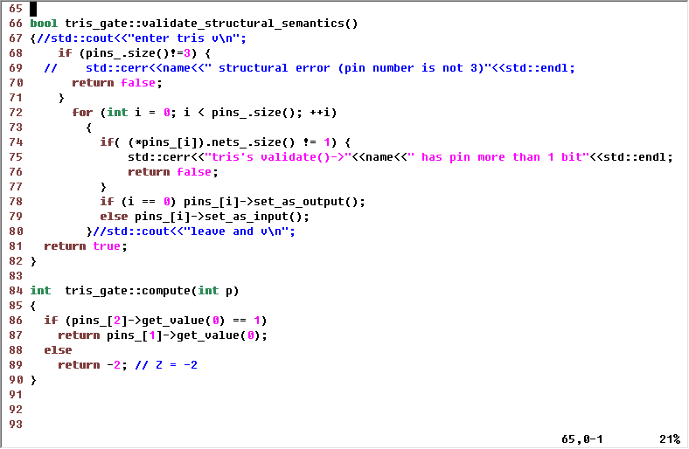
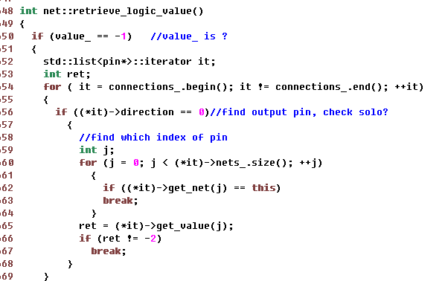

- Look-up Tables
  - Data member tokens hold all inputs
  - bool lut_gate::read_rom(std::string &evl_file, evl_tokens &tokens ) loads the tokens and get rid of title, then each word occupies one line, also is one token.
  - int lut_gate::get_data(int addr, int width, int p) return the 1-bit value according to given arguments.
  - int lut_gate::compute(int p) calculate the offset and call get_data().
  - Evl_file name is needed when opening lut file, so make that as a data member which can be initialize before ctor.
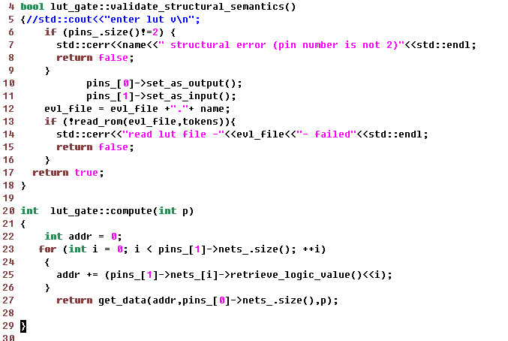
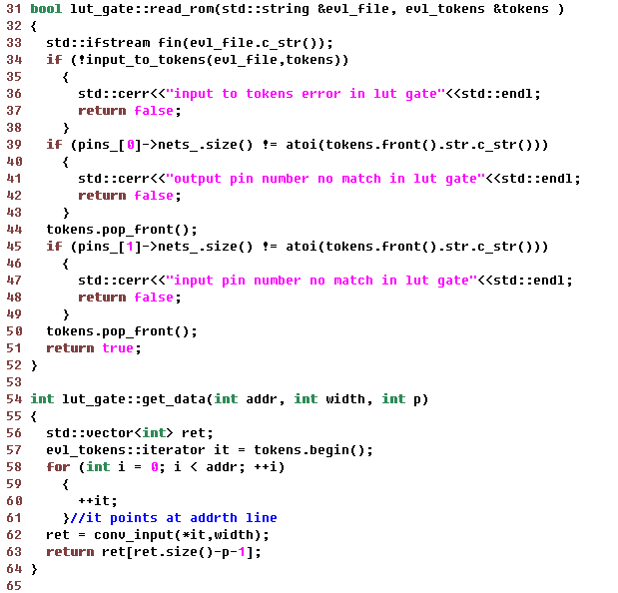
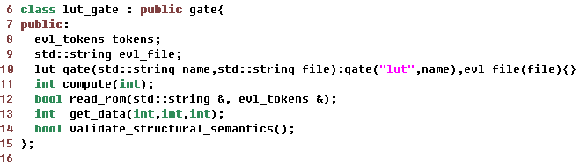
- The ASSIGN Statements
  - FSM implemented as figure shows.
  - After lhs and rhs created and verified, split the bus and create single bit pin which can be attached to buf component.
  - Create multiple buf components

