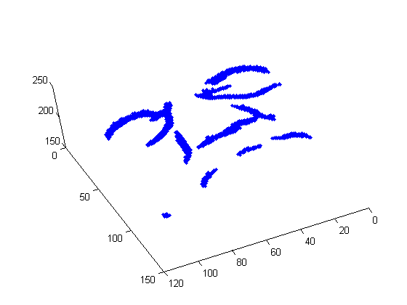
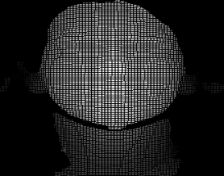
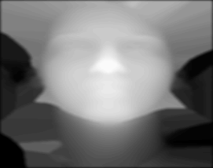
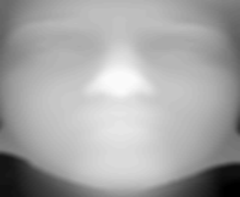
Database
3 Points Labeling
Ridge Image
Hausdorff Distance
or
Iterative Closest Points
Matching Process
Noise removal and Interpolation
Face localization using
Template-Matching
Captured Range Image

