WTL Makes UI Programming a Joy,
Part 1: The Basics

The Windows Template Library (WTL) is available on the January 2000 Platform SDK. It is an SDK sample produced by members of the ATL (Active Template Library) team chartered with building an ATL-based wrapper around the windowing portions of the Win32 API. Since version 2.0, ATL has had simple windowing wrapper classes, such as CWindow, CWindowImpl, and CDialogImpl. However, when compared with MFC, ATL’s windowing classes were little more than a tease. Even in ATL 3.0, there is no support for such popular features as MDI, command bars, DDX, printing, GDI, or even a port of the most beloved class in all of MFC, CString. Without these features WTL cannot satisfy the overwhelming majority of MFC programmers. WTL is what members of the ATL team think a windowing framework should be. Table 1 shows the list of features that WTL provides as compared to MFC.

Table 1: MFC vs. WTL

Feature | MFC | WTL
Stand-alone library | Yes | No (built on ATL)
AppWizard support | Yes | Yes
ClassWizard support | Yes | No
Officially supported by Microsoft | Yes | No (Supported by volunteers inside MS)
Support for OLE Documents | Yes | No
Support for Views | Yes | Yes
Support for Documents | Yes | No
Basic Win32 & Common Control Wrappers | Yes | Yes
Advanced Common Control Wrappers (Flat scrollbar, IP Address, Pager Control, etc.) | No | Yes
Command Bar support (including bitmapped context menus) | No (MFC does provide dialog bars) | Yes
CString | Yes | Yes
GDI wrappers | Yes | Yes
Helper classes (CRect, Cpoint, etc.) | Yes | Yes
Property Sheets/Wizards | Yes | Yes
SDI, MDI support | Yes | Yes
Multi-SDI support | No | Yes
MRU Support | Yes | Yes
Docking Windows/Bars | Yes | No
Splitters | Yes | Yes
DDX | Yes | Yes (not as extensive as MFC)
Printing/Print Preview | Yes | Yes
Scrollable Views | Yes | Yes
Custom Draw/Owner Draw Wrapper | No | Yes
Feature | MFC | WTL
Message/Command Routing | Yes | Yes
Common Dialogs | Yes | Yes
HTML Views | Yes | Yes
Single Instance Applications | No | No
UI Updating | Yes | Yes
Template-based | No | Yes
Size of a statically linked do-nothing SDI application with toolbar, status bar, and menu | 228KB +  MSVCRT.DLL (288KB) | 24k (with /OPT:NOWIN98)  (+ MSVCRT.DLL if you use CString)
Size of a dynamically linked do-nothing SDI application with toolbar, status bar, and menu | 24KB +  MFC42.DLL (972KB) +  MSVCRT.DLL (288KB) | N/A
Runtime Dependencies | CRT (+ MFC42.DLL, if dynamically linked) | None (CRT if you use CString)

WTL certainly doesn’t do everything that MFC does. MFC supports classic OLE, the doc/view architecture and docking windows; WTL does not. In addition, the lack of “official” support from Microsoft is of concern. However, the “unofficial” support from past members of the ATL team (those same members who got WTL included as an SDK sample) and the active ATL community should mitigate the support issue. Why is the ATL community likely to embrace the WTL? The last four items in the feature list tell the tale: WTL is template-based, the minimum application size is small (24KB) and there are no DLL dependencies (except the CRT if you use CString). In short, the flexibility and small footprint that we know and love about ATL has been carried forward into WTL. Coupled with this, WTL is a programming model very similar to that of MFC and it includes an MFC port of CString.
In this two part series, we unravel the mysteries of WTL. In Part 1, we wet our feet in the details of the WTL frame windows architecture. We explain how to write WTL based SDI, MDI, multi-SDI, and Explorer style apps. Next, we cover the WTL helper classes including DDX wrappers. Finally, we look at the WTL AppWizard and the sample applications that ship with WTL.
Part 2 of our series covers the details of WTL command bar architecture, common controls wrappers, and custom UI widgets. We delve into WTL’s message routing architecture, including message cracking, filtering, and idle handling. Our journey to explore WTL won’t be complete unless we cover common dialog boxes, property pages and sheets, printing support, and scrolling windows – all of which we plan for part 2.
Before we show you how to build applications WTL, let’s review how to build applications in raw ATL.

ATL, the Foundation of WTL
ATL provides a set of classes for windowing. Originally aimed to support ATL’s COM control and OLE Property Page architectures, these classes also form the basis for WTL. ATL provides all the basic windowing functional aspects, including window/dialog creation and management, windows procedures, message routing, windows subclassing, superclassing, and message chaining. Figure 1 shows the ATL windowing-class hierarchy.

Figure 1: ATL Windowing-class Hierarchy
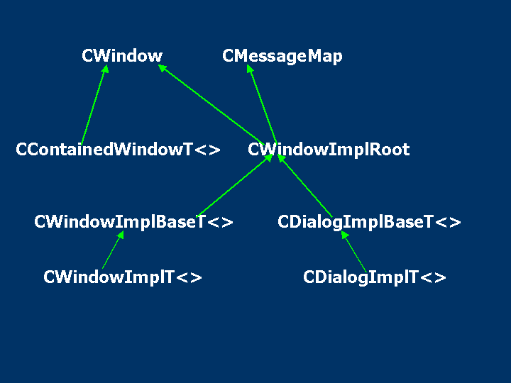

To create a window or a dialog in straight ATL, you need to derive from CWindowImpl or CDialogImpl, respectively. To give you an idea of how to create a window and a dialog with ATL, Figure 2 provides a simple SDI application developed using the windowing support provided by ATL.

Figure 2: Simple SDI Application
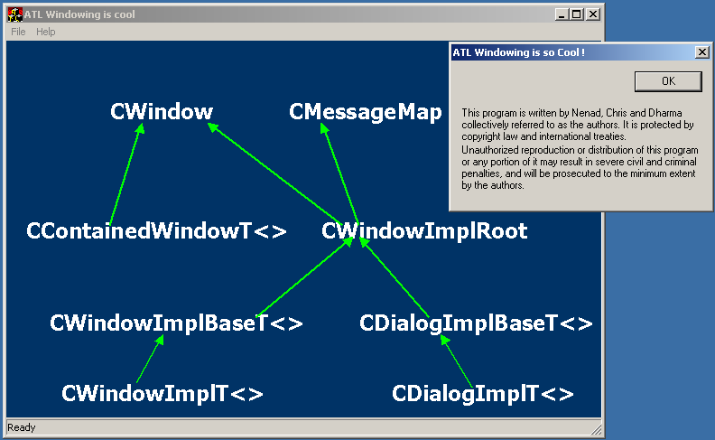
The application consists of an SDI frame window that contains a menu, status bar, and a client area. It also provides an About box to demonstrate how to use dialogs in raw ATL. We started this application by creating a simple Win32 Application project in VC6 and adding the minimal support to do ATL windowing. Figure 3 shows the main source files.

Figure 3: Main Source Files

//---------------------------------------------------------------------
// stdafx.h :

#if !defined(AFX_STDAFX_H__DE06DA2F_25B6_41BA_9B20_A17362C38C8C__INCLUDED_)
#define AFX_STDAFX_H__DE06DA2F_25B6_41BA_9B20_A17362C38C8C__INCLUDED_

#if _MSC_VER > 1000
#pragma once
#endif // _MSC_VER > 1000

#define STRICT
#ifndef _WIN32_WINNT
#define _WIN32_WINNT 0x0400
#endif
#define _ATL_APARTMENT_THREADED

#include <atlbase.h>
//You may derive a class from CComModule and use it if you want to override
//something, but do not change the name of _Module

extern CComModule _Module;
#include <atlwin.h>

//{{AFX_INSERT_LOCATION}}
// Microsoft Visual C++ will insert additional declarations immediately before the previous line.

#endif // !defined(AFX_STDAFX_H__DE06DA2F_25B6_41BA_9B20_A17362C38C8C__INCLUDED)

//---------------------------------------------------------------------
//MainFrame.H

#pragma once
#ifndef _MAINFRAME_H_
#define _MAINFRAME_H_

#include "commctrl.H"

class CMainFrame : public CWindowImpl<CMainFrame,CWindow, CWinTraits<WS_OVERLAPPEDWINDOW|WS_CLIPCHILDREN , WS_EX_APPWINDOW | WS_EX_WINDOWEDGE> >
{
public:
CMainFrame():m_hWndStatusBar(NULL),m_hBmp(NULL) {
m_hBmp =
LoadBitmap(_Module.GetResourceInstance(),
MAKEINTRESOURCE(IDB_ATLWINDOWING));
}
~CMainFrame() {
if(m_hBmp) {
::DeleteObject(m_hBmp);
m_hBmp = NULL;
}
}
BEGIN_MSG_MAP(CMainFrame)
MESSAGE_HANDLER(WM_PAINT, OnPaint)
MESSAGE_HANDLER(WM_CREATE, OnCreate)
MESSAGE_HANDLER(WM_SIZE, OnSize)
MESSAGE_HANDLER(WM_CLOSE, OnClose)
COMMAND_ID_HANDLER(ID_FILE_EXIT, OnFileExit)
COMMAND_ID_HANDLER(ID_APP_ABOUT, OnAbout)
END_MSG_MAP()

void OnFinalMessage(HWND /*hWnd*/) {}
LRESULT OnCreate(UINT, WPARAM wParam, LPARAM lParam, BOOL& bHandled) {
DefWindowProc();
m_hWndStatusBar = ::CreateStatusWindow(WS_CHILD | WS_VISIBLE |
WS_CLIPCHILDREN | WS_CLIPSIBLINGS | SBARS_SIZEGRIP,
_T("Ready"), m_hWnd, 1);

return 0L;
}
LRESULT OnSize(UINT, WPARAM wParam, LPARAM lParam, BOOL& bHandled) {
DefWindowProc();
::SendMessage(m_hWndStatusBar, WM_SIZE, 0, 0);
return 0L;
}
LRESULT OnPaint(UINT, WPARAM, LPARAM, BOOL&) {
PAINTSTRUCT ps;
HDC hdc = BeginPaint(&ps);

RECT rect; GetClientRect(&rect);

//Bitmap
HDC hDCMem = ::CreateCompatibleDC(hdc);
HBITMAP hBmpOld = (HBITMAP)::SelectObject(hDCMem,m_hBmp);

BITMAP bmp;
::GetObject(m_hBmp, sizeof(BITMAP), &bmp);
SIZE size = { bmp.bmWidth,bmp.bmHeight };

::BitBlt(hdc, rect.left, rect.top, (size.cx), (size.cy), hDCMem,
0,0,SRCCOPY);

//cleanup
::SelectObject(hDCMem,hBmpOld);
::DeleteDC(hDCMem);
hDCMem = NULL;

EndPaint(&ps);
return 0;
}
LRESULT OnClose(UINT,WPARAM,LPARAM, BOOL&) {
DestroyWindow();
PostQuitMessage(0);
return 0L;
}
LRESULT OnFileExit(WORD,WORD wID, HWND,BOOL&) {
SendMessage(WM_CLOSE);
return 0L;
}
LRESULT OnAbout(WORD, WORD wID, HWND, BOOL&) {
CAboutDialog dlg;
dlg.DoModal();
return 0L;
}

private:
struct CAboutDialog : public CDialogImpl<CAboutDialog> {
enum { IDD = IDD_ABOUT };
BEGIN_MSG_MAP(CAboutDialog)
COMMAND_ID_HANDLER(IDOK, OnClose)
END_MSG_MAP()

LRESULT OnClose(WORD, WORD wID, HWND, BOOL&) {
EndDialog(wID);
return 0L;
}
};

HWND m_hWndStatusBar;
HBITMAP m_hBmp;
};
#endif

//---------------------------------------------------------------------
//AtlHelloWindowing.Cpp

#include "stdafx.h"
#include "resource.h"
#include "MainFrame.H"

CComModule _Module;

extern "C" int WINAPI
_tWinMain(HINSTANCE hInstance,HINSTANCE, LPTSTR lpCmdLine, int nShowCmd) {
lpCmdLine = GetCommandLine(); //this line necessary for _ATL_MIN_CRT

_Module.Init(0, hInstance,NULL);

//Load Common Controls
INITCOMMONCONTROLSEX iccx;
iccx.dwSize = sizeof(iccx);
iccx.dwICC = ICC_WIN95_CLASSES |ICC_BAR_CLASSES ;
::InitCommonControlsEx(&iccx);

HMENU hMenu = LoadMenu(_Module.GetResourceInstance(),
MAKEINTRESOURCE(IDR_MAINFRAME));

CMainFrame wndFrame;

wndFrame.GetWndClassInfo().m_wc.hIcon = ::LoadIcon(_Module.GetResourceInstance(),
MAKEINTRESOURCE(IDI_FORM));
wndFrame.GetWndClassInfo().m_wc.style = 0;//CS_HREDRAW|CS_VREDRAW;

wndFrame.Create(GetDesktopWindow(), CWindow::rcDefault,
_T("ATL Windowing is cool"), 0, 0, (UINT)hMenu);

wndFrame.ShowWindow(nShowCmd);
wndFrame.UpdateWindow();

MSG msg;
while (GetMessage(&msg, 0, 0, 0)) {
TranslateMessage(&msg);
DispatchMessage(&msg);
}

_Module.Term();
return 0;
}

In MainFrame.h, CMainFrame stores two data members – the HWND of the statusbar control and the HBITMAP of a bitmap. CMainFrame creates the statusbar as a child window in the WM_CREATE handler by calling the CreateStatusWindow function from comctl32.dll, and takes care of sizing the statusbar in its WM_SIZE processing. The WM_PAINT handler uses the bitmap to demonstrate a little bit of GDI (Graphic Device Interface). ATL doesn’t provide any wrappers for drawing, so the painting is all raw Win32 calls.
While the MESSAGE_HANDLER macro requires you to do your own message cracking (notice the WPARAM and LPARAM parameters of most of the message handlers), ATL does crack both WM_COMMAND and WM_NOTIFY messages for you via a family of macros. MainFrame.h shows the use of COMMAND_ID_HANDLER, which CMainFrame uses to handle its menu commands.
Finally, CAboutDialog is a dialog that derives from CDialogImpl. The OnAbout menu handler invokes it with a call to DoModal.
HelloAtlWindowing.cpp shows _tWinMain, the entry point of our ATL application. It creates an instance of CMainFrame and calls the Create, ShowWindow, and UpdateWindow member functions, which wraps the Win32 CreateWindow, ShowWindow, and UpdateWindow functions, respectively. Finally, because this is a Windows application after all, we pump the messages via a standard GetMessage-DispatchMessage loop. Those of you familiar with Win32 will notice the lack of calls to RegisterClass and the window procedures, but will recognize pretty much everything else. Those of you familiar with MFC might be surprised that ATL doesn’t provide such basic niceties as automatic support for creating status bars and menus (not to mention toolbars) and for pumping messages. While it’s obvious that ATL helps, it doesn’t go nearly far enough. Let’s not forget that ATL’s roots are firmly grounded in COM. The windowing support it provides is a by-product and not the main purpose of its existence. ATL allows but does not support MDI, Multi-SDI, or Explorer-style applications, nor does it provide common control wrappers, DDX, or GDI helpers. For those, we turn to WTL.

The WTL Way
The WTL class that makes it possible for us to more easily create an SDI frame window is CFrameWindowImpl. (Figure 4 shows WTL’s SDI windowing hierarchy.)

Figure 4: WTL’s SDI Windowing Hierarchy
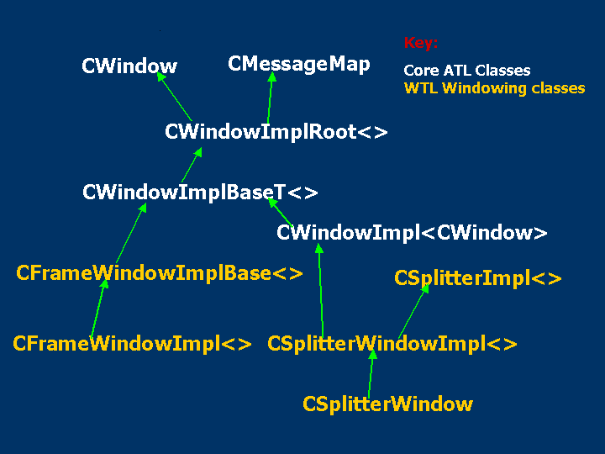

The CFrameWindowImpl class derives from CFrameWindowImplBase and thereby inherits all the functionality of a standard application frame window. The following lists features a WTL created frame window provides support for:
- Hosting toolbars, menu bars, status bar, and rebars
- Basic view manipulation, including the resizing of the view in sync with the frame
- Rebar band manipulation, including adding and resizing of bands
- Chevron menus
- Keyboard accelerators
- Tool tips for the toolbar buttons
- Displaying help string in the status bar
- Displaying frame’s icon
In order to create an SDI app, you need to:
1) Derive your frame class from CFrameWindowImpl
2) Add the WTL’s DECLARE_FRAME_WND_CLASS macro, specifying the resource ID of the toolbar and the menu
3) Add the message map and the corresponding message handlers, which should include chaining to the frame base class
For example, you can write our simple SDI example CMainFrame class using WTL like so:

class CMainFrame : public CFrameWindowImpl<CMainFrame> {
public:
DECLARE_FRAME_WND_CLASS(NULL, IDR_MAINFRAME)
BEGIN_MSG_MAP(CMainFrame)
MESSAGE_HANDLER(WM_PAINT, OnPaint)
MESSAGE_HANDLER(WM_CREATE, OnCreate)
COMMAND_ID_HANDLER(ID_FILE_EXIT, OnFileExit)
COMMAND_ID_HANDLER(ID_HELP_ABOUT, OnAbout)
CHAIN_MSG_MAP(CFrameWindowImpl<CMainFrame>)
END_MSG_MAP()

LRESULT OnCreate(UINT, WPARAM, LPARAM, BOOL&) {
// Create the Toolbar and set
// CFrameWindowImplBase::m_hWndToolBar
CreateSimpleToolBar();

// And the statusbar
CreateSimpleStatusBar();
return 0;
}

LRESULT OnFileExit(WORD,WORD wID, HWND,BOOL&) {

SendMessage(WM_CLOSE); // Frame knows to PostQuitMessage
return 0L;
}
…
};

The DECLARE_FRAME_WND_CLASS sets the “common resource id” for the frame. You can associate this resource id with a string in the string table to use as the frame’s title, a menu resource, an accelerator table, an icon, and a toolbar resource, all optionally. If WTL finds any resources with the common resource id during creation of the frame window, it loads them automatically. The single exception is the toolbar resource, which you must load manually using the CreateSimpleToolBar member function. The status bar needs no associated resource.
The use of CHAIN_MSG_MAP in the message map enables routing of messages to the CFrameWindowImpl, which, in turn, takes care of handling messages like WM_SIZE (to resize the toolbar and status bar) and WM_DESTROY (calls PostQuitMessage).
To support basic WTL functionality, you must augment stdafx.h to include atlapp.h and atlframe.h:

// stdafx.h
#define WIN32_LEAN_AND_MEAN
#include <atlbase.h>
#include <atlapp.h>
extern CAppModule _Module;
#include <atlwin.h>
#include <atlframe.h>

The atlapp.h header defines the CAppModule structure, which derives from the standard ATL CComModule and adds support for a variable number of message loops. The atlframe.h header defines the CFrameWindowImpl class. To create the SDI window in our WTL world, we need to instantiate the CMainFrame object and call its base class member function CreateEx in WinMain:
CAppModule _Module;
int APIENTRY WinMain(…) {
::InitCommonControls();
_Module.Init(NULL, hInstance);

CMainFrame wndMain;
wndMain.CreateEx();
wndMain.ShowWindow(nCmdShow);
wndMain.UpdateWindow();

CMessageLoop theLoop;
_Module.AddMessageLoop(&theLoop);

int nRet = theLoop.Run();
_Module.RemoveMessageLoop();

_Module.Term();
return nRet;
}

The CreateEx member function calls the CWindowImpl::Create base class member function as well as loading the resources associated with the common resource id. The CMessageLoop object replaces our need for a manual message pump. ATL allows one message pump per thread, which is how Multi-SDI is implemented. We will cover the details of CMessageLoop and CAppModule in Part 2 of this series when we study WTL’s message routing architecture.
So far, using WTL, our SDI application looks like Figure 5a.

Figure 5a: SDI Application using WTL
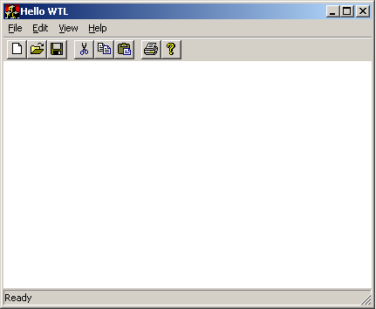

We managed to simplify our code and add a new feature: toolbars. Still, toolbars and menu bars are old fashioned. Users want fancy command bars like they see in the Internet Explorer and MS Office. And since it’s the users writing the checks…

In Command with Command Bars
A command bar is a tool bar that looks like a Windows menu and has bitmapped menu items. Writing command bars from scratch is a pain. If you are an MFC programmer, Paul DiLascia already did it for you in the January 1998, MSJ (Give Your Applications the Hot New Interface Look with Cool Menu Buttons). Likewise, if you are a WTL programmer, the extent of your effort is limited to using WTL’s CCommandBarCtrl class in your WM_CREATE handler thusly:

LRESULT CMainFrame::OnCreate(UINT, WPARAM, LPARAM, BOOL&)
{
// m_CmdBar is of type CCommandBarCtrl, defined in AtlCtrlw.h
HWND hWndCmdBar = m_CmdBar.Create(m_hWnd, rcDefault,
0, ATL_SIMPLE_CMDBAR_PANE_STYLE);

// Let command bar replace the current menu
m_CmdBar.AttachMenu(GetMenu());
m_CmdBar.LoadImages(IDR_MAINFRAME);
SetMenu(NULL);

// First create a simple toolbar
HWND hWndToolBar = CreateSimpleToolBarCtrl(m_hWnd,
IDR_MAINFRAME,FALSE,ATL_SIMPLE_TOOLBAR_PANE_STYLE);

// Set m_hWndToolBar member
CreateSimpleReBar(ATL_SIMPLE_REBAR_NOBORDER_STYLE);

// Add a band to the rebar represented by m_hWndToolBar
AddSimpleReBarBand(hWndCmdBar);

// Add another band to the m_hWndToolBar rebar
AddSimpleReBarBand(hWndToolBar, NULL, TRUE);

// Create the usual statusbar
CreateSimpleStatusBar();
return 0;
}

CCommandBarCtrl is the WTL class that encapsulates the command bar functionality and typically, CMainFrame contains a member of this type. In the aforementioned snippets of the WM_CREATE handler, we first create the call CCommandBarCtrl::Create, passing the parent window as the main frame. Then, we attach our menu resource by calling CCommandBarCtrl::AttachMenu and call CCommandBarCtrl::LoadImages, passing the toolbar resource. The command bar uses the toolbar bitmaps and maps them against the corresponding command ids of the menu items. Because the command bars take charge of the cool menus, we need to get rid of the good old default application menu by calling SetMenu(NULL). Then we create the toolbar control and a rebar control passing our toolbar resource by calling CreateSimpleToolBarCtrl and CreateSimpleRebar, respectively. Finally, we add the commandbar and the toolbar as two bands of the rebar control by calling CFrameWindowImplBase::AddSimpleRebarBand. Figure 5b shows the SDI application with command bars. It also shows how the calls we made in the aforementioned snippets map to the UI elements.

Figure 5b: SDI Application with Command Bars
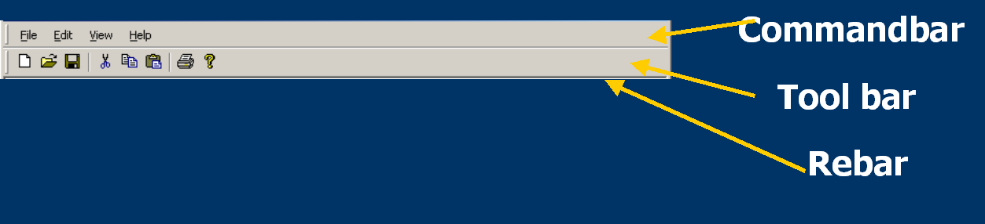

A Frame with a View
It is common practice for MFC programmers to represent the client area of a frame window as a separate child window called a view. The frame is responsible for the “decorations,” for example, menu bar and toolbar; while the view is concerned merely with presenting the information that represents the real reason for running the application in the first place. This abstraction is especially handy when combined with splitters or MDI, as discussed later in this article.
A view can be anything that has an HWND. Give the HWND to the frame by setting the frame’s m_hWndClient member variable during WM_CREATE. For example, to move the bitmap painting functionality of our SDI application to a view, you could define a view class like so:

class CBitmapView : public CWindowImpl<CBitmapView> {
public:
CBitmapView();
~CBitmapView();
BEGIN_MSG_MAP(CBitmapView)
MESSAGE_HANDLER(WM_PAINT, OnPaint)
END_MSG_MAP()
LRESULT OnPaint(UINT, WPARAM, LPARAM, BOOL&);
private:
HBITMAP m_hBmp;
};

To use this view, do the following:
LRESULT OnCreate(UINT, WPARAM, LPARAM, BOOL&) {
…
// Create the View (m_view is of type CBitmapView)
m_hWndClient = m_view.Create(m_hWnd, rcDefault, NULL,
WS_CHILD | WS_VISIBLE,
WS_EX_CLIENTEDGE);
return 0;
}

Now, whenever the frame is resized, so is the view, nestled snuggly with the toolbar, command bars, and status bar.
ATL and WTL provide a large range of Window classes that would work fine as views. You could use all of the Windows control and common control wrappers classes as views. For example, by changing the type of the m_view class from CBitmapView to CEdit (as defined in atlctrls.h), you have yourself a simple text editor (see Figure 6).

Figure 6: Simple Text Editor
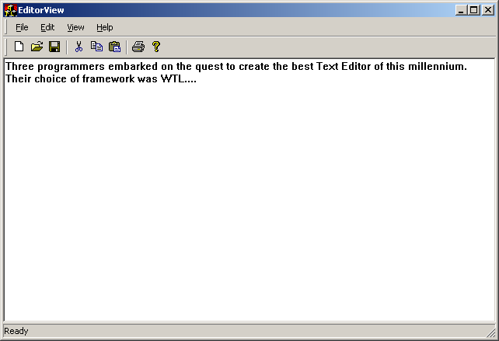

If you want to inherit from one of ATL’s window wrapper classes to use as a view, you have to inherit in two ways: the C++ way and the Windows way; that is, super-classing so that you can add functionality and handle messages. For example, by deriving from CAxWindow, we could have a custom view that hosts HTML.

// Inherit the C++ way to inherit CAxWindow functionality
class CHtmlView : public CWindowImpl<CHtmlView, CAxWindow> {
public:
// Inherit the Windows way to pre-process Windows messages
DECLARE_WND_SUPERCLASS(NULL, CAxWindow::GetWndClassName())

BEGIN_MSG_MAP(CHtmlView)
…
END_MSG_MAP()

CHtmlView() {
// Init control hosting (defined in atlhost.h)
AtlAxWinInit();
}
};
We can use our new view to host a web page like so (Figure 7 displays the result):

LRESULT CMainFrame::OnCreate(UINT, WPARAM, LPARAM, BOOL&)
{
// Create the View (m_view is of type CHtmlView)
m_hWndClient = m_view.Create(m_hWnd, rcDefault,
"http://www.microsoft.com",
WS_CHILD | WS_VISIBLE,
WS_EX_CLIENTEDGE);
return 0;
}

Figure 7: Using the New View to Host a Web Page

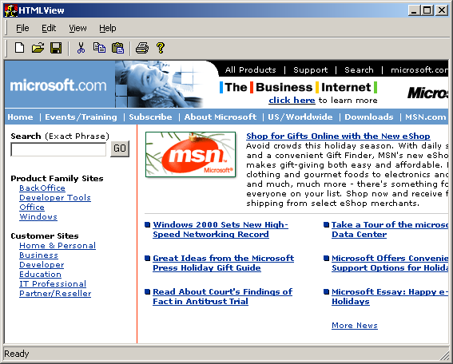

Maintaining the MRU
Although WTL provides support for views, unlike MFC, it does not have a concept of a document. You’re on your own if you want to support the document/view pattern in your WTL based apps. To get you started, we wrote a set of classes that give the very basic functionality of a document, which you can use in your apps. See this set of classes in the WTLDocView sample provided with this article.
If you do document work, you’re almost certainly going to want to support the Most Recently Used file list in the File menu. Ironically, while WTL doesn’t support documents, it does have full support for the MRU via the CRecentDocumentList class (defined in atlmisc.h). The main frame normally manages an instance of CRecentDocumentList. The WM_CREATE handler of the main frame initializes CRecentDocumentList object with a handle to the File menu, which it can then manage. To populate the MRU, the frame calls the CRecentDocumentList::ReadFromRegistry member function to look for up to sixteen entries under a specific Registry key. By default, it sets the limit of MRU documents as four, but you can change that by calling the CRecentDocumentList::SetMaxEntries member function.

LRESULT CMainFrame::OnCreate(UINT, WPARAM, LPARAM, BOOL&) {
…
m_mru.SetMenuHandle(GetMenu().GetSubMenu(0));
m_mru.ReadFromRegistry(_T("Software\\MyCompany\\MyCoolApp"));
m_mru.SetMaxEntries(16);
…
}

To add a document to the MRU list for the first time, you call
CRecentDocumentList::AddToList:

LRESULT CMainFrame::OnFileOpen(WORD, WORD, HWND, BOOL&)
{
if (m_dlgOpen.DoModal(m_hWnd) == IDOK) {
// Try to open file
…

if (bFileOpened) {
USES_CONVERSION;
m_mru.AddToList(OLE2T(m_dlgOpen.m_bstrName));
}
}
return 0;
}

You add the MRU menu items in the range ID_FILE_MRU_FIRST to ID_FILE_MRU_LAST (defined in atlres.h). You can handle the range using the COMMAND_RANGE_HANDLER macro. When the user clicks on one of the MRU menu items, the handler can call CRecentDocumentList::GetFromList to retrieve the name of the document. After the document opens, the handler should call CRecentDocumentList::MoveToTop or CRecentDocumentList::RemoveFromList to indicate whether the document opened or not.

LRESULT CMainFrame::OnOpenUsingMRU(WORD, WORD wID, HWND, BOOL&) {
TCHAR szDocument[MAX_PATH];
m_mru.GetFromList(wID, szDocument);

// Try to open the file specified by the menu item
…

if (bFileOpened) m_mru.MoveToTop(wID);
else m_mru.RemoveFromList(wID);

return 0;
}

Finally, when it is time for your app to shut down, you need to call CRecentDocumentList::WriteToRegistry, which adds the array of menu tags that from the memory to the Registry.

void CMainFrame::OnFinalMessage(HWND /*hWnd*/)
{
m_mru.WriteToRegistry(_T("Software\\MyCompany\\MyCoolApp"));
::PostQuitMessage(0);
}

Multi-SDI
Instead of spawning multiple SDI applications, the Internet Explorer uses multiple top-level SDI windows managed by a single application. If you want this feature in your application, you can use WTL’s support for Multi-SDI. The design philosophy behind the Multi-SDI application is simple.
- Each top-level window (and its children) runs on a separate thread.
- Each of the threads has a message pump and is thus a UI thread, capable of processing messages and dispatching to the windows it owns. This means not only do all the threads share process-wide data, but also when one thread is busy processing something, the other threads are still fully responsive.
- Thus, each top-level frame window acts as an independent application to the user.
The trick for creating such an application lies in designing a thread manager class, which:
- Creates a new SDI frame window for each spawned thread
- Manages the thread handles and the count of the live threads
- Keeps track of the command line parameters and the initial window size
WTL does not provide any base classes for Multi-SDI apps. However, it generates code for creating such apps with the WTL AppWizard (discussed in full towards the end of this article). The WTL wizard generates a thread manager class that looks like this:

class CThreadManager {
public:
// thread init param
struct _RunData
{
LPTSTR lpstrCmdLine;
int nCmdShow;
};

DWORD m_dwCount; //count of threads
HANDLE m_arrThreadHandles[MAXIMUM_WAIT_OBJECTS - 1];

CThreadManager() : m_dwCount(0) {}
DWORD AddThread(LPTSTR lpstrCmdLine, int nCmdShow);
void RemoveThread(DWORD dwIndex);
int Run(LPTSTR lpstrCmdLine, int nCmdShow);
};

WinMain will instantiate the thread manager.

int WINAPI WinMain(…) {
hRes = _Module.Init(NULL, hInstance);

CThreadManager mgr;
int nRet = mgr.Run(lpstrCmdLine, nCmdShow);

_Module.Term();
return nRet;
}

The CThreadManager::Run method creates a new UI thread and waits on all the UI threads using MsgWaitForMultipleObjects. If MsgWaitForMultipleObjects indicates that one of the threads has terminated, it decrements its count and returns to waiting. Once all the threads finish, the Run method returns and our application shuts down. On the other hand, if MsgWaitForMultipleObjects indicates a Windows message, and that message is WM_USER (which WTL uses on the thread manager thread to indicate the request of a new UI thread), the thread manager creates a new UI thread.

int CThreadManager::Run(LPTSTR lpstrCmdLine, int nCmdShow) {
MSG msg;
// force message queue to be created
::PeekMessage(&msg, NULL, WM_USER, WM_USER, PM_NOREMOVE);

AddThread(lpstrCmdLine, nCmdShow);

int nRet = m_dwCount;
DWORD dwRet;
while(m_dwCount > 0)
{
dwRet = ::MsgWaitForMultipleObjects(m_dwCount,
m_arrThreadHandles, FALSE, INFINITE, QS_ALLINPUT);

if(dwRet == 0xFFFFFFFF)
{
::MessageBox(NULL, _T("ERROR: Wait for multiple
objects failed!!!"), _T("MultiSDI_HTMLView"), MB_OK);
}
else if(dwRet >= WAIT_OBJECT_0 && dwRet <= (WAIT_OBJECT_0 +
m_dwCount - 1))
{
RemoveThread(dwRet - WAIT_OBJECT_0);
}
else if(dwRet == (WAIT_OBJECT_0 + m_dwCount))
{
::GetMessage(&msg, NULL, 0, 0);
if(msg.message == WM_USER)
AddThread("", SW_SHOWNORMAL);
else
::MessageBeep((UINT)-1);
}
else
::MessageBeep((UINT)-1);
}
return nRet;
}

Notice that the WTL wizard generated code uses raw WM_USER message instead of using a special user defined message. Because the generated code uses only the main thread to create UI threads and the thread doesn’t create any windows itself, there is no danger of a collision with a custom message with this same value (as would normally be the case).
The AddThread routine creates the actual thread with a call to the Win32 CreateThread API passing the address of the thread procedure. This is a static method of the CThreadManager class called RunThread. RunThread creates the SDI frame, calls ::ShowWindow API with the show command passed to the WinMain, then runs the message loop

// CThreadManager::RunThread
static DWORD WINAPI RunThread(LPVOID lpData)
{
CMessageLoop theLoop;
_Module.AddMessageLoop(&theLoop);

_RunData* pData = (_RunData*)lpData;

CMainFrame wndFrame;
if(wndFrame.CreateEx() == NULL)
{
ATLTRACE(_T("Frame window creation failed!\n"));
return 0;
}

wndFrame.ShowWindow(pData->nCmdShow);
::SetForegroundWindow(wndFrame); // Win95 needs this
delete pData;

int nRet = theLoop.Run();
_Module.RemoveMessageLoop();
return nRet;
}

The handler for the File/New Window menu item in a Multi-SDI application should post a WM_USER message to the main thread to signal the thread manager to create a new thread with a new frame.
LRESULT CMainFrame::OnFileNewWindow(WORD, WORD, HWND, BOOL&) {
::PostThreadMessage(_Module.m_dwMainThreadID, WM_USER, 0, 0L);
return 0;
}

Figure 8a & 8b shows the Multi-SDI application.

Figure 8a: Multi-SDI Application
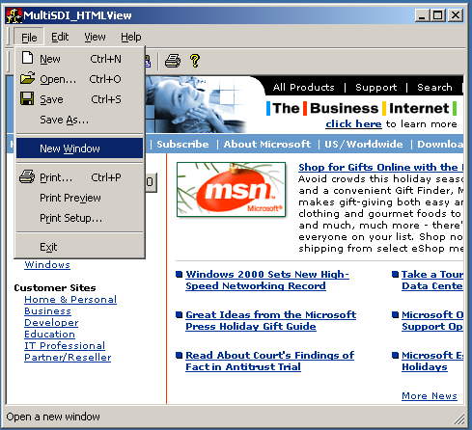

Figure 8b: Multi-SDI Application
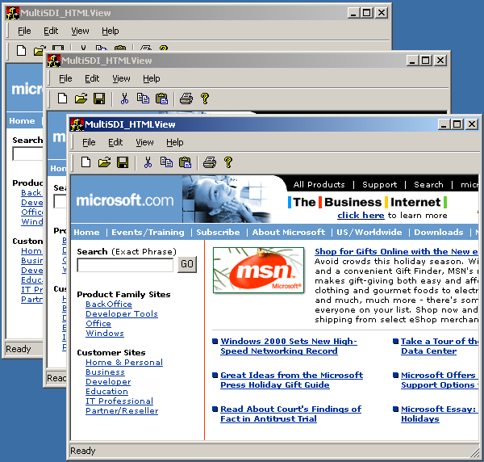
Multi-SDI applications lend themselves to single instance activation, that is, when the user double-clicks on YourMultiSdi.exe, you would probably prefer a new thread to a new instance of the application. WTL does not support this, but you can add it fairly easily using DDE. For an example, see the SingleInstance sample that accompanies this article for an example.
Creating MDI Apps
Before Multi-SDI, there was MDI. WTL provides a set of classes based on the CFramewindowImplBase that enables us to create MDI apps. Figure 9 shows the MDI windowing hierarchy of WTL.

Figure 9: MDI Windowing Hierarchy of WTL
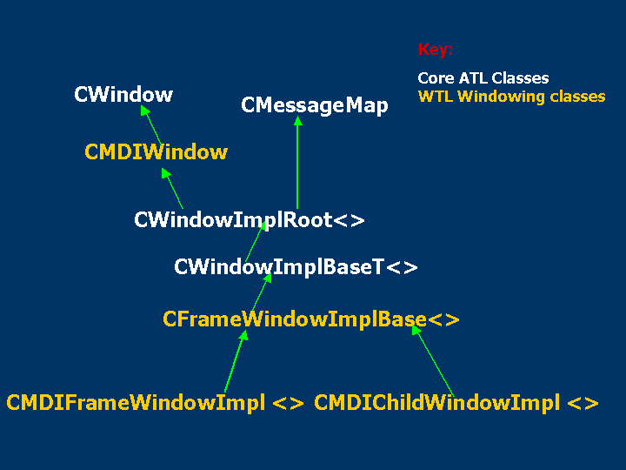

CMDIWindow inherits from CWindow and stores the HWND to the MDI client window and the MDI Frame menu, as well as providing simple wrappers that send the WM_MDIXXX family of messages.
MDI applications consist of the frame, the client area of the frame that manages the MDI children, and the MDI children themselves (as shown in Figure 10).

Figure 10: MDI Application Consisting of Frame, Client Area, and MDI Children
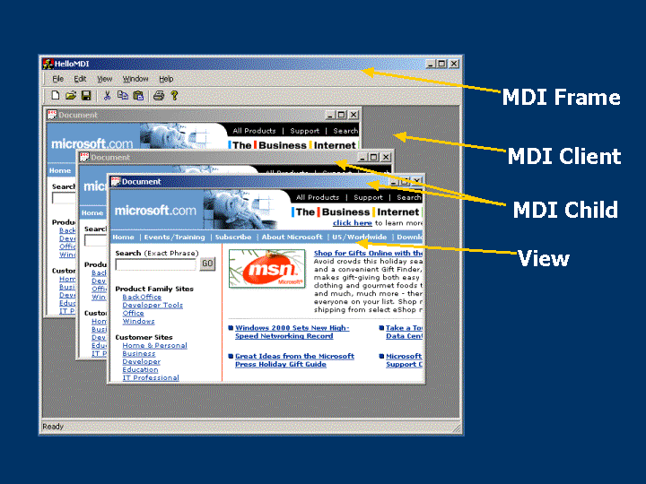

To create an MDI child window, you need to derive your class from WTL’s CMDIChildWindowImpl.
class CChildFrame : public CMDIChildWindowImpl<CChildFrame> {
public:
DECLARE_FRAME_WND_CLASS(NULL, IDR_MDICHILD)

CHtmlView m_view;

virtual void OnFinalMessage(HWND /*hWnd*/) {
delete this;
}

BEGIN_MSG_MAP(CChildFrame)
MESSAGE_HANDLER(WM_CREATE, OnCreate)
CHAIN_MSG_MAP(CMDIChildWindowImpl<CChildFrame>)
END_MSG_MAP()

LRESULT OnCreate(UINT,WPARAM,LPARAM,BOOL&) {
m_hWndClient = m_view.Create(m_hWnd, rcDefault,
_T("http://www.microsoft.com"),
WS_CHILD | WS_VISIBLE, WS_EX_CLIENTEDGE);

bHandled = FALSE; // Let base class have a crack
return 1;
}
…
};

An MDI child frame window is very similar to an SDI frame. For example, we pass the menu resource id of the MDI child to the DECLARE_FRAME_WND_CLASS macro to take care of associated resource creation, just like in our SDI frame. Also, we handle WM_CREATE to create our view. However, notice that after creating our view, we set bHandled to FALSE to indicate that we want the MDI child base class to handle the WM_CREATE message. Finally, notice that our OnFinalMessage handler calls delete on itself. This allows the child to reclaim its own resources, freeing the frame from this responsibility.
Working our way out, the CMDIFrameWindowImpl implements both the MDI frame and MDI client, which will serve as the base class for your MDI frame, for example,

class CMainFrame : public CMDIFrameWindowImpl<CMainFrame> {
public:
DECLARE_FRAME_WND_CLASS(NULL, IDR_MAINFRAME)
BEGIN_MSG_MAP(CMainFrame)
MESSAGE_HANDLER(WM_CREATE, OnCreate)
COMMAND_ID_HANDLER(ID_FILE_NEW, OnFileNew)
COMMAND_ID_HANDLER(ID_WINDOW_CASCADE, OnWindowCascade)
…
CHAIN_MSG_MAP(CMDIFrameWindowImpl<CMainFrame>)
END_MSG_MAP()

LRESULT OnCreate(UINT, WPARAM, LPARAM, BOOL&)
{
// Create command bar window, toolbar and statusbar
…

// Create MDI client
CreateMDIClient();
m_CmdBar.SetMDIClient(m_hWndMDIClient);
…
return 0;
}

LRESULT OnFileNew(WORD, WORD, HWND, BOOL&)
{
// Create MDI child
CChildFrame* pChild = new CChildFrame;
pChild->CreateEx(m_hWndMDIClient);
return 0;
}

LRESULT OnWindowCascade(WORD,WORD,HWND, BOOL&)
{
MDICascade();
return 0;
}
…
};

Our WM_CREATE handler calls the CMDIFrameWindowImpl base-class member function CreateMDIClient, which in-turn creates the MDI client and sets m_hWndMDIClient. The MDI client window parents the MDI child frame windows (containing the HTML View, in our case). Each new MDI child is created in the OnFileNew handler, which creates a new instance of our MDI child window class, using the MDI client as the parent. Finally, we create the MDI Frame window in the WinMain in the same way we did in the SDI case.

Divide and Conquer with Splitters
Both Multi-SDI and MDI is about a single application showing multiple views on an application’s data. Another popular method is to split a window into one or more child windows using a splitter control. WTL provides the support for splitters with the CSplitterImpl, CSplitterWindowImpl, and CSplitterWindow classes. The core of WTL’s splitter architecture, the CSplitterImpl class, provides all the necessary magic to create the splitter window, to resize the panes, and so on. CSplitterImpl it is designed to work as a base class. The class that derives from CSplitterImpl should be a CWindowImpl derived class (or is capable of processing messages by deriving from CMessageMap). Even though CSplitterImpl has its own message map, it depends on its deriving class to chain messages to it.

//atlsplit.h
template <class T, bool t_bVertical = true>
class CSplitterImpl
{…

BEGIN_MSG_MAP(thisClass)
MESSAGE_HANDLER(WM_CREATE, OnCreate)
MESSAGE_HANDLER(WM_PAINT, OnPaint)
MESSAGE_HANDLER(WM_PRINTCLIENT, OnPaint)
if(IsInteractive())
{
MESSAGE_HANDLER(WM_SETCURSOR, OnSetCursor)
MESSAGE_HANDLER(WM_MOUSEMOVE, OnMouseMove)
MESSAGE_HANDLER(WM_LBUTTONDOWN, OnLButtonDown)
MESSAGE_HANDLER(WM_LBUTTONUP, OnLButtonUp)
MESSAGE_HANDLER(WM_LBUTTONDBLCLK,
OnLButtonDoubleClick)
}
MESSAGE_HANDLER(WM_SETFOCUS, OnSetFocus)
MESSAGE_HANDLER(WM_MOUSEACTIVATE, OnMouseActivate)
MESSAGE_HANDLER(WM_SETTINGCHANGE, OnSettingChange)
END_MSG_MAP()
…
…
};

The following code shows how to convert the SDI Frame window that we earlier developed into a frame with a splitterbar dividing two HTML views.

class CMainFrame :
public CFrameWindowImpl<CMainFrame>,
public CSplitterImpl<CMainFrame,true>
{
public:
DECLARE_WND_CLASS_EX(NULL, CS_DBLCLKS, COLOR_WINDOW)

typedef CFrameWindowImpl<CMainFrame> winbaseClass;
typedef CSplitterImpl< CMainFrame,true> splitbaseClass;
BEGIN_MSG_MAP(CMainFrame)
…
MESSAGE_HANDLER(WM_CREATE, OnCreate)
MESSAGE_HANDLER(WM_ERASEBKGND, OnEraseBackground)
MESSAGE_HANDLER(WM_SIZE, OnSize)
CHAIN_MSG_MAP(splitbaseClass)
END_MSG_MAP()
//…
private: //the two panes within the splitter
CHtmlView m_ViewLeft;
CHtmlView m_ViewRight;
…
};

The WM_CREATE handler of the CMainFrame class creates the two panes and splits them by calling the CSplitterImpl::SetSplitterPanes method. Finally, it sets the initial splitter positions by calling CSplitterImpl::SetSplitterPos.

LRESULT CMainFrame::OnCreate(UINT, WPARAM,LPARAM, BOOL& bHandled)
{
…

// First the 2 views (panes)
m_ViewLeft.Create(m_hWnd, rcDefault,
_T("http://www.sellsbrothers.com/tools"), WS_CHILD |
WS_VISIBLE | WS_CLIPSIBLINGS,
WS_EX_STATICEDGE);
m_ViewRight.Create(m_hWnd, rcDefault,
_T("http://www.sellsbrothers.com/comfun"), WS_CHILD |
WS_VISIBLE | WS_CLIPSIBLINGS|WS_VSCROLL | WS_CLIPCHILDREN,
WS_EX_STATICEDGE);

// Link the panes to the splitter
SetSplitterPanes(m_ViewLeft, m_ViewRight);

// Set the initial positions
RECT rc;GetClientRect(&rc);
SetSplitterPos((rc.right - rc.left) / 4);

bHandled = FALSE;
return 0;
}

The WM_SIZE handler calculates the available client area minus the area occupied by the Rebar control and calls CSplitterImpl::SetSplitterRect to reposition the splitter. Notice we don’t do anything when the application minimizes the window.
LRESULT CMainFrame::OnSize(UINT, WPARAM wParam, LPARAM, BOOL& bHandled)
{
if(wParam != SIZE_MINIMIZED)
{
RECT rc; GetClientRect(&rc);
RECT rcBar; ::GetClientRect(m_hWndToolBar,&rcBar);
rc.top = rcBar.bottom;
SetSplitterRect(&rc);
}

bHandled = FALSE;
return 1;
}

Finally, to eliminate the flicker during resizing, CMainFrame handles WM_ERASEBKGND and bypasses the default action done by DefWindowProc. The DefWindowProc function erases the background by using the window class’ background brush, which can cause unwanted flicker. Processing this message and returning a non-zero value indicates that no further erasing is required.

LRESULT CMainFrame::OnEraseBackground(UINT, WPARAM, LPARAM, BOOL&)
{
return 1;
}

Figure 11a shows we mean to use the app. CSplitterImpl in the inheritance scenario; that is, the window class that wants to split its client area into two panes has to derive from CSplitterImpl.

Figure 11a: CSplitterImpl in the Inheritance Scenario
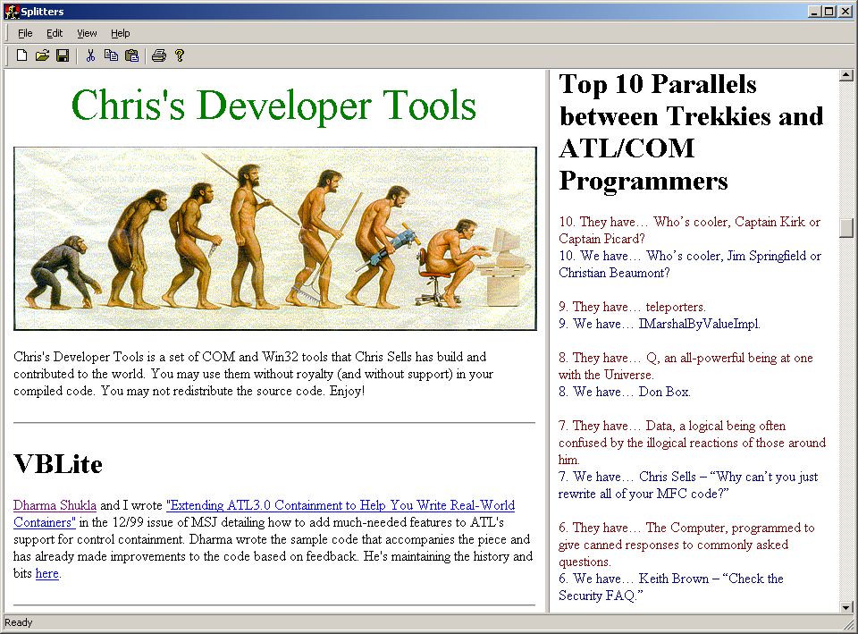

To handle the WM_ERASEBKGND and WM_SIZE messages every time by deriving from CSplitterImpl could be painful. Again, WTL comes to the rescue by providing another layer of abstraction in between the CSplitterImpl and your class. WLT does this by using CSplitterWindowImpl, which takes care of handling WM_ERASEBKGND and WM_SIZE for you. CSplitterWindowImpl also takes care of chaining the messages to CSplitterImpl class and forwarding the notifications (WM_NOTIFY, WM_COMMAND, WM_*SCROLL etc.) to the parent windows using FORWARD_NOTIFICATIONS macro.

//atlsplit.h
template <class T, bool t_bVertical = true, class TBase = CWindow, class TWinTraits = CControlWinTraits>
class ATL_NO_VTABLE CSplitterWindowImpl :
public CWindowImpl< T, TBase, TWinTraits >,
public CSplitterImpl< CSplitterWindowImpl<T ,
t_bVertical, TBase, TWinTraits >,
t_bVertical>
{
public:
DECLARE_WND_CLASS_EX(NULL, CS_DBLCLKS, COLOR_WINDOW)

typedef CSplitterWindowImpl< T , t_bVertical, TBase, TWinTraits > thisClass;
typedef CSplitterImpl<
CSplitterWindowImpl<T,t_bVertical,TBase, TWinTraits >,
t_bVertical>baseClass;

BEGIN_MSG_MAP(thisClass)
MESSAGE_HANDLER(WM_ERASEBKGND, OnEraseBackground)
MESSAGE_HANDLER(WM_SIZE, OnSize)
CHAIN_MSG_MAP(baseClass)
FORWARD_NOTIFICATIONS()
END_MSG_MAP()

LRESULT OnEraseBackground(UINT,WPARAM, LPARAM, BOOL&){return 1;}
LRESULT OnSize(UINT, WPARAM wParam, LPARAM, BOOL& bHandled)
{
if(wParam != SIZE_MINIMIZED)
SetSplitterRect();
bHandled = FALSE;
return 1;
}
};

You can mix-and-match the splitter support of WTL to divide your client area in both the axes into nested multiple views. The NestedSplitters sample application that accompanies this article demonstrates that. (see Figure 11b).

Figure 11b: NestedSplitters Sample Application
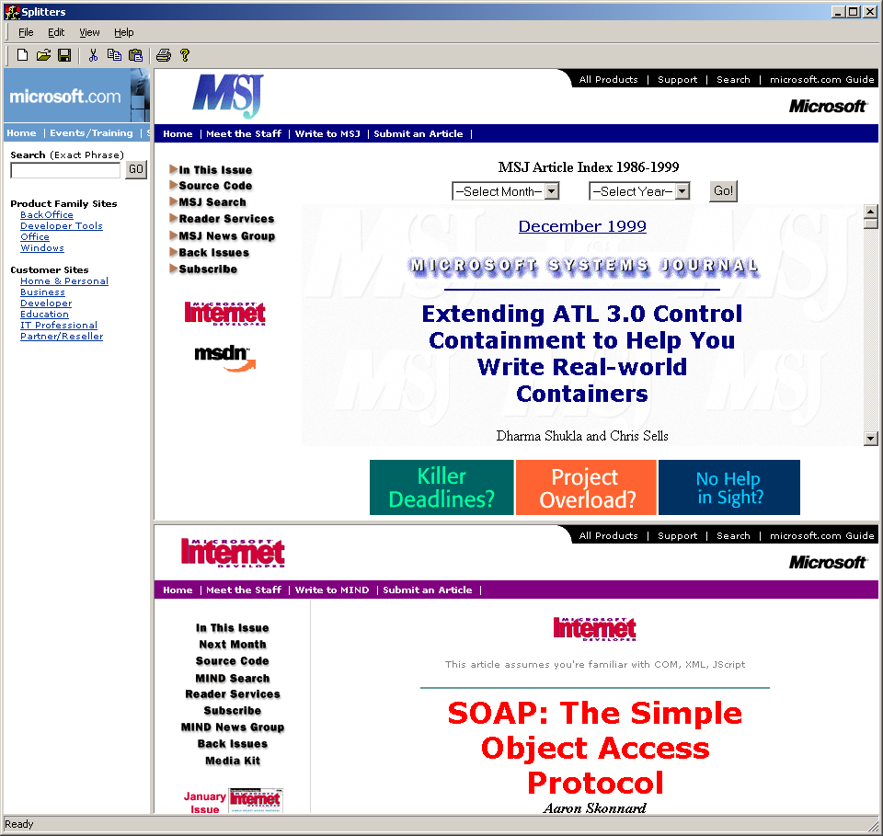

If you prefer to contain your splitter window controls instead of inherit from them, WTL provides CSplitterWindow and CHorSplitterWindow. The following provides an example of CSplitterWindow used in a windowed COM control created with the good old ATL COM AppWizard.

class ATL_NO_VTABLE CFooControl :
public CComObjectRootEx<CComSingleThreadModel>,
public CComControl<CFooControl>,…
{
CFooControl()
{
m_bWindowOnly = TRUE;
}

BEGIN_MSG_MAP(CFooControl)
MESSAGE_HANDLER(WM_CREATE, OnCreate)
CHAIN_MSG_MAP(CComControl<CFooControl>)
DEFAULT_REFLECTION_HANDLER()
END_MSG_MAP()

// Message handlers and other usual suspects

private:
CSplitterWindow m_splitter;
CHtmlView m_LeftView;
CHtmlView m_RightView;
};

Once again the WM_CREATE handler plays its part.

LRESULT CFooControl::OnCreate(UINT, WPARAM, LPARAM, BOOL&)
{
AtlAxWinInit();

//Create the Left and right views
m_LeftView.Create(m_hWnd, rcDefault, _T("http://www.microsoft.com"),WS_CHILD | WS_VISIBLE |
WS_CLIPSIBLINGS | WS_CLIPCHILDREN,WS_EX_STATICEDGE);

m_RightView.Create(m_hWnd, rcDefault, _T("http://www.microsoft.com"),WS_CHILD | WS_VISIBLE |
WS_CLIPSIBLINGS | WS_CLIPCHILDREN,WS_EX_STATICEDGE);
RECT rect; GetClientRect(&rect);

//Create the splitter object
m_splitter.Create(m_hWnd, rect, NULL, WS_CHILD | WS_VISIBLE | WS_CLIPSIBLINGS | WS_CLIPCHILDREN);

m_splitter.SetSplitterPanes(m_LeftView, m_RightView);
m_splitter.SetSplitterPos((rect.right - rect.left) / 4);

return 0L;
}

Finally, the WTL splitter classes also offer the functionality of dynamically flipping different views within a pane by calling CSplitterImpl::SetSplitterPane with a different hWnd. It also allows you to restrict the splitter positions by setting CSplitterImpl::m_cxyMin and calling CSplitterImpl::SetSplitterPos.

GDI Wrappers
No matter how many views you have or how you arrange them, somebody has to do the drawing in them. WTL provides simple wrappers around all of the Win32 GDI objects including those in Table 2.

Table 2: WTL Wrappers for Win32 GDI Objects
HDC | CDCT
HPEN | CPenT
HBRUSH | CBrushT
HFONT | CFontT
HBITMAP | CBitmapT
HRGN | CRgnT
HPALETTE | CPalletT

In fact, there are two versions of wrappers for each of the GDI resource it wraps: managed and unmanaged. The managed version destroys the object that it holds, whereas the unmanaged leaves the destruction of the underlying GDI object to the client of the object. For example, the CFontT class is a wrapper around the HFONT but it takes a Boolean template argument specifying whether it is a managed object or an unmanaged handle. The idea is to provide the flexibility to the client code that uses these wrappers.

//atlgdi.h
typedef CFontT<false> CFontHandle;
typedef CFontT<true> CFont;

template <bool t_bManaged>
class CFontT
{
public:
// Data members
HFONT m_hFont;

// Constructor/destructor/operators
CFontT(HFONT hFont = NULL) : m_hFont(hFont)
{ }

~CFontT()
{
if(t_bManaged && m_hFont != NULL)
DeleteObject();
}

CFontT<t_bManaged>& operator=(HFONT hFont)
{
m_hFont = hFont;
return *this;
}
…
};

Notice the CFontT destructor checks for the t_bManaged template argument for true before calling the DeleteObject method. The two versions of this class are defined for direct use, and the resulting types are CFont and CFontHandle, which are the managed and the unmanaged versions, respectively. WTL takes the exact same approach for all of the GDI wrappers.
The undisputed wrapper champion in all of WTL is CDCT, which wraps over 240 methods covering the GDI and the WGL functions. Four other WTL classes derive from the managed version of this class (CDC): CPaintDC, CWindowDC, CclientDC, and CEnhMetaFileDC. The CPaintDC class wraps the windows with PAINTSTRUCT and uses the BeginPaint/EndPaint pair to obtain/release the DC. The CClientDC class represents a Windows client and uses GetDC and ReleaseDC to obtain/release the DC. The CWindowDC class uses GetWindowDC and ReleaseDC to obtain and destroy the DC for the entire window. Finally, CEnhMetaFileDC wraps an HENHMETAFILE and calls CreateEnhMetaFile and DeleteEnhMetaFile to create and destroy the Windows meta file, respectively. The following CPaintDC declaration shows the way this family of classes works.

//atlgdi.h
class CPaintDC : public CDC
{
public:
HWND m_hWnd;
PAINTSTRUCT m_ps;

CPaintDC(HWND hWnd)
{
m_hWnd = hWnd;
m_hDC = ::BeginPaint(hWnd, &m_ps);
}

~CPaintDC()
{
::EndPaint(m_hWnd, &m_ps);
Detach();
}
};

Using the managed GDI wrappers can simplify raw GDI code considerably. For example, our bitmap view can be reduced to the following:

class CBitmapView : public CWindowImpl<CBitmapView>
{
public:
CBitmapView()
{
m_bmp.LoadBitmap(MAKEINTRESOURCE(IDB_ATLWINDOWING));
}

BEGIN_MSG_MAP(CBitmapView)
MESSAGE_HANDLER(WM_PAINT, OnPaint)
END_MSG_MAP()

LRESULT OnPaint(UINT, WPARAM, LPARAM, BOOL&)
{
CPaintDC dc(m_hWnd);
RECT rect; GetClientRect(&rect);
CDC dcMem; dcMem.CreateCompatibleDC(dc);

CBitmap bmpOld = dcMem.SelectBitmap(m_bmp);
BITMAP bm; m_bmp.GetBitmap(&bm);
SIZE size = { bm.bmWidth, bm.bmHeight };

dc.BitBlt(rect.left, rect.top, size.cx, size.cy, dcMem,
0, 0, SRCCOPY);

// Cleanup
dcMem.SelectBitmap(bmpOld);

return 0;
}

private:
CBitmap m_bmp;
};

To further aid the regular GDI needs of your app, WTL provides a set of inline global helpers all starting with the Atl prefix. These include AtlGetStockBrush, AtlGetStockFont, AtlGetStockPalette, AtlGetStockPen, AtlLoadAccelerators, AtlLoadBitmap, AtlLoadBitmapImage, AtlLoadCursor, and AtlLoadString to name a few.

CString, et al.
There’s a little box on the first screen of the ATL COM AppWizard called “Support MFC.” Because ATL supports basic windowing and dialogs, which is all that is likely to be needed in most COM servers, why would anyone want to check this box? One reason: CString. There are many developers that depend on the subtleties of CString and they are willing to pay the space overhead of MFC in an ATL server just to have it. Now they don’t have to. The ATL team has ported MFC’s CString to ATL and has shipped it with the rest of WTL (defined in atlmisc.h). The goal is transparent compatibility. The following steps show how the two implementations compare:
- WTL’s CString is copy-on-write, just like MFC’s.
- Many of the WTL methods have versions that take CString parameters, just like MFC.
- WTL’s CString has all the methods that are in the MFC counterpart except overloaded versions of a few of methods (discussed next) and CollateNoCase, an NLS-aware comparison.
- WTL’s TrimRight and TrimLeft methods just strip out the white space, whereas MFC’s versions strip out any character/or a set of characters you may specify.
- WTL’s Find method starts from the left looking for a particular character in the string. MFC provides two overloaded versions of Find. One is identical to WTL’s and the other allows you to pass a zero based index marking your search for the character in the string.
- Unfortunately, like MFC, WTL’s CString uses the CRT, making its usage in CRT-less ATL COM servers a problem.
- WTL’s version of AllocBuffer and AllocBeforeWrite methods return BOOL unlike MFC’s, which return a void.
- WTL’s version of Format does not support floating point whereas MFC’s does.
In addition to CString, WTL provides other useful MFC-like wrappers, including CRect, CSize, CPoint, CFileFind (which wraps the WIN32_FIND_DATA structure), and CWaitCursor (for displaying the ever popular hour glass during a long operator). Notably missing from WTL’s arsenal of frequently used helper classes are the wrappers for CURRENCY and DATE, which MFC has support for in terms of COleCurrency and COleDateTime/COleDateTimeSpan. You can download classes that perform these functions from the web site http://www.sellsbrothers.com/tools.

WTL’s support for DDX
Another of MFC’s features that WTL copies is Dynamic Data Exchange (DDX). DDX is the act of moving data back and forth between a Window object’s data members and a window’s child controls. WTL provides support for DDX via the CWinDataExchange class and a set of macros that implement the DoDataExhange method of this class.

// atlddx.h
template <class T> class CWinDataExchange {
public:
// Data exchange method - override in your derived class
BOOL DoDataExchange(BOOL /*bSaveAndValidate*/ = FALSE, UINT
/*nCtlID*/ = (UINT)-1)
{
// this one should never be called, override it in
// your derived class by implementing DDX map
ATLASSERT(FALSE);
return FALSE;
}
…
};

Any class that wants to participate in the DDX ritual simply derives from CWinDataExchange and provides an implementation of the DoDataExchange method. This method is implemented most easily via the DDX_MAP with each entry corresponding to the child controls placed on its client area, for example,

class CStringDialog :
public CDialogImpl<CStringDialog>,
public CWinDataExchange<CStringDialog>
{
public:
CStringDialog() { *m_sz = 0; }

enum { IDD = IDD_STRING };
BEGIN_MSG_MAP(CStringDialog)
COMMAND_ID_HANDLER(IDOK, OnOK)
COMMAND_ID_HANDLER(IDCANCEL, OnCancel)
MESSAGE_HANDLER(WM_INITDIALOG, OnInitDialog)
END_MSG_MAP()

BEGIN_DDX_MAP(CMainDlg)
DDX_TEXT(IDC_STRING, m_sz)
END_DDX_MAP()

LRESULT OnInitDialog(UINT, WPARAM, LPARAM, BOOL&) {
DoDataExchange(FALSE); // Populate the controls
return 0;
}

LRESULT OnOK(WORD, WORD wID, HWND, BOOL&) {
DoDataExchange(TRUE); // Populate the data members
EndDialog(wID);
return 0L;
}

LRESULT OnCancel(WORD, WORD wID, HWND, BOOL&) {
EndDialog(wID);
return 0L;
}

public:
enum { MAX_STRING = 128 };
char m_sz[MAX_STRING+1];
};

CStringDialog is a dialog that derives from CWinDataExhange and contains a single edit control. The dialog first populates the edit control with whatever is in the m_sz data member during WM_INITDIALOG when the handler calls DoDataExchange(FALSE). The dialog synchronizes the data member to the state of the edit control when the user presses the OK button and the handler calls DoDataExchange(TRUE). This is very similar to MFC’s DDX implementation and the usage.

LRESULT CMainFrame::OnFileTitle(WORD,WORD wID, HWND,BOOL&) {
CStringDialog dlg;
GetWindowText(dlg.m_sz, dlg.MAX_STRING);
if( dlg.DoModal() == IDOK ) SetWindowText(dlg.m_sz);
return 0L;
}

In addition to text, WTL’s DDX supports signed and unsigned integers and floating-point numbers. It also supports controls like radio buttons and checkboxes. Table 3 shows the macros that atlddx.h defines.

Table 3: WTL’s DDX Macros
Macro | Purpose
DDX_TEXT(nID, var) | Associates the text content of a control with the CString, CComBSTR or LPTSTR member variable of your class.
DDX_TEXT_LEN(nID, var, len) | Same as DDX_TEXT but also validates the length.
DDX_INT(nID, var) | Associates the numeric value that the user typed in a control with the integer class member.
DDX_INT_RANGE(nID, var, min, max) | Same as DDX_INT but also validates the range.
DDX_UINT(nID, var) | Same as DDX_INT for unsigned Integers.
DDX_UINT_RANGE(nID, var, min, max) | Same as DDX_INT_RANGE for unsigned integers.
DDX_FLOAT(nID, var) | Same as DDX_INT for floats.
DDX_FLOAT_RANGE(nID, var, min, max) | Same as DDX_INT_RANGE for floats.
DDX_CONTROL(nID, obj) | DDX_CONTROL subclasses a control, represented by the obj parameter in the macro (just like in MFC). Because of that, your data member must derive from CWindowImpl (or at least have SubclassWindow method).
DDX_CHECK(nID, var) | Sets the var to the checked state of the button.
DDX_RADIO(nID, var) | Manages the transfer of integer data between a radio control group and a int data member.

Compared to MFC, WTL’s DDX doesn’t happen automatically; you have to call manually call DoDataExchange. This gives you flexibility to call it exactly when you want. Also, you can call it for only one control by passing in the control’s id to DoDataExchange.

WTL Wizardry
At the beginning of this article we mentioned a VC AppWizard that generates WTL-based applications by way of the MFC AppWizard. To use it, you need copy the AtlApp60.awx file from the WTL\AppWiz folder to the C:\Program Files\Microsoft Visual Studio\Common\MSDev98\Bin\Template folder. This puts the ATL/WTL AppWizard in VC’s New Project dialog (as shown in Figure 12).

Figure 12: ATL/WTL AppWizard in VC’s New Project Dialog
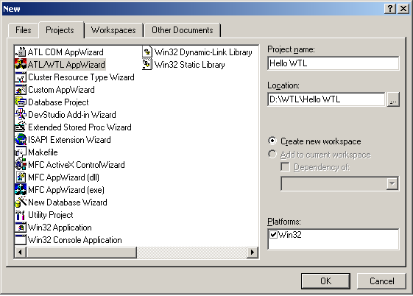

By using the WTL wizard you can create four different types of Applications: SDI, MDI, Multi SDI, and Dialog-based. The control hosting option uses the same functionality provide in ATL 3.0’s atlhost.h. Choosing to have your application act as a COM server (as shown in Figure 13) causes the wizard to generate code very similar to what the ATL COM AppWizard generates if you chose the EXE server option.

Figure 13: Application Acting as a COM Server
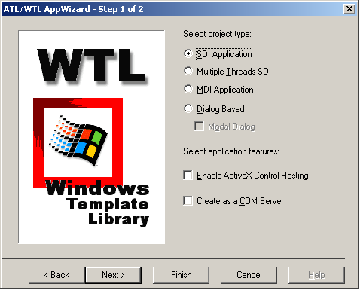

Just like MFC, you can choose various frame decoration options like toolbar, commandbar, rebar, and status bar. Choosing these options has an effect on the main application frame window class’s WM_CREATE handler, which creates these decorations based on your selections. You even can specify a view contained within the application frame. In addition to acting like a Form view or a generic window, you can base the view on listbox, edit, list view, tree view, rich edit based controls, or even an HTML view by using of ATL’s control hosting support (as shown in Figure 14).

Figure 14: Example of Ways to Base Your View
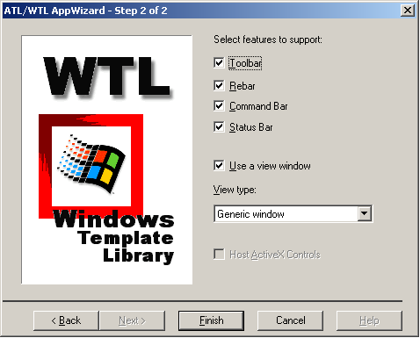

Of course, like all wizards, this wizard does not reflect all capabilities as options, but it reflects enough to give you a good head start on building your WTL-based applications.

WTL Samples
To further your understanding of WTL, WTL ships with three sample apps named GuidGen, MTPad, and MdiDocView. GuidGen, which demonstrates a simple dialog-based application, looks and works exactly like your favorite guidgen.exe (and is smaller). The MTPAd is a Multi-SDI app and demonstrates a lot of WTL’s support for advanced functionality (which we discuss in Part 2 of this series), like Common Dialogs, the common control wrappers, UI updating, etc. Finally, MDIDoc view shows the use of WTL’s MDI classes.
To get a better idea of writing WTL based apps, you also can check out the samples that come with this article. In fact, we decided to put all our understanding of WTL into a larger sample application that mimicked an old favorite: the Windows File Explorer (Figure 15).

Figure 15: Windows File Explorer
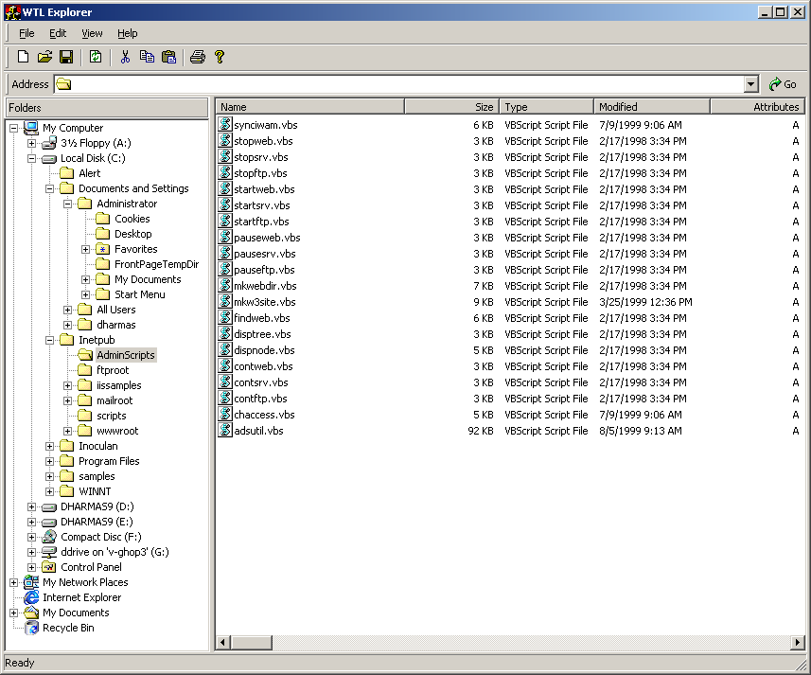

Summary
We are half way there. We just covered the WTL’s support for SDI, Multi SDI, MDI apps, explorer/workspace style apps that use splitters, GDI wrappers, helper classes, and DDX. We haven’t seen WTL command bar architecture, common controls wrappers, message routing architecture including message cracking and filtering, and idle handling yet. Neither have we covered the common dialog wrappers, property pages and sheets, printing support, nor scrolling windows. We’ll cover these topics in Part 2 of this series.

Chris Sells is the Director of Software Engineering at DevelopMentor and the co-author of Effective COM and ATL Internals; he can be reached http://staff.develop.com/csells.
Dharma Shukla is a Software Design Engineer on the BizTalk Server 2000 group at Microsoft and can be reached at dharmas@microsoft.com.
Nenad Stefanovic is a member of the original ATL/WTL team. He is a Software Development Engineer at Microsoft and can be reached at nenads@microsoft.com.

- The newer version of common controls dll provides a way to make tools that have been covered by another band of a rebar control accessible to the user. You can have a chevron to be displayed for toolbars that have been covered. When a user clicks the chevron, a menu is displayed that allows him or her to use the hidden tools.
WGL API consists of a set of "wiggle" functions (named after the wgl prefix to its name). A wiggle function is a Win32 function that bridges the gap between the portable OpenGL™ graphics library and the Microsoft Windows® platform.

