# 在笔者前面有一篇文章 《驱动开发：断链隐藏驱动程序自身》 通过摘除驱动的链表实现了断链隐藏自身的目的，但此方法恢复时会触发PG会蓝屏，偶然间在网上找到了一个作者介绍的一种方法，觉得有必要详 细分析一下他是如何实现的驱动隐藏的，总体来说作者的思路是最终寻找到 MiProcessLoaderEntry 的入口地址，该函数的作用是将驱动信息加入链表和移除链表，运用这个函数即可动态处理驱动的添加和 移除问题。

MiProcessLoaderEntry(pDriverObject->DriverSection, 1) 添 加

MiProcessLoaderEntry(pDriverObject->DriverSection, 0) 移 除

那么如何找到 MiProcessLoaderEntry 函数入口地址就是下一步的目标，寻找入口可以总结为；

1.寻找 MmUnloadSystemImage 函数地址，可通过 MmGetSystemRoutineAddress 函数得到。

2.在 MmUnloadSystemImage 里面寻找 MiUnloadSystemImage 函数地址。

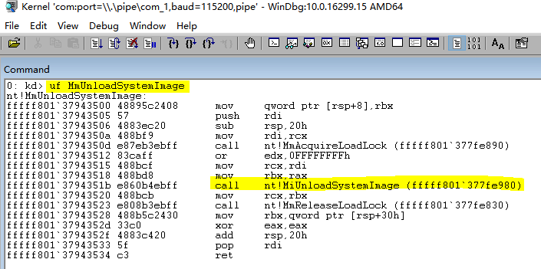3.在 MiUnloadSystemImage 里面继续寻找 MiProcessLoaderEntry 即可。搜索 MmUnloadSystemImage 可定位到 call nt!MiUnloadSystemImage 地址。

搜索 MiUnloadSystemImage 定位到 call nt!MiProcessLoaderEntry 即得到了我们想要的。

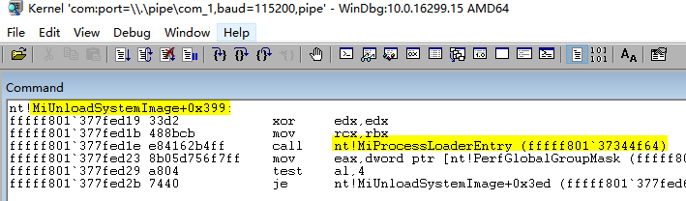

# 根据前面 枚举篇 系列文章，定位这段特征很容易实现，如下是一段参考代码。

// PowerBy: LyShark

// Email: [me@lyshark.com](mailto:me@lyshark.com)

#include <ntddk.h> #include <ntstrsafe.h>

typedef NTSTATUS( fastcall MiProcessLoaderEntry)(PVOID pDriverSection, BOOLEAN bLoad);



// 取出指定函数地址

PVOID GetProcAddress(WCHAR FuncName)

{

UNICODE_STRING u_FuncName = { 0 }; PVOID ref = NULL;

RtlInitUnicodeString(&u_FuncName, FuncName); ref = MmGetSystemRoutineAddress(&u_FuncName);

if (ref != NULL)

{

return ref;

}

return ref;

}

// 特征定位 MiUnloadSystemImage

ULONG64 GetMiUnloadSystemImageAddress()

{

// 在MmUnloadSystemImage函数中搜索的Code

/

lyshark.com: kd> uf MmUnloadSystemImage

fffff801`37943512 83caff or edx,0FFFFFFFFh fffff801`37943515 488bcf mov rcx,rdi

fffff801`37943518 488bd8 mov rbx,rax

fffff801`3794351b e860b4ebff call nt!MiUnloadSystemImage (fffff801`377fe980)

/

CHAR MmUnloadSystemImage_Code[] = "\x83\xCA\xFF" // or edx, 0FFFFFFFFh "\x48\x8B\xCF" // mov rcx, rdi

"\x48\x8B\xD8" // mov rbx, rax

"\xE8"; // call

nt!MiUnloadSystemImage (fffff801`377fe980)

ULONG_PTR MmUnloadSystemImageAddress = 0; ULONG_PTR MiUnloadSystemImageAddress = 0; ULONG_PTR StartAddress = 0;

MmUnloadSystemImageAddress = (ULONG_PTR)GetProcAddress(L"MmUnloadSystemImage");

if (MmUnloadSystemImageAddress == 0)

{

return 0;

}

// 在MmUnloadSystemImage中搜索特征码寻找MiUnloadSystemImage StartAddress = MmUnloadSystemImageAddress;

while (StartAddress < MmUnloadSystemImageAddress + 0x500)

{

if (memcmp((VOID )StartAddress, MmUnloadSystemImage_Code, strlen(MmUnloadSystemImage_Code)) == 0)

{

// 跳过call之前的指令

StartAddress += strlen(MmUnloadSystemImage_Code);

// 取出 MiUnloadSystemImage地址

MiUnloadSystemImageAddress = (LONG )StartAddress + StartAddress +

4;

break;

}

++StartAddress;

}

if (MiUnloadSystemImageAddress != 0)

{

return MiUnloadSystemImageAddress;

}

return 0;

}

// 特征定位 MiProcessLoaderEntry

MiProcessLoaderEntry GetMiProcessLoaderEntry(ULONG64 StartAddress)

{

if (StartAddress == 0)

{

return NULL;

}

while (StartAddress < StartAddress + 0x600)

{

// 操作数MiProcessLoaderEntry内存地址是动态变化的

/

lyshark.com: kd> uf MiUnloadSystemImage fffff801`377fed19 33d2 xor edx,edx

fffff801`377fed1b 488bcb mov rcx,rbx fffff801`377fed1e e84162b4ff call nt!MiProcessLoaderEntry

(fffff801`37344f64)

fffff801`377fed23 8b05d756f7ff mov eax,dword ptr [nt!PerfGlobalGroupMask (fffff801`37774400)]

fffff801`377fed29 a804 test al,4

fffff801`377fed2b 7440 je nt!MiUnloadSystemImage+0x3ed (fffff801`377fed6d) Branch

E8 call | 8B 05 mov eax

/

// fffff801`377fed1e | fffff801`377fed23

// 判断特征 0xE8(call) | 0x8B 0x05(mov eax)

if ( (UCHAR )StartAddress == 0xE8 && (UCHAR )(StartAddress + 5) == 0x8B && (UCHAR )(StartAddress + 6) == 0x05)

{

// 跳过一个字节call的E8 StartAddress++;



4);

// StartAddress + 1 + 4

return (MiProcessLoaderEntry)( (LONG )StartAddress + StartAddress +

}

++StartAddress;

}

return NULL;

}

VOID UnDriver(PDRIVER_OBJECT driver)

{

DbgPrint("卸载完成... \n");

}

NTSTATUS DriverEntry(IN PDRIVER_OBJECT Driver, PUNICODE_STRING RegistryPath)

{

DbgPrint("hello lyshark.com \n");

ULONG64 MiUnloadSystemImageAddress = GetMiUnloadSystemImageAddress(); DbgPrint("MiUnloadSystemImageAddress = %p \n", MiUnloadSystemImageAddress);

MiProcessLoaderEntry MiProcessLoaderEntryAddress = GetMiProcessLoaderEntry(MiUnloadSystemImageAddress);

DbgPrint("MiProcessLoaderEntryAddress = %p \n", (ULONG64)MiProcessLoaderEntryAddress);

Driver->DriverUnload = UnDriver; return STATUS_SUCCESS;

}

运行驱动程序，即可得到 MiProcessLoaderEntryAddress 的内存地址。

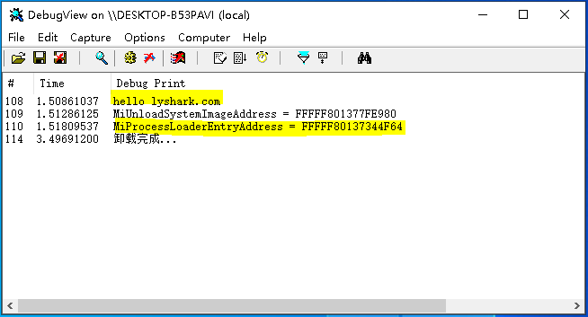

# 得到内存地址之后，直接破坏掉自身驱动的入口地址等，即可实现隐藏自身。



// PowerBy: LyShark

// Email: [me@lyshark.com](mailto:me@lyshark.com) #include <ntddk.h> #include <ntstrsafe.h>

typedef NTSTATUS( NTQUERYSYSTEMINFORMATION)(

IN ULONG SystemInformationClass, OUT PVOID SystemInformation,



IN ULONG_PTR SystemInformationLength,

OUT PULONG_PTR ReturnLength OPTIONAL);

NTSYSAPI NTSTATUS NTAPI ObReferenceObjectByName(

in PUNICODE_STRING ObjectName,

in ULONG Attributes,

in_opt PACCESS_STATE AccessState,

in_opt ACCESS_MASK DesiredAccess,

in POBJECT_TYPE ObjectType,

in KPROCESSOR_MODE AccessMode,

inout_opt PVOID ParseContext,

out PVOID Object

);

typedef struct _SYSTEM_MODULE_INFORMATION

{

HANDLE Section; PVOID MappedBase; PVOID Base;

ULONG Size;

ULONG Flags;

USHORT LoadOrderIndex; USHORT InitOrderIndex; USHORT LoadCount; USHORT PathLength; CHAR ImageName[256];

} SYSTEM_MODULE_INFORMATION, PSYSTEM_MODULE_INFORMATION;

typedef struct _LDR_DATA_TABLE_ENTRY

{

LIST_ENTRY InLoadOrderLinks; LIST_ENTRY InMemoryOrderLinks; LIST_ENTRY InInitializationOrderLinks; PVOID DllBase;

PVOID EntryPoint;

}LDR_DATA_TABLE_ENTRY, PLDR_DATA_TABLE_ENTRY;

extern POBJECT_TYPE IoDriverObjectType;

typedef NTSTATUS( fastcall MiProcessLoaderEntry)(PVOID pDriverSection, BOOLEAN bLoad);

ULONG64 MiUnloadSystemImageAddress = 0;

// 取出指定函数地址

PVOID GetProcAddress(WCHAR FuncName)

{

UNICODE_STRING u_FuncName = { 0 }; PVOID ref = NULL;

RtlInitUnicodeString(&u_FuncName, FuncName); ref = MmGetSystemRoutineAddress(&u_FuncName);

if (ref != NULL)

{

return ref;



}

return ref;

}

// 特征定位 MiUnloadSystemImage

ULONG64 GetMiUnloadSystemImageAddress()

{

CHAR MmUnloadSystemImage_Code[] = "\x83\xCA\xFF\x48\x8B\xCF\x48\x8B\xD8\xE8";

ULONG_PTR MmUnloadSystemImageAddress = 0; ULONG_PTR MiUnloadSystemImageAddress = 0; ULONG_PTR StartAddress = 0;

MmUnloadSystemImageAddress = (ULONG_PTR)GetProcAddress(L"MmUnloadSystemImage");

if (MmUnloadSystemImageAddress == 0)

{

return 0;

}

// 在MmUnloadSystemImage中搜索特征码寻找MiUnloadSystemImage StartAddress = MmUnloadSystemImageAddress;

while (StartAddress < MmUnloadSystemImageAddress + 0x500)

{

if (memcmp((VOID )StartAddress, MmUnloadSystemImage_Code, strlen(MmUnloadSystemImage_Code)) == 0)

{

StartAddress += strlen(MmUnloadSystemImage_Code); MiUnloadSystemImageAddress = (LONG )StartAddress + StartAddress + 4; break;

}

++StartAddress;

}

if (MiUnloadSystemImageAddress != 0)

{

return MiUnloadSystemImageAddress;

}

return 0;

}

// 特征定位 MiProcessLoaderEntry

MiProcessLoaderEntry GetMiProcessLoaderEntry(ULONG64 StartAddress)

{

if (StartAddress == 0)

{

return NULL;

}

while (StartAddress < StartAddress + 0x600)

{

if ( (UCHAR )StartAddress == 0xE8 && (UCHAR )(StartAddress + 5) == 0x8B && (UCHAR )(StartAddress + 6) == 0x05)



{

StartAddress++;

return (MiProcessLoaderEntry)( (LONG )StartAddress + StartAddress + 4);

}

++StartAddress;

}

return NULL;

}

// 根据驱动名获取驱动对象

BOOLEAN GetDriverObjectByName(PDRIVER_OBJECT DriverObject, WCHAR DriverName)

{

PDRIVER_OBJECT TempObject = NULL; UNICODE_STRING u_DriverName = { 0 }; NTSTATUS Status = STATUS_UNSUCCESSFUL;

RtlInitUnicodeString(&u_DriverName, DriverName);

Status = ObReferenceObjectByName(&u_DriverName, OBJ_CASE_INSENSITIVE, NULL, 0, IoDriverObjectType, KernelMode, NULL, &TempObject);

if (!NT_SUCCESS(Status))

{

DriverObject = NULL; return FALSE;

}

DriverObject = TempObject; return TRUE;

}

BOOLEAN SupportSEH(PDRIVER_OBJECT DriverObject)

{

PDRIVER_OBJECT Object = NULL;; PLDR_DATA_TABLE_ENTRY LdrEntry = NULL;

GetDriverObjectByName(&Object, L"\\Driver\\tdx"); if (Object == NULL)

{

return FALSE;

}

// 将获取到的驱动对象节点赋值给自身LDR

LdrEntry = (PLDR_DATA_TABLE_ENTRY)DriverObject->DriverSection; LdrEntry->DllBase = Object->DriverStart; ObDereferenceObject(Object);

return TRUE;

}

VOID InitInLoadOrderLinks(PLDR_DATA_TABLE_ENTRY LdrEntry)

{

InitializeListHead(&LdrEntry->InLoadOrderLinks); InitializeListHead(&LdrEntry->InMemoryOrderLinks);

}

VOID Reinitialize(PDRIVER_OBJECT DriverObject, PVOID Context, ULONG Count)



{

MiProcessLoaderEntry m_MiProcessLoaderEntry = NULL; ULONG p = NULL;

m_MiProcessLoaderEntry = GetMiProcessLoaderEntry(MiUnloadSystemImageAddress);

if (m_MiProcessLoaderEntry == NULL)

{

return;

}

SupportSEH(DriverObject);

m_MiProcessLoaderEntry(DriverObject->DriverSection, 0); InitInLoadOrderLinks((PLDR_DATA_TABLE_ENTRY)DriverObject->DriverSection);

// 破坏驱动对象特征

DriverObject->DriverSection = NULL; DriverObject->DriverStart = NULL; DriverObject->DriverSize = 0; DriverObject->DriverUnload = NULL; DriverObject->DriverInit = NULL; DriverObject->DeviceObject = NULL;

DbgPrint("驱动隐藏 \n");

}

VOID UnDriver(PDRIVER_OBJECT driver)

{

DbgPrint("卸载完成... \n");

}

NTSTATUS DriverEntry(IN PDRIVER_OBJECT Driver, PUNICODE_STRING RegistryPath)

{

DbgPrint("hello lyshark.com \n");

MiUnloadSystemImageAddress = GetMiUnloadSystemImageAddress(); MiProcessLoaderEntry MiProcessLoaderEntryAddress =

GetMiProcessLoaderEntry(MiUnloadSystemImageAddress);

// 无痕隐藏

IoRegisterDriverReinitialization(Driver, Reinitialize, NULL);

Driver->DriverUnload = UnDriver; return STATUS_SUCCESS;

}

# 运行驱动程序，让后看到如下输出信息；

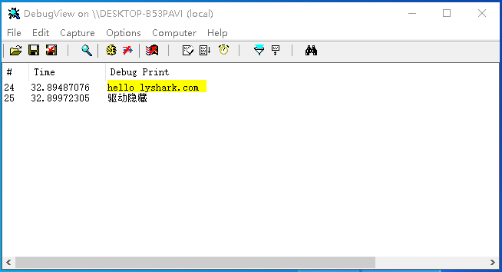

**参考文献**

# https://blog.csdn.net/zhuhuibeishadiao/article/details/75658816 h ttps://github.com/ZhuHuiBeiShaDiao/NewHideDriverEx

本书作者： 王瑞 (LyShark)

作者邮箱： m [e@lyshark.com](mailto:e@lyshark.com)

作者博客： h ttps://lyshark.cnblogs.com

团队首页： w ww.lyshark.com