在笔者上一篇文章 《驱动开发：内核枚举LoadImage映像回调》 中 LyShark 教大家实现了枚举系统回调中的 LoadImage 通知消息，本章将实现对 Registry 注册表通知消息的枚举，与 LoadImage 消息不同

Registry 消息不需要解密只要找到 CallbackListHead 消息回调链表头并解析为 _CM_NOTIFY_ENTRY

# 结构即可实现枚举。

我们来看一款闭源ARK工具是如何实现的：

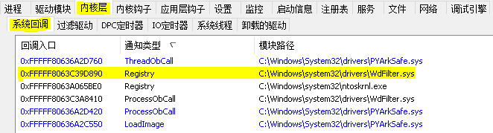

注册表系统回调的枚举需要通过特征码搜索来实现，首先我们可以定位到 uf CmUnRegisterCallback

内核函数上，在该内核函数下方存在一个 CallbackListHead 链表节点，取出这个链表地址。

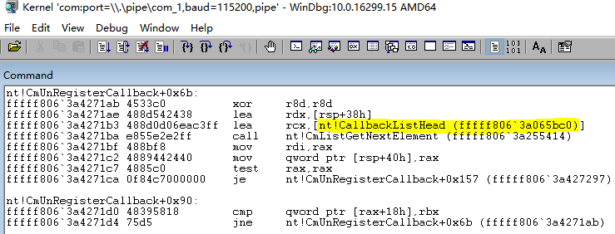

当得到注册表链表入口 0xfffff8063a065bc0 直接将其解析为 _CM_NOTIFY_ENTRY 即可得到数据，如果要遍历下一个链表则只需要 ListEntryHead.Flink 向下移动指针即可。



// 署名权

// right to sign one's name on a piece of work

// PowerBy: LyShark

// Email: [me@lyshark.com](mailto:me@lyshark.com)

// 注册表回调函数结构体定义

typedef struct _CM_NOTIFY_ENTRY

{

LIST_ENTRY ListEntryHead; ULONG UnKnown1;

ULONG UnKnown2;

LARGE_INTEGER Cookie; PVOID Context; PVOID Function;

}CM_NOTIFY_ENTRY, PCM_NOTIFY_ENTRY;

要想得到此处的链表地址，需要先通过 MmGetSystemRoutineAddress() 获取到



CmUnRegisterCallback 函数基址，然后在该函数起始位置向下搜索，找到这个链表节点，并将其后面的基地址取出来，在上一篇 《驱动开发：内核枚举LoadImage映像回调》 文章中已经介绍了定位方式此处跳过介绍，具体实现代码如下。

// 署名权

// right to sign one's name on a piece of work

// PowerBy: LyShark

// Email: [me@lyshark.com](mailto:me@lyshark.com)

#include <ntifs.h> #include <windef.h>

// 指定内存区域的特征码扫描

// PowerBy: LyShark.com

PVOID SearchMemory(PVOID pStartAddress, PVOID pEndAddress, PUCHAR pMemoryData, ULONG ulMemoryDataSize)

{

PVOID pAddress = NULL; PUCHAR i = NULL; ULONG m = 0;

// 扫描内存

for (i = (PUCHAR)pStartAddress; i < (PUCHAR)pEndAddress; i++)

{

// 判断特征码

for (m = 0; m < ulMemoryDataSize; m++)

{

if ( (PUCHAR)(i + m) != pMemoryData[m])

{

break;

}

}

// 判断是否找到符合特征码的地址

if (m >= ulMemoryDataSize)

{

// 找到特征码位置, 获取紧接着特征码的下一地址pAddress = (PVOID)(i + ulMemoryDataSize); break;

}

}

return pAddress;

}

// 根据特征码获取 CallbackListHead 链表地址

// PowerBy: LyShark.com

PVOID SearchCallbackListHead(PUCHAR pSpecialData, ULONG ulSpecialDataSize, LONG lSpecialOffset)

{

UNICODE_STRING ustrFuncName; PVOID pAddress = NULL;

LONG lOffset = 0;

PVOID pCmUnRegisterCallback = NULL; PVOID pCallbackListHead = NULL;



// 先获取 CmUnRegisterCallback 函数地址

RtlInitUnicodeString(&ustrFuncName, L"CmUnRegisterCallback"); pCmUnRegisterCallback = MmGetSystemRoutineAddress(&ustrFuncName); if (NULL == pCmUnRegisterCallback)

{

return pCallbackListHead;

}

// 查找 fffff806`3a4271b3 488d0d06eac3ff lea rcx,[nt!CallbackListHead (fffff806`3a065bc0)]

/ lyshark.com>

nt!CmUnRegisterCallback+0x6b:

fffff806`3a4271ab 4533c0 xor r8d,r8d fffff806`3a4271ae 488d542438 lea rdx,[rsp+38h] fffff806`3a4271b3 488d0d06eac3ff lea rcx,[nt!CallbackListHead

(fffff806`3a065bc0)]

fffff806`3a4271ba e855e2e2ff call nt!CmListGetNextElement (fffff806`3a255414)

fffff806`3a4271bf 488bf8 mov rdi,rax fffff806`3a4271c2 4889442440 mov qword ptr [rsp+40h],rax fffff806`3a4271c7 4885c0 test rax,rax

fffff806`3a4271ca 0f84c7000000 je nt!CmUnRegisterCallback+0x157 (fffff806`3a427297) Branch

/

pAddress = SearchMemory(pCmUnRegisterCallback, (PVOID) ((PUCHAR)pCmUnRegisterCallback + 0xFF), pSpecialData, ulSpecialDataSize);

if (NULL == pAddress)

{

return pCallbackListHead;

}

// 先获取偏移再计算地址

lOffset = (PLONG)((PUCHAR)pAddress + lSpecialOffset);

pCallbackListHead = (PVOID)((PUCHAR)pAddress + lSpecialOffset + sizeof(LONG)

+ lOffset);

return pCallbackListHead;

}

VOID UnDriver(PDRIVER_OBJECT Driver)

{

}

NTSTATUS DriverEntry(IN PDRIVER_OBJECT Driver, PUNICODE_STRING RegistryPath)

{

PVOID pCallbackListHeadAddress = NULL; RTL_OSVERSIONINFOW osInfo = { 0 };

UCHAR pSpecialData[50] = { 0 };

ULONG ulSpecialDataSize = 0; LONG lSpecialOffset = 0;

DbgPrint("hello lyshark.com \n");

|  |  |  |  |
| --- | --- | --- | --- |
| fffff806`3a4271bf | 488bf8 | mov | rdi,rax |
| fffff806`3a4271c2 | 4889442440 | mov | qword ptr [rsp+40h],rax |
| fffff806`3a4271c7 | 4885c0 | test | rax,rax |
| fffff806`3a4271ca | 0f84c7000000 | je | nt!CmUnRegisterCallback+0x157 |
| (fffff806`3a427297) | Branch |  |  |

# 运行这段代码，并可得到注册表回调入口地址，输出效果如下所示：



// 查找 fffff806`3a4271b3 488d0d06eac3ff

(fffff806`3a065bc0)]

/ lyshark.com>

nt!CmUnRegisterCallback+0x6b:

lea

rcx,[nt!CallbackListHead

fffff806`3a4271ab 4533c0 fffff806`3a4271ae 488d542438 fffff806`3a4271b3 488d0d06eac3ff

(fffff806`3a065bc0)]

fffff806`3a4271ba e855e2e2ff (fffff806`3a255414)

xor lea

lea

r8d,r8d rdx,[rsp+38h]

rcx,[nt!CallbackListHead

call

nt!CmListGetNextElement

/

pSpecialData[0] = 0x48; pSpecialData[1] = 0x8D; pSpecialData[2] = 0x0D; ulSpecialDataSize = 3;

// 根据特征码获取地址

pCallbackListHeadAddress = SearchCallbackListHead(pSpecialData, ulSpecialDataSize, lSpecialOffset);

DbgPrint("[LyShark.com] CallbackListHead => %p \n", pCallbackListHeadAddress);

Driver->DriverUnload = UnDriver; return STATUS_SUCCESS;

}

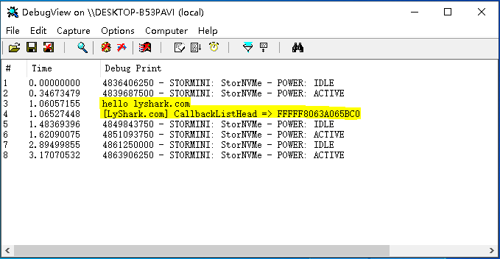

得到了注册表回调入口地址，接着直接循环遍历输出这个链表即可得到所有的注册表回调。

// 署名权



// right to sign one's name on a piece of work

// PowerBy: LyShark

// Email: [me@lyshark.com](mailto:me@lyshark.com)

#include <ntifs.h> #include <windef.h>

// 指定内存区域的特征码扫描

// PowerBy: LyShark.com

PVOID SearchMemory(PVOID pStartAddress, PVOID pEndAddress, PUCHAR pMemoryData, ULONG ulMemoryDataSize)

{

PVOID pAddress = NULL; PUCHAR i = NULL; ULONG m = 0;

// 扫描内存

for (i = (PUCHAR)pStartAddress; i < (PUCHAR)pEndAddress; i++)

{

// 判断特征码

for (m = 0; m < ulMemoryDataSize; m++)

{

if ( (PUCHAR)(i + m) != pMemoryData[m])

{

break;

}

}

// 判断是否找到符合特征码的地址

if (m >= ulMemoryDataSize)

{

// 找到特征码位置, 获取紧接着特征码的下一地址pAddress = (PVOID)(i + ulMemoryDataSize); break;

}

}

return pAddress;

}

// 根据特征码获取 CallbackListHead 链表地址

// PowerBy: LyShark.com

PVOID SearchCallbackListHead(PUCHAR pSpecialData, ULONG ulSpecialDataSize, LONG lSpecialOffset)

{

UNICODE_STRING ustrFuncName; PVOID pAddress = NULL;

LONG lOffset = 0;

PVOID pCmUnRegisterCallback = NULL; PVOID pCallbackListHead = NULL;

// 先获取 CmUnRegisterCallback 函数地址RtlInitUnicodeString(&ustrFuncName, L"CmUnRegisterCallback"); pCmUnRegisterCallback = MmGetSystemRoutineAddress(&ustrFuncName);

if (NULL == pCmUnRegisterCallback)

{



return pCallbackListHead;

}

// 查找 fffff806`3a4271b3 488d0d06eac3ff lea rcx,[nt!CallbackListHead (fffff806`3a065bc0)]

/ lyshark.com>

nt!CmUnRegisterCallback+0x6b:

fffff806`3a4271ab 4533c0 xor r8d,r8d fffff806`3a4271ae 488d542438 lea rdx,[rsp+38h] fffff806`3a4271b3 488d0d06eac3ff lea rcx,[nt!CallbackListHead

(fffff806`3a065bc0)]

fffff806`3a4271ba e855e2e2ff call nt!CmListGetNextElement (fffff806`3a255414)

fffff806`3a4271bf 488bf8 mov rdi,rax

fffff806`3a4271c2 4889442440 mov qword ptr [rsp+40h],rax fffff806`3a4271c7 4885c0 test rax,rax

fffff806`3a4271ca 0f84c7000000 je nt!CmUnRegisterCallback+0x157

(fffff806`3a427297) Branch

/

pAddress = SearchMemory(pCmUnRegisterCallback, (PVOID) ((PUCHAR)pCmUnRegisterCallback + 0xFF), pSpecialData, ulSpecialDataSize);

if (NULL == pAddress)

{

return pCallbackListHead;

}

// 先获取偏移再计算地址

lOffset = (PLONG)((PUCHAR)pAddress + lSpecialOffset);

pCallbackListHead = (PVOID)((PUCHAR)pAddress + lSpecialOffset + sizeof(LONG)

+ lOffset);

return pCallbackListHead;

}

// 注册表回调函数结构体定义

typedef struct _CM_NOTIFY_ENTRY

{

LIST_ENTRY ListEntryHead; ULONG UnKnown1;

ULONG UnKnown2;

LARGE_INTEGER Cookie; PVOID Context; PVOID Function;

}CM_NOTIFY_ENTRY, PCM_NOTIFY_ENTRY;

VOID UnDriver(PDRIVER_OBJECT Driver)

{

}

NTSTATUS DriverEntry(IN PDRIVER_OBJECT Driver, PUNICODE_STRING RegistryPath)

{

PVOID pCallbackListHeadAddress = NULL; RTL_OSVERSIONINFOW osInfo = { 0 };

UCHAR pSpecialData[50] = { 0 }; ULONG ulSpecialDataSize = 0; LONG lSpecialOffset = 0;



DbgPrint("hello lyshark.com \n");

// 查找 fffff806`3a4271b3 488d0d06eac3ff lea rcx,[nt!CallbackListHead (fffff806`3a065bc0)]

/ lyshark.com>

nt!CmUnRegisterCallback+0x6b:

fffff806`3a4271ab 4533c0 xor r8d,r8d fffff806`3a4271ae 488d542438 lea rdx,[rsp+38h] fffff806`3a4271b3 488d0d06eac3ff lea rcx,[nt!CallbackListHead

(fffff806`3a065bc0)]

fffff806`3a4271ba e855e2e2ff call nt!CmListGetNextElement (fffff806`3a255414)

|  |  |  |  |
| --- | --- | --- | --- |
| fffff806`3a4271bf | 488bf8 | mov | rdi,rax |
| fffff806`3a4271c2 | 4889442440 | mov | qword ptr [rsp+40h],rax |
| fffff806`3a4271c7 | 4885c0 | test | rax,rax |
| fffff806`3a4271ca  (fffff806`3a427297) | 0f84c7000000  Branch | je | nt!CmUnRegisterCallback+0x157 |

/

pSpecialData[0] = 0x48; pSpecialData[1] = 0x8D; pSpecialData[2] = 0x0D; ulSpecialDataSize = 3;

// 根据特征码获取地址

pCallbackListHeadAddress = SearchCallbackListHead(pSpecialData, ulSpecialDataSize, lSpecialOffset);

DbgPrint("[LyShark.com] CallbackListHead => %p \n", pCallbackListHeadAddress);

// 遍历链表结构

ULONG i = 0;

PCM_NOTIFY_ENTRY pNotifyEntry = NULL;

if (NULL == pCallbackListHeadAddress)

{

return FALSE;

}

// 开始遍历双向链表

pNotifyEntry = (PCM_NOTIFY_ENTRY)pCallbackListHeadAddress; do

{

// 判断pNotifyEntry地址是否有效

if (FALSE == MmIsAddressValid(pNotifyEntry))

{

break;

}

// 判断回调函数地址是否有效

if (MmIsAddressValid(pNotifyEntry->Function))

{

DbgPrint("[LyShark.com] 回调函数地址: 0x%p | 回调函数Cookie: 0x%I64X

\n", pNotifyEntry->Function, pNotifyEntry->Cookie.QuadPart);

}

// 获取下一链表

pNotifyEntry = (PCM_NOTIFY_ENTRY)pNotifyEntry->ListEntryHead.Flink;

} while (pCallbackListHeadAddress != (PVOID)pNotifyEntry);

Driver->DriverUnload = UnDriver; return STATUS_SUCCESS;

}

# 最终运行这个驱动程序，输出如下效果：

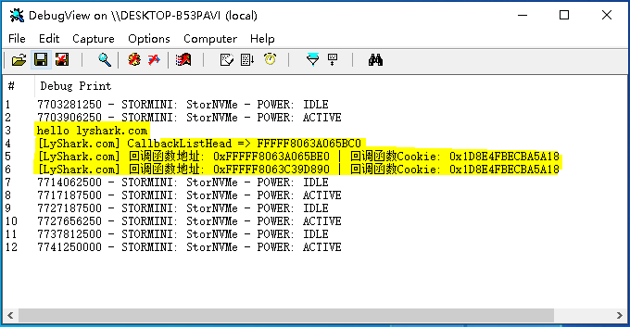

目前系统中有两个回调函数，这一点在第一张图片中也可以得到，枚举是正确的。

作者： 王瑞 (LyShark)

作者邮箱： m [e@lyshark.com](mailto:e@lyshark.com)

版权声明：本博客文章与代码均为学习时整理的笔记，文章 [均为原创] 作品，转载文章请遵守

《中华人民共和国著作权法》相关法律规定或遵守《署名CC BY-ND 4.0国际》规范，合理合规携带原创出处转载，如果不携带文章出处，并恶意转载多篇原创文章被本人发现，本人保留起诉权！