在笔者上一篇文章 《驱动开发：内核特征码搜索函数封装》 中为了定位特征的方便我们封装实现了一个可以传入数组实现的 SearchSpecialCode 定位函数，该定位函数其实还不能算的上简单，本章 LyShark 将对特征码定位进行简化，让定位变得更简单，并运用定位代码实现扫描内核PE的 .text 代码段，并从代码段中得到某个特征所在内存位置。

# 老样子为了后续教程能够继续，先来定义一个 lyshark.h 头文件，该头文件中包含了我们本篇文章所必须要使用到的结构体定义，这些定义的函数如果不懂请去看 LyShark 以前的文章，这里就不罗嗦了。

#include <ntifs.h> #include <ntimage.h>



typedef struct _KLDR_DATA_TABLE_ENTRY

{

LIST_ENTRY64 InLoadOrderLinks; ULONG64 Undefined1;

ULONG64 Undefined2; ULONG64 Undefined3; ULONG64 NonPagedDebugInfo; ULONG64 DllBase;

ULONG64 EntryPoint; ULONG SizeOfImage;

UNICODE_STRING FullDllName; UNICODE_STRING BaseDllName; ULONG Flags;

USHORT LoadCount; USHORT Undefined5; ULONG64 Undefined6; ULONG CheckSum; ULONG padding1; ULONG TimeDateStamp; ULONG padding2;

}KLDR_DATA_TABLE_ENTRY, PKLDR_DATA_TABLE_ENTRY;

typedef struct _RTL_PROCESS_MODULE_INFORMATION

{

HANDLE Section; PVOID MappedBase; PVOID ImageBase; ULONG ImageSize; ULONG Flags;

USHORT LoadOrderIndex; USHORT InitOrderIndex; USHORT LoadCount; USHORT OffsetToFileName;

UCHAR FullPathName[256];

} RTL_PROCESS_MODULE_INFORMATION, PRTL_PROCESS_MODULE_INFORMATION;

typedef struct _RTL_PROCESS_MODULES

{

ULONG NumberOfModules; RTL_PROCESS_MODULE_INFORMATION Modules[1];

} RTL_PROCESS_MODULES, PRTL_PROCESS_MODULES;

typedef enum _SYSTEM_INFORMATION_CLASS

{

SystemBasicInformation = 0x0, SystemProcessorInformation = 0x1, SystemPerformanceInformation = 0x2, SystemTimeOfDayInformation = 0x3, SystemPathInformation = 0x4, SystemProcessInformation = 0x5, SystemCallCountInformation = 0x6, SystemDeviceInformation = 0x7, SystemProcessorPerformanceInformation = 0x8, SystemFlagsInformation = 0x9, SystemCallTimeInformation = 0xa, SystemModuleInformation = 0xb, SystemLocksInformation = 0xc, SystemStackTraceInformation = 0xd, SystemPagedPoolInformation = 0xe, SystemNonPagedPoolInformation = 0xf, SystemHandleInformation = 0x10, SystemObjectInformation = 0x11, SystemPageFileInformation = 0x12, SystemVdmInstemulInformation = 0x13, SystemVdmBopInformation = 0x14, SystemFileCacheInformation = 0x15, SystemPoolTagInformation = 0x16, SystemInterruptInformation = 0x17, SystemDpcBehaviorInformation = 0x18, SystemFullMemoryInformation = 0x19, SystemLoadGdiDriverInformation = 0x1a, SystemUnloadGdiDriverInformation = 0x1b, SystemTimeAdjustmentInformation = 0x1c, SystemSummaryMemoryInformation = 0x1d, SystemMirrorMemoryInformation = 0x1e, SystemPerformanceTraceInformation = 0x1f, SystemObsolete0 = 0x20, SystemExceptionInformation = 0x21, SystemCrashDumpStateInformation = 0x22, SystemKernelDebuggerInformation = 0x23, SystemContextSwitchInformation = 0x24, SystemRegistryQuotaInformation = 0x25, SystemExtendServiceTableInformation = 0x26, SystemPrioritySeperation = 0x27, SystemVerifierAddDriverInformation = 0x28, SystemVerifierRemoveDriverInformation = 0x29, SystemProcessorIdleInformation = 0x2a, SystemLegacyDriverInformation = 0x2b, SystemCurrentTimeZoneInformation = 0x2c, SystemLookasideInformation = 0x2d, SystemTimeSlipNotification = 0x2e, SystemSessionCreate = 0x2f, SystemSessionDetach = 0x30, SystemSessionInformation = 0x31, SystemRangeStartInformation = 0x32, SystemVerifierInformation = 0x33,

SystemVerifierThunkExtend = 0x34, SystemSessionProcessInformation = 0x35, SystemLoadGdiDriverInSystemSpace = 0x36, SystemNumaProcessorMap = 0x37, SystemPrefetcherInformation = 0x38, SystemExtendedProcessInformation = 0x39, SystemRecommendedSharedDataAlignment = 0x3a, SystemComPlusPackage = 0x3b, SystemNumaAvailableMemory = 0x3c, SystemProcessorPowerInformation = 0x3d, SystemEmulationBasicInformation = 0x3e, SystemEmulationProcessorInformation = 0x3f, SystemExtendedHandleInformation = 0x40, SystemLostDelayedWriteInformation = 0x41, SystemBigPoolInformation = 0x42, SystemSessionPoolTagInformation = 0x43, SystemSessionMappedViewInformation = 0x44, SystemHotpatchInformation = 0x45, SystemObjectSecurityMode = 0x46, SystemWatchdogTimerHandler = 0x47, SystemWatchdogTimerInformation = 0x48, SystemLogicalProcessorInformation = 0x49, SystemWow64SharedInformationObsolete = 0x4a, SystemRegisterFirmwareTableInformationHandler = 0x4b, SystemFirmwareTableInformation = 0x4c, SystemModuleInformationEx = 0x4d, SystemVerifierTriageInformation = 0x4e, SystemSuperfetchInformation = 0x4f, SystemMemoryListInformation = 0x50, SystemFileCacheInformationEx = 0x51, SystemThreadPriorityClientIdInformation = 0x52, SystemProcessorIdleCycleTimeInformation = 0x53, SystemVerifierCancellationInformation = 0x54, SystemProcessorPowerInformationEx = 0x55, SystemRefTraceInformation = 0x56, SystemSpecialPoolInformation = 0x57, SystemProcessIdInformation = 0x58, SystemErrorPortInformation = 0x59, SystemBootEnvironmentInformation = 0x5a, SystemHypervisorInformation = 0x5b, SystemVerifierInformationEx = 0x5c, SystemTimeZoneInformation = 0x5d, SystemImageFileExecutionOptionsInformation = 0x5e, SystemCoverageInformation = 0x5f, SystemPrefetchPatchInformation = 0x60, SystemVerifierFaultsInformation = 0x61, SystemSystemPartitionInformation = 0x62, SystemSystemDiskInformation = 0x63, SystemProcessorPerformanceDistribution = 0x64, SystemNumaProximityNodeInformation = 0x65, SystemDynamicTimeZoneInformation = 0x66, SystemCodeIntegrityInformation = 0x67, SystemProcessorMicrocodeUpdateInformation = 0x68, SystemProcessorBrandString = 0x69, SystemVirtualAddressInformation = 0x6a,

SystemLogicalProcessorAndGroupInformation = 0x6b, SystemProcessorCycleTimeInformation = 0x6c, SystemStoreInformation = 0x6d, SystemRegistryAppendString = 0x6e, SystemAitSamplingValue = 0x6f, SystemVhdBootInformation = 0x70, SystemCpuQuotaInformation = 0x71, SystemNativeBasicInformation = 0x72, SystemErrorPortTimeouts = 0x73, SystemLowPriorityIoInformation = 0x74, SystemBootEntropyInformation = 0x75, SystemVerifierCountersInformation = 0x76, SystemPagedPoolInformationEx = 0x77, SystemSystemPtesInformationEx = 0x78, SystemNodeDistanceInformation = 0x79, SystemAcpiAuditInformation = 0x7a, SystemBasicPerformanceInformation = 0x7b, SystemQueryPerformanceCounterInformation = 0x7c, SystemSessionBigPoolInformation = 0x7d, SystemBootGraphicsInformation = 0x7e, SystemScrubPhysicalMemoryInformation = 0x7f, SystemBadPageInformation = 0x80, SystemProcessorProfileControlArea = 0x81, SystemCombinePhysicalMemoryInformation = 0x82, SystemEntropyInterruptTimingInformation = 0x83, SystemConsoleInformation = 0x84, SystemPlatformBinaryInformation = 0x85, SystemThrottleNotificationInformation = 0x86, SystemHypervisorProcessorCountInformation = 0x87, SystemDeviceDataInformation = 0x88, SystemDeviceDataEnumerationInformation = 0x89, SystemMemoryTopologyInformation = 0x8a, SystemMemoryChannelInformation = 0x8b, SystemBootLogoInformation = 0x8c, SystemProcessorPerformanceInformationEx = 0x8d, SystemSpare0 = 0x8e, SystemSecureBootPolicyInformation = 0x8f, SystemPageFileInformationEx = 0x90, SystemSecureBootInformation = 0x91, SystemEntropyInterruptTimingRawInformation = 0x92, SystemPortableWorkspaceEfiLauncherInformation = 0x93, SystemFullProcessInformation = 0x94, SystemKernelDebuggerInformationEx = 0x95, SystemBootMetadataInformation = 0x96, SystemSoftRebootInformation = 0x97, SystemElamCertificateInformation = 0x98, SystemOfflineDumpConfigInformation = 0x99, SystemProcessorFeaturesInformation = 0x9a, SystemRegistryReconciliationInformation = 0x9b, MaxSystemInfoClass = 0x9c,

} SYSTEM_INFORMATION_CLASS;

// 声明函数

// By: Lyshark.com

NTSYSAPI PIMAGE_NT_HEADERS NTAPI RtlImageNtHeader(_In_ PVOID Base);



NTSTATUS NTAPI ZwQuerySystemInformation(SYSTEM_INFORMATION_CLASS SystemInformationClass, PVOID SystemInformation, ULONG SystemInformationLength, PULONG ReturnLength);

typedef VOID( cdecl PMiProcessLoaderEntry)(PKLDR_DATA_TABLE_ENTRY section, IN LOGICAL Insert);

typedef NTSTATUS( NTQUERYSYSTEMINFORMATION)(IN ULONG SystemInformationClass, OUT PVOID SystemInformation, IN ULONG_PTR SystemInformationLength, OUT PULONG_PTR ReturnLength OPTIONAL);

我们继续，首先实现特征码字符串的解析与扫描实现此处 UtilLySharkSearchPattern 函数就是

LyShark 封装过的，这里依次介绍一下参数传递的含义。

pattern 用于传入一段字符串特征值 (以\x开头)

len 代表输入特征码长度 (除去\x后的长度)

# base 代表扫描内存的基地址

size 代表需要向下扫描的长度

ppFound 代表扫描到首地址以后返回的内存地址

这段代码该如何使用，如下我们以定位 IoInitializeTimer 为例，演示 UtilLySharkSearchPattern 如何定位特征的，如下代码 pattern 变量中就是我们需要定位的特征值， pattern_size 则是需要定位的特征码长度，在 address 地址位置向下扫描 128 字节，找到则返回到 find_address 变量内。



// 署名权

// right to sign one's name on a piece of work

// PowerBy: LyShark

// Email: [me@lyshark.com](mailto:me@lyshark.com) #include "lyshark.h"

PVOID GetIoInitializeTimerAddress()

{

PVOID VariableAddress = 0; UNICODE_STRING uioiTime = { 0 };

RtlInitUnicodeString(&uioiTime, L"IoInitializeTimer"); VariableAddress = (PVOID)MmGetSystemRoutineAddress(&uioiTime); if (VariableAddress != 0)

{

return VariableAddress;

}

return 0;

}

// 对指定内存执行特征码扫描

NTSTATUS UtilLySharkSearchPattern(IN PUCHAR pattern, IN ULONG_PTR len, IN const VOID base, IN ULONG_PTR size, OUT PVOID ppFound)

{

// 计算匹配长度

// LyShark.com 特征码扫描

NT_ASSERT(ppFound != 0 && pattern != 0 && base != 0); if (ppFound == 0 || pattern == 0 || base == 0)

{

return STATUS_INVALID_PARAMETER;

}



try

{

for (ULONG_PTR i = 0; i < size - len; i++)

{

BOOLEAN found = TRUE;

for (ULONG_PTR j = 0; j < len; j++)

{

if (pattern[j] != ((PUCHAR)base)[i + j])

{

found = FALSE; break;

}

}

if (found != FALSE)

{

ppFound = (PUCHAR)base + i;

DbgPrint("[LyShark.com] 特征码匹配地址: %p \n", (PUCHAR)base + i); return STATUS_SUCCESS;

}

}

}

except (EXCEPTION_EXECUTE_HANDLER)

{

return STATUS_UNHANDLED_EXCEPTION;

}

return STATUS_NOT_FOUND;

}

VOID UnDriver(PDRIVER_OBJECT driver)

{

DbgPrint(("Uninstall Driver Is OK \n"));

}

NTSTATUS DriverEntry(IN PDRIVER_OBJECT Driver, PUNICODE_STRING RegistryPath)

{

DbgPrint(("hello lyshark.com \n"));

// 返回匹配长度5

CHAR pattern[] = "\x48\x89\x6c\x24\x10"; PVOID find_address = NULL;

int pattern_size = sizeof(pattern) - 1;

DbgPrint("匹配长度: %d \n", pattern_size);

// 得到基地址

PVOID address = GetIoInitializeTimerAddress();

// 扫描特征

NTSTATUS nt = UtilLySharkSearchPattern((PUCHAR)pattern, pattern_size, address, 128, &find_address);

DbgPrint("[LyShark 返回地址 => ] 0x%p \n", (ULONG64)find_address);

Driver->DriverUnload = UnDriver;

return STATUS_SUCCESS;

}

# 运行驱动程序完成特征定位，并对比定位效果。

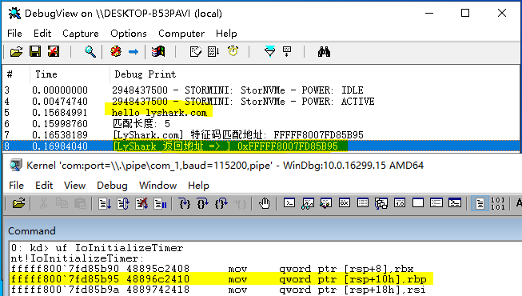

如上述所示定位函数我们已经封装好了，相信你也能感受到这种方式要比使用数组更方便，为了能定位 到内核PE结构我们需要使用 RtlImageNtHeader 来解析，这个内核函数专门用来得到内核程序的PE头部结构的，在下方案例中首先我们使用封装过的 LySharkToolsUtilKernelBase 函数拿到内核基址，如果你不懂函数实现细节请阅读 《驱动开发：内核取ntoskrnl模块基地址》 这篇文章，拿到基址以后可以直接使用 RtlImageNtHeader 对其PE头部进行解析，如下所示。

// 署名权

// right to sign one's name on a piece of work

// PowerBy: LyShark

// Email: [me@lyshark.com](mailto:me@lyshark.com) #include "lyshark.h"

// 定义全局变量

static PVOID g_KernelBase = 0; static ULONG g_KernelSize = 0;

// 得到KernelBase基地址

// lyshark.com

PVOID LySharkToolsUtilKernelBase(OUT PULONG pSize)

{

NTSTATUS status = STATUS_SUCCESS;

ULONG bytes = 0; PRTL_PROCESS_MODULES pMods = 0;

PVOID checkPtr = 0; UNICODE_STRING routineName;

if (g_KernelBase != 0)

{

if (pSize)

{



pSize = g_KernelSize;

}

return g_KernelBase;

}

RtlInitUnicodeString(&routineName, L"NtOpenFile");

checkPtr = MmGetSystemRoutineAddress(&routineName); if (checkPtr == 0)

return 0;

try

{

status = ZwQuerySystemInformation(SystemModuleInformation, 0, bytes, &bytes);

if (bytes == 0)

{

return 0;

}

pMods = (PRTL_PROCESS_MODULES)ExAllocatePoolWithTag(NonPagedPoolNx, bytes, L"LyShark");

RtlZeroMemory(pMods, bytes);

status = ZwQuerySystemInformation(SystemModuleInformation, pMods, bytes, &bytes);

if (NT_SUCCESS(status))

{

PRTL_PROCESS_MODULE_INFORMATION pMod = pMods->Modules;

for (ULONG i = 0; i < pMods->NumberOfModules; i++)

{

if (checkPtr >= pMod[i].ImageBase && checkPtr < (PVOID) ((PUCHAR)pMod[i].ImageBase + pMod[i].ImageSize))

{

g_KernelBase = pMod[i].ImageBase; g_KernelSize = pMod[i].ImageSize; if (pSize)

{

pSize = g_KernelSize;

}

break;

}

}

}

}

except (EXCEPTION_EXECUTE_HANDLER)

{

return 0;

}

if (pMods)

{

ExFreePoolWithTag(pMods, L"LyShark");

}

DbgPrint("KernelBase = > %p \n", g_KernelBase); return g_KernelBase;

}

VOID UnDriver(PDRIVER_OBJECT driver)

{

DbgPrint(("Uninstall Driver Is OK \n"));

}

NTSTATUS DriverEntry(IN PDRIVER_OBJECT Driver, PUNICODE_STRING RegistryPath)

{

DbgPrint(("hello lyshark.com \n"));

// 获取内核第一个模块的基地址

PVOID base = LySharkToolsUtilKernelBase(0); if (!base)

return STATUS_NOT_FOUND;

// 得到NT头部PE32+结构

// lyshark.com

PIMAGE_NT_HEADERS64 pHdr = RtlImageNtHeader(base); if (!pHdr)

return STATUS_INVALID_IMAGE_FORMAT;

// 首先寻找代码段

PIMAGE_SECTION_HEADER pFirstSection = (PIMAGE_SECTION_HEADER)(pHdr + 1);

for (PIMAGE_SECTION_HEADER pSection = pFirstSection; pSection < pFirstSection + pHdr->FileHeader.NumberOfSections; pSection++)

{

ANSI_STRING LySharkSection, LySharkName; RtlInitAnsiString(&LySharkSection, ".text"); RtlInitAnsiString(&LySharkName, (PCCHAR)pSection->Name);

DbgPrint("[LyShark.PE] 名字: %Z | 地址: %p | 长度: %d \n", LySharkName, (PUCHAR)base + pSection->VirtualAddress, pSection->Misc.VirtualSize);

}

Driver->DriverUnload = UnDriver; return STATUS_SUCCESS;

}

运行这段驱动程序，你会得到 当前内核 的 所有PE节 信息，枚举效果如下所示。

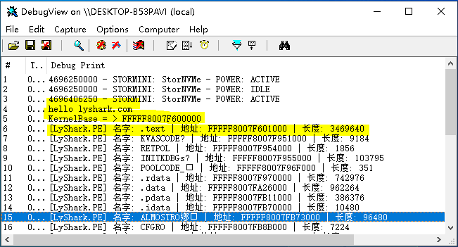

# 既然能够得到PE头部数据了，那么我们只需要扫描这段空间并得到匹配到的数据即可，其实很容易实 现，如下代码所示。



// 署名权

// right to sign one's name on a piece of work

// PowerBy: LyShark

// Email: [me@lyshark.com](mailto:me@lyshark.com) #include "lyshark.h"

// 定义全局变量

static PVOID g_KernelBase = 0; static ULONG g_KernelSize = 0;

// 得到KernelBase基地址

// lyshark.com

PVOID LySharkToolsUtilKernelBase(OUT PULONG pSize)

{

NTSTATUS status = STATUS_SUCCESS;

ULONG bytes = 0; PRTL_PROCESS_MODULES pMods = 0;

PVOID checkPtr = 0;

UNICODE_STRING routineName;

if (g_KernelBase != 0)

{

if (pSize)

{

pSize = g_KernelSize;

}

return g_KernelBase;

}

RtlInitUnicodeString(&routineName, L"NtOpenFile");

checkPtr = MmGetSystemRoutineAddress(&routineName); if (checkPtr == 0)

return 0;



try

{

status = ZwQuerySystemInformation(SystemModuleInformation, 0, bytes, &bytes);

if (bytes == 0)

{

return 0;

}

pMods = (PRTL_PROCESS_MODULES)ExAllocatePoolWithTag(NonPagedPoolNx, bytes, L"LyShark");

RtlZeroMemory(pMods, bytes);

status = ZwQuerySystemInformation(SystemModuleInformation, pMods, bytes, &bytes);

if (NT_SUCCESS(status))

{

PRTL_PROCESS_MODULE_INFORMATION pMod = pMods->Modules;

for (ULONG i = 0; i < pMods->NumberOfModules; i++)

{

if (checkPtr >= pMod[i].ImageBase && checkPtr < (PVOID) ((PUCHAR)pMod[i].ImageBase + pMod[i].ImageSize))

{

g_KernelBase = pMod[i].ImageBase; g_KernelSize = pMod[i].ImageSize; if (pSize)

{

pSize = g_KernelSize;

}

break;

}

}

}

}

except (EXCEPTION_EXECUTE_HANDLER)

{

return 0;

}

if (pMods)

{

ExFreePoolWithTag(pMods, L"LyShark");

}

DbgPrint("KernelBase = > %p \n", g_KernelBase); return g_KernelBase;

}

// 对指定内存执行特征码扫描

NTSTATUS UtilLySharkSearchPattern(IN PUCHAR pattern, IN UCHAR wildcard, IN ULONG_PTR len, IN const VOID base, IN ULONG_PTR size, OUT PVOID ppFound)

{

NT_ASSERT(ppFound != 0 && pattern != 0 && base != 0); if (ppFound == 0 || pattern == 0 || base == 0)

{

return STATUS_INVALID_PARAMETER;

}

try

{

for (ULONG_PTR i = 0; i < size - len; i++)

{

BOOLEAN found = TRUE;

for (ULONG_PTR j = 0; j < len; j++)

{

j])

if (pattern[j] != wildcard && pattern[j] != ((PUCHAR)base)[i +

{

found = FALSE; break;

}



}

if (found != FALSE)

{

ppFound = (PUCHAR)base + i;

DbgPrint("[LyShark] 特征码匹配地址: %p \n", (PUCHAR)base + i); return STATUS_SUCCESS;

}

}

}

except (EXCEPTION_EXECUTE_HANDLER)

{

return STATUS_UNHANDLED_EXCEPTION;

}

return STATUS_NOT_FOUND;

}

// 扫描代码段中的指令片段

NTSTATUS ByLySharkComUtilScanSection(IN PCCHAR section, IN PUCHAR pattern, IN UCHAR wildcard, IN ULONG_PTR len, OUT PVOID ppFound)

{

NT_ASSERT(ppFound != 0); if (ppFound == 0)

return STATUS_INVALID_PARAMETER;

// 获取内核第一个模块的基地址

PVOID base = LySharkToolsUtilKernelBase(0); if (!base)

return STATUS_NOT_FOUND;

// 得到NT头部PE32+结构

PIMAGE_NT_HEADERS64 pHdr = RtlImageNtHeader(base); if (!pHdr)

return STATUS_INVALID_IMAGE_FORMAT;

// 首先寻找代码段



PIMAGE_SECTION_HEADER pFirstSection = (PIMAGE_SECTION_HEADER)(pHdr + 1);

for (PIMAGE_SECTION_HEADER pSection = pFirstSection; pSection < pFirstSection + pHdr->FileHeader.NumberOfSections; pSection++)

{

ANSI_STRING LySharkSection, LySharkText; RtlInitAnsiString(&LySharkSection, section); RtlInitAnsiString(&LySharkText, (PCCHAR)pSection->Name);

// 判断是不是我们要找的.text节

if (RtlCompareString(&LySharkSection, &LySharkText, TRUE) == 0)

{

// 如果是则开始匹配特征码

return UtilLySharkSearchPattern(pattern, wildcard, len, (PUCHAR)base

+ pSection->VirtualAddress, pSection->Misc.VirtualSize, ppFound);

}

}

return STATUS_NOT_FOUND;

}

VOID UnDriver(PDRIVER_OBJECT driver)

{

DbgPrint(("Uninstall Driver Is OK \n"));

}

NTSTATUS DriverEntry(IN PDRIVER_OBJECT Driver, PUNICODE_STRING RegistryPath)

{

DbgPrint("hello lyshark.com \n");

PMiProcessLoaderEntry m_MiProcessLoaderEntry = NULL; RTL_OSVERSIONINFOW Version = { 0 };

Version.dwOSVersionInfoSize = sizeof(Version); RtlGetVersion(&Version);

//获取内核版本号

DbgPrint("主版本: %d -->次版本: %d --> 编译版本: %d", Version.dwMajorVersion, Version.dwMinorVersion, Version.dwBuildNumber);

if (Version.dwMajorVersion == 10)

{

// 如果是 win10 18363 则匹配特征

if (Version.dwBuildNumber == 18363)

{

CHAR pattern[] = "\x48\x89\x5c\x24\x08"; int pattern_size = sizeof(pattern) - 1;

ByLySharkComUtilScanSection(".text", (PUCHAR)pattern, 0xCC, pattern_size, (PVOID )&m_MiProcessLoaderEntry);

DbgPrint("[LyShark] 输出首地址: %p", m_MiProcessLoaderEntry);

}

}

Driver->DriverUnload = UnDriver;

return STATUS_SUCCESS;

}

代码中首先判断系统主版本 windows 10 18363 如果是则执行匹配，只匹配 .text 也就是代码段中的数据，当遇到 0xcc 时则取消继续，否则继续执行枚举，程序输出效果如下所示。

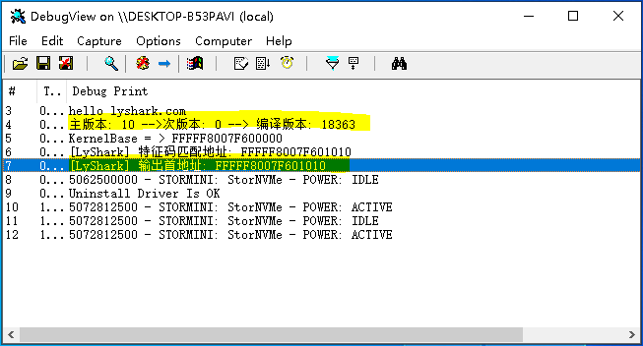

在WinDBG中输入命令 !dh 0xfffff8007f600000 解析出内核PE头数据，可以看到如下所示，对比无误。

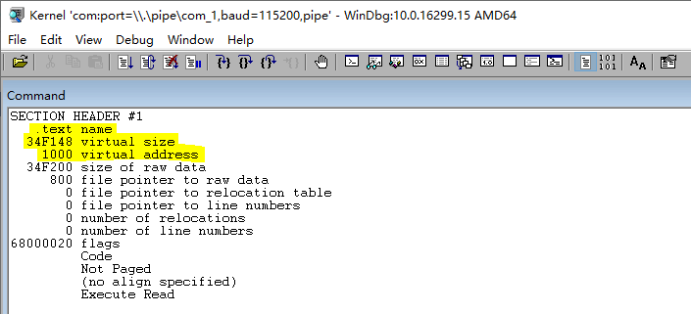

# 作者： 王瑞 (LyShark)

作者邮箱： m [e@lyshark.com](mailto:e@lyshark.com)

版权声明：本博客文章与代码均为学习时整理的笔记，文章 [均为原创] 作品，转载文章请遵守

《中华人民共和国著作权法》相关法律规定或遵守《署名CC BY-ND 4.0国际》规范，合理合规携带原创出处转载，如果不携带文章出处，并恶意转载多篇原创文章被本人发现，本人保留起诉权！