在前面的博文 《驱动开发：Win10内核枚举SSDT表基址》 中已经教大家如何寻找 SSDT 表基地址了，找到后我们可根据序号获取到指定 SSDT 函数的原始地址，而如果需要输出所有 SSDT 表信息，则可以定义字符串列表，以此循环调用 GetSSDTFunctionAddress() 函数得到，当然在此之间也可以调用系统提供的

MmGetSystemRoutineAddress() 函数顺便把当前地址拿到，并通过循环方式得到完整的SSDT列表。

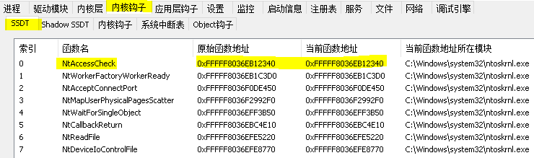

调用 MmGetSystemRoutineAddress() 得到当前地址很容易实现，只需要将函数名字符串通过

RtlInitUnicodeString() 格式化一下即可。

// 署名权

// right to sign one's name on a piece of work

// PowerBy: LyShark

// Email: [me@lyshark.com](mailto:me@lyshark.com)

#include <ntifs.h>

VOID UnDriver(PDRIVER_OBJECT driver)

{

DbgPrint(("驱动程序卸载成功! \n"));

}

NTSTATUS DriverEntry(PDRIVER_OBJECT DriverObject, PUNICODE_STRING RegistryPath)

{

DbgPrint("hello lyshark.com \n");

// 获取SSDT起源地址

UNICODE_STRING uncode; RtlInitUnicodeString(&uncode, L"NtOpenFile");

PULONGLONG source_address = MmGetSystemRoutineAddress(&uncode); DbgPrint("[LyShark] NtOpenFile起源地址 = %p \n", source_address);

DriverObject->DriverUnload = UnDriver; return STATUS_SUCCESS;

}

代码获得 NtOpenFile 这个函数的内存地址，输出效果如下所示：

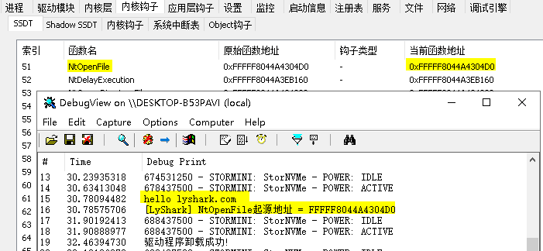

# 根据上一章节的内容扩展，枚举完整SSDT表我们可以这样来实现。



// 署名权

// right to sign one's name on a piece of work

// PowerBy: LyShark

// Email: [me@lyshark.com](mailto:me@lyshark.com)

#include <ntifs.h>

#pragma intrinsic( readmsr)

typedef struct _SYSTEM_SERVICE_TABLE

{

PVOID ServiceTableBase;

PVOID ServiceCounterTableBase; ULONGLONG NumberOfServices; PVOID ParamTableBase;

} SYSTEM_SERVICE_TABLE, PSYSTEM_SERVICE_TABLE;

ULONGLONG ssdt_base_aadress; PSYSTEM_SERVICE_TABLE KeServiceDescriptorTable;

typedef UINT64( fastcall SCFN)(UINT64, UINT64); SCFN scfn;

// 解密算法

VOID DecodeSSDT()

{

UCHAR strShellCode[36] = "\x48\x8B\xC1\x4C\x8D\x12\x8B\xF8\xC1\xEF\x07\x83\xE7\x20\x4E\x8B\x14\x17\x4D\x6 3\x1C\x82\x49\x8B\xC3\x49\xC1\xFB\x04\x4D\x03\xD3\x49\x8B\xC2\xC3";

/

48:8BC1

rcx=index

4C:8D12

rdx=ssdt

8BF8 C1EF 07

83E7 20

4E:8B1417

4D:631C82

| mov rax,rcx

|

| lea r10,qword ptr ds:[rdx]

|

| mov edi,eax

| shr edi,7

| and edi,20

| mov r10,qword ptr ds:[rdi+r10]

| movsxd r11,dword ptr ds:[r10+rax 4]

|

|

|

|

|

|  |  |  |  |  |  |
| --- | --- | --- | --- | --- | --- |
| 49:8BC3 |  | | | mov | rax,r11 | | |
| 49:C1FB | 04 | | | sar | r11,4 | | |
| 4D:03D3 |  | | | add | r10,r11 | | |
| 49:8BC2 |  | | | mov | rax,r10 | | |
| C3 |  | | | ret |  | | |
| / |  |  |  |  |  |
| scfn = ExAllocatePool(NonPagedPool, 36); memcpy(scfn, strShellCode, 36);  }  // 获取 KeServiceDescriptorTable 首地址  ULONGLONG GetKeServiceDescriptorTable()  {  // 设置起始位置  PUCHAR StartSearchAddress = (PUCHAR) readmsr(0xC0000082) - 0x1806FE;  // 设置结束位置  PUCHAR EndSearchAddress = StartSearchAddress + 0x8192;  // DbgPrint("扫描起始地址: %p --> 扫描结束地址: %p \n", StartSearchAddress, EndSearchAddress);  PUCHAR ByteCode = NULL;  UCHAR OpCodeA = 0, OpCodeB = 0, OpCodeC = 0; ULONGLONG addr = 0;  ULONG templong = 0;  for (ByteCode = StartSearchAddress; ByteCode < EndSearchAddress; ByteCode++)  {  // 使用MmIsAddressValid()函数检查地址是否有页面错误  if (MmIsAddressValid(ByteCode) && MmIsAddressValid(ByteCode + 1) && MmIsAddressValid(ByteCode + 2))  {  OpCodeA = ByteCode; OpCodeB = (ByteCode + 1); OpCodeC = (ByteCode + 2);  // 对比特征值 寻找 nt!KeServiceDescriptorTable 函数地址  // LyShark.com  // 4c 8d 15 e5 9e 3b 00 lea r10,[nt!KeServiceDescriptorTable (fffff802`64da4880)]  // 4c 8d 1d de 20 3a 00 lea r11,[nt!KeServiceDescriptorTableShadow  (fffff802`64d8ca80)]  if (OpCodeA == 0x4c && OpCodeB == 0x8d && OpCodeC == 0x15)  {  // 获 取 高 位 地 址 fffff802 memcpy(&templong, ByteCode + 3, 4);  // 与低位64da4880地址相加得到完整地址  addr = (ULONGLONG)templong + (ULONGLONG)ByteCode + 7; return addr;  }  }  }  return 0; | | | | | |



}

// 得到函数相对偏移地址

ULONG GetOffsetAddress(ULONGLONG FuncAddr)

{

ULONG dwtmp = 0;

PULONG ServiceTableBase = NULL;

if (KeServiceDescriptorTable == NULL)

{

KeServiceDescriptorTable = (PSYSTEM_SERVICE_TABLE)GetKeServiceDescriptorTable();

}

ServiceTableBase = (PULONG)KeServiceDescriptorTable->ServiceTableBase; dwtmp = (ULONG)(FuncAddr - (ULONGLONG)ServiceTableBase);

return dwtmp << 4;

}

// 根据序号得到函数地址

ULONGLONG GetSSDTFunctionAddress(ULONGLONG NtApiIndex)

{

ULONGLONG ret = 0;

if (ssdt_base_aadress == 0)

{

// 得到ssdt基地址

ssdt_base_aadress = GetKeServiceDescriptorTable();

}

if (scfn == NULL)

{

DecodeSSDT();

}

ret = scfn(NtApiIndex, ssdt_base_aadress); return ret;

}

// 查询函数系统地址

ULONG_PTR QueryFunctionSystemAddress(PWCHAR name)

{

UNICODE_STRING na;

ULONG_PTR address; RtlInitUnicodeString(&na, name);

address = (ULONG_PTR)MmGetSystemRoutineAddress(&na); return address;

}

VOID UnDriver(PDRIVER_OBJECT driver)

{

DbgPrint(("驱动程序卸载成功! \n"));

}

NTSTATUS DriverEntry(PDRIVER_OBJECT DriverObject, PUNICODE_STRING RegistryPath)

{

DbgPrint("hello lyshark.com \n");

char SSDT[464] = { "NtAccessCheck", "NtWorkerFactoryWorkerReady", "NtAcceptConnectPort", "NtMapUserPhysicalPagesScatter", "NtWaitForSingleObject", "NtCallbackReturn", "NtReadFile", "NtDeviceIoControlFile", "NtWriteFile", "NtRemoveIoCompletion", "NtReleaseSemaphore", "NtReplyWaitReceivePort", "NtReplyPort", "NtSetInformationThread", "NtSetEvent", "NtClose", "NtQueryObject", "NtQueryInformationFile", "NtOpenKey", "NtEnumerateValueKey", "NtFindAtom", "NtQueryDefaultLocale", "NtQueryKey", "NtQueryValueKey", "NtAllocateVirtualMemory", "NtQueryInformationProcess", "NtWaitForMultipleObjects32", "NtWriteFileGather", "NtSetInformationProcess", "NtCreateKey", "NtFreeVirtualMemory", "NtImpersonateClientOfPort", "NtReleaseMutant", "NtQueryInformationToken", "NtRequestWaitReplyPort", "NtQueryVirtualMemory", "NtOpenThreadToken", "NtQueryInformationThread", "NtOpenProcess", "NtSetInformationFile", "NtMapViewOfSection", "NtAccessCheckAndAuditAlarm", "NtUnmapViewOfSection", "NtReplyWaitReceivePortEx", "NtTerminateProcess", "NtSetEventBoostPriority", "NtReadFileScatter", "NtOpenThreadTokenEx", "NtOpenProcessTokenEx", "NtQueryPerformanceCounter", "NtEnumerateKey", "NtOpenFile", "NtDelayExecution", "NtQueryDirectoryFile", "NtQuerySystemInformation", "NtOpenSection", "NtQueryTimer", "NtFsControlFile", "NtWriteVirtualMemory", "NtCloseObjectAuditAlarm", "NtDuplicateObject", "NtQueryAttributesFile", "NtClearEvent", "NtReadVirtualMemory", "NtOpenEvent", "NtAdjustPrivilegesToken", "NtDuplicateToken", "NtContinue", "NtQueryDefaultUILanguage", "NtQueueApcThread", "NtYieldExecution", "NtAddAtom", "NtCreateEvent", "NtQueryVolumeInformationFile", "NtCreateSection", "NtFlushBuffersFile", "NtApphelpCacheControl", "NtCreateProcessEx", "NtCreateThread", "NtIsProcessInJob", "NtProtectVirtualMemory", "NtQuerySection", "NtResumeThread", "NtTerminateThread", "NtReadRequestData", "NtCreateFile", "NtQueryEvent", "NtWriteRequestData", "NtOpenDirectoryObject", "NtAccessCheckByTypeAndAuditAlarm", "NtQuerySystemTime", "NtWaitForMultipleObjects", "NtSetInformationObject", "NtCancelIoFile", "NtTraceEvent", "NtPowerInformation", "NtSetValueKey", "NtCancelTimer", "NtSetTimer", "NtAccessCheckByType", "NtAccessCheckByTypeResultList", "NtAccessCheckByTypeResultListAndAuditAlarm", "NtAccessCheckByTypeResultListAndAuditAlarmByHandle", "NtAcquireProcessActivityReference", "NtAddAtomEx", "NtAddBootEntry", "NtAddDriverEntry", "NtAdjustGroupsToken", "NtAdjustTokenClaimsAndDeviceGroups", "NtAlertResumeThread", "NtAlertThread", "NtAlertThreadByThreadId", "NtAllocateLocallyUniqueId", "NtAllocateReserveObject", "NtAllocateUserPhysicalPages", "NtAllocateUuids", "NtAllocateVirtualMemoryEx", "NtAlpcAcceptConnectPort", "NtAlpcCancelMessage", "NtAlpcConnectPort", "NtAlpcConnectPortEx", "NtAlpcCreatePort", "NtAlpcCreatePortSection", "NtAlpcCreateResourceReserve", "NtAlpcCreateSectionView", "NtAlpcCreateSecurityContext", "NtAlpcDeletePortSection", "NtAlpcDeleteResourceReserve", "NtAlpcDeleteSectionView", "NtAlpcDeleteSecurityContext", "NtAlpcDisconnectPort", "NtAlpcImpersonateClientContainerOfPort", "NtAlpcImpersonateClientOfPort", "NtAlpcOpenSenderProcess", "NtAlpcOpenSenderThread", "NtAlpcQueryInformation", "NtAlpcQueryInformationMessage", "NtAlpcRevokeSecurityContext", "NtAlpcSendWaitReceivePort", "NtAlpcSetInformation", "NtAreMappedFilesTheSame", "NtAssignProcessToJobObject", "NtAssociateWaitCompletionPacket", "NtCallEnclave", "NtCancelIoFileEx", "NtCancelSynchronousIoFile", "NtCancelTimer2", "NtCancelWaitCompletionPacket", "NtCommitComplete", "NtCommitEnlistment", "NtCommitRegistryTransaction", "NtCommitTransaction", "NtCompactKeys", "NtCompareObjects", "NtCompareSigningLevels", "NtCompareTokens", "ArbPreprocessEntry", "NtCompressKey", "NtConnectPort",



"NtConvertBetweenAuxiliaryCounterAndPerformanceCounter", "ArbAddReserved", "NtCreateDebugObject", "NtCreateDirectoryObject", "NtCreateDirectoryObjectEx", "NtCreateEnclave", "NtCreateEnlistment", "NtCreateEventPair", "NtCreateIRTimer", "NtCreateIoCompletion", "NtCreateJobObject", "ArbAddReserved", "NtCreateKeyTransacted", "NtCreateKeyedEvent", "NtCreateLowBoxToken", "NtCreateMailslotFile", "NtCreateMutant", "NtCreateNamedPipeFile", "NtCreatePagingFile", "NtCreatePartition", "NtCreatePort", "NtCreatePrivateNamespace", "NtCreateProcess", "NtCreateProfile", "NtCreateProfileEx", "NtCreateRegistryTransaction", "NtCreateResourceManager", "NtCreateSectionEx", "NtCreateSemaphore", "NtCreateSymbolicLinkObject", "NtCreateThreadEx", "NtCreateTimer", "NtCreateTimer2", "NtCreateToken", "NtCreateTokenEx", "NtCreateTransaction", "NtCreateTransactionManager", "NtCreateUserProcess", "NtCreateWaitCompletionPacket", "NtCreateWaitablePort", "NtCreateWnfStateName", "NtCreateWorkerFactory", "NtDebugActiveProcess", "NtDebugContinue", "NtDeleteAtom", "NtDeleteBootEntry", "NtDeleteDriverEntry", "NtDeleteFile", "NtDeleteKey", "NtDeleteObjectAuditAlarm", "NtDeletePrivateNamespace", "NtDeleteValueKey", "NtDeleteWnfStateData", "NtDeleteWnfStateName", "NtDisableLastKnownGood", "NtDisplayString", "NtDrawText", "NtEnableLastKnownGood", "NtEnumerateBootEntries", "NtEnumerateDriverEntries", "NtEnumerateSystemEnvironmentValuesEx", "NtEnumerateTransactionObject", "NtExtendSection", "NtFilterBootOption", "NtFilterToken", "NtFilterTokenEx", "NtFlushBuffersFileEx", "NtFlushInstallUILanguage", "ArbPreprocessEntry", "NtFlushKey", "NtFlushProcessWriteBuffers", "NtFlushVirtualMemory", "NtFlushWriteBuffer", "NtFreeUserPhysicalPages", "NtFreezeRegistry", "NtFreezeTransactions", "NtGetCachedSigningLevel", "NtGetCompleteWnfStateSubscription", "NtGetContextThread", "NtGetCurrentProcessorNumber", "NtGetCurrentProcessorNumberEx", "NtGetDevicePowerState", "NtGetMUIRegistryInfo", "NtGetNextProcess", "NtGetNextThread", "NtGetNlsSectionPtr", "NtGetNotificationResourceManager", "NtGetWriteWatch", "NtImpersonateAnonymousToken", "NtImpersonateThread", "NtInitializeEnclave", "NtInitializeNlsFiles", "NtInitializeRegistry", "NtInitiatePowerAction", "NtIsSystemResumeAutomatic", "NtIsUILanguageComitted", "NtListenPort", "NtLoadDriver", "NtLoadEnclaveData", "NtLoadKey", "NtLoadKey2", "NtLoadKeyEx", "NtLockFile", "NtLockProductActivationKeys", "NtLockRegistryKey", "NtLockVirtualMemory", "NtMakePermanentObject", "NtMakeTemporaryObject", "NtManageHotPatch", "NtManagePartition", "NtMapCMFModule", "NtMapUserPhysicalPages", "NtMapViewOfSectionEx", "NtModifyBootEntry", "NtModifyDriverEntry", "NtNotifyChangeDirectoryFile", "NtNotifyChangeDirectoryFileEx", "NtNotifyChangeKey", "NtNotifyChangeMultipleKeys", "NtNotifyChangeSession", "NtOpenEnlistment", "NtOpenEventPair", "NtOpenIoCompletion", "NtOpenJobObject", "NtOpenKeyEx", "NtOpenKeyTransacted", "NtOpenKeyTransactedEx", "NtOpenKeyedEvent", "NtOpenMutant", "NtOpenObjectAuditAlarm", "NtOpenPartition", "NtOpenPrivateNamespace", "NtOpenProcessToken", "NtOpenRegistryTransaction", "NtOpenResourceManager", "NtOpenSemaphore", "NtOpenSession", "NtOpenSymbolicLinkObject", "NtOpenThread", "NtOpenTimer", "NtOpenTransaction", "NtOpenTransactionManager", "NtPlugPlayControl", "NtPrePrepareComplete", "NtPrePrepareEnlistment", "NtPrepareComplete", "NtPrepareEnlistment", "NtPrivilegeCheck", "NtPrivilegeObjectAuditAlarm", "NtPrivilegedServiceAuditAlarm", "NtPropagationComplete", "NtPropagationFailed", "NtPulseEvent", "NtQueryAuxiliaryCounterFrequency", "NtQueryBootEntryOrder", "NtQueryBootOptions", "NtQueryDebugFilterState", "NtQueryDirectoryFileEx", "NtQueryDirectoryObject", "NtQueryDriverEntryOrder", "NtQueryEaFile", "NtQueryFullAttributesFile", "NtQueryInformationAtom",

"NtQueryInformationByName", "NtQueryInformationEnlistment", "NtQueryInformationJobObject", "NtQueryInformationPort", "NtQueryInformationResourceManager", "NtQueryInformationTransaction", "NtQueryInformationTransactionManager", "NtQueryInformationWorkerFactory", "NtQueryInstallUILanguage", "NtQueryIntervalProfile", "NtQueryIoCompletion", "NtQueryLicenseValue", "NtQueryMultipleValueKey", "NtQueryMutant", "NtQueryOpenSubKeys", "NtQueryOpenSubKeysEx", "CmpCleanUpHigherLayerKcbCachesPreCallback", "NtQueryQuotaInformationFile", "NtQuerySecurityAttributesToken", "NtQuerySecurityObject", "NtQuerySecurityPolicy", "NtQuerySemaphore", "NtQuerySymbolicLinkObject", "NtQuerySystemEnvironmentValue", "NtQuerySystemEnvironmentValueEx", "NtQuerySystemInformationEx", "NtQueryTimerResolution", "NtQueryWnfStateData", "NtQueryWnfStateNameInformation", "NtQueueApcThreadEx", "NtRaiseException", "NtRaiseHardError", "NtReadOnlyEnlistment", "NtRecoverEnlistment", "NtRecoverResourceManager", "NtRecoverTransactionManager", "NtRegisterProtocolAddressInformation", "NtRegisterThreadTerminatePort", "NtReleaseKeyedEvent", "NtReleaseWorkerFactoryWorker", "NtRemoveIoCompletionEx", "NtRemoveProcessDebug", "NtRenameKey", "NtRenameTransactionManager", "NtReplaceKey", "NtReplacePartitionUnit", "NtReplyWaitReplyPort", "NtRequestPort", "NtResetEvent", "NtResetWriteWatch", "NtRestoreKey", "NtResumeProcess", "NtRevertContainerImpersonation", "NtRollbackComplete", "NtRollbackEnlistment", "NtRollbackRegistryTransaction", "NtRollbackTransaction", "NtRollforwardTransactionManager", "NtSaveKey", "NtSaveKeyEx", "NtSaveMergedKeys", "NtSecureConnectPort", "NtSerializeBoot", "NtSetBootEntryOrder", "NtSetBootOptions", "NtSetCachedSigningLevel", "NtSetCachedSigningLevel2", "NtSetContextThread", "NtSetDebugFilterState", "NtSetDefaultHardErrorPort", "NtSetDefaultLocale", "NtSetDefaultUILanguage", "NtSetDriverEntryOrder", "NtSetEaFile", "NtSetHighEventPair", "NtSetHighWaitLowEventPair", "NtSetIRTimer", "NtSetInformationDebugObject", "NtSetInformationEnlistment", "NtSetInformationJobObject", "NtSetInformationKey", "NtSetInformationResourceManager", "NtSetInformationSymbolicLink", "NtSetInformationToken", "NtSetInformationTransaction", "NtSetInformationTransactionManager", "NtSetInformationVirtualMemory", "NtSetInformationWorkerFactory", "NtSetIntervalProfile", "NtSetIoCompletion", "NtSetIoCompletionEx", "BvgaSetVirtualFrameBuffer", "NtSetLowEventPair", "NtSetLowWaitHighEventPair", "NtSetQuotaInformationFile", "NtSetSecurityObject", "NtSetSystemEnvironmentValue", "NtSetSystemEnvironmentValueEx", "NtSetSystemInformation", "NtSetSystemPowerState", "NtSetSystemTime", "NtSetThreadExecutionState", "NtSetTimer2", "NtSetTimerEx", "NtSetTimerResolution", "NtSetUuidSeed", "NtSetVolumeInformationFile", "NtSetWnfProcessNotificationEvent", "NtShutdownSystem", "NtShutdownWorkerFactory", "NtSignalAndWaitForSingleObject", "NtSinglePhaseReject", "NtStartProfile", "NtStopProfile", "NtSubscribeWnfStateChange", "NtSuspendProcess", "NtSuspendThread", "NtSystemDebugControl", "NtTerminateEnclave", "NtTerminateJobObject", "NtTestAlert", "NtThawRegistry", "NtThawTransactions", "NtTraceControl", "NtTranslateFilePath", "NtUmsThreadYield", "NtUnloadDriver", "NtUnloadKey", "NtUnloadKey2", "NtUnloadKeyEx", "NtUnlockFile", "NtUnlockVirtualMemory", "NtUnmapViewOfSectionEx", "NtUnsubscribeWnfStateChange", "NtUpdateWnfStateData", "NtVdmControl", "NtWaitForAlertByThreadId", "NtWaitForDebugEvent", "NtWaitForKeyedEvent", "NtWaitForWorkViaWorkerFactory", "NtWaitHighEventPair", "NtWaitLowEventPair" };

for (size_t lyshark = 0; lyshark < 464; lyshark++)

{

// 获取起源地址

ANSI_STRING ansi = { 0 }; UNICODE_STRING uncode = { 0 };

ULONGLONG ssdt_address = GetKeServiceDescriptorTable();

// DbgPrint("SSDT基地址 = %p \n", ssdt_address);

// 根据序号得到函数地址

ULONGLONG address = GetSSDTFunctionAddress(lyshark); ULONG offset = GetOffsetAddress(address);

RtlInitAnsiString(&ansi, SSDT[lyshark]); RtlAnsiStringToUnicodeString(&uncode, &ansi, TRUE);

PULONGLONG source_address = MmGetSystemRoutineAddress(&uncode);

DbgPrint("[LyShark] 序号 => [%d] | 当前地址 => %p | 起源地址 => %p | 相对地址

=> %p | SSDT => %s \n", lyshark, address, source_address, offset, SSDT[lyshark]);

}

DriverObject->DriverUnload = UnDriver; return STATUS_SUCCESS;

}

# 我们运行这段程序，即可得到整个系统中所有的SSDT表地址信息；

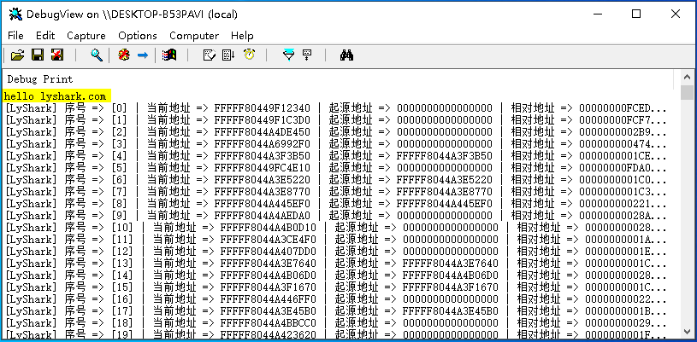

在WinDBG中可看到完整的输出内容，当然有些函数没有被导出，起源地址是拿不到的。

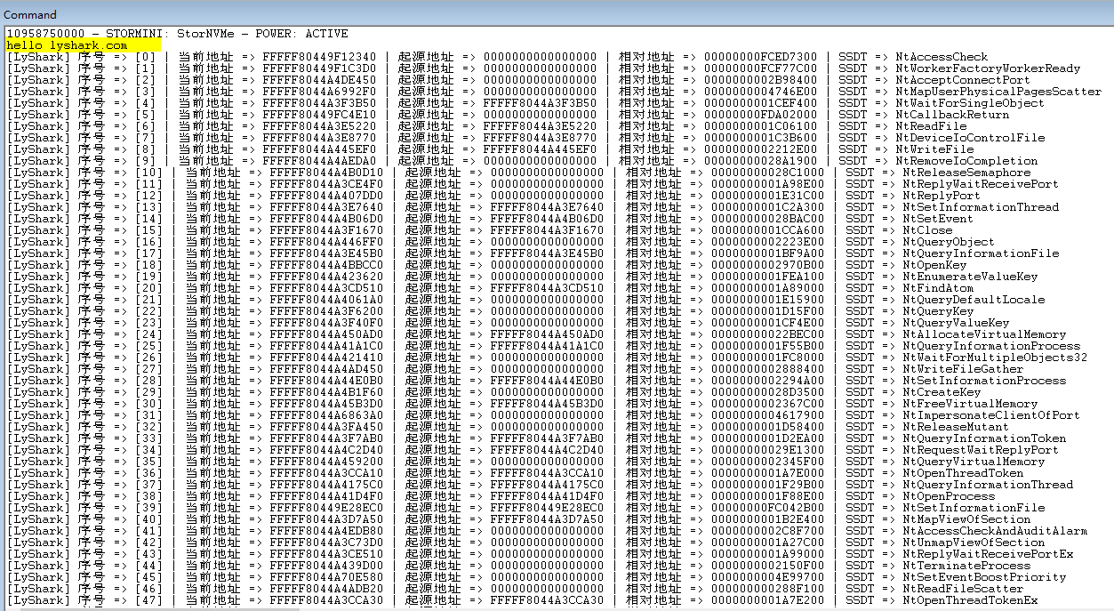

本书作者： 王瑞 (LyShark)

作者邮箱： m [e@lyshark.com](mailto:e@lyshark.com)

作者博客： h ttps://lyshark.cnblogs.com

团队首页： w ww.lyshark.com