# 内核层与应用层之间的数据交互是必不可少的部分，只有内核中的参数可以传递给用户数据才有意义， 一般驱动多数情况下会使用 SystemBuf 缓冲区进行通信，也可以直接使用网络套接字实现通信，如下将简单介绍通过SystemBuf实现的内核层与应用层通信机制。

内核与应用层传递结构体，实现应用层用户传入一个结构体到内核，内核处理后返回一段字符串。 内核代码如下，代码已经备注。

#include <ntifs.h> #include <windef.h>



#define My_Code CTL_CODE(FILE_DEVICE_UNKNOWN,0x800,METHOD_BUFFERED,FILE_ANY_ACCESS)

// 通信结构体

typedef struct Hread

{

ULONG Flage; ULONG Addr;

ULONG WriteBufferAddr; ULONG Size;

ULONG Pid;

}_Hread, PtrHread;

typedef struct _DEVICE_EXTENSION

{

UNICODE_STRING SymLinkName;

} DEVICE_EXTENSION, PDEVICE_EXTENSION;

// 驱动关闭提示

VOID DriverUnload(PDRIVER_OBJECT pDriverObject)

{

PDEVICE_OBJECT pDevObj;

pDevObj = pDriverObject->DeviceObject;

PDEVICE_EXTENSION pDevExt = (PDEVICE_EXTENSION)pDevObj->DeviceExtension; UNICODE_STRING pLinkName = pDevExt->SymLinkName;

IoDeleteSymbolicLink(&pLinkName); IoDeleteDevice(pDevObj);

}

// 默认派遣

NTSTATUS DefDispatchRoutine(PDEVICE_OBJECT pDevObj, PIRP pIrp)

{

NTSTATUS status = STATUS_SUCCESS;

pIrp->IoStatus.Status = status; pIrp->IoStatus.Information = 0;

IoCompleteRequest(pIrp, IO_NO_INCREMENT); return status;

}

// 主派遣函数

NTSTATUS IoctlDispatchRoutine(PDEVICE_OBJECT pDevObj, PIRP pIrp)

{



NTSTATUS Status = STATUS_UNSUCCESSFUL;

ULONG_PTR Informaiton = 0; PVOID InputData = NULL; ULONG InputDataLength = 0; PVOID OutputData = NULL; ULONG OutputDataLength = 0;

PIO_STACK_LOCATION IoStackLocation = IoGetCurrentIrpStackLocation(pIrp);

// Irp堆栈

InputData = pIrp->AssociatedIrp.SystemBuffer;

// 输入堆栈

OutputData = pIrp->AssociatedIrp.SystemBuffer;

// 输出堆栈

InputDataLength = IoStackLocation-

>Parameters.DeviceIoControl.InputBufferLength; // 输入数据大小

OutputDataLength = IoStackLocation-

>Parameters.DeviceIoControl.OutputBufferLength; // 输出数据大小

ULONG Code = IoStackLocation->Parameters.DeviceIoControl.IoControlCode;

// 控制码

switch (Code)

{

case My_Code:

{

PtrHread PtrBuff = (PtrHread)InputData; ULONG RetFlage = PtrBuff->Flage;

ULONG RetAddr = PtrBuff->Addr;

ULONG RetBufferAddr = PtrBuff->WriteBufferAddr; ULONG Size = PtrBuff->Size;

ULONG Pid = PtrBuff->Pid;

DbgPrint("读取文件标志：%d", RetFlage);

DbgPrint("读取写入地址：%x", RetAddr);

DbgPrint("读取缓冲区大小：%d", RetBufferAddr);

DbgPrint("读取当前大小：%d", Size);

DbgPrint("要操作进程PID: %d", Pid);

// 通过内存返回数据.

char retBuffer = "hello lyshark"; memcpy(OutputData, retBuffer, strlen(retBuffer)); Informaiton = strlen(retBuffer) + 1;

Status = STATUS_SUCCESS;

// 通过内存返回数据,另一种通信方式.

/

PVOID addr = (PVOID)"ok";

RtlCopyMemory(OutputData, addr, 4);

Informaiton = 4;

Status = STATUS_SUCCESS;

/ break;

}

}

pIrp->IoStatus.Status = Status; // 设置IRP完成状态，会设置用户模式下的GetLastError

pIrp->IoStatus.Information = Informaiton; // 设置操作的字节

IoCompleteRequest(pIrp, IO_NO_INCREMENT); // 完成IRP，不增加优先级

return Status;

}

// 驱动入口

NTSTATUS DriverEntry(PDRIVER_OBJECT pDriverObject, PUNICODE_STRING pRegistryPath)

{

pDriverObject->DriverUnload = DriverUnload; // 注册驱动卸载函数

pDriverObject->MajorFunction[IRP_MJ_CREATE] = DefDispatchRoutine; // 注册派遣函数

pDriverObject->MajorFunction[IRP_MJ_CLOSE] = DefDispatchRoutine; pDriverObject->MajorFunction[IRP_MJ_WRITE] = DefDispatchRoutine; pDriverObject->MajorFunction[IRP_MJ_READ] = DefDispatchRoutine; pDriverObject->MajorFunction[IRP_MJ_DEVICE_CONTROL] = IoctlDispatchRoutine;

NTSTATUS status; PDEVICE_OBJECT pDevObj; PDEVICE_EXTENSION pDevExt;

// 创建设备名称的字符串

UNICODE_STRING devName; RtlInitUnicodeString(&devName, L"\\Device\\MyDevice");

// 创建设备

status = IoCreateDevice(pDriverObject, sizeof(DEVICE_EXTENSION), &devName, FILE_DEVICE_UNKNOWN, 0, TRUE, &pDevObj);

pDevObj->Flags |= DO_BUFFERED_IO; // 将设备设置为缓冲I/O设

备

pDevExt = (PDEVICE_EXTENSION)pDevObj->DeviceExtension; // 得到设备扩展

// 创建符号链接

UNICODE_STRING symLinkName; RtlInitUnicodeString(&symLinkName, L"\\??\\MyDevice"); pDevExt->SymLinkName = symLinkName;

status = IoCreateSymbolicLink(&symLinkName, &devName); return STATUS_SUCCESS;

}

客户端代码中只需要通过 DeviceIoControl() 发送控制信号即可，需要注意驱动需要安装并运行起来，否则无法获取到数据。

#include <Windows.h> #include <iostream>

// 自定义的控制信号

#define My_Code CTL_CODE(FILE_DEVICE_UNKNOWN,0x800,METHOD_BUFFERED,FILE_ANY_ACCESS)

// 通信结构体

typedef struct Hread



{

ULONG Flage; ULONG Addr;

ULONG WriteBufferAddr; ULONG Size;

ULONG Pid;

}_Hread, PtrHread;

int main(int argc, char argv[])

{

// 创建

HANDLE handle = CreateFileA("\\\\.\\MyDevice", GENERIC_READ | GENERIC_WRITE, 0, NULL, OPEN_EXISTING, FILE_ATTRIBUTE_NORMAL, NULL);

unsigned char RetBufferData[20] = { 0 }; DWORD ReturnLength = 4;

_Hread buf;

buf.Flage = 2; buf.Addr = 0x401234;

buf.WriteBufferAddr = 1024;

buf.Size = 100;

buf.Pid = 2566;

DeviceIoControl(handle, My_Code, &buf, 20, (LPVOID)RetBufferData, 4,

&ReturnLength, 0);

for (size_t i = 0; i < 20; i++)

{

printf("返回数据: %d \n", RetBufferData[i]);

}

CloseHandle(handle);

getchar(); return 0;

}

# 运行这段代码我们看下返回效果：

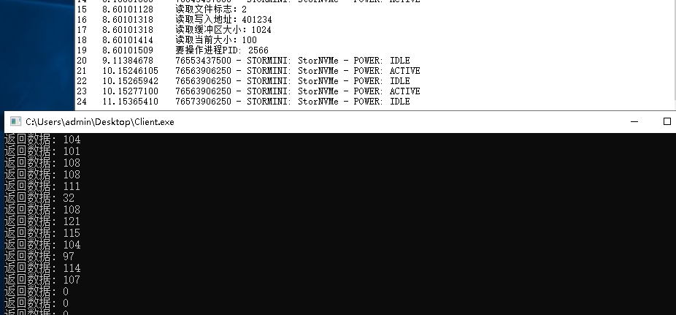

本书作者： 王瑞 (LyShark)

作者邮箱： m [e@lyshark.com](mailto:e@lyshark.com)

作者博客： h ttps://lyshark.cnblogs.com

团队首页： w ww.lyshark.com