WinDbg Themes
A theme is a preconfigured WinDbg workspace that contains a useful configuration of debugging information windows.
Any theme can be saved as your “default workspace.” Themes in the Debugging Tools for Windows package are provided as a set of registry files (with the .reg extension). As you accumulate more debugging sessions, “explicit workspaces” will be set up. These explicit workspaces will use the default workspace as a starting point. Note that explicit workspaces have also been provided as a set of workspace files (with the .wew extension).
For the best user experience, it is recommended that you follow the instructions in this document before starting your debugging session.
Loading a Theme
- Recommended: Clear all of your workspace data. This can be done through the WinDbg UI, or by deleting the registry key under HKCU\Software\Microsoft\Windbg\Workspaces.
  - Running reg delete HKCU\Software\Microsoft\Windbg will also accomplish this.
- Execute one of the Themes. These are stored as .reg files, in the Themes directory of your Debugging Tools for Windows installation. This will import its settings into the registry, redefining your default workspace.
Before Using a Theme
- After loading your theme, start WinDbg with no command-line parameters. This will open the default workspace
- Tweak the theme to your liking. Some specific areas of focus are:
  - Set your symbol path. For example:
SRV*c:\MySymCache*\\CompanySymbolServer\Symbols;SRV*c:\WinSymCache*http://msdl.microsoft.com/download/symbols
  - Set your source path. For example: SRV*;d:\MySourceRoot
  - Set your executable path. This is usually the same path as your symbol path.
  - Tweak your window positioning. (See below.)
- Exit WinDbg, and save your workspace. The new workspace will now be remembered as your default workspace.
- If you wish to save your new settings to a .reg file, open regedit and export the registry key under HKCU\Software\Microsoft\Windbg\Workspaces to a .reg file.
Tweaking your Window Positioning
Debugging information windows remember their last docking operation. These themes were created by the following actions:
- Placing and positioning the placeholder*.c files into the dock.
- Tab-docking every window type above the desired placeholder window.
Before using your theme, you should tweak the window positioning so that WinDbg will handle your source files correctly. This ensures that source windows will know where to dock
- Open a source window.
- Tab-dock it with the placeholder set aside for your source windows.
  - Note: The placeholder window must be the top-most window in the dock before performing a tab-dock operation for the proper relationship to be made.
- Close the newly-opened source window (but not the placeholder file)
Once you have performed this procedure, each source window’s last docking operation will be associated with one of the placeholder files. Because of this, you should not close any of your placeholder windows.
If you choose to tweak the theme’s configuration, keep the above rules in mind. Any window you reposition in a dock should always be tab-docked with a placeholder file.
Themes provided in the Debugging Tools for Windows
Standard.reg:
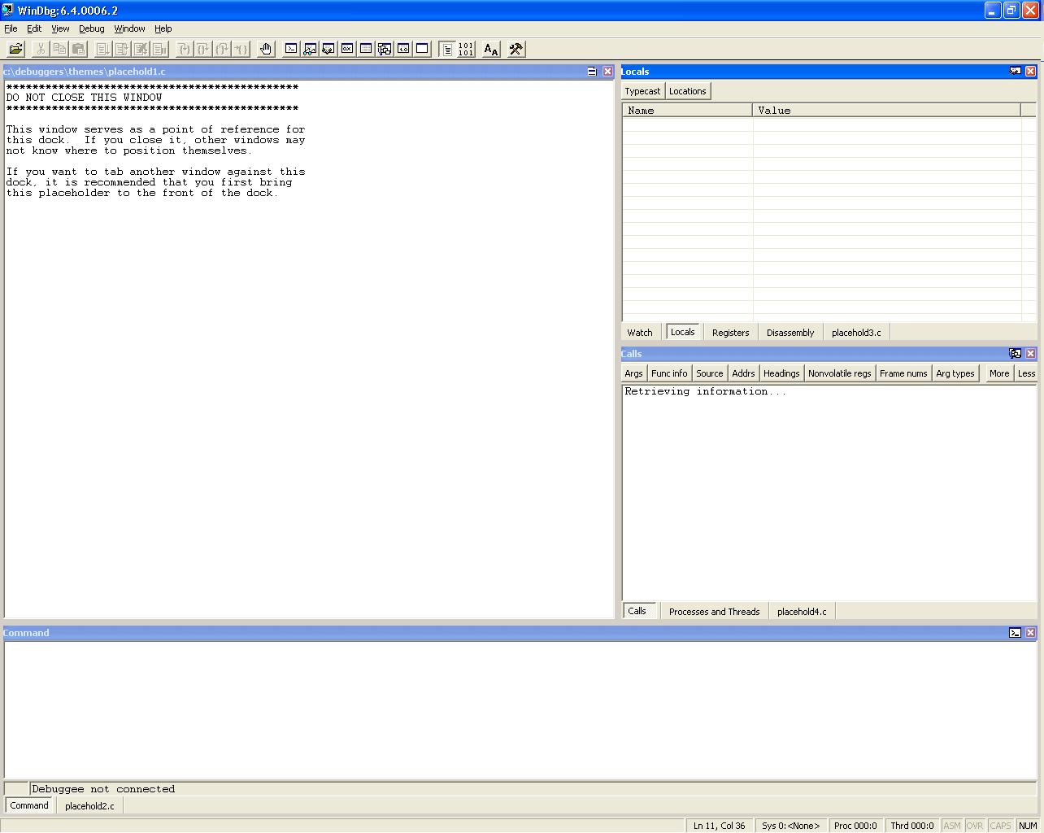

StandardVS.reg:

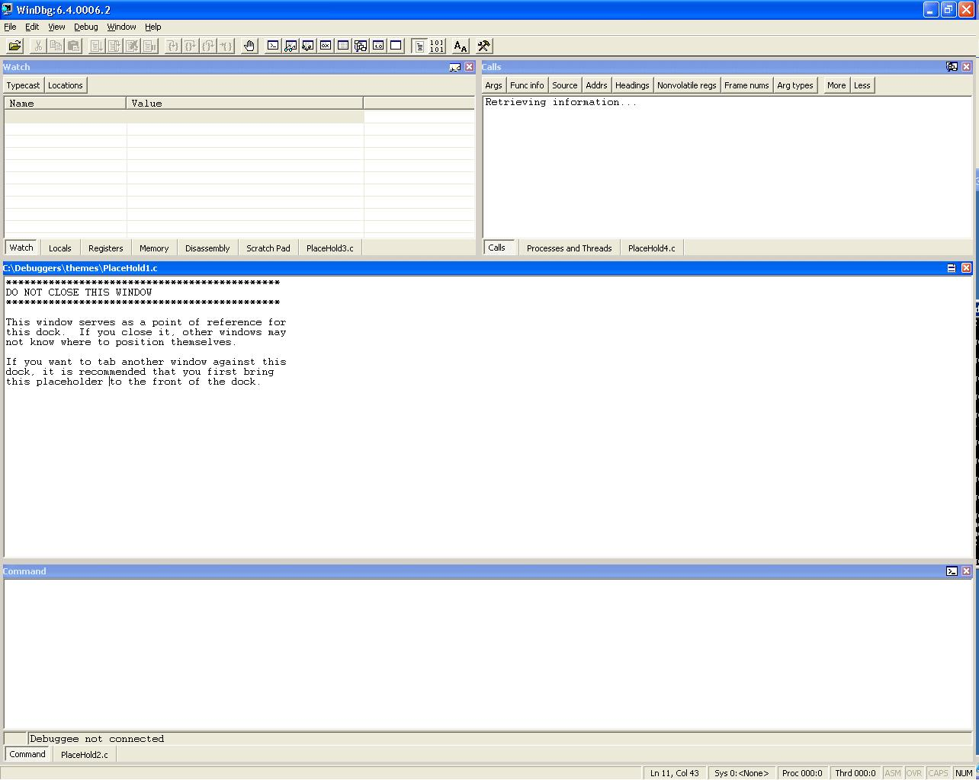

SrcDisassembly.reg:
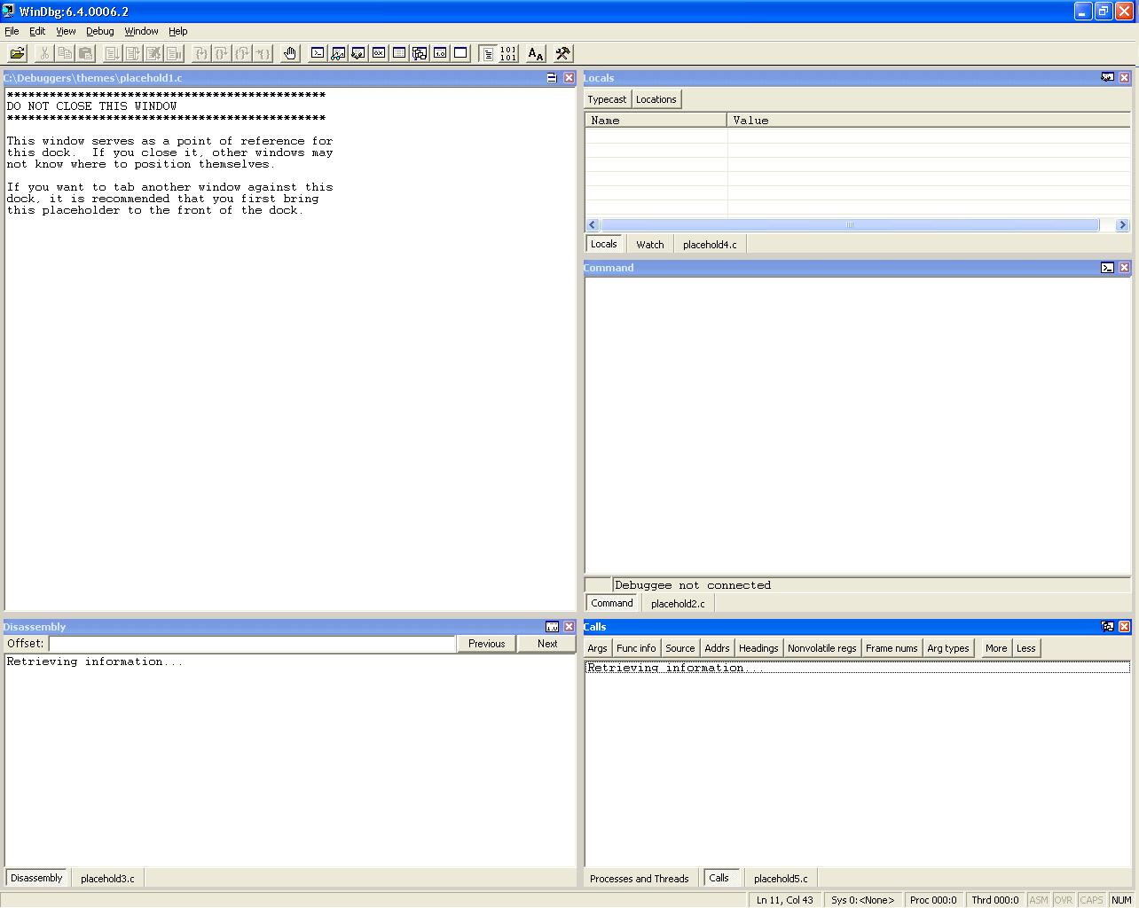

MultiMon.reg:
