Andrew RFPA Test Data Collection

Table Of Contents

Andrew RFPA Test Data Collection 1
Table Of Contents 2
1 Introduction 3
2 Interface with CM 4
2.1 Overview 4
2.2 Process Check 4
2.2.1 PC Request File 5
2.2.2 PC Response File 6
2.3 Test Update 7
2.4 DCF Data Archiving Requirements 9
2.5 Initialization (INI) Files 10
2.6 Timing 12
3 Andrew RFPA Functional Test Data Collection 13
3.1 General Description 13
3.2 DCF Format 13
3.3 String Fields 16
3.4 Assembly_Type, Program_ID, Process_Step_ID 16
3.4.1 Field Name Selection when not using DLL 17
3.4.2 Field Name Selection when using DLL 18
4 Test Data Reporting 19
4.1 Data Access 19
5 RFPA Interface Software DLL 21
6 Andrew Burn In Data File Transfer 22
6.1 General Description 22
6.2 File Description 24
6.3 CM’s FTP Server 27
6.4 Andrew FTP Server 27

Introduction
This document describes the Andrew RF Power Amplifier (RFPA) test data collection scheme. The focus is on the interface between the functional test software and the automated processes implemented by the contract manufacture (CM) of Andrew RFPA products. As such, the intended audience includes both Andrew test engineers responsible for developing automated test software as well as CM test engineers responsible for oversight of Andrew RFPA products.
The following topics are discussed in this document
- Synchronization and data transfer between Andrew RFPA test application software and automated Process Tracking utilities available at the CM
- Requirements for collection and transfer of Andrew RFPA functional test data to Andrew
- Defined format of test data files (DCF files)
- Requirements for collection and transfer of auxiliary (non-DCF) test files such as Burnin logging files to Andrew

Interface with CM

Overview
The various Andrew test applications have functionality that allows them to interact and exchange data with software programs implemented by a CM. The interaction is intended to benefit both Andrew and the CM. The primary benefit for the CM is the ability to integrate the Andrew test process into the overall product tracking capability. The primary benefit for Andrew is the automated collection and delivery of all testing results to Andrew. The remainder of this section focuses on defining this interaction such that both Andrew and a CM can develop software programs that work together.
The Andrew / CM interface is designed to provide synchronization between the Andrew and CM software at both the beginning and end of each test sequence. ASCII text files are used to exchange data between the programs. The synchronization that occurs at the beginning of the test sequence is called Process Check while the synchronization that occurs at the end is called Test Update.
When the operator starts the test sequence for a given unit under test (UUT), the Andrew test application performs the following operations:
- Prompt operator to scan barcode
- Invoke Process Check
- Perform all product testing
- Write test results to DCF file
- Invoke Test Update

The items in bold are those particularly relevant to the Andrew / CM interface. After scanning the barcode, the Andrew test application optionally executes a CM utility program, Process Check, to determine if the UUT is at the proper test stage (execution of this program can be enabled / disabled by means of an initialization file). The test application and Process Check utility exchange data using a file-based handshaking process.
When all testing is complete, the Andrew test application writes all test results to an ASCII data file in “DCF” format. Finally, the test application optionally executes a second CM utility program, Test Update, so that the CM can perform 2 functions: 1) process the DCF file to extract any test results of interest to the CM, and 2) transfer the DCF file from the local tester PC to a server.
The following sections describe Process Check and Test Update functions in more detail. The DCF file format is described in Section 3.2.

Process Check
The Process Check routine is a stand-alone program (e.g., .bat, .cmd, or .exe) that can be executed from a DOS command prompt. [The CM is responsible for creating / maintaining this program. If the CM has no need for this functionality, the Process Check option can be disabled through the Andrew test software initialization file.] This program must accept two command line arguments that identify the names of two text files that are used to transfer data between the test application and the Process Check routine. These files are referred to as the PC request file and PC response file. The following is an example command line.
Proc_Check.exe c:\pc_request.txt c:\pc_response.txt
Although the Process Check routine is a stand-alone program that can be manually executed from the DOS prompt, the typical usage is for the Andrew Test application to generate the above command and automatically launch the Process Check program. The Process Check program name, as well as the PC request and response filenames can be changed as necessary by the CM by editing the appropriate fields of the test application INI file (described in a section 2.5).
The following paragraphs illustrate the sequence of events related to the Process Check routine.
- The test application reads its INI file to determine the name of the Process Check utility as well as the data file names for the PC request file and PC response file.
- The test application creates the PC request file, which includes information about the unit to be tested
- The test application launches the Process Check routine and passes the names of the PC request and response files as command line arguments. The test application then waits for Process Check to complete
- Process Check reads the PC request file and performs the appropriate queries to determine if the UUT is at the correct test stage
- Process Check creates the PC response file, which includes the results of the query and then Process Check terminates
- The test application reads the PC response file and begins testing the unit

PC Request File
The following is an example PC request file.
OperatorID=00493 ⇐ optional field
END COMMON

TestStep=1E ⇐ mandatory field
UUTType=CAM_0880_120P ⇐ mandatory field
OperatorID=00493 ⇐ optional field
Barcode=99H61B00128 ⇐ optional field
Slot=1 ⇐ optional field
END PC

The file consists of one “common” section and one or more “unit-specific” sections. The common section has only 1 field, OperatorID. [To my knowledge, this field is always left blank by the test software and I don’t remember its intended use.] The “END COMMON” statement denotes the end of this section.
The example above contains only one unit-specific section, which is concluded with the “END PC” statement. There are five fields in this section, two mandatory and three optional. The TestStep field contains the name of the test stage that is about to be performed. Examples for this field include “1E”, “2E”, “PRE_BURN_IN”, and “BURNIN”. This field must be identical to the Program_ID field that the test application populates in the DCF file at the conclusion of testing the product. The UUTType field contains the model name for the UUT. Examples include “KLAM”, “TAZ”, and “MLAM”. This field must be identical to the Assembly_Type field that the test application populates in the DCF file.
The OperatorID field is typically left blank by the test application [again, I don’t remember the intended use].
The Barcode field contains the serial number of the UUT. The test application prompts the operator to scan the barcode and then the test application populates this field. In some cases, the UUT may have multiple serial numbers (e.g., an end-customer serial number and a CM internal serial number). When this is true, the test application typically only scans one barcode (usually the end-customer barcode). The Process Check utility must work properly for test applications that scan the end-customer serial number as well as test applications that scan the CM internal serial number.
The Slot field is significant only if there are multiple “unit-specific” sections. Multiple unit-specific sections are convenient when the test application is testing multiple units simultaneously, such as Burnin test. The PC request file contains one “unit-specific” section for each UUT. The Slot field is an index that is intended to identify each UUT location in a multiple UUT fixture. The test application can use this field to associate each request in the PC request file with each response in the PC response file. Therefore, if the PC request file contains multiple “unit-specific” sections, each should have a unique Slot field.
When there are multiple “unit-specific” sections in the PC request file, each section is concluded with an “END PC” statement. The Process Check routine must be able to handle a minimum of 12 “unit-specific” requests in one PC request file.

PC Response File
The following is an example PC response file.

OperatorID=00493
PCStatus=pass
END COMMON

CelesticaBarcode=99H61B00128
AndrewBarcode=99H61B00128
PCStatus=pass
PCString=
UUTType=CAM_0880_120P
OperatorID=00493
Slot=1
END PC

The structure of this file is identical to the PC request file with one “common” section and one or more “unit-specific” sections. As with the PC request file, the “END COMMON” and “END PC” statements are used to delineate the various sections. The PC response file must have the same number of “unit-specific” sections as the PC request file.
In the common section there are two fields. Operator ID identifies the person who runs the test. The test application does not use this field except to populate it without modification in the test results DCF file. The PCStatus field is the logical AND of the PCStatus fields from all of the “unit-specific” sections (i.e., this is “pass” if and only if all of the unit-specific sections are “pass”; otherwise, it is “fail”). If there is only one unit-specific section, then the PCStatus field in the common section will be identical to the same field in the unit-specific section.
In the unit-specific sections, there are seven fields. The CelesticaBarcode field contains the CM internal serial number for the UUT. The AndrewBarcode field contains the serial number for the end-customer barcode, if any. If there is no end-customer barcode for the product, then the AndrewBarcode field must contain a duplicate of the CelesticaBarcode field.
The PCStatus field represents the pass/fail status for the Process Check query for the given serial number. If the UUT is at the appropriate test stage, this field contains “pass”. If not, the field contains “fail”. [The Process Check routine should also fail any unit for which the serial number is inconsistent with the UUTType field. For example, this can happen if the operator is running the MLAM test application, but accidentally begins testing with a C2PAM unit. In this case, the test application will populate the UUTType field of the PC request file with “MLAM” and the Barcode field with the scanned serial number of the C2PAM unit, but the Process Check utility should recognize the inconsistency and report a failed response.]
If the PCStatus field is “fail”, the PCString field contains a string description of the failure. This description is at the discretion of the CM and is not used by the test application except to prompt the operator with a failure message. If the PCStatus field is “pass”, the PCString field is normally blank. One exception for the PCString field is for the Andrew TAZ product. For this product, if the PCStatus is “pass”, the PCString field contains the “Date Code” that is printed (but not scan able) on the UUT barcode.
The UUTType field is a duplicate of the UUTType field from the PC request file. The OperatorID field is a duplicate of the OperatorID field from the “common section” of the PC response file. The Slot field is a duplicate of the Slot field from the PC request file.

Test Update
The Test Update routine is a stand-alone program (e.g., .bat, .cmd, or .exe) that can be executed from a DOS command prompt. [The CM is responsible for creating / maintining this program. If the CM has no need for this functionality, the Test Update option can be disabled through the Andrew test software initialization file. However, the CM is still responsible for collecting all DCF files and transferring to Andrew as described in Section 2.4.] This program must accept one command line argument that identifies the name of the DCF text file that contains the test results. The following is an example command line.
Test_update.exe c:\mlam_data.dcf
The TestUpdate routine is automatically launched by the test application at the end of the test sequence once the application determines if the unit has passed or failed and has completed writing results to the DCF file. The test application does not wait for the Test Update routine to complete execution and does not check whether or not the routine is successful. The test application can be configured to use any name for the Test Update routine and/or DCF text file by editing the appropriate fields in the test application INI file (described in section 2.5).
The test application always writes to the DCF file in “append” mode. If the file is not present, it is created. If the file is present, the results are appended to any previous results records. Thus, if the previous DCF file is not transferred to a server and deleted, the new test results will be appended to the old. Thus, it is possible for the DCF file to contain multiple records. The CM Test Update program should be capable of handling a DCF file with multiple records.
There are two main reasons why the Test Update functionality is provided by the test application. First, this functionality provides the CM the opportunity to parse the DCF file to obtain any test results or parametric data useful to the CM (the DCF file format is described in section 3.2). This function is for the purposes of the CM, not for Andrew. Second, this functionality provides the CM the opportunity to transfer the DCF file to a common server (and delete it from the local tester PC) at the conclusion of each test sequence in order to meet Andrew’s data collection requirements (see section 2.4). It is CM’s responsibility to have backup data for each DCF file. The original DCF files generated by Andrew test software should be deleted once data backup is successful.

Although the CM is free to extract any of the information from the DCF file, the following paragraphs describe those fields that are most likely to be useful.

From the EVENTSTART record:
Assembly_Type ← identical to UUTType field in PC request / response files.
← typically hard coded in test application
Assembly_Serial_Number ← indicates the serial number of the product
Process_Step_ID ← indicates the test stage (i.e. ‘FTEST1’, ‘FTEST2’, etc)
Program_ID ← also indicates the test stage (i.e. ‘1E’, ‘2E’, etc)

From the EVENTSTOP record:
Event_Status ← indicates the overall test sequence Status (i.e. ‘Pass’, ‘Fail’)

From the PRODUCTMEASURE record:
Test_Designator ← indicates the name for an individual measurement
Numeric_Value ← indicates the parametric value for the measurement
Test_Status ← indicates the status of the measurement (i.e. ‘Pass’, ‘Fail’)

DCF Data Archiving Requirements
Andrew RFPA maintains an internal test database containing the test results and parametric data for all units tested at any CM. This data is used for a variety of internal reports. The Andrew test applications generate the necessary data input for this database by formatting all test results in the DCF format. Andrew created a utility to automatically transfer data from these files into the Andrew RFPA test database.
The general requirement for the CM is to collect all the DCF files, which are created on the tester PCs and to transfer these files to a server accessible by Andrew. Specific details of the requirements are listed below:
- all the DCF files generated on the various tester PCs must be collected and archived into a single “zip” file on a periodic basis
- the zip file must have a filename according to the following convention: YYYYMMDDHH-LOC.gz where YYYY is the year, MM is the month, DD is the day, HH is the hour, and LOC is a location code representing the manufacturing location. Present values for the location code are: SUZ for Celestica-Suzhou, TOR for Celestica-Toronto, CIT for Celestica-Italy, and ATBF for Andrew-France.
- all DCF files within the zip file must have unique filenames (not just unique file paths). [The DCF file format supports multiple test records within the same data file. Therefore, it is possible to append all test results from all tester PCs into one large DCF file. It is acceptable for the zip file to contain either one large DCF file with all of the test records or many small DCF files, each with one or more test records.]
- the zip file must be transferred to an FTP server accessible by Andrew
- the frequency for creating and transferring the zip file should be at least once per day (multiple times per day is preferable)

Andrew has automated processes for retrieving the compressed data files from the Andrew or CM FTP server, unzipping the files, and executing a custom program to insert all data to the internal database.

The functional data transmission process is shown in the following diagram:

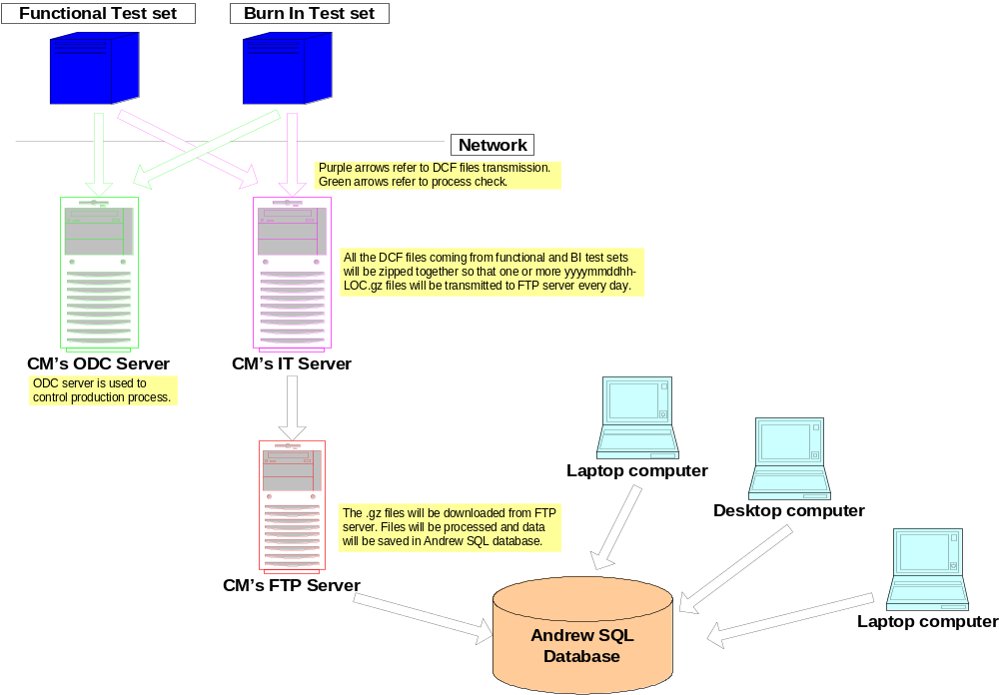

The functional data transmission process can be described as follows:
- DCF files will be generated from each functional test set and Burn In test set.
- All the DCF files will be transmitted to CM’s IT server
- The DCF files on IT server will be transmitted to CM’s FTP server as yyyymmddhh.LOC.gz files (LOC refers to ‘location’, such as ‘SUZ’, ‘CIT’, etc).
- Andrew will download .gz files from FTP server, process the data files, and save data into Andrew SQL database.
- Andrew employees can access SQL database to analyze the data.

Initialization (INI) Files
The Andrew test applications are configurable by changing data parameters in the appropriate INI file. The name of the INI file (e.g., d:\monarch.ini) is different for each test software application and is hard coded into the application.
There are two sections in the INI file that are relevant to the CM interface. These sections are “ProcessCheck” and “DataCollection”.
The following shows example sections from an INI file:
[ProcessCheck]
Enable = True
Program = d:\testapplications\javaw\javaw.exe cli.ProcessCheck
RequestFile = c:\pc_request.txt
ResponseFile = c:\pc_response.txt

[DataCollection]
Enable = True
Program = d:\testapplications\javaw\javaw.exe cli.TestUpdate
DataFile = c:\mat_data.dcf

For each section, the Enable field can be set to true or false to enable or disable the test application from calling the given Celestica utility program. For example, if the ProcessCheck->Enable flag is false, the test application will not launch the Process Check utility program. This is typically the setting used in Andrew’s development labs.
The Program field allows the CM to select the name for the given utility. The test software uses this field along with the data file fields to generate the actual command line used to launch the Celestica utility program. For example, the INI file example above would cause the test application to generate the following “command line” for the Process Check utility:
d:\testapplications\javaw\javaw.exe cli.ProcessCheck c:\pc_request.txt c:\pc_response.txt
For the Test Update utility, the “command line” would be
d:\testapplications\javaw\javaw.exe cli.TestUpdate c:\mat_data.dcf
Note that in the example above, the Program field in both the ProcessCheck and DataCollection sections are actually the same executable name (javaw.exe) with a different command line argument. This works fine with the Andrew test application because the test application blindly copies this string and appends the data files as additional command line arguments in order to generate the full command line.
The above discussion presents an easy way for the CM to control the behavior of the Andrew test applications with regards to the CM interfacing functions. Unfortunately, the various Andrew test applications do not all follow these conventions. Andrew’s goal is to follow these conventions going forward, but there are several existing Andrew test applications that use different field names to control the same functions. In some test applications, the names may even be hardcoded. The following paragraphs provide some common “equivalent” fields that are used in some test applications.
ProcessCheck: sometimes used in place of ProcessCheck->Enable; values TRUE/FALSE
PCpath: sometimes used in place of ProcessCheck->Program
RequestPath: sometimes used in place of ProcessCheck->RequestFile
ResponsePath: sometimes used in place of ProcessCheck->ResponseFile
XferProg: sometimes used in place of DataCollection->Program
XferData: sometimes used in place of DataCollection->Enable; values ON/OFF

These fields are sometimes located in the “General” section of the INI file, but this is not universal either.

Timing
Andrew functional test software will not start to record the test time until after the barcode scan and after the message box that instructs the operators to hook up the test cables. The software stops to record the test time just prior to the PASS/FAIL display. The sequence of events for testing a unit is shown as follows:
1) Start test
2) Scan barcode
3) Invoke Process Check
4) Show connection message
5) Start to record the test time
6) Take all measurements
7) Stop recording the test time
8) Write DCF file
9) Invoke Test Update
10) Display Pass/Fail
11) Stop test or loop back to step 2

If the RFPA Interface DLL (see Section 4) is used, this sequence is automatically implemented by the Operator Interface class. If this DLL is not used, it is up to the test engineer to implement this sequence.

Andrew RFPA Functional Test Data Collection

General Description
The Andrew data collection process centers upon the creation of an ASCII text file with all the measurement results for a given test stage. At the conclusion of a test sequence, the test application creates (or appends to) this text file containing the overall test status as well as the numeric results of individual measurements. The format of this data file is provided below.
The RFPA test software includes some “hooks” to provide synchronization between the Andrew test software and any custom software developed by the CM. Among other things, these hooks allow for the processing and transfer of the DCF data files after the DCF files are created by the test software. See section 2.3 for more information.

DCF Format
The DCF format file is a text file containing a series of data records. Each data record is delimited by a new-line (carriage-return, line-feed combination). There are 3 types of data records in the file: EventStart, EventStop, and ProductMeasure. Each type of record contains several fields delimited by the pipe symbol ‘|’.
The EventStart and EventStop records are the first and last records, respectively, for a given test event. Multiple ProductMeasure records normally occur in between the EventStart and EventStop records and contain all the measurement results for the test event.
There is no limit on the number of test events that occur in the DCF file. A sample DCF file is shown in the following:
1 2 3 4 6 7 8 12 14 17 19 24
EVENTSTART|1|2003072112195900|TEST|CEL-TOR||M&C|M+C006|1||||M&C||2|||TAZ||99999|||||YES|||||
PRODUCTMEASURE|1|MA_POWER_DET_MIN_DELTA||PASS|||0.000|Counts|||||||||||||-10|10|A2DS|||
PRODUCTMEASURE|1|MA_POWER_DET_MID_DELTA||PASS|||1.000|Counts|||||||||||||-10|10|A2DS|||
PRODUCTMEASURE|1|MA_POWER_DET_MAX_DELTA||PASS|||-4.000|Counts|||||||||||||-10|10|A2DS|||
PRODUCTMEASURE|1|MA_TEMP_SENSE_MIN_DELTA||PASS|||1.000|Counts|||||||||||||-10|10|A2DS|||
PRODUCTMEASURE|1|MA_TEMP_SENSE_MID_DELTA||PASS|||-1.000|Counts|||||||||||||-10|10|A2DS|||
...................
Measurements Removed for Brevity
...................
PRODUCTMEASURE|1|COUNTS_NEG_80||PASS|||87.000|Counts|||||||||||||25|200|RF_TESTS|||
PRODUCTMEASURE|1|FINAL_RF_LEVEL||PASS|||-2.000|dBm|||||||||||||-20|20|RF_TESTS|||
PRODUCTMEASURE|1|IM||PASS|||-78.000|dBc|||||||||||||-100|-60|RF_TESTS|||
PRODUCTMEASURE|1|IIP3||PASS|||37.000|dBm|||||||||||||34|60|RF_TESTS|||
PRODUCTMEASURE|1|TIME_RF_TESTS||PASS|||39.000||||||||||||||0|100000|RF_TESTS|||
PRODUCTMEASURE|1|STATUS_RF_TESTS||PASS|||0.000||||||||||||||0|0|RF_TESTS|||
EVENTSTOP|1|PASS|233||2.0.9|TAZ00000156_2_02.00.05||||
1 2 3 5 6

The following tables outline the DCF Record Structure. Items in blue are mandatory items and should not be blank.
EVENTSTART index
dcf_rev 1
event_date_time 2
event_type 3
production_site_id 4
production_line_id 5
process_step_id 6
controller_id 7
machine_id 8
machine_type 9
machine_mode 10
machine_step_status 11
program_id 12
program_rev 13
resource_id 14
customer_id 15
order_id 16
assembly_type 17
assembly_rev 18
assembly_serial_number 19
assembly_option 20
verification_assembly 21
lot_id 22
batch_id 23
sampled 24
sampling_rate 25
sampling_method 26
operator_id 27
operator_type 28

PRODUCTMEASURE index
dcf_rev 1
test_designator 2
sub_test_designator 3
test_status 4
event_duration 5
non_numeric_value 6
numeric_value 7
units 8
diagnosis_vector_number 9
test_vector_number 10
non_conformity_code 11
non_conformance_count_1 12
non_conformance_count_2 13
non_conformance_count_3 14
reference_designator 15
x_location 16
y_location 17
machine_record_type 18
machine_step_status 19
machine_step_sub_status 20
gen1 (LowerLimit) 21
gen2 (UpperLimit) 22
gen3 (TestGroup) 23
gen4 24
gen5 25

EVENTSTOP index
dcf_rev 1
event_status 2
event_duration 3
validity 4
gen1 (Software Document) 5
gen2 (Firmware Rev ) 6
gen3 (CM serial number) 7
gen4 8
gen5 9

Table 1. EventStart Record
Column | Field | Field Format | Description
0 | record_type | [EVENTSTART] | Indicates the start of a test event
1 | dcf_revision | [1]
2 | Event_date_time | YYYYMMDDhhmmsstt | Start time for the overall test:  YYYY = year  MM = month  DD = day  hh = hour  mm = minute  ss = second  tt = hundredths of sec
3 | Event_type | [TEST]
4 | production_site_id | char (80) | Manufacturing location (CEL-TOR for Celestica Toronto)
6 | process_step_id | char (80) | Identification string for test process step. Examples include ‘FTEST1’ or ‘PRE_BURN_IN’. Generally redundant with ‘program_id’.
7 | controller_id | char (80) | Identification string for test platform (tester or test set)
12 | program_id | char (80) | Identification string for test process step, such as ‘1E’ or ‘PRE_BURN_IN’. Generally redundant with ‘process_step_id’
14 | resource_id | char (80) | Identification string for test fixture, if any
17 | assembly_type | char (80) | Identification string for name of product, such as TAZ, MLAM
19 | assembly_serial_number | char (80) | Unit serial number
27 | operator_id | char (80) | Identifies test operator

Table 2. EventStopRecord
Column | Field | Field Format | Description
0 | record_type | [EVENTSTOP]
1 | dcf_revision | [1]
2 | event_status | [PASS|FAIL] | overall status of test event
3 | event_duration | signed, exp, double precision | duration of test event (seconds)
5 | gen1 | char (80) | Test Software revision ID
6 | gen2 | char (80) | product firmware revision ID
7 | gen3 | char (80) | Unit serial number for contract manufacturer

Table 3. ProductMeasure Record
Column | Field | Field Format | Description
0 | record_type | [PRODUCTMEASURE]
1 | dcf_revision | [1]
2 | test_designator | char (80) | Name (or identifier) of each measurement
4 | test_status | PASS|FAIL | Status of each measurement
6 | non_numeric_value | char (80) | “Text” results for each measurement, if any
7 | numeric_value | signed, exp, double precision | “Numeric” results for each measurement
8 | Units | char (80) | Measurement units (e.g., Volts) [optional]
21 | gen1 | char (80) | Lower limit [optional]
22 | Gen2 | char (80) | Upper limit [optional]
23 | Gen3 | Char (80) | Name (or identifier) of test grouping (e.g., ACPR_Tests)

String Fields
Several fields in the section above are string fields (e.g., char(80)). There are certain ASCII characters that should not be used in these fields. The DCF file format does not allow carriage return (ASC 13) or line feed (ASC 10). The reason for this limitation is that the database stuffer program uses these codes to determine the end of each record. Similary, some of the database reporting tools make use of XML files which treat certain characters as “special”, &@$()?/. The SQL language treats the following characters as special, ()%^?*. Finally, the CM “Process Check / Test Update” utilities sometimes impose limitations. For example, Celestica Toronto did not permit spaces in the Program_id field.
The RFPA Interface DLL (see Section 4) will check for the occurrence of special characters and will remove them from the string before sending the string to the DCF file.

Assembly_Type, Program_ID, Process_Step_ID
The Assembly_Type, Program_Id, and Process_ID field are important because these are the fields used to differentiate the various DUT and DUT test stages. The reporting tools rely on these fields to be consistent.
Prior to the introduction of the RFPA Interface DLL, the selection of these fields was at the discretion of the individual test engineer creating the test software application. This resulted in a lack of consistency. Since most existing test applications and those currently under development do not use the RFPA Interface DLL, the following subsection describes how names are/were typically chosen.
The RFPA Interface DLL contains functionality that will generate an error if the names do not match the names from a controlled data file. This data file is controlled by the Test Engineering NPI manager and will be updated as necessary with the introduction of new product tests. Therefore, any errors in these names will be caught and fixed prior to introduction of a product into manufacturing.

Field Name Selection when not using DLL
The Andrew Test Engineer responsible for implementing a particular test software application has the responsibility of selecting the names that will be used for the fields Assembly_Type, Program_ID, and Process_Step_ID (among others). These fields are used in both the Process Checking communication with the CM as well as within the test data results file (DCF file). Once these names are chosen and supplied to the CM, they should not be changed since they become part of the Andrew/CM interface. Also, if one of these names is changed, the Andrew database treats the new data separately from data prior to the change. This has negative impacts for reports such as yields and paretos.
It is important for Andrew test engineers to keep consistency when naming the assembly_type, program_Id, and process_step_Id in Andrew test software. The assembly_type field should be representative of the product tested. Examples of previous assembly types are: “MLAM”, “C2PAM”, “TAZ”.
The program_Id and Process_Step_Id field are two fields that share essentially the same information – a unique name for the test sequence. The fact that these fields have the same information has been the source of some confusion and many errors in the Andrew data collection process. The reason for duplication of information in the two fields is beyond the scope of the document. What is important is that there should always be a one-to-one relationship between these fields and that each test sequence is identified with a unique name.

The following are examples of typical Program_Ids and Process_Step_Ids.
Program_ID | Process_Step_ID | Comment
1E | FTEST1 | Typically used on a “pre-burnin” test
2E | FTEST2 | Typically used on a “post-burnin” test sequence
PRE_BURN_IN | PRE_BURN_IN | Some more recent products use a more descriptive name and make it identical for both fields
POST_BURN_IN | POST_BURN_IN | Same comment as above
BURNIN1 | BURNIN1

If the Process_Step_ID or Program_ID is not unique for different test sequences, the Andrew RFPA Yield reports (and other reporting) will mix the data together creating faulty reports. This has happened several times in the past. Usually, the reason for the error is related to re-use of an older software module that can populate the Process_Step_ID field incorrectly (such as “FTESTP” for both the Pre-burnin and Post-burnin test sequences). Again, it is the responsibility of the Andrew test engineer to ensure that this does not happen.

Field Name Selection when using DLL
If the client test application uses the RFPA Interface DLL (see Section 4), the DLL will automatically verify that the names for these fields match the names contained in a data file that is accessed from the DLL. If the names do not match, an error is generated and the resulting name in the DCF file is modified to indicate the error.
The controlled data file must be updated with the introduction of new products. The Test Engineering NPI manager has the responsibility of selecting the names for these fields and for updating the controlled data file with the new names so that the client test application can make use of these field names.

Test Data Reporting
The test data reporting capabilities fall into 3 categories:
- Standard Reports
- Custom Reports
- Custom Queries
The first two categories are available through the Test Engineering web site. The Standard reports include Yields, Paretos, and Measurement Statistics. The Custom reports allow user selection of several fields such as data range, Test Station ID, etc. These reports include Histograms, Box-n-Whiskers plots, and Serial Number History, raw measurement data, etc.
The final category is Custom Queries. This category permits direct SQL queries against the test database. This can be done from Microsoft Access or from an SQL client application.

Test Data Reporting Website
The test data reporting website is located at the following URL: http://webcore/rfpareports/. This website is relatively new such that new features / capabilities are added frequently. Send requests / comments regarding this website to the Test Engineering NPI manager.

Database Access from Microsoft Access
Andrew employees can access Andrew SQL database once they have been authorized the access to database. The following steps describe how to connect local PC with the database:
- Click Start → Settings → Control Panel
- Double click Administrative Tools icon
- Double click Data Sources (ODBC) icon
- Click User DSN on ODBC Data Source Administrator window and click “Add…”
- Select “SQL Server” from the drop down list on Create New Data Source window and click Finish
- Enter “PADataCollection” and select “AOPATESQL” from the drop down list, then click Next on Create a New Data Source to SQL Server window
- Click Next on Create a New Data Source to SQL Server window
- Click “Change the default database to:” checkbox and select “PADataCollection” from the drop down list on Create a New Data Source to SQL Server window and click Next
- Click “Change the language of SQL Servre system messages to:” checkbox and select “English” from the drop down list and click Finish on Create a New Data Source to SQL Server window
- Click OK on ODBC Microsoft SQL Server Setup window
- Click OK on ODBC Data Source Administrator window (PADataCollection vs. SQL Server should be found now)
- Click Start → Program → Office 2000 → Microsoft Access
- Select Blank Access database on Microsoft Access window and click OK
- Enter “test1.mdb” or any file name you prefer on File New Database window and click Create
- On Microsoft Access window, click File → Get External Data → Link Tables
- Select “ODBC Databases()” from the drop down list on Link window and click Link
- Click Machine Data Source on Select Data Source window and select “PADataCollection”. Click “New…”
- Select table names related to data collection (such as dbo.Assembly_Info, dbo.Product_Event, etc.) on Link Tables window and click OK
- Select the field names as necessary on Select Unique Record Identifier window and click OK
- Now the user’s PC is linked with the selected database tables
- Users can start to collect the data by clicking Queries in Design view based on the linked database tables.

RFPA Interface Software DLL
The RFPA Test Engineering group has created a software dynamic link library (DLL) that can be used by RFPA test engineers to handle several functions. The primary functions of this DLL are:
- provide data collection class that handles formatting / writing of DCF file
- provide standard operator interface to test applications
- provide Process Check / Test Update synchronization with CM

There are two versions of this DLL that are supported, an Active-X COM DLL that can be easily called from VB6 and a .NET version that can be easily called from any .NET language.
The details of this DLL are contained in a separate document, but the following provides a brief overview. The DLL contains 2 primary classes. The client test application can instantiate an object of either one
- Operator Interface class. The client application can instantiate an object of this class to obtain the following functionality:
  - Standard operator GUI
  - Automatic configuration according to INI file parameters
  - Automatic calls to Process Check
  - Automatic initialization of Test Results class (see below)
  - Event driven callbacks to client test application to execute test sequence
  - Automatic data writing to DCF file
  - Automatic call to Test Update

- Test Results class. If the client application uses the Operator Interface object above, it is not necessary to create a Test Results object since one is automatically created. However, if the client application does not use the Operator Interface object, it is still possible to instantiate a Test Results object directly for the purpose of collecting / formatting / writing the DCF results.

By using this DLL, it makes it possible to keep the DCF file consistent and less error prone. It also makes it possible to keep the CM interface consistent regarding both the operator interface and the maintenance of the INI files.

Andrew Burn In Data File Transfer

General Description
The Andrew RFPA Burn In (BI) test software package generates four different data files during the Burn In test process:
- QSTAT DCF Files
- Data Dump Files
- Unit Record Files
- Error Log Files
All these files will allow the Burn In test engineer and quality engineers to analyze the data, make improvement in production, and correct defaults in the Burn In test system. The Andrew RFPA Reliability Group uses these data to examine the manufacturing process, justify Burn In sampling, etc.
All the data files locate on BI test sets. Among the above four data files, only QSTAT DCF files will be transferred and saved in Andrew’s database. The data transferring process for Burn In DCF files will be the same as the process for all the functional test data collection and transmission. The rest data files will be collected and transferred to a specific directory on the CM’s FTP server, from there files will be downloaded to Andrew’s FTP server. There is no data backup on CM’s FTP server. Data files will be deleted once the size of the directory is full. But data will be archived on Andrew’s FTP server.
The data file transfer process is shown in the following diagram.

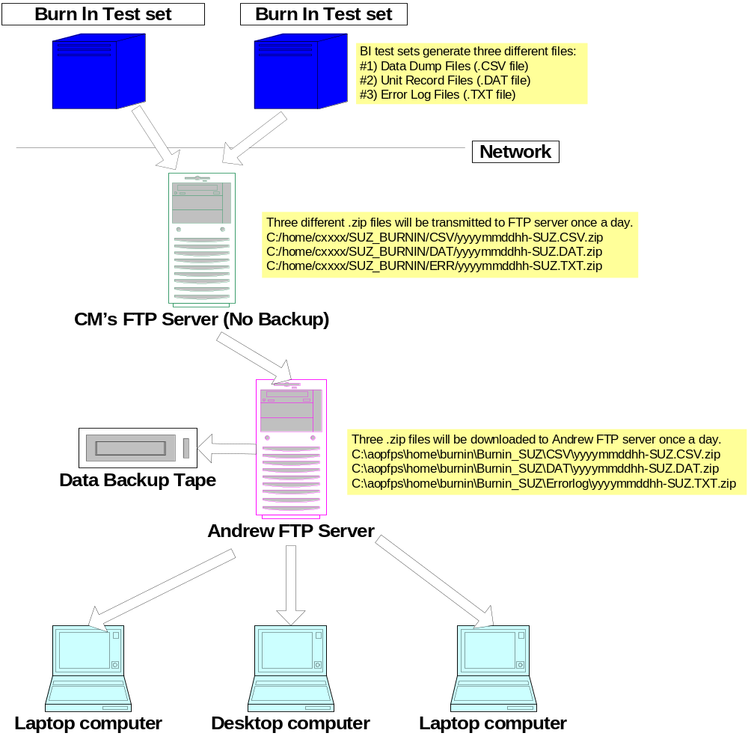

File Description
4.2.1 Data Dump File
The data dump file is a comma-separated variable file containing all data gathered from a Unit Under Test (UUT) data poll. The file may contain UUT alarm information, UUT temperature, UUT DC current drew, DC voltage, total DC current delivered, external thermocouple and RF power meter measurements. The header in the data dump file contains the test start time, UUT type, test software version, test set ID, MTR version, unit serial number, and populated slots. The exact format of the record fields is product-specific. One data dump file is generated from each BI cycle. The file typically contains 1000 records, and may contain up to 3000+ records. The size of a file is usually 250KB. BI test engineer will need data dump files to give insight into BI failures and quality engineers will need data dump files to examine the overall BI process. The BI test software will generate a unique name for each data dump file. Examples of data dump file name are:
TAZ_48_DD20041229_1355.csv
C2PAM_010705_0648.csv
pkLAMList7_PKLAML7_DD_010505_1610.csv
CM does not need to care about the name of each data dump file. All the .csv files on each BI test set will be collected once a day to generate a .zip file. The naming conversion for the .zip file will be: yyyymmddhh-SUZ.CSV
- ‘yyyy’ refers to 4-digit year
- ‘mm’ refers to 2-digit month
- ‘dd’ refers to 2-digit day
- ‘hh’ refers to 2-digit hour
- ‘SUZ’ refers to data location
‘SUZ’ for SuZhou, China. ‘CIT’ for Vimercate, Italy. ‘AFAI’ for Agrate, Italy. ‘TOR’ for Toronto, Canada. ‘AWNJ’ for New Jersey, US. ‘ACOH’ for Andrew, Ohio, US. ‘ATBF’ for Telia, France.
A sample data dump file is shown as follows:
Time Start: 01/09/2005 22:19:49
Rack 1
1: ANDWCS00D5VN,PA: MCPA 2100 30/45W UMTS
2: ANDWCS00CXFN,PA: MCPA 2100 30/45W UMTS
3: ANDWCS00CP7N,PA: MCPA 2100 30/45W UMTS
4: ANDWCS00D51N,PA: MCPA 2100 30/45W UMTS
5: ANDWCS00D61N,PA: MCPA 2100 30/45W UMTS
6: ,
7: ANDWCS00CXNN,PA: MCPA 2100 30/45W UMTS
8: ,
9: ANDWCS00CRRN,PA: MCPA 2100 30/45W UMTS
10: ,
11: ,
12: ,

Seconds, Phase , Temp_1, Maj_1, Min_1, Pout_1, Temp_2, Maj_2, Min_2, Pout_2, Temp_3, Maj_3, Min_3, Pout_3, Temp_4, Maj_4, Min_4, Pout_4, Temp_5, Maj_5, Min_5, Pout_5, Temp_6, Maj_6, Min_6, Pout_6, Temp_7, Maj_7, Min_7, Pout_7, Temp_8, Maj_8, Min_8, Pout_8, Temp_9, Maj_9, Min_9, Pout_9, Temp_10, Maj_10, Min_10, Pout_10, Temp_11, Maj_11, Min_11, Pout_11, Temp_12, Maj_12, Min_12, Pout_12, DC, IoutPS_0
140,Up_85,39,0,90,43.4,38,0,90,43.6,37,0,90,44.8,39,0,90,43.5,35,0,90,43.1, , , , ,34,0,90,43.4, , , , ,32,0,90,43.5, , , , , , , , , , , , ,46 ,41.056
167,Up_85,40,0,0,43.5,40,0,0,43.8,38,0,80,44.8,40,0,0,43.6,36,0,80,43.3, , , , ,35,0,90,43.4, , , , ,34,0,90,43.5, , , , , , , , , , , , ,46 ,41.005
194,Up_85,42,0,0,43.6,41,0,0,43.8,40,0,80,44.6,42,0,0,43.6,38,0,0,43.3, , , , ,37,0,0,43.5, , , , ,36,0,0,43.5, , , , , , , , , , , , ,46 ,40.781
221,Up_85,43,0,0,43.6,43,0,0,43.8,42,0,80,44.6,43,0,0,43.8,40,0,0,43.4, , , , ,39,0,0,43.6, , , , ,38,0,0,43.6, , , , , , , , , , , , ,46 ,40.624
248,Up_85,44,0,0,43.8,44,0,0,43.8,43,0,80,44.5,45,0,0,43.8,41,0,0,43.5, , , , ,40,0,0,43.5, , , , ,40,0,0,43.8, , , , , , , , , , , , ,46 ,40.378

4.2.2 Unit Record File
The unit record files contain data specific to a UUT. The file contains only the information pertaining to the unit in question. The unit record file contains a header describing the UUT Type, unit serial number, test start time, test status (pass/fail), and the populated slots. Up to twelve Unit Record files may be generated from each BI cycle. The file usually contains 1000 records, and may contain up to 3000+ records. A typical file is 100KB. The Burn In test engineer will look into the file to examine the problems for a particular UUT.
The BI test software will generate a unique name for each unit record file. Examples of unit record file name are:
TAZ_48_ANDWCS00D8YN_20041228_0638.dat
ULAM_04BG73120031_20041227_1059.dat
pkLAMList7_PKLAML7_05BG21080955_20050112_1610_20050113_0816.dat
CM does not need to care about the name of each unit record file. All the .dat files on each BI test set will be collected once a day to generate a .zip file. The naming conversion for the .zip file will be: yyyymmddhh-SUZ.DAT
A sample unit record file is shown as follows:
KLAM1900L Burn In Test Summary
Slot: 3
BarCode: 05BG21080525
Test Start: 01/12/2005 22:55:12
Status: PASS
Date Time Secs Curr TS0 TS1 TS2 TS3 TS4 TS5 Alarm Stat DC Phase
01/12/2005 22:56:29 77 25.0 30 30 31 30 31 NONE 18 28 Startup
01/12/2005 23:09:08 836 25.0 30 29 30 30 31 NONE 98 28 Up_75
01/12/2005 23:09:35 863 25.0 31 30 32 30 31 NONE 90 28 Up_75
01/12/2005 23:10:03 891 25.0 32 32 34 31 32 NONE 90 28 Up_75
01/12/2005 23:10:32 920 25.0 34 34 36 32 33 NONE 90 28 Up_75
01/12/2005 23:11:01 949 25.0 35 36 38 33 34 NONE 90 28 Up_75
01/12/2005 23:11:29 977 25.0 36 38 40 34 35 NONE 90 28 Up_75
01/12/2005 23:11:58 1006 25.0 38 39 42 36 36 NONE 90 28 Up_75
01/12/2005 23:12:26 1034 25.0 39 41 43 37 37 NONE 90 28 Up_75
01/12/2005 23:12:55 1063 25.0 40 42 45 38 38 NONE 90 28 Up_75
01/12/2005 23:13:24 1092 25.0 41 44 46 39 39 NONE 90 28 Up_75
01/12/2005 23:13:52 1120 25.0 42 45 48 41 40 NONE 90 28 Up_75
01/12/2005 23:14:21 1149 25.0 44 46 49 42 41 NONE 90 28 Up_75
01/12/2005 23:14:49 1177 25.0 45 48 50 43 42 NONE 90 28 Up_75

4.2.3 Error Log File
The BI test software maintains a log of all errors encountered during the BI process. The BI software appends entries to the error log file as needed. An entry is made into this file when the following conditions are encountered:
- AC power supply failure
- UUT data communications failure
- BI test set sanity check
- BI cycle start
- BI cycle end
- Software run time errors
- Some operating sanity errors
When many errors happen during BI test, the size of the error log file becomes larger. Burn In test engineer will look into the file to examine the problems for BI test sets.
The BI test software will generate a unique error log file name for each BI test set. Examples of error log file names are:
TAZ_48_ERR20041228_0638.txt
C2PAM_ERR20041227_1059.txt
CM does not need to care about the name of each error log file. All the .txt files will be collected once per day to generate a .zip file. The naming conversion for the .zip file will be: yyyymmddhh-SUZ.TXT
A sample error log file is shown as follows:
01/07/2005 06:34:36 Burn In Set Verification
SID: 44085-2.22 Time: 01/07/2005 06:34:28

Verify 24V Supply OK 23.934 EXPECTED: 24.000
Verify 15V Supply OK 15.055 EXPECTED: 14.500
Verify 5V Supply OFF OK 0.506 EXPECTED: 0.490
Verify 5V Supply ON OK 5.010 EXPECTED: 5.000
Verify 880MHz Voltage OK 2.648 EXPECTED: 2.630
Verify 1950MHz Voltage OK 3.038 EXPECTED: 3.070
Verify 2150MHz Voltage OK 0.165 EXPECTED: 0.130
Verify RF OFF Voltage OK 0.165 EXPECTED: 0.490

01/07/2005 06:36:01 Start New Test at 1/7/2005 6:36:01 AM
SW_Rev: 2.4.39
glo.Abort=False
01/07/2005 06:36:14 Burn In Set Verification
SID: 44085-2.22 Time: 01/07/2005 06:36:06

Verify 24V Supply OK 23.933 EXPECTED: 24.000
Verify 15V Supply OK 15.054 EXPECTED: 14.500
Verify 5V Supply OFF OK 0.515 EXPECTED: 0.490
Verify 5V Supply ON OK 5.010 EXPECTED: 5.000

CM’s FTP Server
All three kinds of .zip files (.CSV.zip file, .DAT.zip file, and .TXT.zip file) will be transmitted to three related directory on CM’s FTP server once per day. For example:
All yyyymmddhh-SUZ.CSV.zip files go to C:/home/c1797/SUZ_BURNIN/CSV
All yyyymmddhh-SUZ.DAT.zip files go to C:/home/c1797/SUZ_BURNIN/DAT
All yyyymmddhh-SUZ.TXT.zip files go to C:/home/c1797/SUZ_BURNIN/ERR
CM is free to decide the name for the second level directory such as “c1797”, but needs to keep consistency for naming the third and the fourth level directory. Examples for data coming from Italy are:
All yyyymmddhh-CIT.CSV.zip go to C:/home/cxxxx/ITALY_BURNIN/CSV
All yyyymmddhh-CIT.DAT.zip go to C:/home/cxxxx/ITALY_BURNIN/DAT
All yyyymmddhh-CIT.TXT.zip go to C:/home/cxxxx/ITALY_BURNIN/ERR
There is no data backup for all three kinds of files described in the above on CM’s FTP server. Once the size of the directory is full, the oldest files will be deleted first. So the latest files will always be kept on the FTP server for some time (at least two weeks).

Andrew FTP Server
The Andrew FTP server is located in AOP and the server name is AOPFS1. A DFS shared folder named “Burnin” will be setup first. The sub-folders under this share to accommodate the other entities such as “Burnin-SUZ” or “Burnin-CIT” will be created afterwards. This shared folder will allow the users access the data without the need to enter the login name as well as the password. Users can access the data by clicking the following link:
<\\aopfps\home\burnin <file:///\\aopfps\home\burnin>>
Or go to Start → Run and type "\\aopfps\home\burnin <file:///\\aopfps\home\burnin>"
There will be a nightly backup to tape for this AOPFS1 file server. The backup tapes will be recycled after one year.
The zipped BI files will simply be downloaded from CM’s FTP server to AOPFS1 sever once per day. Files will be located to the related sub-folders. For example:

All yyyymmddhh-SUZ.CSV.zip files go to C:\aopfps\home\Burnin\Burnin-SUZ\CSV
All yyyymmddhh-SUZ.TXT.zip files go to C:\aopfps\home\Burnin\Burnin-SUZ\Errorlog
All yyyymmddhh-CIT.DAT.zip files go to C:\aopfps\home\Burnin\Burnin-CIT\DAT

