**Assignment Title:** Saibai Island and Climate-Adaptive Food Systems: Continuity and Cultural Change

**Student name:** Getao Liu  
**Student number:** 14560066  
**Tutorial Class:** Thursday 6-9 pm **Project opportunity :** Climate-adaptive - food systems - cultural context of the commmunity

**Introduction**

Saibai Island, located in the Torres Strait, faces increasing threats from climate change, including rising sea levels, coastal erosion, and saltwater intrusion. These environmental changes are impacting not only the natural landscape but also the cultural fabric of the community. On Saibai Island, food, land, and traditional culture are closely linked. As the island faces environmental changes, the question of preserving traditional culture and transitioning it to a new one arises.

**Cultural Significance of Food in the Community**

Food occupies a central place in Saibai Island's cultural identity, connecting local people to their land, history, and traditions. For generations, the Koeybuway and Moegibuway peoples have lived in village communities "following traditional patterns of hunting, fishing, agriculture, and trade" (Queensland Government, n.d., para. 2). These traditional ways of living emphasize that food is more than just about survival. It holds social and spiritual significance, strengthening kinship and fostering a sense of community and cultural norm. The deep relationship between food and land has also been marked by episodes of disruption. In 1948, for example, Saibai experienced severe tidal inundation that forced part of the community to relocate to what is now Seisia and Bamaga, leaving a lasting imprint on cultural memory. As Green and Warusam (2010, p. 1) note, “this issue is especially important for Saibai because the community has already had one movement of people from the island … in response to previous high tides in 1948.” This history shows that the impact of environmental change on food is not only a physical challenge but also a cultural challenge that shapes the community’s understanding of identity and belonging.

**Cultural Continuity Enabled by Adaptive Food Systems**

Saibai Island's cultural continuity is closely tied to people remaining in their homeland and maintaining the transmission of ancestral culture. The Coastal Disaster Adaptation Strategy emphasizes the community's determination to stay, stating that "local communities and councillors have been actively involved in shaping this strategy, expressing their deep desire to remain in their homeland and maintain the connection to Country and ancestors. Continued cultural adaptation cannot occur unless the people are in their own Country" (Torres Strait Island Regional Council [TSIRC], 2024, p. 3). Living in Saibai is not only a practical necessity for people but also a cultural one. As the Torres Strait Regional Authority explains, "living on country provides enduring connection and the ability to continue managing land and sea country in line with unbroken traditions and customs" (TSRA, n.d., para. 4). These perspectives suggest that only by remaining on the island can Saibai Island's culture remain strong, where food, land, and traditional culture shape people's daily lives.

**Cultural Transformation and Emerging Tensions**

While Saibai's food system has long maintained its unique cultural identity, climate change pressures could alter these traditions. Sea-level rise, erosion, and shifting seasonal cycles are altering and threatening local food production practices, undermining the ability of local people to rely on both land and sea for cultural nourishment. The Torres Strait Regional Authority notes that "we are already seeing changes in sea levels, coastal erosion, shifts in seasonality of weather patterns, and impacts on our sea country. These trends… have the potential to cause significant disruptions to our wellbeing, culture, and environment" (TSRA, 2016, p. i). This means that the production and preparation of food, once a cultural expression and a social bond, may be forced to change. Younger generations may become more reliant on imported goods or modern systems, potentially diminishing the role of traditional ecological knowledge and weakening cultural connections between land and sea. These phenomena suggest that the transformation of Saibai's food system is also a cultural shift, reshaping the social landscape of Saibai's residents and challenging the continuity of their long-standing traditions.

**Conclusion**

The cultural impacts of climate change on Saibai Island are inextricably linked to its food system. Traditional hunting, fishing, and agricultural practices have long formed the foundation of identity and community life. Maintaining the island's food system allows people to maintain connections to their ancestors, the land, and traditional culture, thereby ensuring cultural continuity even under external pressures. At the same time, the food impacts of environmental change are reshaping how food is produced and consumed, creating uncertainty and cultural tensions. Dependence on imported goods or modern systems could gradually erode traditional knowledge and alter how culture is expressed through food. Ultimately, the transformation of Saibai's food system reflects the cultural transformation of Saibai Island. The future cultural resilience of Saibai depends on how the community maintains its food and cultural traditions in the face of climate challenges.

**References**

Green, D., & Warusam, P. (2010). Building resilience to climate change impacts on Saibai, Torres Strait. National Climate Change Adaptation Research Facility (NCCARF).

Torres Strait Island Regional Council (TSIRC). (2024). Zenadth Kes Coastal Hazard Adaptation Strategy. TSIRC.

Torres Strait Regional Authority (TSRA). (2016). Torres Strait Regional Adaptation and Resilience Plan 2016–2021. TSRA.

Queensland Government. (n.d.). Community histories – Saibai. First Nations, Queensland Government. Retrieved August 29, 2025, from [https://www.qld.gov.au/firstnations/cultural-awareness-heritage-arts/community-histories/community-histories-s-t/community-histories-saibai](https://www.qld.gov.au/firstnations/cultural-awareness-heritage-arts/community-histories/community-histories-s-t/community-histories-saibai?utm_source=chatgpt.com" \t "C:\\Users\\MEOWCO~1\\AppData\\Local\\Temp\_new)

Torres Strait Regional Authority (TSRA). (n.d.). Sustainable human settlements. Torres Strait State of the Environment. Retrieved August 29, 2025, from [https://torresstraitsoe.org.au/land/sustainable-human-settlements/](https://torresstraitsoe.org.au/land/sustainable-human-settlements/?utm_source=chatgpt.com" \t "C:\\Users\\MEOWCO~1\\AppData\\Local\\Temp\_new)

**Appendix 1: Sources**

EWB Challenge

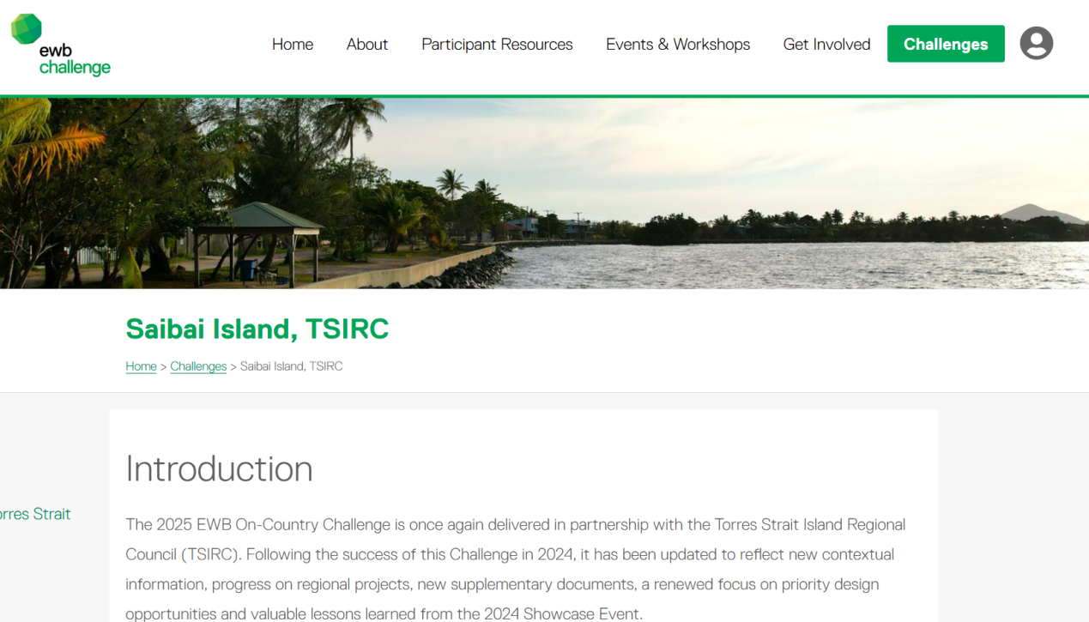

Green & Warusam (2010), “Building resilience to climate change impacts on Saibai, Torres Strait”

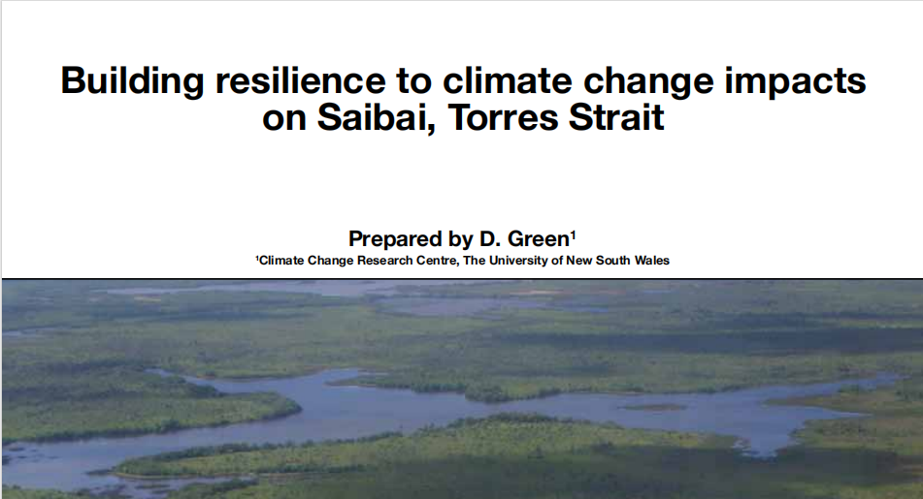

Queensland Government

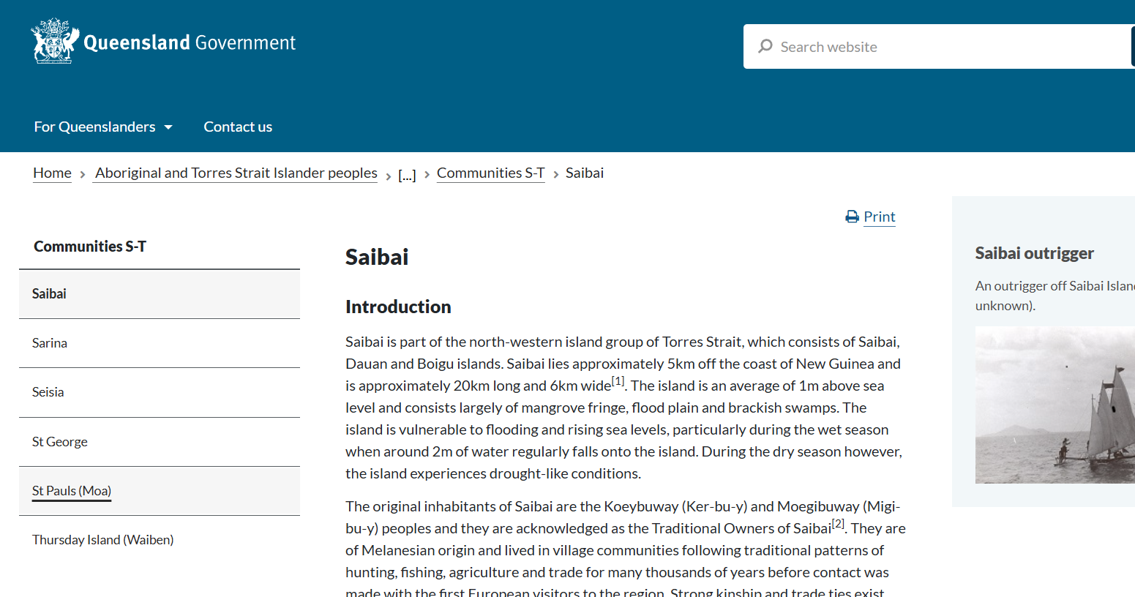

Torres Strait Island Regional Council (2024), “Zenadth Kes coastal hazard adaptationstrategy”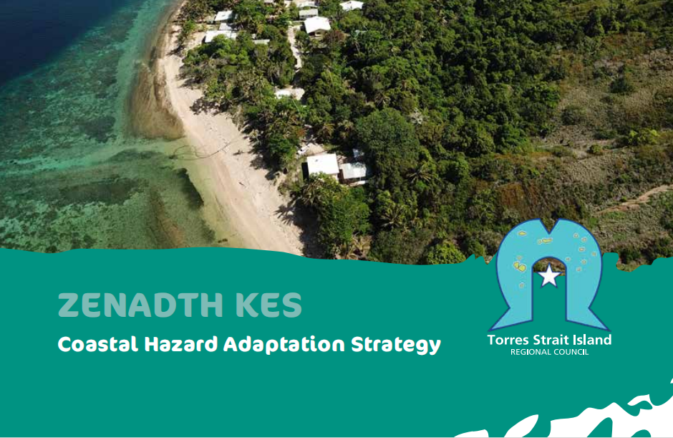

Torres Strait Regional Authority (2016), “Torres Strait regional adaptation and resilience plan 2016- 2021”

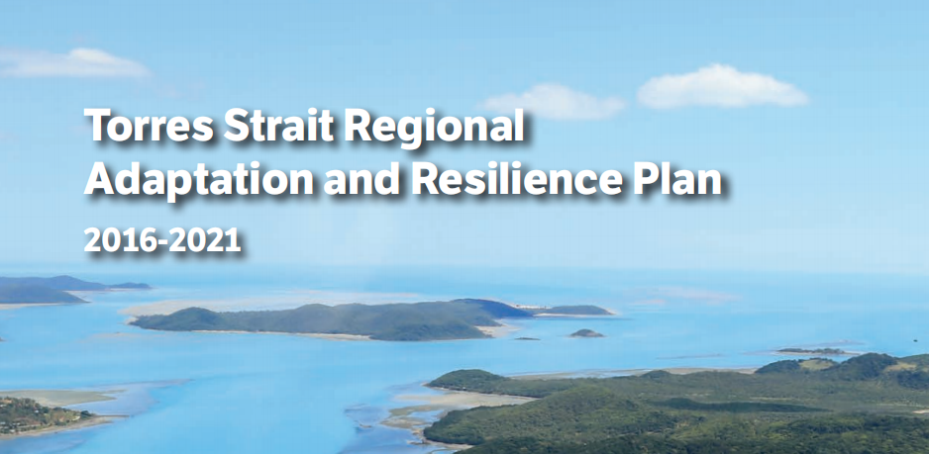

Sustainable human settlements

