**Assignment Title： The impact of the environment on the climate-adapted agricultural system of Saibai Island.**

**Student name: Kaiyang Sun**

**Student number：14547677**

**5.4 Climate-adaptive food systems**

The agricultural system on Saibai Island is vulnerable and highly dependent on imports, making it susceptible to disruptions in the supply chain. An agricultural system adapted to climate change can enhance local food supply, ensure food security, lower food prices, and provide fresh produce to local residents.

**Overview of Saibai Island**

Saibai Island is a large island with a relatively low average altitude in the northwest of the Torres Strait. It covers an area of approximately 108 square kilometers and is located only about 4 kilometers south of Papua New Guinea and about 150 kilometers north of the Australian mainland. The terrain is flat, dominated by mangroves, with the highest point at 1.7 meters. During the rainy season, it is prone to flooding (EWB Challenge 2025). The periphery of the island is covered with mangroves, and there are salt marshes within the island with less vegetation. (Torres Strait Island Regional Council, 2024, p. 146) Saibai Island is a mudflat island formed by sedimentation. Its main vegetation types include open woodlands, grasslands, and wetlands, with large areas of marshes where the water is slightly salty. (eAtlas, 2016/2024)

Saibai is mainly an indigenous community. According to the 2021 census, there were 338 people, but locals estimate that there are around 500 people who have a deep cultural connection with this land. Historically, fishing and agriculture have been crucial to the lives of the Saibai people. The residents have developed sustainable practices in line with cultural values - traditional horticulture and fishing have supported the self-sufficiency of generations. However, nowadays, the changing environment poses significant challenges to local food production (EWB Challenge 2025).

**The climate of Saibai Island**

Saibai Island has a tropical climate that is hot and humid, with a distinct monsoon pattern. The rainy season lasts from October to April of the following year, accounting for about 95% of the annual precipitation. The dry season, from May to September, sees less rainfall. (Time and Date, n.d.) This precipitation pattern means that Saibai Island experiences abundant rainfall during the rainy season, which may even lead to flooding, while the long dry season is relatively water-scarce.

**The impact of climate change on Saibai Island**

The rising sea level and more extreme weather have led to frequent flooding on Saibai Island, putting it at risk of being submerged by floods. Climate change in the Torres Strait will result in higher temperatures and more heavy rain. More heavy rain means that the probability of floods occurring in January and February may increase significantly, while higher temperatures may lead to the emergence of heatwaves, which will greatly endanger the health of the elderly. Although there may be more heavy rain, the total precipitation is expected to decrease because there may be less rainfall during the dry season. (Green & Warusam, 2010, p. 7)

As the frequency and intensity of storms increase, along with the rise in sea levels, the impact of storm surges will also grow and may affect more areas. (Torres Strait Island Regional Council, 2024, p. 19)

**The main disasters on Saibai Island**

Tidal flooding and storm surge flooding are the main natural disasters currently faced by Saibai Island. (Torres Strait Island Regional Council, 2024, p. 147) Among them, storm surge flooding is a natural disaster formed by the combined effect of ordinary tides, storm surges and waves. (Torres Strait Island Regional Council, 2024, p. 19) Tidal flooding, on the other hand, is mainly caused by periodic floods due to astronomical tides. With the continuous rise in sea level, the area submerged by seawater is expected to increase. (Torres Strait Island Regional Council, 2024, p. 16) Among them, the high tide that is much higher than the average height is called "King tides", which usually occur around Christmas.

**Conclusion**

The precipitation on Saibai Island is uneven throughout the seasons. The island is at a relatively low altitude, making it prone to floods during the rainy season and susceptible to the influence of high tides. Saibai Island is a mud island formed by sedimentation. It is home to mangroves and swamps, and the water in the swamps is slightly salty.

**Reference**

**eAtlas. (2016, February 17; updated 2024, December). *Saibai: Land and sea profile* [PDF]. Australian Institute of Marine Science. Retrieved August 28, 2025, from** [**https://eatlas.org.au/sites/default/files/2024-12/Saibai%20Land%20and%20Sea%20Profile%2017-02-16.pdf**](https://eatlas.org.au/sites/default/files/2024-12/Saibai%20Land%20and%20Sea%20Profile%2017-02-16.pdf?utm_source=chatgpt.com)

**Engineers Without Borders Australia. (2025). *Saibai Island, TSIRC* [Webpage]. EWB Challenge.** [**https://ewbchallenge.org/challenge/saibai-island-tsirc/**](https://ewbchallenge.org/challenge/saibai-island-tsirc/?utm_source=chatgpt.com)

**Green, D., & Warusam, H. (2010). *Building resilience to climate change impacts on Saibai, Torres Strait*. Report to the Marine and Tropical Sciences Research Facility. Reef and Rainforest Research Centre Limited.**

**Maritime Safety Queensland. (2025). *King tides*.** [**https://www.msq.qld.gov.au/tides/king-tides**](https://www.msq.qld.gov.au/tides/king-tides?utm_source=chatgpt.com)

**Time and Date. (n.d.). *Climate & weather averages in Saibai Island, Queensland, Australia*. Time and Date. Retrieved August 27, 2025, from** [**https://www.timeanddate.com/weather/%402101466/climate**](https://www.timeanddate.com/weather/%402101466/climate?utm_source=chatgpt.com)

**Torres Strait Island Regional Council. (2024). *Zenadth Kes coastal hazard adaptation strategy*. Torres Strait Island Regional Council.**

**Appendix 1: Sources**

***Saibai: Land and sea profile***

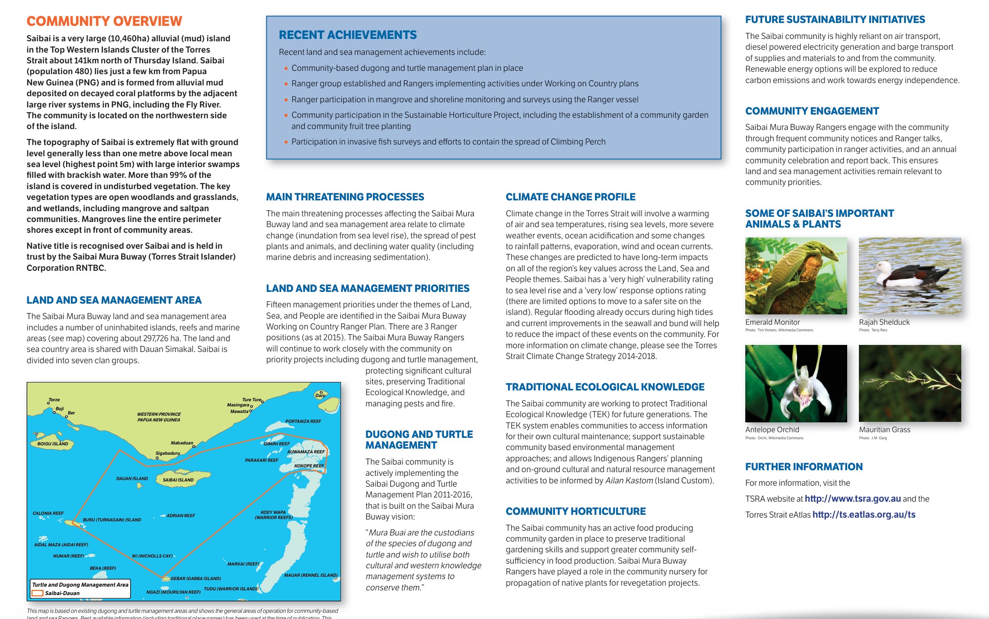

**Engineers Without Borders Australia.**

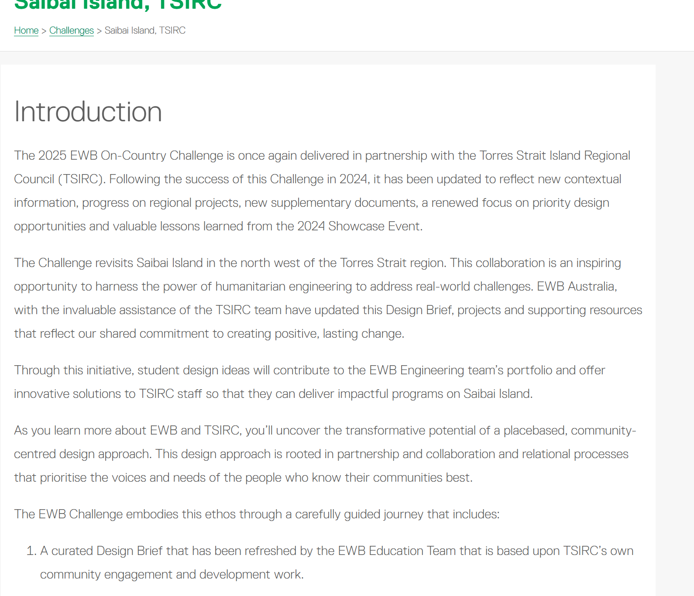

***Building resilience to climate change impacts on Saibai, Torres Strait*.**

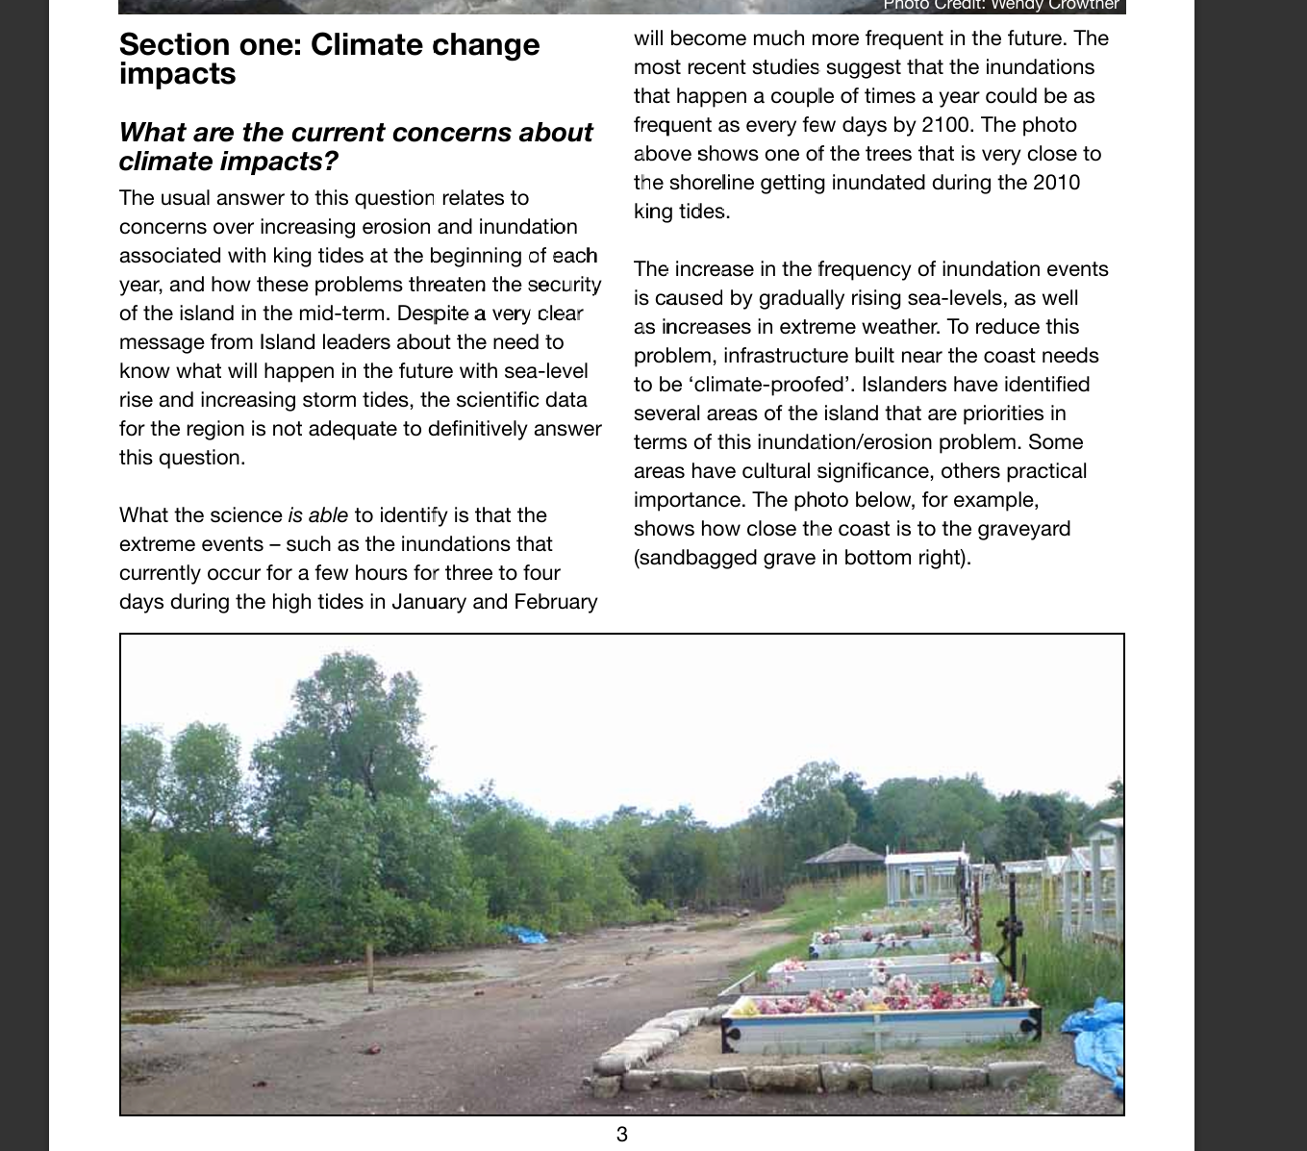

**Maritime Safety Queensland. (2025). *King tides*.**

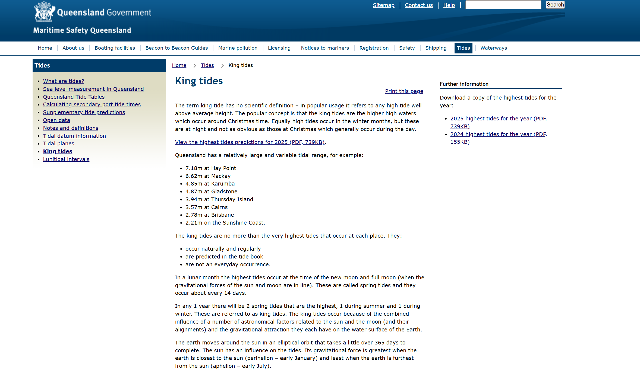

**Time and Date.**

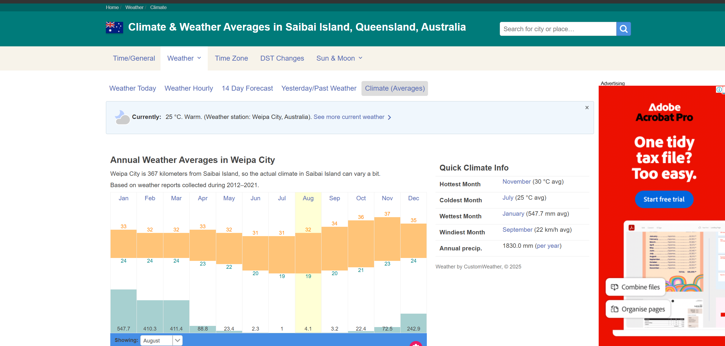

**Torres Strait Island Regional Council.**

