读取电子秤称重记录

添加C++依赖库
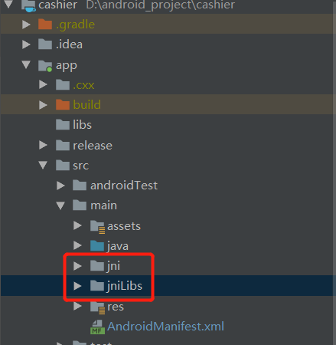

添加串口操作工具类
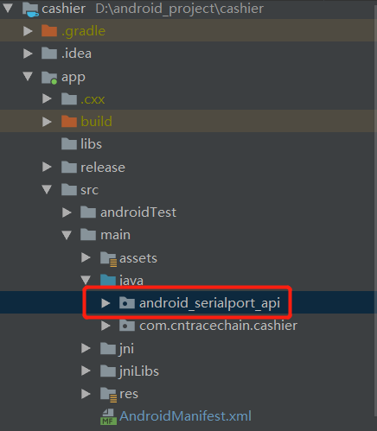

示例代码
/*
* 打开串口，返回文件输入输出流
* */
SerialPort sp = null;
try {
sp=new SerialPort(new File("/dev/ttyS3"),9600,0);
} catch (IOException e) {
e.printStackTrace();
}
//初始化串口输入流，用于读取重量数据
mInputStream= (FileInputStream) sp.getInputStream();
//启动线程监听重量数据
new ReadThread().start();

/**
* 开启线程监听称重数据
*/
private class ReadThread extends Thread {
@Override
public void run() {
while (true) {
int size;
try {
if (mInputStream == null)
return;
byte[] buffer = new byte[18];
size = mInputStream.read(buffer);
if (size > 0) {
if (current_product_id == 0)
continue;
onDataReceived(buffer,size);
}
Thread.sleep(10);
} catch (Exception e) {
e.printStackTrace();
return;
}
}
}
}

/**
* 处理接收到的电子秤数据
* @param buffer
* @param size
*/
void onDataReceived(final byte[] buffer,final int size){
runOnUiThread(new Runnable() {
@Override
public void run() {
//result为接收到的电子秤数据，具体返回的格式请自行参考沃立定制主板使用说明书(2019-07)(1)进行设置
String result = new String(buffer,0,size);
}
});
}

打印电子小票

引入标准打印模块
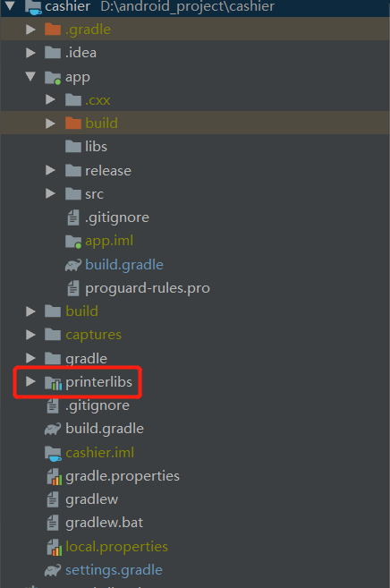

示例代码
/**
* 打开打印小票的USB端口
*/
private void openUsb() {
String[] devicePaths = printerlibs_caysnpos.CaysnPos_EnumUsbVidPid_Helper.CaysnPos_EnumUsbVidPidA();
if (devicePaths != null) {
pointer = printerlibs_caysnpos.INSTANCE.CaysnPos_OpenUsbVidPidStringA(devicePaths[0]);
}
}

/**
* 打印小票
* @param
*/
private void printSmallTicket(Pointer h) {
int paperWidth = 384;
printerlibs_caysnpos.INSTANCE.CaysnPos_ResetPrinter(h);
printerlibs_caysnpos.INSTANCE.CaysnPos_SetMultiByteMode(h);
printerlibs_caysnpos.INSTANCE.CaysnPos_SetMultiByteEncoding(h, printerlibs_caysnpos.MultiByteModeEncoding_UTF8);
//系统当前时间
Calendar now = Calendar.getInstance(TimeZone.getTimeZone("GMT+8:00"));
int year = now.get(Calendar.YEAR);
int month = now.get(Calendar.MONTH) + 1; // Note: zero based!
int day = now.get(Calendar.DAY_OF_MONTH);
int hour = now.get(Calendar.HOUR_OF_DAY);
int minute = now.get(Calendar.MINUTE);
int second = now.get(Calendar.SECOND);
printerlibs_caysnpos.INSTANCE.CaysnPos_SetAlignment(h, printerlibs_caysnpos.PosAlignment_HCenter);
printerlibs_caysnpos.INSTANCE.CaysnPos_FeedLine(h, 1);
printerlibs_caysnpos.INSTANCE.CaysnPos_PrintTextInUTF8W(h, new WString("中追溯源电子收银系统"));
printerlibs_caysnpos.INSTANCE.CaysnPos_FeedLine(h, 1);
printerlibs_caysnpos.INSTANCE.CaysnPos_SetAlignment(h, printerlibs_caysnpos.PosAlignment_HCenter);
printerlibs_caysnpos.INSTANCE.CaysnPos_PrintTextA(h, String.format(DATE_FORMAT, year,month,day,hour,minute,second));
printerlibs_caysnpos.INSTANCE.CaysnPos_FeedLine(h, 1);
printerlibs_caysnpos.INSTANCE.CaysnPos_FeedLine(h, 1);
printerlibs_caysnpos.INSTANCE.CaysnPos_PrintTextInUTF8W(h, new WString("商品"));
printerlibs_caysnpos.INSTANCE.CaysnPos_SetHorizontalAbsolutePrintPosition(h, paperWidth - 12*24);
printerlibs_caysnpos.INSTANCE.CaysnPos_PrintTextInUTF8W(h, new WString("单价"));
printerlibs_caysnpos.INSTANCE.CaysnPos_SetHorizontalAbsolutePrintPosition(h, paperWidth - 12*14);
printerlibs_caysnpos.INSTANCE.CaysnPos_PrintTextInUTF8W(h, new WString("重量"));
printerlibs_caysnpos.INSTANCE.CaysnPos_SetHorizontalAbsolutePrintPosition(h, paperWidth - 12*6);
printerlibs_caysnpos.INSTANCE.CaysnPos_PrintTextInUTF8W(h, new WString("小计"));
printerlibs_caysnpos.INSTANCE.CaysnPos_FeedLine(h, 1);
List<TradeItem> tradeItems = trade.getTradeItems();
for (int i = 0 ; i < tradeItems.size() ; i++) {
TradeItem tradeItem = tradeItems.get(i);
printerlibs_caysnpos.INSTANCE.CaysnPos_PrintTextInUTF8W(h, new WString(tradeItem.getName()));
printerlibs_caysnpos.INSTANCE.CaysnPos_SetHorizontalAbsolutePrintPosition(h, paperWidth - 12*23);
printerlibs_caysnpos.INSTANCE.CaysnPos_PrintTextInUTF8W(h, new WString("¥" + tradeItem.getPrice()));
printerlibs_caysnpos.INSTANCE.CaysnPos_SetHorizontalAbsolutePrintPosition(h, paperWidth - 12*18);
printerlibs_caysnpos.INSTANCE.CaysnPos_PrintTextInUTF8W(h, new WString(tradeItem.getWeight() + "KG"));
printerlibs_caysnpos.INSTANCE.CaysnPos_SetHorizontalAbsolutePrintPosition(h, paperWidth - 12*6);
printerlibs_caysnpos.INSTANCE.CaysnPos_PrintTextInUTF8W(h, new WString("¥" + tradeItem.getTotal()));
printerlibs_caysnpos.INSTANCE.CaysnPos_FeedLine(h, 1);
}
printerlibs_caysnpos.INSTANCE.CaysnPos_FeedLine(h, 1);
String line = "";
for (int i = 0; i < paperWidth / 12; ++i)
line += " ";
printerlibs_caysnpos.INSTANCE.CaysnPos_SetTextUnderline(h, printerlibs_caysnpos.TextUnderline_Two);
printerlibs_caysnpos.INSTANCE.CaysnPos_PrintTextA(h, line);
printerlibs_caysnpos.INSTANCE.CaysnPos_SetTextUnderline(h, printerlibs_caysnpos.TextUnderline_None);
printerlibs_caysnpos.INSTANCE.CaysnPos_FeedLine(h, 1);
printerlibs_caysnpos.INSTANCE.CaysnPos_SetTextScale(h, 1, 0);
printerlibs_caysnpos.INSTANCE.CaysnPos_PrintTextInUTF8W(h, new WString("合计"));
printerlibs_caysnpos.INSTANCE.CaysnPos_SetHorizontalAbsolutePrintPosition(h, paperWidth - 12*2*7);
printerlibs_caysnpos.INSTANCE.CaysnPos_PrintTextInUTF8W(h, new WString("¥" + total));
printerlibs_caysnpos.INSTANCE.CaysnPos_SetTextScale(h, 0, 0);
printerlibs_caysnpos.INSTANCE.CaysnPos_FeedLine(h, 1);
printerlibs_caysnpos.INSTANCE.CaysnPos_PrintTextInUTF8W(h, new WString("温馨提示：扫描下方二维码获取食材追溯信息"));
printerlibs_caysnpos.INSTANCE.CaysnPos_FeedLine(h, 1);
//打印二维码
printerlibs_caysnpos.INSTANCE.CaysnPos_SetBarcodeUnitWidth(h, 8);
printerlibs_caysnpos.INSTANCE.CaysnPos_PrintQRCodeA(h, 0, printerlibs_caysnpos.QRCodeECC_L, "https://aaaa.cn/1960345");
int result = printerlibs_caysnpos.INSTANCE.CaysnPos_Beep(h, 1, 500);
}

