苏州大学实验报告
院、系 | 计算机科学与技术学院 |  | 年级专业 |  | 19计算机科学与技术 |  | 姓名 | 徐唐昱 | 学号 | 1927405015
课程名称 |  | 操作系统课程实践 |  |  |  |  |  |  | 成绩
指导教师 |  | 王红玲 |  | 同组实验者 |  | 无 |  | 实验日期 | 2022/3/20

实 验 名 称 | Linux进程通信

- 实验目的
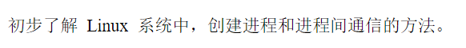
- 实验内容
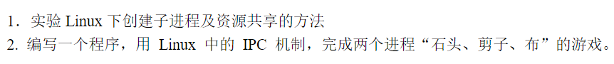

- 实验步骤
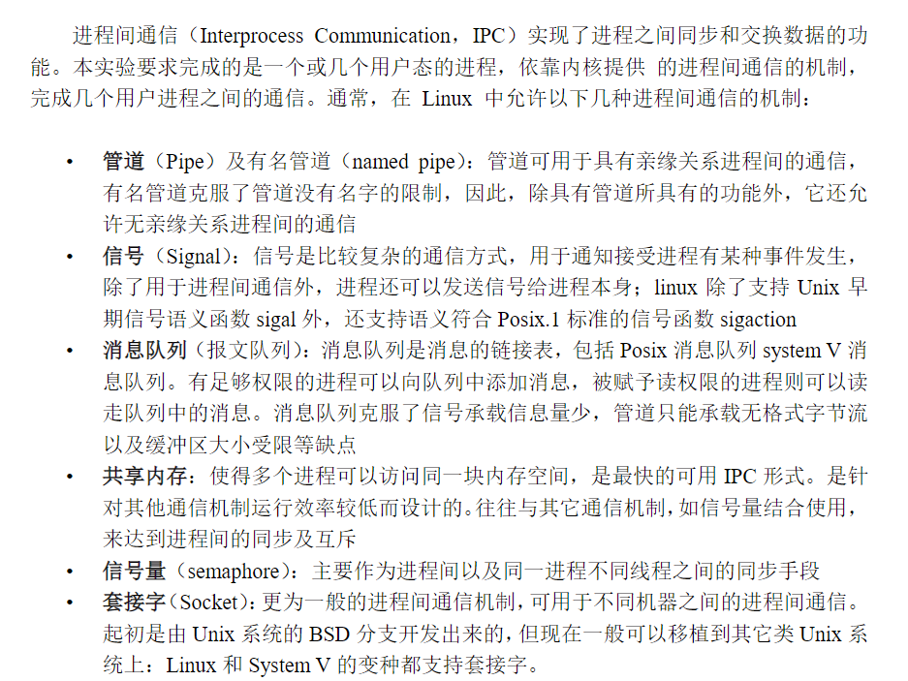
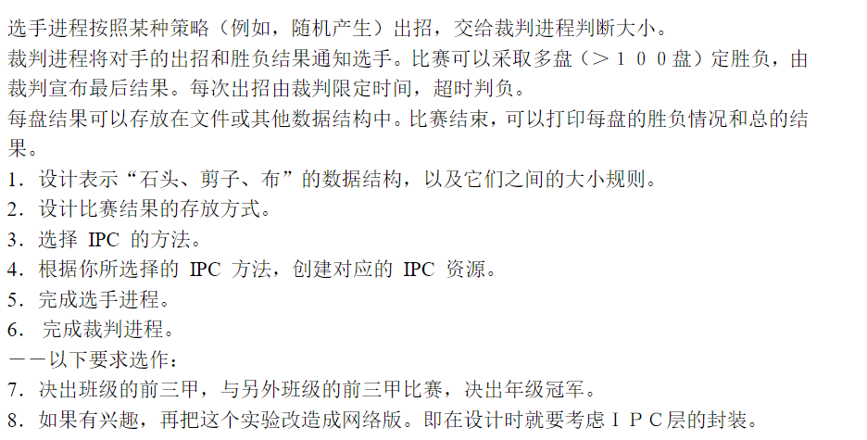
- 实验结果
  - 实验数据结构：
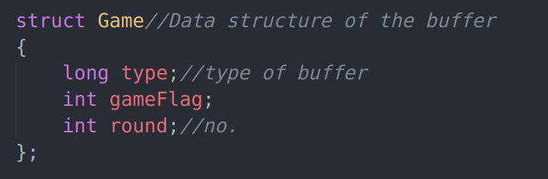
  - 实验大小规则&存放方式：
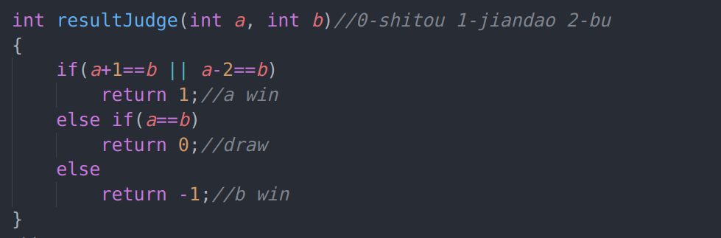
0代表石头，1代表剪刀，2代表布，因为石头克剪刀课布克石头，所以可以用上述判断语句来输出输赢结果。
结果存放在一个预定长度的整数数组里面，可以通过遍历数组来读取AB玩家输赢平局的次数，最终得出赢家是谁
  - 实验所选择的IPC 方法和理由：
消息队列，因为消息队列可以实现消息的随机查询，而且克服了管道只能承载无格式字节流及缓冲区大小受限等缺点。
  - 如果选择消息队列机制，描述消息缓冲区结构：
long类型的type变量代表缓冲区类型，gameFlag代表了游戏中玩家出的剪刀石头布，round代表当前回合数
  - 如何创建IPC 资源？
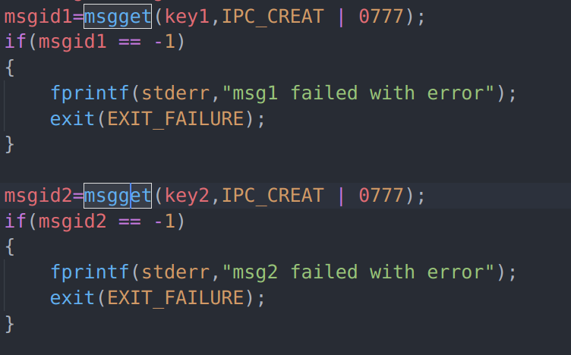
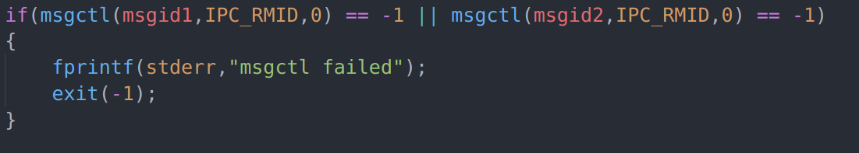
通过msgget函数创建消息队列，msgctl函数删除消息队列
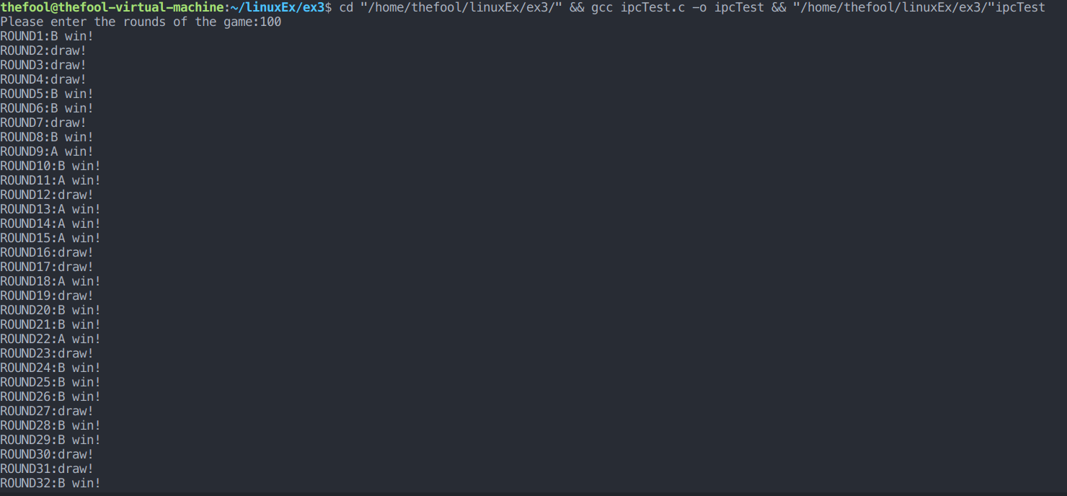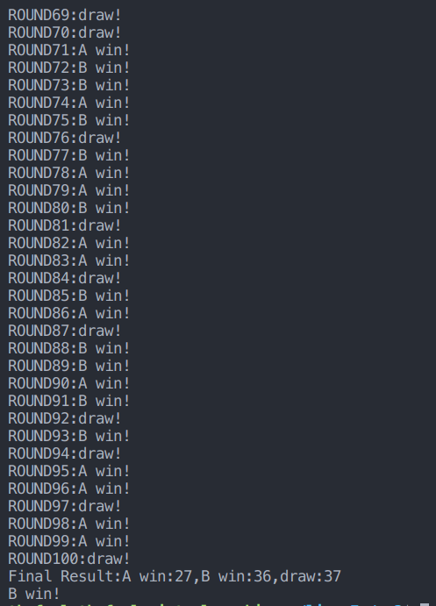
  - 程序主要流程或关键算法：
#include <time.h>
#include <sys/types.h>
#include <sys/wait.h>
#include <sys/ipc.h>
#include <sys/msg.h>
#include <stdio.h>
#include <stdlib.h>
#include <unistd.h>

struct Game//Data structure of the buffer
{
long type;//type of buffer
int gameFlag;
int round;//no.
};

void resultSend(int msgid, int round)
{
struct Game game;
game.type=1;//set the buffer type
game.gameFlag=rand()%3;
game.round=round;
msgsnd(msgid,&game,sizeof(game)-sizeof(long),0);
}

int resultJudge(int a, int b)//0-shitou 1-jiandao 2-bu
{
if(a+1==b || a-2==b)
return 1;//a win
else if(a==b)
return 0;//draw
else
return -1;//b win
}
//------------------------------------------------------------------------
void tongji(int *resultList,int times)
{
int aWin=0,bWin=0,draw=0;
FILE *fin;
if((fin = fopen("result.txt","w"))==NULL)
printf("Open Failed");
for(int i=1;i<=times;i++)
{
switch(resultList[i])
{
case 1:
{
aWin++;
fprintf(fin,"ROUND%d:A win!\n",i);
printf("ROUND%d:A win!\n",i);
break;
}
case 0:
{
draw++;
fprintf(fin,"ROUND%d:draw!\n",i);
printf("ROUND%d:draw!\n",i);
break;
}
case -1:
{
bWin++;
fprintf(fin,"ROUND%d:B win!\n",i);
printf("ROUND%d:B win!\n",i);
break;
}
}
}
printf("Final Result:A win:%d,B win:%d,draw:%d\n",aWin,bWin,draw);
if(aWin>bWin)
printf("A win!\n");
else if(aWin<bWin)
printf("B win!\n");
else
printf("A B draw!\n");
fclose(fin);
}
//------------------------------------------------------------------------
int main()
{
int times;
int key1=1111;
int key2=2222;
int *resultList;
pid_t pid1,pid2;
int msgid1,msgid2;
msgid1=msgget(key1,IPC_CREAT | 0777);
if(msgid1 == -1)
{
fprintf(stderr,"msg1 failed with error");
exit(EXIT_FAILURE);
}

msgid2=msgget(key2,IPC_CREAT | 0777);
if(msgid2 == -1)
{
fprintf(stderr,"msg2 failed with error");
exit(EXIT_FAILURE);
}

printf("Please enter the rounds of the game:");
scanf("%d",&times);
resultList=(int*)malloc(times*sizeof(int));
//----------------------------------------------------------------
for (int i=0;i<times;i++)//i represent round
{
clock_t start1,stop1,start2,stop2;
start1=clock();
pid1=fork();//A process
if(pid1 == 0)
{
srand((unsigned)time(0)*3000);
resultSend(msgid1,i);
exit(-1);
}
stop1=clock();

start2=clock();
pid2=fork();//B process
if(pid2 == 0)
{
srand((unsigned)time(NULL)*i);
resultSend(msgid2,i);
exit(-1);
}
stop2=clock();
int time1=(stop1-start1)/_SC_CLK_TCK;
int time2=(stop2-start2)/_SC_CLK_TCK;
int limit=4000;
//-----------------------------
if(pid1 < 0 || pid2 < 0)
{
fprintf(stderr,"Fork failed");
exit(-1);
}
//------------------------------
else
{
if(time1 < limit && time2 > limit)
{
wait(NULL);
wait(NULL);//judger wait for two players ending
struct Game game1;
struct Game game2;
msgrcv(msgid1,&game1,sizeof(game1)-sizeof(long),0,0);
msgrcv(msgid2,&game2,sizeof(game2)-sizeof(long),0,0);
resultList[i] = -1;
}
else if(time1 > limit && time2 < limit)
{
wait(NULL);
wait(NULL);//judger wait for two players ending
struct Game game1;
struct Game game2;
msgrcv(msgid1,&game1,sizeof(game1)-sizeof(long),0,0);
msgrcv(msgid2,&game2,sizeof(game2)-sizeof(long),0,0);
resultList[i] = 1;
}
else if(time1 > limit && time2 > limit)
{
wait(NULL);
wait(NULL);//judger wait for two players ending
struct Game game1;
struct Game game2;
msgrcv(msgid1,&game1,sizeof(game1)-sizeof(long),0,0);
msgrcv(msgid2,&game2,sizeof(game2)-sizeof(long),0,0);
resultList[i] = 0;
}
else
{
wait(NULL);
wait(NULL);//judger wait for two players ending
struct Game game1;
struct Game game2;
msgrcv(msgid1,&game1,sizeof(game1)-sizeof(long),0,0);
msgrcv(msgid2,&game2,sizeof(game2)-sizeof(long),0,0);
int score=resultJudge(game1.gameFlag,game2.gameFlag);
resultList[i] = score;
}
}
}
tongji(resultList,times);
if(msgctl(msgid1,IPC_RMID,0) == -1 || msgctl(msgid2,IPC_RMID,0) == -1)
{
fprintf(stderr,"msgctl failed");
exit(-1);
}

exit(EXIT_SUCCESS);
}
- 实验总结与思考

重复代码过多，可以用函数包装起来减少代码冗余

