**基于LVS**

**LB集群解决方案一：**

**LVS + KeepAlived**

KeepAlived在该项目中的功能：  
1. 实现调度器的HA  
2. 对RealServer做健康检查  
3. 动态维护IPVS路由表  
http://www.keepalived.org  
=================================================================================  
  
拓扑结构：

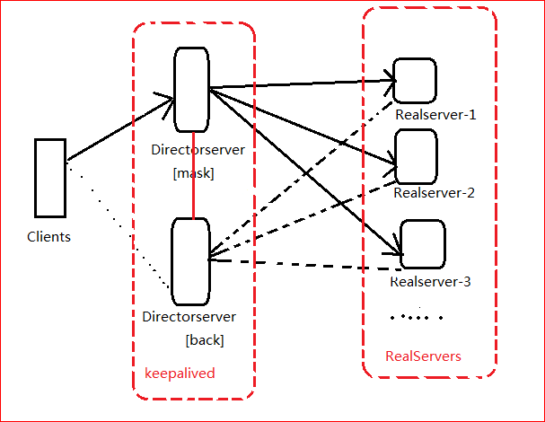

LVS/DR模式

Client： CIP： 192.168.122.1  
  
Director： VIP：192.168.122.100   
DIP: director1 192.168.122.2 director2 192.168.122.3   
  
Real Server： RIP： 192.168.122.10 192.168.122.20 192.168.122.30  
VIP： 192.168.122.100 192.168.122.100 192.168.122.100   
  
DNS Server： server ===> 192.168.122.100  
注：主/备Directory VIP由高可用软件添加  
  
  
一、实施步骤  
1. 准备工作（集群中所有主机）  
IP, hostname, hosts, iptables, SELinux, ssh trust, ntp   
[root@tianyun ~]# cat /etc/hosts  
127.0.0.1 localhost  
192.168.122.2 director1  
192.168.122.3 director2  
192.168.122.10 node1   
192.168.122.20 node2   
192.168.122.30 node3   
  
2. RS配置  
配置好网站服务器，测试所有RS //为了测试效果，提供不同的页面

//在lo接口上绑定VIP  
[root@tianyun ~]# ip addr add dev lo 192.168.122.100/32

//non-arp  
[root@tianyun ~]# echo 1 > /proc/sys/net/ipv4/conf/all/arp_ignore   
[root@tianyun ~]# echo 2 > /proc/sys/net/ipv4/conf/all/arp_announce   
  
3. 主/备调度器安装软件  
[root@master ~]# yum -y install ipvsadm keepalived   
[root@backup ~]# yum -y install ipvsadm keepalived  
  
===============================================================  
方法二：源码安装方法  
ipvsadm  
[root@tianyun ~]# yum -y install ipvsadm

KeepAlived  
[root@tianyun keepalived-1.2.1]# ./configure --prefix=/   
  
  
---------------------------------------------  
Keepalived version : 1.2.1  
Compiler : gcc  
Compiler flags : -g -O2 -DETHERTYPE_IPV6=0x86dd  
Extra Lib : -lpopt -lssl -lcrypto  
Use IPVS Framework : Yes  
IPVS sync daemon support : Yes  
Use VRRP Framework : Yes  
Use Debug flags : No  
[root@tianyun keepalived-1.2.1]# make  
[root@tianyun keepalived-1.2.1]# make install  
============================================================

4. 主/备调度器Keepalived配置  
Master   
[root@tianyun ~]# vim /etc/keepalived/keepalived.conf

! Configuration File for keepalived

global_defs {

router_id director1 //辅助改为director2

}

#vrrp_script check_nginx {

# script "/etc/keepalived/*.sh"

# interval 5

#}

vrrp_instance VI_1 {

state MASTER //辅助改为BACKUP

interface eth0 //VIP绑定的接口

virtual_router_id 80 //MASTER,BACKUP一致

priority 100 //辅助改为50

advert_int 1

authentication {

auth_type PASS

auth_pass 1111

}

virtual_ipaddress {

192.168.122.100

}

track_script {

check_nginx

}

}

virtual_server 192.168.122.100 80 {

delay_loop 6

lb_algo rr

lb_kind DR

nat_mask 255.255.255.0

persistence_timeout 50

protocol TCP

real_server 192.168.122.10 80 {

weight 1

TCP_CHECK {

connect_timeout 3

nb_get_retry 3

delay_before_retry 3

connect_port 80

}

}

real_server 192.168.122.20 80 {

weight 1

TCP_CHECK {

connect_timeout 3

nb_get_retry 3

delay_before_retry 3

connect_port 80

}

}

real_server 192.168.122.30 80 {

weight 1

TCP_CHECK {

connect_timeout 3

nb_get_retry 3

delay_before_retry 3

connect_port 80

}

}

}

5. 启动KeepAlived（主备均启动）

[root@tianyun ~]# chkconfig keepalived on

[root@tianyun ~]# service keepalived start

[root@tianyun ~]# tail -f /var/log/messages

BACKUP做相同的操作！！！  
  
  
5. 启动KeepAlived（主备均启动）  
[root@tianyun ~]# chkconfig keepalived on  
[root@tianyun ~]# service keepalived start  
[root@tianyun ~]# tail -f /var/log/messages  
  
[root@tianyun ~]# ipvsadm -Ln  
IP Virtual Server version 1.2.1 (size=4096)  
Prot LocalAddress:Port Scheduler Flags  
-> RemoteAddress:Port Forward Weight ActiveConn InActConn  
TCP 192.168.122.100:80 wrr  
-> 192.168.122.10:80 Route 1 0 0   
-> 192.168.122.20:80 Route 3 0 0   
-> 192.168.122.30:80 Route 3 0 0   
  
[root@tianyun ~]# ipvsadm -Ln -c  
IPVS connection entries  
pro expire state source virtual destination  
TCP 01:57 FIN_WAIT 192.168.1.254:58698 192.168.122.100:80 192.168.122.10:80  
TCP 01:57 FIN_WAIT 192.168.1.254:58699 192.168.122.100:80 192.168.122.20:80  
TCP 01:57 FIN_WAIT 192.168.1.254:58695 192.168.122.100:80 192.168.122.20:80  
TCP 01:56 FIN_WAIT 192.168.1.254:58691 192.168.122.100:80 192.168.122.20:80  
TCP 01:58 FIN_WAIT 192.168.1.254:58700 192.168.122.100:80 192.168.122.20:80  
TCP 01:58 FIN_WAIT 192.168.1.254:58702 192.168.122.100:80 192.168.122.10:80  
TCP 01:58 FIN_WAIT 192.168.1.254:58703 192.168.122.100:80 192.168.122.20:80  
TCP 01:57 FIN_WAIT 192.168.1.254:58696 192.168.122.100:80 192.168.122.20:80  
TCP 01:57 FIN_WAIT 192.168.1.254:58693 192.168.122.100:80 192.168.122.20:80  
  
  
  
二、测试  
所有分发器和Real Server都正常  
  
主分发器故障及恢复  
  
Real Server故障及恢复  
  
  
三、Keepalived不抢占  
nopreempt 仅针对BACKUP