# Hazelcast Example

下面介绍Hazelcast的使用：

1. 使用Hazelcast创建一个简单的Java App，在程序中使用Distributed Map和Queue
2. 在主机上运行两次，构成一个JVM Cluster
3. 使用Hazelcast Native Java客户端访问集群

编写示例1：

*public class HazelcastStarterMaster {*

*public static void main(String[] args) {*

*Config config = new Config();*

*config.getManagementCenterConfig().setEnabled(true);*

*config.getManagementCenterConfig().setUrl("http://10.139.4.98:8080/hazelcast-mancenter");*

*//以上连接Hazelcast Mancenter*

*HazelcastInstance instance = Hazelcast.newHazelcastInstance(config);*

*//使用分布式Distributed Map*

*Map<Integer,String> clusterMap = instance.getMap("MyMap");*

*clusterMap.put(1,"Hello Hazelcast Map!");*

*//使用分布式Distributed Queue*

*Queue<String> clusterQueue = instance.getQueue("MyQueue");*

*clusterQueue.offer("Hello Hazelcast Queue");*

*clusterQueue.offer("Hello ALl Hazelcasters");*

*}*

*}*

创建Hazelcast 示例2：

*public class HazelcastStarterSlave {*

*public static void main(String[] args) {*

*Config config = new Config();*

*config.getManagementCenterConfig().setEnabled(true);*

*config.getManagementCenterConfig().setUrl("http://10.139.4.98:8080/hazelcast-mancenter");*

*HazelcastInstance instance = Hazelcast.newHazelcastInstance(config);*

*Map<Integer,String> clusterMap = instance.getMap("MyMap");*

*Queue<String> clusterQueue = instance.getQueue("MyQueue");*

*System.out.println("Map Value:" + clusterMap.get(1));*

*System.out.println("Queue Size:" + clusterQueue.size());*

*System.out.println("Queue Value:" + clusterQueue.poll()); }}*

启动Hazelcast manCenter后，界面如下：

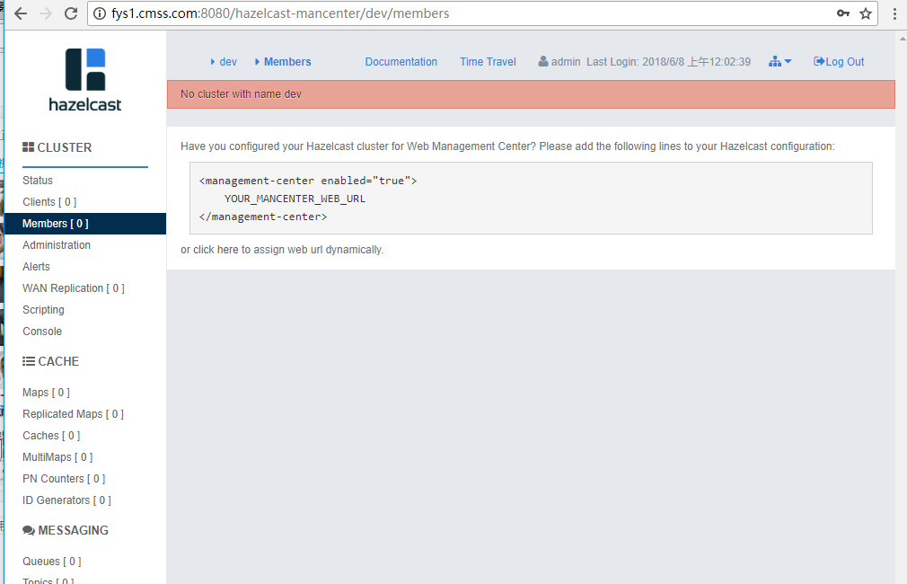

启动Hazelcast Master，输出如下：

Members {size:1, ver:1} [

Member [10.139.4.82]:5701 - 9c9c0082-d0bf-4c55-88a6-fe9a5a96a5a0 this

]

启动Hazelcast Slave后，输入如下：

Members {size:2, ver:2} [

Member [10.139.4.82]:5701 - 9c9c0082-d0bf-4c55-88a6-fe9a5a96a5a0

Member [10.139.4.82]:5702 - 7cbb76df-241c-4f1e-bcbf-98709031744d this

]

两个JVM进程，构成了Hazelcast集群。