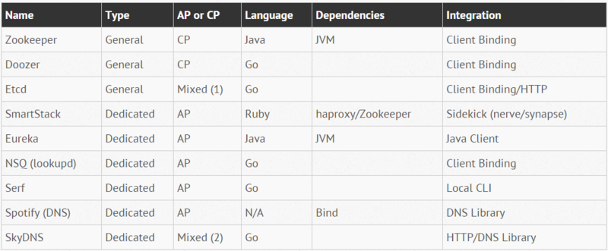

DNS

Zookeeper

Etcd

Consul

eureka

https://segmentfault.com/a/1190000004944218#articleHeader7

http://blog.csdn.net/alex_xfboy/article/details/77947429

http://blog.csdn.net/mr_seaturtle_/article/details/77618403

http://blog.csdn.net/lmy86263/article/details/75156520