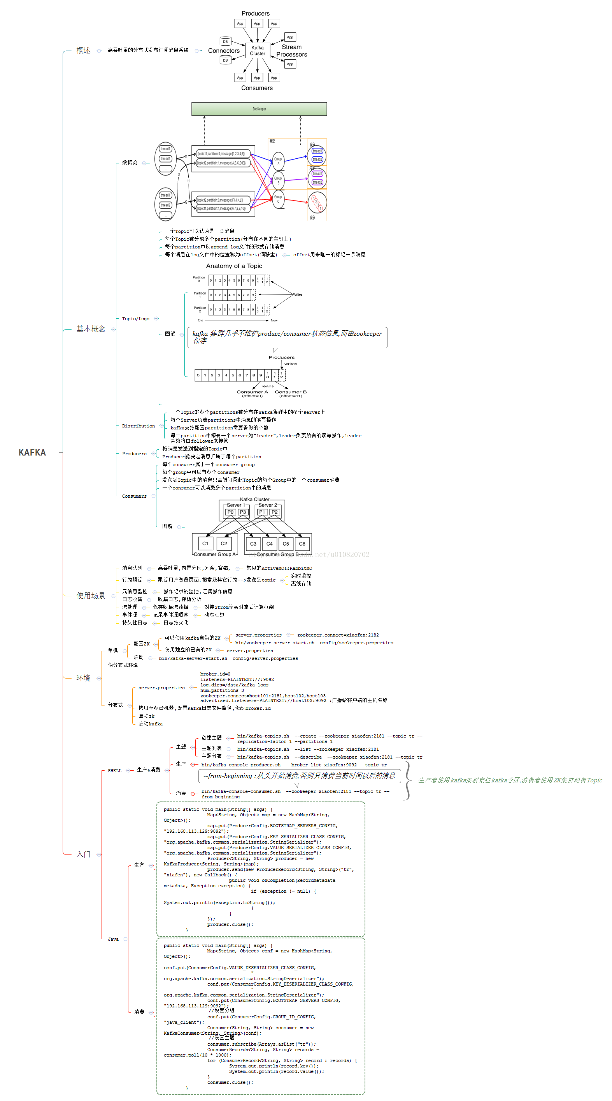

https://blog.csdn.net/u010820702/article/details/63683766?locationNum=1&fps=1