Mesos安装及使用

1.下载软件安装包

$wget http://archive.apache.org/dist/mesos/0.22.0/[mesos-0.22.0.tar.gz](http://archive.apache.org/dist/mesos/0.22.0/mesos-0.22.0.tar.gz)

2.安装依赖包

$wget -O /etc/yum.repos.d/slc6-devtoolset.repo http://linuxsoft.cern.ch/cern/devtoolset/slc6-devtoolset.repo

$wget http://repos.fedorapeople.org/repos/dchen/apache-maven/

epel-apache-maven.repo -O /etc/yum.repos.d/epel-apache-maven.repo

$yum install -y apache-maven python-devel java-1.7.0-openjdk-devel zlib-devel libcurl-devel openssl-devel cyrus-sasl-devel cyrus-sasl-md5 apr-devel subversion-devel apr-util-devel

3.编译及安装

$cd mesos-0.22.0

./configure

make

make install

4.安装目录简介

/usr/local/share/mesos

/usr/local/bin/mesos

/usr/local/etc/mesos

/usr/local/lib/python2.6/site-packages/mesos

/usr/local/libexec/mesos

/usr/local/libexec/mesos/python/mesos

/usr/local/include/mesos

/var/lib/mesos

5.Mesos的启动

打开Mesos目录，启动mesos master，命令如下：

./bin/mesos-master.sh --ip=127.0.0.1 --work_dir=/var/lib/mesos

启动mesos slave，命令如下：

./bin/mesos-slave.sh --master=127.0.0.1:5050

访问mesos master web ui，如下所示：

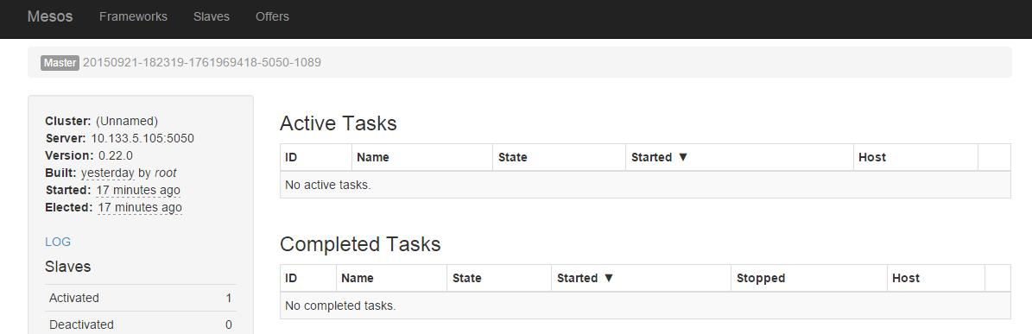

测试，运行python framework

[root@bdi32 python]# ./test-framework 10.133.5.105:5050

结果如下图所示：

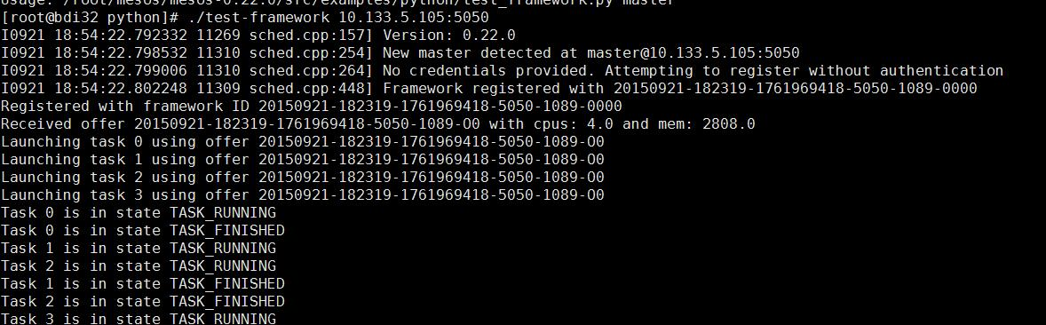

参考文献：

http://mesos.apache.org/gettingstarted/

http://archive.apache.org/dist/mesos/0.22.0/