轻量级分布式Rpc框架的实现

Rpc可以基于HTTP或者TCP 协议，Web Service就是基于HTTP协议的RPC，但是其性能比如基于TCP协议。为了实现RPC框架，思路如下所示：

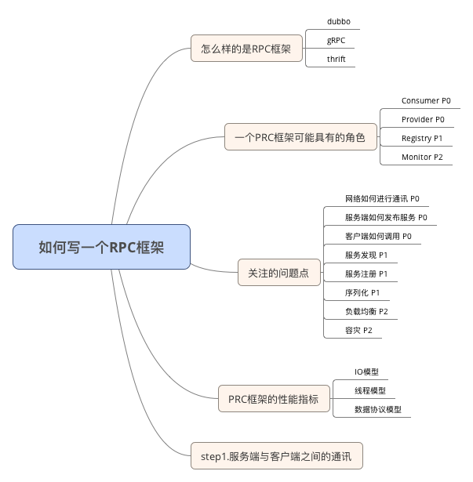

典型的Rpc整体框架如下图所示：

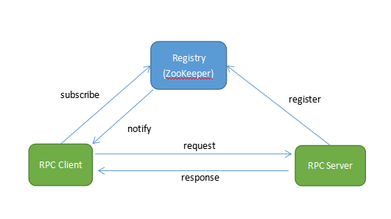

Rpc Server将服务部署在分布式环境下的不同节点，然后通过服务注册的方式，让客户端自动来发现当前可用的服务，并调用这些服务。

实现的轻量级Rpc架构如上图，使用以下技术：

* Spring，强大的依赖注入框架
* Netty， NIO编程技术库
* Protostuff，基于Protobuf序列化框架，面向POJO，无需编写.proto文件
* Zookeeper，提供服务注册与发现功能

具体过程如下

# 定义RPC协议

通过协议定义客户端和服务端可以理解的消息传输结构

1. 客户端请求消息，RpcRequest，定义如下：

*public class RpcRequest {  
 private String requestId; //请求标识  
 private String className; //请求类名  
 private String methodName; //方法名  
 private Class<?>[] parameterTypes; //参数类型  
 private Object[] parameters; //参数值*

*}*

1. 服务端响应消息，RpcResponse，定义如下：

*public class RpcResponse {*

*private String requestId;*

*private String error;*

*private Object result;*

*}*

客户端（RpcClientHandler）通过动态代理将RpcRequest发送给服务端，如下：

*public RPCFuture sendRequest(RpcRequest request) {*

*final CountDownLatch latch = new CountDownLatch(1);*

*RPCFuture rpcFuture = new RPCFuture(request);*

*pendingRPC.put(request.getRequestId(), rpcFuture);*

*channel.writeAndFlush(request).addListener(new ChannelFutureListener() {*

*@Override*

*public void operationComplete(ChannelFuture future) {*

*latch.countDown();*

*}*

*}); .....*

*return rpcFuture;*

*}*

服务端(RpcHandler)接收到RpcRequest后进行处理，并响应RpcResponse，如下：

*@Override*

*public void channelRead0(final ChannelHandlerContext ctx,final RpcRequest request) throws Exception {*

*RpcServer.submit(new Runnable() {*

*@Override*

*public void run() {*

*RpcResponse response = new RpcResponse();*

*response.setRequestId(request.getRequestId());*

*try {*

*Object result = handle(request); //处理RpcRequest*

*response.setResult(result); //设置RcpResponse*

*} ... //发送消息信息*

*ctx.writeAndFlush(response).addListener(new ChannelFutureListener() {*

*@Override*

*public void operationComplete(ChannelFuture channelFuture) {*

*logger.debug("Send response for request " + request.getRequestId());*

*}*

*});*

*}*

*});*

*}*

# **序列化**

RpcRequest和RpcResponse的发送都要经过网路传输，因此要经过序列化后形成传输字节，本处使用Netty作为NIO，其序列化及反序列化在RpcEncoder和RpcDecoder中进行处理，这里使用Protostuff作为序列化工具

1. 序列化-RpcEncoder

*cp.addLast(new RpcEncoder(RpcRequest.class)); //定义其序列化类RpcRequest*

序列化操作如下：

*@Override //Object in <= RpcRequest*

*public void encode(ChannelHandlerContext ctx, Object in, ByteBuf out) throws Exception {*

*if (genericClass.isInstance(in)) {*

*byte[] data = SerializationUtil.serialize(in);*

*out.writeInt(data.length);*

*out.writeBytes(data);*

*}*

*}*

1. 反序列化-RpcDecoder，处理RpcResponse

*cp.addLast(new RpcDecoder(RpcResponse.class));*

其反序列化如下：

*@Override*

*public final void decode(ChannelHandlerContext ctx, ByteBuf in, List<Object> out) {*

*if (in.readableBytes() < 4) {*

*return;*

*}*

*in.markReaderIndex();*

*int dataLength = in.readInt();*

*if (in.readableBytes() < dataLength) {*

*in.resetReaderIndex();*

*return;*

*}*

*byte[] data = new byte[dataLength];*

*in.readBytes(data);*

*Object obj = SerializationUtil.deserialize(data, genericClass);*

*out.add(obj);*

*}*

1. 序列化操作在类中SerializationUtil中实现，使用Protostuff类库

*public class SerializationUtil {*

*private static Map<Class<?>, Schema<?>> cachedSchema = new ConcurrentHashMap<>();*

*private static Objenesis objenesis = new ObjenesisStd(true);*

*@SuppressWarnings("unchecked")*

*private static <T> Schema<T> getSchema(Class<T> cls) {*

*Schema<T> schema = (Schema<T>) cachedSchema.get(cls);*

*if (schema == null) {*

*schema = RuntimeSchema.createFrom(cls);*

*if (schema != null) {*

*cachedSchema.put(cls, schema);*

*}*

*}*

*return schema;*

*}*

*@SuppressWarnings("unchecked")*

*public static <T> byte[] serialize(T obj) {*

*Class<T> cls = (Class<T>) obj.getClass();*

*LinkedBuffer buffer = LinkedBuffer.allocate(LinkedBuffer.DEFAULT_BUFFER_SIZE);*

*try {*

*Schema<T> schema = getSchema(cls);*

*return ProtostuffIOUtil.toByteArray(obj, schema, buffer);*

*} .....*

*}*

*public static <T> T deserialize(byte[] data, Class<T> cls) {*

*try {*

*T message = (T) objenesis.newInstance(cls);*

*Schema<T> schema = getSchema(cls);*

*ProtostuffIOUtil.mergeFrom(data, message, schema);*

*return message;*

*} ......*

*}*

*}*

# **网络通信层**

SimpleRpc使用Netty作为通信框架，其序列化及反序列化通过RpcEncoder和RpcDecoder来实现

1. Server端初始化，核心是RpcHandler，RpcServer初始化如下：

*public void start() throws Exception {*

*if (bossGroup == null && workerGroup == null) {*

*bossGroup = new NioEventLoopGroup();*

*workerGroup = new NioEventLoopGroup();*

*ServerBootstrap bootstrap = new ServerBootstrap();*

*bootstrap.group(bossGroup, workerGroup).channel(NioServerSocketChannel.class)*

*.childHandler(new ChannelInitializer<SocketChannel>() {*

*@Override*

*public void initChannel(SocketChannel channel) throws Exception {*

*channel.pipeline()*

*.addLast(new LengthFieldBasedFrameDecoder(65536, 0, 4, 0, 0))*

*.addLast(new RpcDecoder(RpcRequest.class))*

*.addLast(new RpcEncoder(RpcResponse.class))*

*.addLast(new RpcHandler(handlerMap));*

*}*

*})*

*.option(ChannelOption.SO_BACKLOG, 128)*

*.childOption(ChannelOption.SO_KEEPALIVE, true);*

*String host = array[0]*

*int port = Integer.parseInt(array[1]);*

*ChannelFuture future = bootstrap.bind(host, port).sync();*

*future.channel().closeFuture().sync();*

*}*

*}*

1. Client端初始化

*public class RpcClientInitializer extends ChannelInitializer<SocketChannel> {*

*@Override*

*protected void initChannel(SocketChannel socketChannel) throws Exception {*

*ChannelPipeline cp = socketChannel.pipeline();*

*cp.addLast(new RpcEncoder(RpcRequest.class));*

*cp.addLast(new LengthFieldBasedFrameDecoder(65536, 0, 4, 0, 0));*

*cp.addLast(new RpcDecoder(RpcResponse.class));*

*cp.addLast(new RpcClientHandler());*

*}*

*}*

*public void run() {*

*Bootstrap b = new Bootstrap();*

*b.group(eventLoopGroup)*

*.channel(NioSocketChannel.class)*

*.handler(new RpcClientInitializer());*

*ChannelFuture channelFuture = b.connect(remotePeer);...*

*}*

其处理过程不再详述，见源码

# **服务注册与发现**

使用Zookeeper实现服务注册与发现功能

1. 注册，Server端启动时将其注册到Zookeeper中

*public void start() throws Exception {*

*......*

*if (serviceRegistry != null) {*

*serviceRegistry.register(serverAddress);*

*}*

*}*

在ZK中，信息如下：

*[zk:] get /registry/data0000000004*

*127.0.0.1:18866*

1. 发现，客户端使用时从Zookeeper中获取服务地址

*private void watchNode(final ZooKeeper zk) {*

*try {*

*List<String> nodeList = zk.getChildren(Constant.ZK_REGISTRY_PATH, new Watcher() {*

*@Override*

*public void process(WatchedEvent event) {*

*if (event.getType() == Watcher.Event.EventType.NodeChildrenChanged) {*

*watchNode(zk);*

*}*

*}*

*});*

*List<String> dataList = new ArrayList<>();*

*for (String node : nodeList) {*

*byte[] bytes = zk.getData(Constant.ZK_REGISTRY_PATH + "/" + node, false, null);*

*dataList.add(new String(bytes));*

*}*

*this.dataList = dataList;*

*updateConnectedServer();*

*}*

*}*

在updateConnectedServer中将服务端地址发布到ConnectionManager中

*private void connectServerNode(final InetSocketAddress remotePeer) {*

*threadPoolExecutor.submit(new Runnable() {*

*@Override*

*public void run() {*

*Bootstrap b = new Bootstrap();*

*b.group(eventLoopGroup)*

*.channel(NioSocketChannel.class)*

*.handler(new RpcClientInitializer());*

*ChannelFuture channelFuture = b.connect(remotePeer);*

*channelFuture.addListener(new ChannelFutureListener() {*

*@Override*

*public void operationComplete(final ChannelFuture channelFuture)*

*RpcClientHandler handler =*

*channelFuture.channel().pipeline().get(RpcClientHandler.class);*

*addHandler(handler);*

*}*

*} }); } });}*

# **负载均衡**

启动多个Server后，客户端提交程序时从中选择某个Server，从而实现负载均衡，

*ObjectProxy#*

*@Override*

*public Object invoke(Object proxy, Method method, Object[] args) throws Throwable {*

*......*

*RpcRequest request = new RpcRequest();*

*request.setRequestId(UUID.randomUUID().toString());*

*request.setClassName(method.getDeclaringClass().getName());*

*request.setMethodName(method.getName());*

*request.setParameterTypes(method.getParameterTypes());*

*request.setParameters(args);*

*......*

*RpcClientHandler handler = ConnectManager.getInstance().chooseHandler();*

*RPCFuture rpcFuture = handler.sendRequest(request);*

*return rpcFuture.get();*

*}*

在ConnectManager#chooseHandler中实现负载均衡

*public RpcClientHandler chooseHandler() {*

*int size = connectedHandlers.size();*

*......*

*int index = (roundRobin.getAndAdd(1) + size) % size;*

*return connectedHandlers.get(index);*

*}*

参考链接:

http://www.cnblogs.com/LBSer/p/4853234.html

https://github.com/luxiaoxun/NettyRpc

http://www.cnblogs.com/luxiaoxun/p/5272384.html

https://my.oschina.net/huangyong/blog/361751

<https://github.com/SimonHunag/simpleRPC>