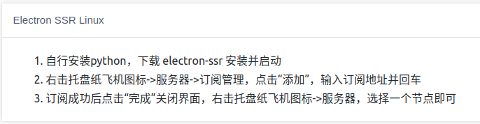

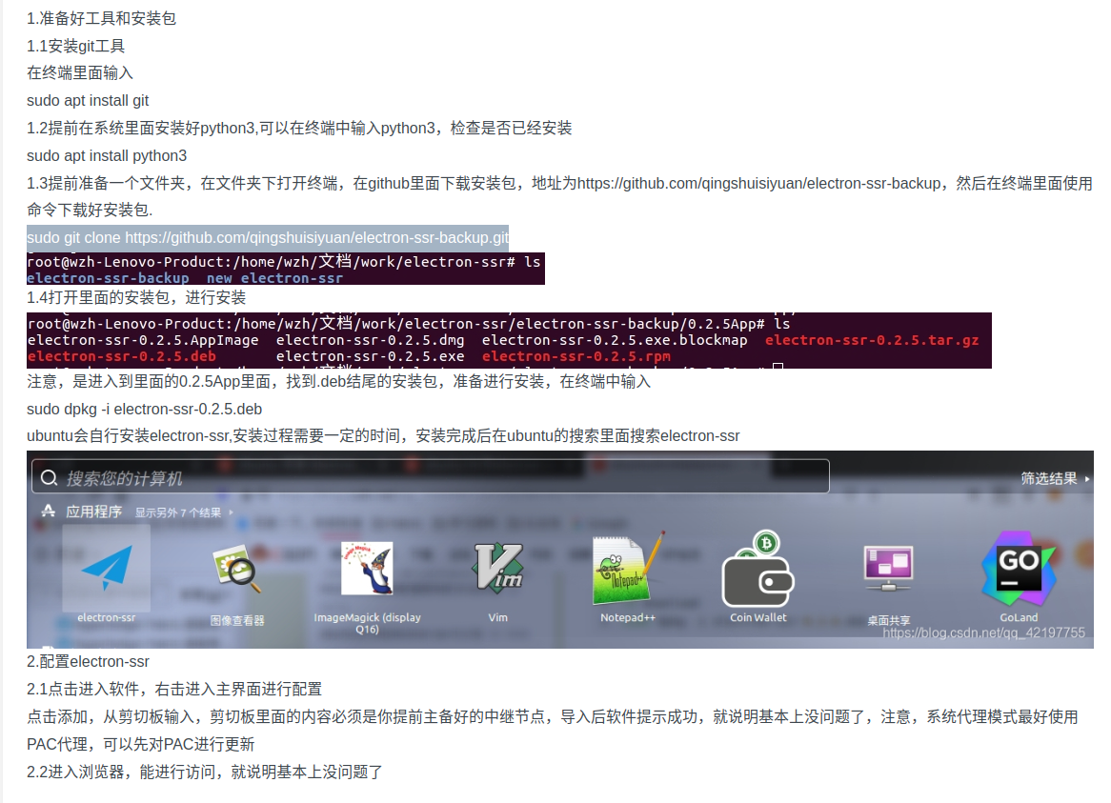

指令：sudo git clone https://github.com/qingshuisiyuan/electron-ssr-backup.git